# 

REVISION 1

November 2010

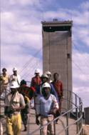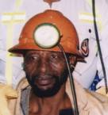

# 

**MINING INDUSTRY OCCUPATIONAL SAFETY AND HEALTH ADOPTION**

# 

***Eliminating Noise Induced Hearing Loss in South African Mines***

# 

**Leading Practice Adoption Guide for the Hearing Protection Device: Training, Awareness and Selection Tool (HPD_TAS_TOOL)**

Prepared by: Dickie Coutts

Approved by: Des Wrigley, Dries Labuschagne, Mervin van Rooyen Booysen

# Executive Summary

Despite ongoing efforts to improve the effectiveness of mine HCPs, NIHL has cost the South African mining industry in excess of R890 million in compensation claims alone from 1997 to 2007 (Kritzinger, 2009) and this does not take into account the impacts on productivity/profitability and mineworkers’ quality of life. The latest provisional statistics available show that in 2009 approximately 1600 people suffered NIHL as depicted in the graph below.

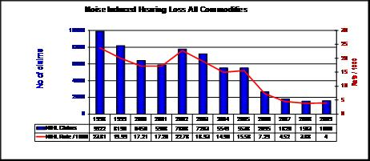

The Mine Health and Safety Council (MHSC) Safety in Mines Research Advisory Committee (SIMRAC) initiated a Prevention of NIHL research programme, “Track C” (SIM 050501)1, to address the needs of stakeholders in the mining industry when implementing HCPs.

Previous SIMRAC projects dealing with occupational noise have included “GEN 011” (1997) and more recently, “Health 806” (Franz, 2005), which incorporated guidelines for best practice in the implementation and management of mine HCPs. Despite initiatives to reduce noise through engineering controls, personal protection, being the last resort in the hierarchy of controls, will however continue to be a very important means of limiting NIHL risks to mineworkers. Both of the abovementioned projects emphasised the need to improve mineworkers’ knowledge of NIHL and awareness of noise as a hazard, as well as to improve their motivation to comply with safe work practices that include the correct use of Hearing Protection Device (HPDs).

The MOSH Noise Adoption Team HPD Selection Tool is therefore selected as a leading practice with the objective of assisting the South African Mining Industry in realizing the elimination of NIHL by improving the effectiveness of mine HCPs. This tool will improve mineworkers’ knowledge of NIHL and awareness of noise as a hazard, as well as improve motivation to comply with healthy and safe work practices. Furthermore, the tool also includes the correct use / wearing of HPDs, and also enables Occupational Hygienists and Health and Safety Practitioners to ensure that the correct HPD is made available to the various end users in the mining industry.

# The MOSH Leading Practice Adoption System

***Milestones in Health and Safety***

In June 2003, at the third Mine Health and Safety Council (MHSC) Summit, the Chamber of Mines of South Africa and its social partners, government and labour, established occupational safety and health targets and milestones to be attained over a 10 year period. This was followed in 2005, and later reinforced in 2008, by the Chief Executive Officers in the mining industry expressing the commitment of industry to continuous improvement towards zero harm.

Against this background, a Mining Industry Occupational Safety and Health (MOSH) Task Force was established in 2006 to identify the barriers and aids to the reduction of fatalities, occupational injuries and diseases on the mines and find sustainable solutions for the attainment of the 2013 targets. The Task Force found that there were pockets of industry leading practice that had directly contributed to improved health and safety performance. If applied widely throughout the industry, they would contribute significantly to the achievement of the milestones. As a result, in December 2007, the Chamber of Mines established the Mining Industry Occupational Safety and Health (MOSH) Leading Practice Adoption System to facilitate the widespread adoption of these leading practices throughout industry.

***The MOSH Leading Practice Adoption System***

The MOSH Leading Practice Adoption System is a process driven system approach that identifies a potential leading practice at a mine (the source mine), tests and refines that leading practice, and then demonstrates it at another mine (the demonstration mine). Finally, the leading practice technology, together with a behavioural leadership and communication strategy, is disseminated throughout industry for adoption (at adoption mines) utilising the Community of Practice (COPA) mechanism.

The MOSH Leading Practice Adoption System fully recognizes that, while a technological or procedural solution may have demonstrated effectiveness, its success as a leading practice will depend on people – at all levels of employment - and their leaders at all levels. Research has shown that decades of emphasis on technology transfer to improve safety and health have produced little true transfer of technology or significant improvement in performance. Research also shows that the need is to realise adoption – not transfer – of technology and leading practice.

Adoption is a human activity and the two most powerful influences on adoption are behavioural communication (modes of communication appropriate to different levels of employees and situations) and leadership behaviour (actions and inactions of leaders) as these have a significant influence on people’s decision-making, judgment and behaviour.

Therefore, the two distinguishing features of the Adoption System and why it is so different from past approaches are:

* inclusion of a structured communication strategy to achieve the desired behaviors, and
* inclusion of a leadership behaviour strategy to evoke and re-enforce the desired behaviors of leaders.

Fundamental to the development of leadership behaviour and behavioural communication strategies is an understanding of stakeholder and adopter perceptions (mental models) with regard to the risk/hazard being addressed by the recommended leading practice. The behavioural communication and leadership behaviour strategies that form part of the leading practices have been developed to align with and respond to these mental models of potential stakeholders and adopters of the leading practice.

# Leading Practice Adoption Guide Index

Executive Summary 2

The MOSH Leading Practice Adoption System 3

Leading Practice Adoption Guide Index 5

Part 1: Strategic Context 7

1.1 The problem addressed 7

1.2 Summary description of the practice 8

1.3 Summary of documented performance and impacts 10

1.4 The generic value case: 10

1.4.1 Industry performance on Noise Induced Hearing Loss 10

1.4.2 Expected Health and Safety performance improvement 10

1.4.2.1 Shorter-term improvements: 10

1.4.2.2 The ultimate long-term improvements: 11

1.4.3 Financial benefit of H&S improvements 11

1.4.3.1 Shorter-term benefits: 11

1.4.3.2 Longer-term benefits: 11

1.4.4 Initial cost to implement 11

Part 2: Adoption Guide 12

2.1 Clarify potential for the mine to benefit – develop the value/business case for the mine (*5.12) 12

2.2 Ensure existence of a clear implementation decision by mine manager (*6.2 / 6.4) 12

2.3 Identify project manager and team for implementation (*6.4) 12

2.4 Identify adopters (supervisors/workers) and stakeholders (management, OHS Committee, Unions, Safety Reps) (*6.4 / 6.5) 13

2.5 Identify initial implementation site (*6.4) 14

2.6 Briefing of adopters and stakeholders and communications plan (*6.4 / 6.5) 14

2.7 Behavioural Communication plan and Leadership Behaviour plan (*6.4/ 6.5) 15

2.7.1 Background and purpose 15

2.7.2 Key considerations 15

2.7.3 Direct enquiry process, drawing mental models and customisation of behaviour-based plans 28

Communication plan for adopters and stakeholders 42

2.8 Visits to and or discussions with source and demo mines (*6.4) 42

2.9 Arrangements for special assistance considered necessary (*6.4) 42

2.10 Identification of any special training considered necessary (*6.4) 42

2.10.1 Training Instructors 42

2.10.2 Occupational Hygienist 43

2.11 Identification of key success factors (*6.6) 43

2.12 Design of a monitoring programme (*6.4 / 6.7) 43

2.13 Development of the implementation plan for the mine (*6.1 / 6.4) 43

2.14 Implementation at the selected pilot site (*6.4) 44

2.15 Identification and documenting of any customisation needed prior to extension across the mine (*6.4) 44

2.16 Implementation of customization (*6.4) 44

2.17 Managing extension of the practice across the mine (*6.4) 44

2.18 Completion of checklist to confirm adequate consideration of critical elements (*6.4) 45

Part 3: Details of the leading practice 46

3.1 Equipment: 46

3.2 Equipment maintenance 47

3.3 Installation of equipment 47

3.4 Necessary supporting physical infrastructure 47

3.5 Risk Assessment 47

3.6 Training 47

3.7 Instruction documentation 48

3.8 Behavioural communication 48

3.9 Signage 48

3.10 Management structure 48

3.11 Incentive arrangements 48

3.12 Operational procedures 48

3.13 Relevant mine standards 48

3.14 Monitoring and reporting arrangements 49

3.15 Performance measures 49

3.16 Proprietary knowledge or technology 49

Part 4: Supporting documents 49

4.1 Cost Associated with Hearing Impairment - Compensation & Premiums 49

4.2 Appendix 1: A Comprehensive Plan for Leadership Behaviour with Behavioural Communications In Support of Adoption of Leading Practice to assist mines in the adoption process. 50

4.4 Appendix 3- Assessment Form 62

4.5 Appendix 4- Route Form 64

4.6 Appendix 5 - Instruction and Training Guide 64

# Part 1: Strategic Context

## The problem addressed

NIHL is one of the most common occupational illnesses in the South African Mining Industry. The use of heavy equipment, the inherently noisy aspect of ore winning processes, and the confined work environment are some of the factors that contribute to high levels of noise exposure to workers in the mining industry.

There are several barriers to reducing NIHL. These include gaps in knowledge of noise dose/source relationships, the unavailability of effective noise controls, and needs for worker education and worker empowerment. A related issue is the difficulty of communication in noisy workplaces by both hearing-impaired and normally hearing workers.

Despite ongoing efforts to improve the effectiveness of mine HCPs, NIHL has cost the South African mining industry in excess of R890 million in compensation claims alone from 1997 to 2007 (Kritzinger, 2009) and this does not take into account the impacts on productivity/profitability and mineworkers’ quality of life. The latest provisional statistics available show that in 2009 approximately 1600 people suffered NIHL as depicted in the graph below.



Graph 1: NIHL statistics for all commodities

Hearing conservation is potentially the most difficult of all the possible health and safety topics. One of the reasons for this is that there is no pain associated with hearing loss. In fact, some people actually enjoy loud noise that damages their hearing e.g. music, motor sport, etc.! It is by no means an easy task to convince people to wear, what is often perceived as, uncomfortable Personal Protective Equipment (PPE), especially when they cannot immediately feel or see the benefits. Ideally a willingness to comply is to be created. This can be done by ensuring that the employee fully understands the working of the ear, how the ear is damaged and that noise induced damage is irreversible and totally isolates one from the world.

The Mine Health and Safety Council (MHSC) Safety in Mines Research Advisory Committee (SIMRAC) initiated a Prevention of NIHL research programme, “Track C” (SIM 050501)1, to address the needs of stakeholders in the mining industry when implementing HCPs.

Previous SIMRAC projects dealing with occupational noise have included “GEN 011” (1997) and more recently, “Health 806” (Franz, 2005), which incorporated guidelines for best practice in the implementation and management of mine HCPs. Despite initiatives to reduce noise through engineering controls, personal protection, being the last resort in the hierarchy of controls, will however continue to be a very important means of limiting NIHL risks to mineworkers. Both of the abovementioned projects emphasized the need to improve mineworkers’ knowledge of NIHL and awareness of noise as a hazard, as well as to improve their motivation to comply with safe work practices that include the correct use of Hearing Protection Device (HPDs).

## Summary description of the practice

The MOSH Noise Adoption Team HPD Training, Awareness and Selection Tool is a user-friendly Excel®-based version of SIM 05 05 01-NIHL Prevention Programme – Track C Training and Awareness and HPD selection report June 2009, see Figure 1.

A user's guide, intended to give assistance to people using the tool, is included and contains both a written guide and the associated screenshots/images in the tool. The language used is matched to the intended audience, with jargon kept to a minimum or explained thoroughly.

Given the need to enhance the effectiveness of awareness and training materials and mine personal protection strategies the Tool has as its primary outputs;

Updated multimedia training, educational, awareness and motivational materials for the prevention/elimination of NIHL, aimed at all levels of mine employees, comprising of;

1. A training video programme in English, Xhosa, South Sotho and Zulu for the South African mining industry:
   * Module 1: Educational/Motivational (15 minutes long), which conveys the message that loud noise is hazardous and illustrates the potential consequences of exposure;
   * Module 2: HPD training (10 minutes long), which reinforces educational and motivational aspects from Module 1 and demonstrates the correct use and care of various types of HPDs;
2. Handouts for trainees in the form of 16-page, A-5 self-cover booklets illustrating the risks of excessive noise exposure, as well as the correct use and care of HPDs, produced in English and Zulu;

1. Four volumes of guidelines for trainers, comprising:

* A script for induction talks on the noise hazard, with a demonstration of the benefits of using HPDs in noisy areas and their correct use and care, with four supporting overhead transparencies;
* Use of the training videos, with the scripts for Modules 1 and 2 appended;
* Use of the handout booklet, with a reproduction of the booklet appended; and
* Suggestions for ways of responding to reasons or excuses commonly given by mineworkers who neglect to use HPDs.

1. The ability to select frequency-specific data for all noise associated with various occupations, workplaces and machinery in the SA mining industry.
2. The ability to select frequency-specific attenuation data for all currently available HPDs in the SA mining industry.
3. What should be known about HPDs’ Noise Reduction Rating (NRR) values?
4. The effect of HPD non-wear time.
5. Cost associated with Hearing Impairment – Compensation and Premiums.
6. Other materials available in the tool from local and international sources comprising of:

* PowerPoint® presentation – Hearing Conservation – Stick to Basics

The PowerPoint® presentation allows the presenter to demonstrate, what sound is, what noise is, the working of the ear, how the ear is damaged and that noise induced damage is irreversible and totally isolates one from the world. The presentation also evaluates the various HPD styles available in the mining industry.

* The National Institute of Occupational Safety and Health (NIOSH) Hearing Loss Simulator

The NIOSH Hearing Loss Simulator is a software training and communication tool for promoting hearing conservation. It allows a user or trainer to demonstrate the effects of noise exposure on hearing without experiencing an actual noise-induced hearing loss. Estimates of the effects of different levels of noise exposure are based on the American National Standard Determination of Occupational Noise Exposure and Estimation of Noise-Induced Hearing Impairment otherwise known as ANSI S3.44. This standard specifies the predicted hearing loss for noise-exposed populations of individuals on the basis of risk factors that include sex, age, noise exposure levels (dBA) and years of exposure.

* The NIOSH Noise Meter

The NIOSH Noise Meter is a software training and communication tool for promoting hearing conservation. It allows a user or trainer to demonstrate to the trainees the different sounds and sound intensities of everyday objects.

## Summary of documented performance and impacts

* ***Accessibility*** of the HPD_TAS_Tool material in terms of different mother–tongue languages, different cultural practices, and varying levels of sophistication and literacy;
* ***Motivational value*** of the HPD_TAS_Tool material for mineworkers to protect themselves from NIHL by explaining the risks and making the consequences of noise exposure clear;
* ***Relevance*** of the HPD_TAS_Tool material to individual needs at different levels of authority and in various workplaces;
* ***Enabling*** ***value*** of the HPD_TAS_Tool material to inform and instruct clearly on the correct and effective use of hearing protection devices (HPDs) and HCP practices; and
* ***Technical quality*** of the HPD_TAS_Tool materials with regard to image quality, sound quality, and availability of material.

## The generic value case:

### Industry performance on Noise Induced Hearing Loss

Despite ongoing efforts to improve the effectiveness of mine HCPs, NIHL has cost the South African mining industry in excess of R890 million in compensation claims alone from 1997 to 2007 (Kritzinger, 2009) and this does not take into account the impacts on productivity/profitability and mineworkers’ quality of life. The latest provisional statistics available show that in 2009 approximately 1600 people suffered NIHL.

### Expected Health and Safety performance improvement

#### Shorter-term improvements:

* Noise reduction and maintenance of hearing sensitivity can benefit safety because employees are better able to communicate, and to hear alarms and warning shouts.
* Good hearing is essential for more subtle warning signals, such as a malfunctioning machine or the sounds of “roof-talk” in underground mines.
* Reductions in noise exposure may also result in less fatigue and irritation, and possibly fewer stress-related health complaints.
* Reduced noise exposures also can be associated with improved employee morale.
* The ease and accuracy of communication is improved as noise levels are lowered.

#### The ultimate long-term improvements:

* NIHL usually occurs gradually over a career. The ultimate long-term measure of success is the elimination of new cases of NIHL. The overall success of the leading practice will only be seen in years to come.

### Financial benefit of H&S improvements

#### Shorter-term benefits:

* A good HCP is good business. It promotes good labor relations because employees know that management is concerned, and this type of concern may translate to improved productivity and product quality.
* The reduced likelihood of DMR citations and fines for hearing conservation violations.
* Reduced noise exposures also can be associated with improved employee morale, and, in some cases, higher production efficiency.
* Additionally, the conservation of hearing leads to the conservation of valuable employee resources.
* Versatility, adaptability, and promo ability of employees are likely to be maintained.
* Noise itself can have an adverse effect on productivity. For complex jobs and those requiring concentration, studies show that greater efficiency is linked to lower noise levels. Also, the ease and accuracy of communication is improved as noise levels are lowered. These benefits should prove to be cost-effective for management.
* Finally, morale may also benefit, which should lead to greater employee satisfaction and retention.

#### Longer-term benefits:

* The company benefits from reduced worker compensation payments and medical expenses.
* Employee compensation insurance carriers also advocate HCPs, and companies that do not protect their employees from hearing loss may find their premiums increasing.

### Initial cost to implement

Effective hearing loss prevention program costs money to implement, but the necessary investment will produce a beneficial return.

# Part 2: Adoption Guide

## Clarify potential for the mine to benefit – develop the value/business case for the mine (*5.12)

Before an informed decision can be made to adopt any leading practice, a comprehensive business and value case should be drafted. It should include as a minimum the costs involved (direct and indirect) and the health and safety benefits. The payback period should be presented.

In the HPD_TAS_Tool the MOSH Noise Team developed a Excel® Spreadsheet “Cost Associated with Hearing Impairment - Compensation & Premiums” to assist the user in evaluating the cost of Compensation & Premiums making use of the following parameters:

* Employees Noise Exposure Level,
* Exposure time per shift, No. of years of exposure,
* Average settlement cost per claim,
* HPD Type, Estimated Risk of compensable impairment (%),
* Value of compensation claims per 100 employees so exposed,
* Cost to be paid in premiums by employer to cover claims.

**An example of this Excel® Spreadsheet can be seen in section 4 of this report as per 4.1**

## Ensure existence of a clear implementation decision by mine manager (*6.2 / 6.4)

The next step towards adoption is the decision taken by the Mine Manager. The person responsible for the adoption of the leading practice, in most cases the Project Manager, should present to the Mine Manager a comprehensive business and value case as discussed in 2.1 in order to make an informed decision.

## Identify project manager and team for implementation (*6.4)

The Project Manager for the duration of the adoption of the leading practice should be of high seniority at the mine. In the case of the Cooke 2 Shaft experience, the Mine Manager took the role of Project Sponsor and the Manager Occupational Hygiene the role of the Project Manager. The team that formed part of the project should at least include, but not limited to, the following:

* + - Mine Manager – Sponsor
    - Manager Occupational Hygiene – Project Manager
    - Training Manager
    - Trainers
    - End Users – Representative From All Employees
    - Unions
    - Health & Safety Representatives
    - PPE Store Manager/Supervisor
    - Purchasing Department Representative
    - IT Representative

## Identify adopters (supervisors/workers) and stakeholders (management, OHS Committee, Unions, Safety Reps) (*6.4 / 6.5)

To better achieve the objectives of the Communication Plan, a number of stakeholders and stakeholder groups should be identified and addressed through communication of various kinds. Such stakeholders can further be categorized according to levels, intensity, frequency, objectives and sophistication of the messages to be communicated.

**Adopters**:

Also called end-users, People on the “face” that will be adopting the leading practice and using the requisite equipment consistently as well - such as rock drill operators.

**Other Stakeholders**:

**Decision-Makers**: These include the Mine Management team of the mine.

**Engagers**: Those who have a primary or shared role in the implementation of the leading practice and include the Original Equipment Manufacturer (OEM), Management and Health and Safety Committees of the mine.

**Champions**: Those who assume direct responsibility for the implementation of the project on their mine.

**Active interests**: Individuals or groups who have a stake in the Adoption System, but are not directly involved. These include Labour, the Department of Minerals and Energy and the members of the community of practice for adoption (COPA).

## Identify initial implementation site (*6.4)

The selection of the initial implementation site is critical to ensure success. The site should be easily accessible and easy to implement. In the case of the Cooke 2 Shaft experience Rand Uranium Training Centre was utilized for the implementation of Part 2 – HPD Training and Awareness section of the tool and the Occupational Hygiene was utilized for Part 1 – HPD Selection section of the tool.

## Briefing of adopters and stakeholders and communications plan (*6.4 / 6.5)

The initial point of contact should be the Mine Health and Safety Committee to ensure buy-in from all stakeholders. Briefing should be done to all the stakeholders as identified in section 2.4 and different communication methods for different stakeholders should be used. These methods could include personal contact, posters, meetings, etc. whichever is the most effective for the application. A comprehensive communications plan should be set up including the stakeholder, message, type of communication, frequency and the responsible party.

## Behavioural Communication plan and Leadership Behaviour plan (*6.4/ 6.5)

### Background and purpose

Research and experience have shown that communications of all kinds and the actions (and inactions) of leaders at all levels are the most powerful influence on people’s decision-making, judgment and behaviour. Tellingly, communications and leaders’ behaviour occur continuously every day in mines. It is impossible to get anything done in the course of a day without communications and leaders’ behaviour of various sorts and combinations: *Persons cannot not communicate; Leaders cannot not act.*

A leading practice within the Adoption System is described in three parts involving inextricably linked and interdependent activities. They are: 1) technology, knowledge or procedure; 2) communication to achieve desired behaviours and; 3) leadership behaviour to evoke and re-enforce desired behaviours for adoption. These three elements have been documented and developed by the *Lead Adoption Team* at the source and demonstration mines respectively and the challenge is to ensure that these key elements of the leading practice are customised by the *Adoption Mine Team* to appropriately take account of mine specific circumstances at the adoption mines. In respect of leadership behaviour and behavioural communication, this is the challenge addressed in this guidance note.

The purpose of this note is to:

* Present a simple illustration, outlining the steps involved in customising the behavioural communication and leadership behaviour plans developed for the demonstration mine to meet the needs of a mine adopting the practice.
* Provide guidance on conducting and using a direct enquiry process to identify insight-based adjustments to the behaviour-based plans developed for the demonstration mine.
* Provide guidance on integration of the customised plans into the overall plan implementing the leading practice at the adoption mine.

### Key considerations

**Implementation of the customisation process should be kept as simple as possible:** The key elements of the customisation process are presented in the following simple diagram, which identifies what needs to be done in an eight step process, along with the quality checks that need to be implemented to ensure a quality outcome.

|  |  |  |  |  |  |  |
| --- | --- | --- | --- | --- | --- | --- |
| **Step** |  | | **What** | |  | **Check – go/no-go decision question** |
|  | |  | |  |  |  |
| 1 |  | | **Identify adopters and key stakeholders at the mine** | |  | Do we have a good understanding and complete identification of potential adopters and stakeholders? |
|  |  | | |  |  |  |
| 2 |  | | | **Select people to be interviewed** |  | Have we chosen the appropriate people to interview? |
|  |  | | |  |  |  |
| 3 |  | | | **Identify and brief the interviewers** |  | Are the interviewers ready to interview? |
|  |  | | |  |  |  |
| 4 |  | | | **Conduct the interviews** |  | Have all the interviews been done and full worksheets completed and returned for processing? |
|  |  | | |  |  |  |
| 5 |  | | | **Summarise the interview results** |  | Have the interview results been systematically assessed and significant new findings clearly identified? |
|  |  | | |  |  |  |
| 6 |  | | | **Use the findings to customise the behavioural communication plan** |  | Are the customised plans coherent and properly understood by the mine team and can they be implemented and effectively monitored in behavioural terms? |
|  |  | | |  |  |  |
| 7 |  | | | **Use the findings to customise the leadership behaviour communication plan** |  | Are the customised plans coherent and properly understood by the mine team and can they be implemented and effectively monitored in behavioural terms? |
|  |  | | |  |  |  |
| 8 |  | | | **Integrate the customised plans into the implementation plan at the mine** |  | Is the overall implementation plan coherent and properly understood by the mine project team? |

A key point about the process outlined above is that it enables the behavioural communication and leadership behaviour plans to be customised on the basis of insight and not guesswork about the thinking, Key beliefs and values of the adopters and stakeholders. This allows the communication and leaders actions to be tailored to the critical behaviours needed to accomplish adoption of the leading practice.

An expanded diagram indicating how the various steps would be implemented and the practical implications of who needs to do what is provided at the end of the note. More detailed guidance is set out in the points that follow.

**Attention must be focussed on ensuring that the key tasks in each step are completed as described in order to produce a quality result:** Behavioural communication and leadership behaviour plans typically have goals, or desired outcomes, that are expressed in behavioural terms. They are expressed in the form of what a person could observe happening in the workplace, or hear in a conversation or interview in the workplace. Both should be as a clear result of communications implemented and the behaviour of leaders. Accomplishing desirable goals of this nature, which is what is needed to achieve the adoption being sought. This can best be done by following the guidance provided.

**Responsibilities for stewarding the process to completion must be clearly assigned as must responsibilities for completing the requisite individual tasks:** Implementation responsibilities should be clearly set within the adoption mine team in order to ensure that the entire process outlined in this note is appropriately stewarded. This will ensure that individual tasks are completed as required, and that the outcomes for plans are appropriately measured and reported. This could involve spreading the tasks across many individuals, or perhaps concentrating the process in a small number of key individuals. While the use of a small number of key individuals may be more manageable, the group should be large enough to reduce the risk of personal bias and to spread the benefits derived from meaningful interaction with staff on a matter of direct concern to them.

The Adoption Mine Team should however ensure that a single person with appropriate skill and orientation takes on the responsibility for overseeing the process. The selected person should be experienced in interacting effectively with a wide variety of people, be at ease with and be able to effectively listen to people, and to correctly interpret conversations with people. The training department at mines is likely to have a few such people, but other functions should also be considered. Other persons providing the support needed to execute the required tasks may require special training in order to be effective in undertaking the work, and such training should be provided. The Adoption Mine Team Leader should be consulted on this point as necessary.

**The eight-step customisation process must be systematically executed:** To facilitate easy application of the process at adoption mines, each of the eight steps describes an essential task and a small number of sub-tasks. The steps and sub-tasks should be completed in the recommended order without any skipping or reordering of tasks. Guidance on how to complete the tasks is typically offered in the form of key questions to be answered by those at the adoption mine responsible for preparing and implementing the plans.

At the end of each step, a checkpoint question and action is indicated. The checkpoint question is intended to act as a “go/no go” decision point for the adoption mine team. If the adoption mine team cannot satisfactorily answer the checkpoint question, then they should not go to the next step. Instead, they must take steps to rectify the matter.

**Step one - Identify adopters and key stakeholders at the adoption mine.**

Adopters and stakeholders are those people and groups who will be the focus of behavioural communication and leadership behaviour efforts. Key points for identifying adopters and stakeholders are as follows:

* The Lead Adoption Team should provide the adoption mine project team with a one page or otherwise simple summary of the risk “story” being addressed by the leading practice, based on the risk summary table finalized during their planning workshop. The risk story should identify anticipated adopters and stakeholders for the leading practice. In some cases it is possible that the adoption mine project team may need to modify the risk story to take account of special circumstances at the mine.
* The Adoption Mine Team should review the risk story summary and confirm or elaborate on the description of adopters and stakeholders to ensure that:
  1. All members of the team have the same understanding of the risks being addressed by the leading practice and,
  2. They have identified the adopters and stakeholders at the adoption mine that will be involved in achieving implementation of the leading practice.

A list specifying the adopters and stakeholders that will be the focus of behavioural communication and leadership behaviour efforts in the adoption mine should be prepared by the Adoption Mine Team.

The adoption mine project team should address the checkpoint question of whether the team has a good understanding and has a complete identification of the potential adopters and stakeholders in order to make a “go/no-go” decision in respect of proceeding to the next step in the process.

**Step two - Select people to be interviewed**

The only way to accurately understand people’s thinking is to directly enquire into it. People are complicated and their thinking is unpredictable. One cannot successfully guess or predict people’s thinking and their information needs. The process of direct enquiry requires that an appropriate number of persons be interviewed, as follows:

* From a final list of adopters and stakeholders at the adoption mine, a selection of an appropriate type and number of people to be interviewed should be identified. The types of people selected should range across the adopters and stakeholders in such a way as to ensure good representation of those most likely to be most involved in accomplishing adoption of leading practice. The number of persons to be interviewed should be between 25 and 30. This has been shown to be an appropriate number to get useful interview results.
* The adoption mine should address the checkpoint question of whether the appropriate people have been chosen to be interviewed in order to make the “go/no-go” decision in respect of proceeding to the next step in the process.

**Step three – Identify and brief interviewers.**

Interviews with the selected adopters and stakeholders should be done confidentially and one-on-one. No interviews of people in groups or in a group setting should be done because of challenges in accurately interpreting their results. Also, the circulation of printed questionnaires where people are asked to fill-in answers to questions is to be avoided because of challenges in producing satisfactory insights into people’s thinking. Key points in selecting and training the interviewers are as follows:

* Adoption mine teams should chose as interviewers those people whom:
  1. interviewees are most likely to feel comfortable with in an interview setting, that is, to feel free to speak openly and candidly with the person conducting the interview, and
  2. are most likely to complete each assigned interview in the manner prescribed.
* Interviewers should be self-briefed or trained in the interview to be conducted by:

1. studying and discussing the risk summary and simple risk story with an appropriate member of the Adoption Mine Team to ensure that they have a thorough understanding the risks being addressed by the leading practice.
2. reading the interviewer’s briefing on the list of questions to be asked in the interview, as well as the guidance note on conducting a one-on-one interview properly. The Lead Adoption Team should prepare and include this material in the leading practice adoption guide.
3. practicing the interview at least once (perhaps with an adoption mine team member), and
4. reviewing their understanding with the adoption mine team of the interview and how it should be conducted and documented.

The Adoption Mine Team should check that the interviewers are ready to conduct the interviews in order make a “go/no-go” decision in respect of proceeding to the next step in the process.

**Step four – Conduct the interviews.**

The interview process consists of two parts which seek to establish the following:

* Stakeholders/ Adopters beliefs about the causes and outcomes of [the risk/hazard]
* Stakeholders/ Adopters beliefs about the best ways to protect people from [the risk/hazard], and
* Stakeholders/Adopters beliefs about key leader behaviours and behavioural communication needs.

The use of the term [the risk/hazard] means the risk associated with the particular hazard that is under consideration. It encompasses the complete picture of the risks associated with a specific hazard and in a way consistent with the treatment of both concepts in the risk summary.

* Each interviewer should schedule all of their allotted interviews to be conducted one-on-one in a place suitably private and free from noise and other distractions. The interviews should be conducted as planned and as practiced. Interviewers should ask all questions fully, prompting for as complete and in-depth answers as possible.
* Interview responses should be carefully documented at the time of the interview onto the Interview Worksheet in detail and using the Interviewee’s own words. An example worksheet is attached as Worksheet #1. Immediately following conclusion of the interview, the brief notes should be expanded upon to fully document the interviewee responses in the interview worksheets. One Interview Worksheet should be completed for each interview conducted. Worksheets should be collected into sets for reading and analysis.

The questions to be asked in the interview are provided in the worksheet and are as follows:

**Part A: Adopter/Stakeholder beliefs about [the risk/hazard] (Causes and Outcomes)**

* Please describe your role and responsibilities at the mine.
* Please describe [the hazard] in your own words.
* How may [the hazard] occur? *or* What are the possible causes of [the risk/hazard]?
* What happens as a result of [the risk/hazard]?
* How might you be affected by [the risk/hazard]?
* Who else may be most affected by [the risk/hazard]? What may happen to people who are affected by [the risk/hazard]?
* How important do you think it is to find a way to better protect people from [the risk/hazard]? Why do you say that?

**Part B: Adopter/Stakeholder Beliefs about Leading Practices**

* What do you think could be done to better protect people from [the risk/hazard]? Why?
* This mine is currently working to bring about leading practices to better protect people from [the risk/hazard]. The interviewer should describe the proposed leading practice in simple neutral terms.
* What should leaders and supervisors in the mine do to help make sure that these practices are successful?
* What should leaders not do in order to make sure that these practices are successful?
* What other kinds of things might stand in the way of the leading practice being successful at this mine? How should these things be addressed?
* What information would be important for people like you to know about how people can be affected by the risk and what is being done to protect them?
* What is the best way for people like you to receive this information?

Before going to the next step, the adoption mine project team should address the check that all the interviews have been done and that full worksheets have been completed and returned for processing in order to make a “go/no-go” decision in respect of proceeding to the next step in the process.

**Step five – Summarize the interview results.**

The simple analysis outlined below is designed to allow the Adoption Mine Team to better understand the thinking of their stakeholders and adopters and to compare the thinking at their mine with:

* The most informed understanding of the hazard, as summarized in the Risk Story provided by the Adoption Team – see step 1, and
* The thinking of stakeholders at the demonstration mine, and to this end the Lead Adoption Team should include in the leading practice adoption guide a summary of the mental models that they identified for these groups at the demonstration mine.
* Persons capable of reliably summarising the interview results must be chosen to undertake this work. The Adoption Mine Team should find the analysis process relatively straightforward. In essence, the analyst will need to carefully read each set of interview notes and make observations against key questions provided in an analysis worksheet. The analysis worksheet is attached as worksheet #2.
* Members of the adoption mine team could be selected as analysts. This would have the advantage of ensuring that some or all of the adoption team members would have a first hand understanding of the interview results. Alternatively, the task may be assigned to two or more individuals associated with the team and adoption effort, but not to only one person. In any event, each analyst should have a sound understanding of the risk summary in order to properly interpret the interview results.
* Working alone, each analyst should read and note their observations against questions posed in the analysis worksheet. Once all interviews have been analysed in this way, the analysts should meet in a group session to share and compare the results of their analyses. The analysts should identify where their individual analyses agree, and why, and where they disagree and why. Disagreements between analysts should be noted. As a group the analysts should address the main questions in the worksheet for analysis, writing detailed answers to the questions, identify the most influential beliefs & their underlying rationale in the process of doing so.
* As a final check, the group should re-read the interviews to ensure that the group has adequately captured and described the key beliefs on the questions asked of the stakeholders and adopters.
* The questions in the analysis worksheet, Worksheet #2, that form the basis of the analysis are as follows:

**Part A: Adopter/Stakeholder Beliefs about *[the risk/hazard] (Causes and Outcomes)***

* List and tabulate the mentioned causes of [the risk/hazard]
* Which, if any, of these causes agree with the Risk Summary / Previous interview results?
* List any causes that disagree with the Risk Summary / Previous interview results? Describe any areas where people who were interviewed may be wrong in their thinking about the hazard and risk.
* List any information on causes that interviewees say they want to know?
* List and tabulate mentioned impacts of [the risk/hazard] including a description of who may be affected?
* Repeat Prompts under first bullet above

**Part B: Adopter/Stakeholder Beliefs about the *Leading Practice***

* List and tabulate mentioned opportunities to better protect people from the hazard, describing why in the interviewees words.
* Which, if any, of these ways agree with the features of the leading practice?
* Are there any ways mentioned that differ from the features of the leading practice? Explain the possible reasons for this disagreement.
* List and tabulate mentioned leadership behaviours that should be done, and should not be done, describing why in the interviewees words.
* Repeat prompts under the first bullet of Part B.
* List and tabulate mentioned potential barriers to the success of the leading practice at this mine and describe the interviewees’ perceptions on how they should be addressed.
* Repeat prompts under the first bullet of Part B.
* List and tabulate the information people need and describe why in the interviewees words.
* Repeat prompts under the first bullet of Part B.
* List and tabulate the mentioned best ways to communicate with people.

Repeat prompts under the first bullet of Part B.

Using Worksheet #2, analysts should then compare the results of their analyses of adopter and stakeholder interview findings with the results of interviews conducted with similar individuals at the demonstration mine. This analysis should note where adoption mine results are similar to those noted at the adoption mine and where they are different. These similarities and differences are to serve as the basis for customising the behavioural communication and leadership behaviour plans to address the particular circumstances identified at the adoption mine.

The questions in the analysis worksheet that guide the comparison process are as follows:

**Part A: Adopter/Stakeholder Beliefs about [the risk/hazard] (Causes and Outcomes)**

* What, if any, are the key similarities between the results in Part A and those of the demonstration mine that should be emphasized?
* What, if any, are the key differences between the results in Part A and those of the demonstration mine that should be emphasized?

**Part B: Adopter/Stakeholder Beliefs Leading Practices**

* What, if any, are the key similarities between the results in Part B and those of the demonstration mine that should be emphasized?
* What, if any, are the key differences between the results in Part B and those of the demonstration mine that should be emphasized?

Before going to the next step, the adoption mine should check whether the all of the

interview results have been systematically reviewed and all of the significant differences

clearly identified as a basis for making a “go/no-go” decision in respect of proceeding to the next step in the process.

**Step six – Customise the behavioural communication plan.**

The Adoption Team should provide a suitably detailed behavioural communication plan to serve as the base plan to be customised by the adoption mine. This should be the plan developed for the demonstration mine modified as necessary to take account of the experience gained in implementing it. In providing the plan they should also provide a clear description of the process that was used to arrive at the plan. The Adoption Mine Team should ensure that they fully understand the plan developed for the demonstration mine, and its derivation, before proceeding with the process of customising the plan to suit their mine specific circumstances. (The detailed behavioural communication plan prepared by the Falls of Ground Adoption Team provides a good example of such a plan.)

The Adoption Mine Team (or a designated plan preparer) should prepare the customised behavioural communication plan based on answers to the following guiding questions:

**Guiding questions for customisation of the behavioural communications plan***.*

* What, if any, of the modes of communication in the demonstration mine’s behavioural communication plan should be included in the adoption mine’s plan? Can any be removed without affecting the overall quality of the plan?
* What, if any, of the content or key messages in the different modes in demonstration mine’s behavioural communication plan should be kept in the adoption mine’s plan?
* What, if any, new content or key messages should be added to the behavioural communication plan for the adoption mine?
* Will these changes best match with the modes that should be used and key messages that should be conveyed in the adoption mine as revealed through the interview results?
* What is the best way to go about implementing the behavioural communication plan?

**Additional questions that should be answered in considering the communication content of the new plan are as follows:**

* From the interview results, what correct understandings about [the hazard] should be emphasized in communications?
* What incorrect beliefs or misunderstandings about [the risk/hazard] should be corrected through communications? What key messages should be emphasized in order to do so?
* What do people not know that is important to understand in order to fully appreciate the nature of [the hazard], and which should therefore be emphasized in communications?
* What information about [the risk/hazard] do people most want to know, and which should therefore be emphasized in communications?
* What sorts of messages should be emphasized to help people judge the trustworthiness and competence of their fellow employees and leaders involved in addressing [the risk/hazard]?

1. In respect of the modes of communication and the contents of each communication, on the basis of the answers to the above questions, and the modes of communication available at the adoption mine, the Adoption Mine Team should adjust the modes and content of the base plan provided by the Lead Adoption Team.
2. Where new material is introduced into the plan, measurable objectives should be identified. These should be in the form of behavioural outcomes. This means that they should be expressed as actions that can be observed as the intended outcome from the communication in question. (What could people be seen to do?) They could also be understandings, concepts or beliefs expressed in conversations or interviews that clearly follow from the communications, as intended. (What could people be heard to say?) While the objectives preserved from the base plan should provide examples of what is required, they should also be checked, and modified if necessary to ensure consistency.
3. The Adoption Mine Team should explore the possibility of reviewing their customised plan with one or other of the following: the Lead Adoption Team leader, the relevant Program Manager at the Learning Hub, the Behavioural Specialist at the Learning Hub, the project team leader at a mine that has successfully adopted the practice, or a qualified external resource. The input received should be used to adjust the plan as appropriate.

The Adoption Mine Team should then check whether the customised plans are coherent and properly understood, that they have readily measurable behavioural goals for communication, and that they can be readily implemented, as a basis for making a “go/no-go” decision in respect of proceeding to the next step in the process.

**Step seven – Adjust the leadership behaviour plan.**

In a manner similar to that for customising the behavioural communication plan, the Lead Adoption Team should prepare a suitably detailed leadership behaviour plan to serve as the base plan to be customised by the adoption mine. The plan should set out the required antecedents, key leader behaviours and re-enforcing consequences for those behaviours. Again, this should be the plan developed for the demonstration mine, modified as necessary to take account of the experience gained in implementing it. As with the behavioural communication plan, the Adoption Mine Team should ensure that they fully understand the plan developed for the demonstration mine, and its derivation, before proceeding with the process of customising the plan to suit their mine specific circumstances. (The detailed leadership behaviour plan prepared by the Falls of Ground Adoption Team provides a good example of such a plan.)

The adoption mine team (or a designated plan preparer) should prepare the customised leadership behaviour plan based on answers to the following guiding questions:

**Guiding Questions for customisation of the Leadership Behaviour Plan.**

* With respect to the stakeholders and adopters involved, who are considered to be the key leaders involved in accomplishing adoption of the leading practice?
* For each leader or type of leader, what key behaviours or actions must they perform to appropriately influence the decisions and actions of the stakeholders and adopters? (The set of Behaviours)
* What must the leaders to provided to enable them to perform these behaviours? (The set of Antecedents)
* What consequences – positive, immediate and certain – must follow performance of the key behaviours that will encourage them to be repeated and sustained? (The set of Consequences)
* What, if any, of the key behaviours, antecedents and consequences in the demonstration mine’s behavioural communication plan should be included in this mine’s behavioural communication plan?
* What, if any, of the key behaviours, antecedents and consequences in the demonstration mine’s behavioural communication plan should be omitted from this mine’s behavioural communication plan?
* What is the best way to go about implementing the leadership behaviour plan?

1. Where new material is introduced into the plan, measurable objectives should be identified. These should be in the form of behavioural outcomes. That is, they should be expressed as actions of leaders that could be observed that clearly follow from the leadership behaviour plan as intended (the key desired behaviours - What could leaders be seen to do?) They could also be understandings, concepts or beliefs expressed in conversations or interviews with leaders or others that clearly follow from the leadership behaviour plans, as intended. (What could leaders be heard to say or what could they be accurately reported to say?) While the objectives preserved from the base plan should provide examples of what is required, they should also be checked, and modified if necessary to ensure consistency.
2. As with the behavioural communication plan, the Adoption Mine Team should explore the possibility of reviewing their customised plan with one or other of the following: the Lead Adoption Team leader, the relevant Program Manager at the Learning Hub, the Behavioural Specialist at the Learning Hub, the project team leader at a mine that has successfully adopted the practice, or a qualified external resource. The input received should be used to adjust the plan as appropriate.
3. The adoption mine project team should then check whether the customised leadership behaviour plans are coherent and properly understood, and that they can be readily implemented as a basis for making a “go/no-go” decision in respect of proceeding to the next step in the process.

**Step eight – Integrate behavioural communication and leadership behaviour plans into the implementation plan at the adoption mine.**

With a view to providing guidance to the adoption mines, the Lead Adoption Team should identify and document the key elements associated with integrating the behavioural communication and leadership behaviour plans into the implementation plan developed for the demonstration mine:

* 1. Based on the experience gained at the demonstration mine, the Lead Adoption Team should clearly set out guidance to assist the Adoption Mine Team in integrating their customised behavioural communication and leadership behaviour plans into the overall implementation plan at the adoption mine.
  2. This guidance should be included in the Leading Practice Adoption Guide that is to be distributed to potential adoption mines.
  3. A component of the integrated implementation plan should be a monitoring programme that includes appropriate checking and reporting on the occurrence of the desired observable behaviours, as well checking and reporting on provision of the necessary antecedents and re-enforcing consequences.

Before beginning implementation, the Adoption Mine Team should check whether the overall implementation plan is coherent and properly understood by the team, as a basis for making a “go/no-go” decision in respect of proceeding implementation of the adoption plan.

**Concluding comment**

It will be essential for the Lead Adoption Team to include in the Leading Practice Adoption Guide appropriate guidance on the customisation process described in this note. It is anticipated that with minimal adjustment much of the content of this guidance note may be suitably used for this purpose.

### Direct enquiry process, drawing mental models and customisation of behaviour-based plans

It is necessary to conduct a process of direct enquiry to identify the mine specific circumstances that need to be taken into account in the leadership behaviour and behavioural communication plans for implementation at that mine. Such a process is necessary at the demonstration mine in order to customise the generic behaviour-based plans that have been developed to facilitate adoption of the leading practice at mines.

A questionnaire was developed to enable the team to draw a mental model of the adopters and different stakeholders, **See Appendix H.** The objective of the mental model is to determine what people know and what they want to know in terms of their unmet needs. The questionnaire was completed by means of personal interviews and the results used to draft a Behavioural Communications plan and Leadership Behaviour plan.

The mental model results revealed that, in aggregate, interviewees tended to believe:

* The most important thing that can be done to reduce noise induced hearing loss is preventing the loss of hearing through the wearing of hearing protection devices;
* Rock drills are the biggest source of noise;
* There is a need for an engineering or engineered control;
* New controls / leading practices may lead to production loss and high costs;
* Reduction in noise induced hearing losses is strongly correlated with enforcement on the wearing of hearing protection;
* Involving people (most affected by adoption of technology or leading practice) in introducing new technology will help overcome presumed inherent resistance to change;
* Leadership is vital during change. So, the behaviour of leaders is among – if it is not in fact the single most important – influences on performance in the workplace;
* Training was seen as the most important behavioural communication element that can help accomplish adoption of technology and best practice; and
* Leaders should coach, demonstrate, show statistics and lead by example in order to successfully influence adoption behaviour on the part of others.



**Worksheet #1: Questions for use in conducting interviews**



**Worksheet #2: Analysis of results from interviews**



**Worksheet #2 Continued**



**Worksheet #2 Continued**



**Worksheet #3: Customisation of behavioural communication and leadership behaviour plans**



**Worksheet #3 Continued**



Decades of scientific research and experience have shown that human behaviour is triggered by antecedents – “inputs” of various kinds for behaviour - which tend to prompt behaviour and consequences that follow behaviour and which tend to re-enforce it, positively of negatively.

For any given desired behaviour to be encouraged to be done consistently and well, the correct balance, or blend, of antecedents and consequences must occur.

Behavioural communication embraces all communications specifically intended to encourage or achieve behavioural outcomes. Accordingly, behavioural communications typically includes training of various kinds as well as communications interactions (such as safety meetings) and materials (such as brochures, DVDs, posters and warning or caution signage in the workplace).

Here, desired behavioural outcomes or results have been identified that are intended to be accomplished through a variety of key or strategic activities supported by other types of messages.

Based on the mental models research, a comprehensive Behavioural Communications and Leadership Behaviour plan was drafted as per **Appendix I.**

**Behavioural Communication Strategy**



**Leadership Behaviour Strategy**



## Communication plan for adopters and stakeholders

A comprehensive communication plan was drafted at the project initiation phase where firstly the respective stakeholders both external and internal were identified and who all should be involved in the whole communication process.

***A Comprehensive Plan for Leadership Behaviour with Behavioural Communications In Support of Adoption of Leading Practice is included to assist mines in the adoption process. Appendix 1***

## Visits to and or discussions with source and demo mines (*6.4)

Visits to and discussions with mines that have already implemented the HPD_TAS_Tool should be arranged including the Project Manager and the end users.

## Arrangements for special assistance considered necessary (*6.4)

A Community of Practice for Adoption (COPA) had been established to assist in any event where assistance would be required. The COPA is being managed by the MOSH Adoption Team and consist of members from all commodities to share experiences and successes.

## Identification of any special training considered necessary (*6.4)

### Training Instructors

Training and guidance material for the training instructor’s forms part of the HPD_TAS_Tool under the following headings;

* Guidelines for Trainers Induction talk Vol 1.doc: A script for induction talks on the noise hazard, with a demonstration of the benefits of using HPDs in noisy areas and their correct use and care, with four supporting overhead transparencies;
* Guidelines for Trainers Induction talk Vol 2.doc: Use of the training videos, with the scripts for Modules 1 and 2 appended
* Guidelines for Trainers Induction talk Vol 3.doc: Use of the handout booklet, with a reproduction of the booklet appended; and
* Guidelines for Trainers Induction talk Vol 4.doc: Suggestions for ways of responding to reasons or excuses commonly given by mineworkers who neglect to use HPDs.

### Occupational Hygienist

Training and guidance material for the Occupational Hygienist forms part of the HPD_TAS_Tool under the following headings;

* HPD_TAS_Tool - Instruction and Training Guide;
* Guidelines for 2009 HPD selection tables.

Both these files form part of the HPD_TAS_Tool folder and can be viewed by opening these files.

## Identification of key success factors (*6.6)

One of the key aspects of successful implementation is the acceptance of different key role players, especially the end users. Success factors should be identified and monitored on a regular basis. These factors could include the number of complaints received or even short personal interviews with the end users.

## Design of a monitoring programme (*6.4 / 6.7)

Each mine will ultimately have its own monitoring program. Depending on what operational information each mine requires, and the human resources each mine is prepared to allocate in order to have a well managed monitoring system, will ultimately drive what reports will be generated to keep track of any implementation process.

Monitoring parameters could include the following

* Competent verification;
* Knowledge retention;
* HPD compliance.

## Development of the implementation plan for the mine (*6.1 / 6.4)

An implementation plan should be drawn up involving all the project team members. Clear objectives should be set with timelines and responsibilities as per the example below. The behavioural communication and leadership behaviour plans should be incorporated into the implementation plan. Ideally a software package such as Microsoft projects should be utilized.

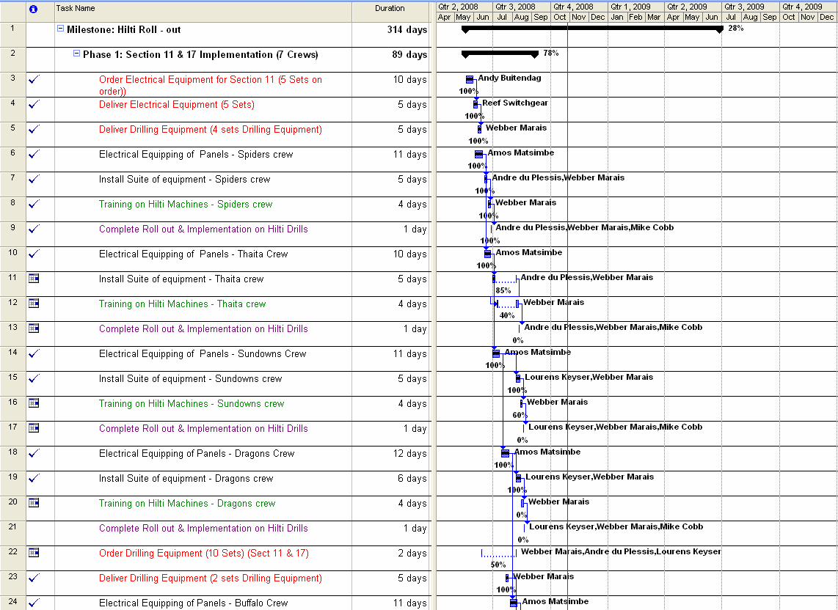

## Implementation at the selected pilot site (*6.4)

Implementation should be in accordance with the implementation plan. All the end users need to be trained and the risk assessment completed before the start of implementation. The Suppliers need to be aligned to ensure prompt delivery and availability of equipment.

## Identification and documenting of any customisation needed prior to extension across the mine (*6.4)

During the initial implementation proper record should be kept of any problems encountered for it to be addressed before extending across the mine.

## Implementation of customization (*6.4)

It is important to update all relevant training material and standard operating procedures during customization. All trained staff need to be retrained on the new material.

## Managing extension of the practice across the mine (*6.4)

During the roll out phase to the rest of the mine, particular emphasis should be placed on the following critical aspects:

* Employee’s behavior training with particular emphasis on sensitizing the employs towards the roll out process for NIHL awareness and HPD usage compliance;
* Involvement of all union structures in the sensitizing process;
* Managing the training schedule of employees on a dedicated plan and schedule and conduct regular progress meetings;
* Ensuring that the suppliers of equipment are aligned with the planned roll out, especially the availability of the selected HPD type/style;
* Ensure that the plan and schedule that have been drawn up is manageable but flexible.

For effective management of roll-out across the rest of the mine, steps 2.1 to 2.16 should be followed.

## Completion of checklist to confirm adequate consideration of critical elements (*6.4)

Before roll out can commences, it is necessary to determine whether the mine is “ready” for roll out and implementation and the checklist below is an example of the relevant questions that should be answered.

***Figure 19: Demonstration project factors and factors checklist***



# Part 3: Details of the leading practice

## 3.1 Equipment:

The Noise Adoption Team Hearing Protection Devices – Training, Awareness and Selection Tool is an Excel®-based software training and communication tool for promoting hearing loss prevention and is based on the SIM 05 05 01-NIHL Prevention Programme – Track C Training and Awareness and HPD selection report dated June 2009. Required and Recommended Items are;

**Computer:** The Tool runs on computers with Windows 98 or higher. The computer must have standard Windows sound support. As long as the computer can run current mainstream applications (word processing, web browser, etc.) and can play music, it should be more than adequate. Laptop and notebook computers usually work fine, but may need supplemental external speakers. On Windows Vista systems, the NIHL Simulator must be run as administrator in order to register its components. The Simulator does not run on Apple Macintosh computers, but users can access selected hearing loss simulations on the NIOSH Mining Web site.

**Speakers:** External speakers that can play at comfortable listening volumes are necessary to hear the different speech types, industrial sounds, and musical sounds generated by the simulator. For a classroom setting, you should have larger amplified speakers that can fill the room with sound.

**Projector (optional):** When training a group, a projector or large display will help the trainees see the information on the Simulator screen. The Simulator can be used even if the trainees can’t see the display because the instructor can explain the settings that result in the different sounds they are hearing.

**Headphones (optional):** In conference halls and other settings with significant distracting background noise, headphones can be used to let trainees hear the Simulator while the background noise is blocked out. Full-size circumaural headphones that cover the ears completely are best at blocking background noise. An inexpensive headphone splitter/amplifier can be used to allow multiple trainees to listen through headphones at the same time.

**Microphone (optional):** A microphone can be used to record custom sounds (voices, machinery, etc.) with the Simulator to customize it for a specific workplace. A good-quality external microphone that can connect to the computer’s microphone jack works best. The simple microphones built into notebook computers tend to have low quality and pick up unwanted noise from the computer itself.

## Equipment maintenance

IT support, on audio video equipment.

Noise Clipper, will inspect, service the unit annually.

## Installation of equipment

The Training Center has the necessary audiovisual equipment to present the Training DVD’s.

## Necessary supporting physical infrastructure

Noise Clipper has a Clinic at the Medical Centre attend to any issue that may occur.

When moulds are required, the relevant employees are paraded on the shaft at the end of the shift so as to ensure the necessary can be done. The moulds are then returned to the Noise Clipper Offices, were the actual unit is made up. (4 – 6 week delay). When completed Noise Clipper then returns the unit to the shaft to ensure fitment is done with the identified employee.

## Risk Assessment

**As per Appendix 2**

## Training

The Training Center staff was training in accordance with the Guidelines as set out in the Hearing Protection Device, Programme by the MOSH representatives. Training is done daily with all employees reporting to the Training Center for Induction Training or Annual Refresher Training, using the DVD’s of the Mine Health and Safety Council.”To Hear or not to Hear”. After completion of the training, the employee is assessed by the Training Assessor to be found “Competent”, if not then the employee will do the Training again.

***Appendix 3- Assessment Form***

## Instruction documentation

A user's guide, intended to give assistance to people using the tool, contains both a written guide and the associated screenshots/images in the tool. The language used is matched to the intended audience, with jargon kept to a minimum or explained thoroughly. (See Part 4. Point 4.1)

## Behavioural communication

## Signage

Symbolic signage training is part of the Annual Refresher Induction training requirement so as when an employee observes a sign, they will know what the meaning and requirement will be thereof.

## Management structure

## Incentive arrangements

The company that places a high value on safety and health maintenance should evaluate the performance of managers responsible for hearing loss prevention programs and reward those whose programs succeed in preventing hearing loss.

## Operational procedures

When an employee proceeds on annual leave they will hand in their N/C at the Bobebi Center when they collect the “Leave Certificate”. All the relevant information is recorded in the register provided by the staff in the center. Noise Clipper will collect the HPD’s on a weekly basis. On returning from leave the employee reports to the Occupational Health Center, were they will complete the annual Medical Examination. A route form is given to the employee so as to ensure that all the necessary departments are visited. ***Appendix 4- Route Form***  (X-Rays, Lung Functional Test, Eyes, Audiometrical Test, Noise Clipper Clinic and Medical Examination.) Noise Clipper will, within the period when the employee is on leave clean and repair the unit so as to ensure the employee on their return will receive a unit that is in order.

## Relevant mine standards

All employees to wear HPD’s when the noise levels exceed 85dBa’s

## Monitoring and reporting arrangements

On the routine inspections conducted by the Occupational Hygiene staff the compliance to use by the employees is recorded for management’s information.

## Performance measures

On the routine inspections conducted by the Occupational Hygiene staff, they will interview employees to determine the skills retention of employees that have viewed the Training DVD’s.

## Proprietary knowledge or technology

Rand Uranium’s management indicated their willingness to participate in the project and sharing of relevant information by signing an agreement letter containing the following text “The mine and the Chamber may separately publish details of the procedures and performance associated with implementation of the practice”.

# Part 4: Supporting documents

## Cost Associated with Hearing Impairment - Compensation & Premiums

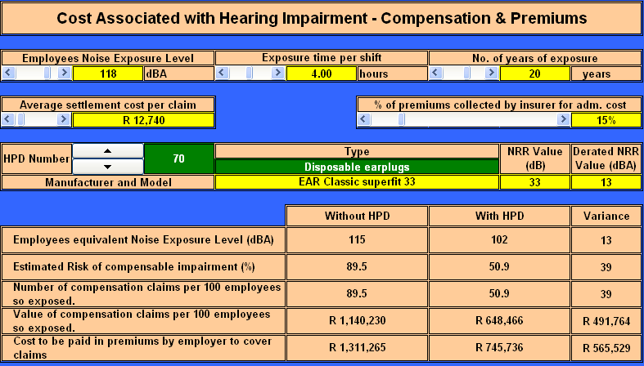

## Appendix 1: A Comprehensive Plan for Leadership Behaviour with Behavioural Communications In Support of Adoption of Leading Practice to assist mines in the adoption process.



Eliminating Noise Induced Hearing Loss in South African Mines

**A Comprehensive Plan for Leadership Behaviour with Behavioural Communications**

**In Support of Adoption of Leading Practice**

**Noise MOSH Adoption Team**

Prepared by: Dries Labuschagne

Reviewed by: Des Wrigley, Dickie Coutts

01 November 2010

**1. Introduction**

A system to better achieve adoption of safety and health performance improvement technology and leading practices in mining workplaces in South Africa was developed over the course of 2006 and 2007. The system – properly entitled the Adoption System - comprises a formal industry organization, a series of key activities and a recommended set of science-based methods and tools for better achieving adoption of technology and leading practices. The leading practice identified through the MOSH system and which will be demonstrated is a Hearing Protection Device (HPD) Selection, Training and Awareness Tool.

In this application, the centerpiece of the adoption system will be the success of the MOSH Noise team in realizing that this leading practice will positively contribute to improving health performance through elimination of, or significant reduction in, noise induced hearing losses in South African mines.

**2. Mission**

The mission of the MOSH Leading Practice Adoption System is to facilitate widespread adoption of knowledge, technology and practice that will significantly improve health and safety performance in South African mines. Our adoption teams interact widely to identify leading practice and technology to address priority areas and work with key staff on mines to foster eager adoption of demonstrated solutions, and a culture of continuous improvement, accountability and visible felt leadership. Our target is to provide working conditions that are free of harmful impacts.

**3. Values**

We value:

***People:*** Care for people drives our continued effort to achieve our ultimate objective, which is zero harm to people.

***Empathy:*** Demonstrated alignment with people’s values for safety and health and effective communication is our primary means to earning the confidence of employees, and Leadership credibility.

***Excellence:*** Goals and standards for our work will be consistent with the highest standards worldwide for safety and health performance.

***Involvement:*** Employees at all levels will be involved in the design, implementation and measurement of technologies and best practices that may affect them; it creates ownership and better assures success.

**4. Project team**

Project team name – Noise Adoption team

Team Members - Des Wrigley (Chamber of mines)

- Dickie Coutts (Harmony)

- Dries Labuschagne (Chamber of Mines Secretariat)

Demonstration host mine – Cooke 3# (Rand Uranium)

Demonstration host mine project team

**5. Scope**

The efforts of the Noise Adoption Team are intended to:

* generate assistance and collaboration in identifying best technology and leading practice opportunities in the focal area of eliminating noise induced hearing loss;
* identify and get support for establishing adoption pilot projects;
* develop leadership and behavioural communications strategies – enabling practical leading practice implementation - to encourage eager adoption. In so doing, systematically identify and resolve barriers to adoption;
* provide appropriate feedback on progress, challenges and experiences in the interest of accomplishing widespread adoption.

In support of achieving these goals, this plan will need to address the systematic creation and implementation of a fully shared understanding of the Adoption System intended to build and sustain support for the Adoption System and the efforts of the Noise Adoption Team to encourage eager participation by affected stakeholders.

This is to be achieved through focusing the decision-making and action of key internal and external stakeholder groups through proactive engagement and communication.

**6. Mental model research**

Decades of scientific research have demonstrated that all people interpret their experience and communications of various kinds through a tacit, personal framework for thinking that has come to be called: Mental Models. As scientists and others have noted, mental models shape how we learn and make judgments about topics that come to our attention through communications of various kinds. Mental models at work on a variety of topics in the mining industry in South Africa have been identified through formal and informal research. This plan builds on the results of both.

To help develop this plan, a questionnaire was prepared and interviews guided by it were held with different stakeholders in order to reveal salient stakeholder mental models on current understanding and unmet needs in the area of reducing the incidence of noise induced hearing loss.

Research results revealed that, in aggregate, interviewees tended to believe:

* The most important thing that can be done to reduce noise induced hearing loss is preventing the loss of hearing through the wearing of hearing protection devices;
* Rock drills are the biggest source of noise;
* There is a need for an engineering or engineered control;
* New controls / leading practices may lead to production loss and high costs;
* Reduction in noise induced hearing losses is strongly correlated with enforcement on the wearing of hearing protection;
* Involving people (most affected by adoption of technology or leading practice) in introducing new technology will help overcome presumed inherent resistance to change;
* Leadership is vital during change. So, the behaviour of leaders is among – if it is not in fact the single most important – influences on performance in the workplace;
* Training was seen as the most important behavioural communication element that can help accomplish adoption of technology and best practice; and
* Leaders should coach, demonstrate, show statistics and lead by example in order to successfully influence adoption behaviour on the part of others.

**7. Stakeholders**

To better achieve the objectives of this plan, a number of stakeholders and stakeholder groups have been identified and must be addressed through communication of various kinds. Such stakeholders have been further categorized according to levels, intensity, frequency, objectives and sophistication of the messages to be communicated:

**Decision-Makers**: These includes the MOSH Task Force members, Adoption Team members, Sponsor and Secretariat and will be kept updated on the activities of the Noise Adoption team.

**Engagers**: Those who have a primary or shared role in the demonstration of the leading practice and include Management and Health and Safety Committees of the demonstration mine.

**Adopters**: Those who will be directly responsible for the implementation and use of the leading practice e.g. Training Manager and Occupational Hygienist.

**End Users**: People on the “face” that will be adopting the leading practice – and using the requisite equipment consistently and well.

**Champions**: Those who assume direct responsibility for the implementation of the demonstration project on their mine.

**Active interests**: Individuals or groups who have a stake in the Adoption System, but are not directly involved. These include Labour, the Department of Minerals Resources and the members of the community of practice for adoption (COPA).

1. **Primary objectives for stakeholder engagement in the Noise team demonstration project**

The team’s primary behavioural communication objectives for enabling stakeholder engagement in the noise demonstration project at the demonstration host mine are:

1. Build support for the Hearing protection Device selection, training and awareness tool demonstration project at the demonstration host mine through the design and implementation of a comprehensive leadership behaviour and behavioural communication strategy;
2. Achieve100% HPD compliance with a selected group of employees in the demonstration host mine as a result of systematic design and implementation of a comprehensive leadership behaviour and behavioural communication strategy.
3. Achieve and retain knowledge through proper training and awareness utilizing the leading practice.
4. Enable continuous improvement of performance through strategic use of data generated by formal measurement of outcomes, or results, of leadership behaviour and behavioural communications activities.

This will be achieved through the following:

* Finalizing leadership behaviour and behavioural communication plans with key employees including Labour, Occupational Hygienists, Training Manager, etc.
* Establishing the necessary channels for communicating with key stakeholders
* Developing the requisite communications ways and means, including materials, to achieve adoption of the best practice.
* Conducting communications, consistent with the behavioural goals set for them.
* Measuring leadership behaviour and behavioural communications processes and outcomes to produce the insights required for successfully accomplishing continuous improvement in both.
* Widely sharing measurement results and insights to foster widespread adoption.

1. **Leadership and Behavioural Communications Plan**

Decades of scientific research and experience have shown that human behaviour is triggered by antecedents – “inputs” of various kinds for behaviour - which tend to prompt behaviour and consequences that follow behaviour which tend to re-enforce it, positively of negatively.

For any given desired behaviour to be encouraged to be done consistently and well, the correct balance, or blend, of antecedents and consequences must occur.

The tables below show proposed desired behaviours for the identified leaders which the leadership behaviour and behavioural communications plans are intended to deliver.



* 1. **Behavioural Communication Plan**

Behavioural communication embraces all communications specifically intended to encourage or achieve behavioural outcomes. Accordingly, behavioural communications typically includes training of various kinds as well as communications interactions (such as safety meetings) and materials (such as brochures, DVDs, posters and warning or caution signage in the workplace).

Here, desired behavioural outcomes or results have been identified that are intended to be accomplished through a variety of key or strategic activities supported by other types of messages.

**BEHAVIOURAL COMMUNICATION STRATEGY**



1. **Primary objectives for leadership behaviour in the Noise team demonstration project**

The team’s primary leadership behaviour objectives for the noise demonstration project at the demonstration host mine are:

1. Achieve 100% support from the demonstration host mine Leaders to conduct a demonstration project on the HPD Selection, Training and Awareness Tool and share the learnings and results;
2. Achieve 100% support from the demonstration host mine Leaders for piloting a process to build 100% employee support of and compliance in wearing hearing protection devices (HPD).
3. Achieve support from the demonstration host mine leaders to achieve and retain knowledge through proper training and awareness utilizing the leading practice.
4. Enable continuous improvement of performance through strategic use of data generated by formal measurement of outcomes, or results, of leadership behaviour and behavioural communications activities.

This will be achieved through the following:

* Develop the plan with key employees or stakeholders including Labour, Occupational Hygienists, Training Managers, etc.
* Establish core channels for communicating with key stakeholders
* Develop critical materials
* Conduct communications
* Measure communication process and outcomes, share results.
  1. **Leadership behaviour Plan**

As with the behavioural communication strategy, the behavioural leadership strategy will be derived from the table belo

* 1. Appendix 2: Expert risk summary, updated for use by adoption mines

## Appendix 3- Assessment Form

**EMPLOYEE NAME & SURNAME : ………………………………………………………………………………….**

**EMPLOYEE SIGNATURE: …………………………………………………………………………………**

**OCCUPATION: …………………………………………………………………………………**

**ASSESSOR NAME: …………………………………………………………………………………**

**ASSESSOR SIGNATURE: …………………………………………………………………………………**

**DATE: ………………………………… SHAFT : ……………………………………...**

|  |  |  |  |
| --- | --- | --- | --- |
| **COMPETENT** |  | **NOT YET COMPETENT** |  |

1. Did you watch the DVD, relating to Hearing Protection Device?

|  |  |
| --- | --- |
| C | NYC |
|  | Yes, Continue with assessment |  |  |
|  | No, Return to Induction Training |  |  |

2. During the DVD viewing, what PPE was referred to?

|  |  |  |  |
| --- | --- | --- | --- |
|  | Hard Hat, Eye Protection, Dust Mask, Gloves, Hearing Protection, Knee Guards |  |  |
|  | Gum Boots, Overall |  |  |

3. What types of Hearing Protection Devices area available?

|  |  |  |  |
| --- | --- | --- | --- |
|  | Personalized Hearing Protection – Noise Clipper, Ear Muffs, Soft Type – Disposal & |  |  |
|  | Reusable |  |  |

4. When do you put in your HPD and when may you remove it from your ear?

|  |  |  |  |
| --- | --- | --- | --- |
|  | When you enter a area demarcated with a Noise Sign is displayed |  |  |
|  | When you leave a area demarcated with a Noise Sign |  |  |

5. Are you allowed to remove your HPD when you are in a Noisy Area?

|  |  |  |  |
| --- | --- | --- | --- |
|  | No |  |  |
|  |  |  |  |

6. How do you know that you were exposed to load noise?

|  |  |  |  |
| --- | --- | --- | --- |
|  | You will hear a ringing sound in your ears for sometime after you were exposed. |  |  |
|  |  |  |  |

7. Is Hearing Loss repairable?

|  |  |  |  |
| --- | --- | --- | --- |
|  | No it is not repairable |  |  |
|  |  |  |  |

8. Is it necessary to wear a HPD if your ear is already damaged?

|  |  |  |  |
| --- | --- | --- | --- |
|  | Yes, it will assist in preventingany more damage to your ear. |  |  |
|  |  |  |  |

9. Will you feel any pain when you have Hearing Loss?

|  |  |  |  |
| --- | --- | --- | --- |
|  | No |  |  |
|  |  |  |  |

10. How does Hearing Loss affect your relationship at work and at home?

|  |  |  |  |
| --- | --- | --- | --- |
|  | People around you will be seriously affected as when they talk to you, you will not be able to hear what they are asking, telling or warning you about. |  |  |
|  | It becomes a safety issue when one does not hear warning signals. |  |  |

11. Who is at risk to Hearing Loss?

|  |  |  |  |
| --- | --- | --- | --- |
|  | Everyone who is exposed to Noise. |  |  |
|  |  |  |  |

12. How do you ensure that that your HPD remains clean?

|  |  |  |  |
| --- | --- | --- | --- |
|  | By daily cleaning the HPD at the end of the shift. |  |  |
|  | Replacing disposable type HPD when dirty. |  |  |

13. Demonstrate how to install a HPD in your ear?

|  |  |  |  |
| --- | --- | --- | --- |
|  | Correct method of installation. |  |  |
|  |  |  |  |

**Training Declaration:**

**I hereby acknowledge that I have been adequately reviewed and assessed on the knowledge component of Noise, Hearing Protection Device (HPD) and Noise Induced Hearing Loss. I will perform all tasks assigned to me safely, effectively and efficiently.**

**All tasks will be done adhering to the mine procedures and standards.**

**I have been given the opportunity to ask questions.**

|  |  |  |  |
| --- | --- | --- | --- |
|  | **NAME** | **SIGNATURE** | **DATE** |
| **PERSON ASSESSED** |  |  |  |
| **ASSESSOR** |  |  |  |
| **MODERATOR** |  |  |  |

## Appendix 4- Route Form

## Appendix 5 - Instruction and Training Guide

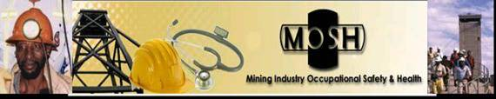

**MOSH Noise Adoption Team**

**Hearing Protection Devices – Training, Awareness and Selection**

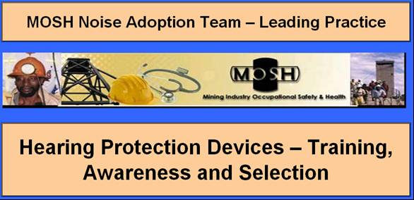***Instruction and Training Guide***

**This document is in the public domain and may be freely copied or reprinted.**

**Disclaimer**

Mention of any company or product does not constitute endorsement by the Mining Industry Occupational Safety & Health (MOSH). In addition, citations to Web sites external to MOSH do not constitute MOSH endorsement of the sponsoring organizations or their programs or products. Furthermore, MOSH is not responsible for the content of these Web sites.

**Noise Adoption Team HPDs – Training, Awareness and Selection Tool**

**Instruction and Training Guide**

Dick Coutts, MOSH Noise Adoption Team Manager

**Index**

1. Purpose 67

2. Required and Recommended Items 68

2.1. Computer: 68

2.2. Speakers: 68

2.3. Projector (optional): 68

2.4. Headphones (optional): 68

2.5. Microphone (optional): 69

3. Settings: 69

3.1. Display: 69

3.2. Toolbar Settings: 69

3.3. Security Level: 71

3.3.1. For Microsoft Office ………2003 71

3.3.2. For Microsoft Office ………2007 72

4. Installation 72

5. Primary Outputs 8

6. HPD selection tables 9

7. Guide to All Features 75

7.1. Start-Up 75

7.2. Introduction 75

7.3. Main Menu 76

7.4. Educational, motivational and training materials 77

7.5. HPD’s available in SA 2009 78

7.6. HPD’s selection tables for various Occupations 79

7.7. Hearing Protection Devices - NRR Values 82

7.8. Hearing Protection Devices - Actual In Ear NRR Values 83

7.9. HPD Selection Tool - Single Protection for the various Activities/Areas 84

7.10. Tab functions; the tab functions throughout these five screens are all similar. 85

7.11. HPD Selection Tool All Activities - Dual Protection 87

8. Outputs 87

9. Colour coding of output results: 89

10. HPDs’ - Default Values to Demonstrate Wear Time Effect 90

10.1. HPD Wearing Time (WT) Effect 90

10.2. HPD’s - the Effect of WT on the NRR Value 91

10.3. HPD’s - The Effect of WT on the at Ear Protection Value 91

10.4. HPD’s - the Effect of WT on the Actual at Ear Noise Exposure Level 92

10.5. HPD’s - the Effect of WT on the Daily Noise Dosage 93

10.6. HPD’s - the Effect of WT on the Allowable Exposure Time 93

10.7. HPD’s - The Effect of WT on the Percentage Risk of Obtaining NIHL 94

10.8. The Effect of WT when considering HPD’s with High and Low NRR Values 95

10.9. Cost Associated with Hearing Impairment - Compensation & Premiums 95

11. Other materials available in the tool from local and international sources 96

11.1. PowerPoint® presentation – Hearing Conservation – Stick to Basics 96

11.2. The NIOSH NIHL Simulator 97

11.3. The NIOSH Noise Meter 98

12. The NIOSH Hearing Loss Simulator – Guide to All Features 99

12.1. Installation: 99

12.2. Main Screen 99

12.3. Main Screen with Exposure 100

12.4. Toolbar 100

12.5. Graphical Display 100

12.6. Hearing Loss choices 101

12.7. Frequency Band Sliders 102

12.8. Hearing Loss Status 102

12.9. Exposure Predicted Loss Parameters 103

12.10. Set Speech and Noise Source 105

12.11. Record Screen 106

13. The NIOSH Hearing Loss Simulator Training Scenario 106

13.1. Instructive scenarios 106

13.2. Predicted loss on the basis of exposure 107

13.3. Predictive impact on the basis of the listening environment 108

**1. Purpose**

The Noise Adoption Team Hearing Protection Devices – Training, Awareness and Selection Tool is a software training and communication tool for promoting hearing loss prevention and is based on the SIM 05 05 01-NIHL Prevention Programme – Track C Training and Awareness and HPD selection report dated June 2009. Previous SIMRAC projects dealing with occupational noise have included “GEN 011” (1997) and more recently, “Health 806” (Franz, 2005), which incorporated guidelines for best practice in the implementation and management of mine HCPs. Despite initiatives to reduce noise through engineering controls, personal protection, being the last resort in the hierarchy of controls, will however continue to be a very important means of limiting NIHL risks to mineworkers. Users are encouraged to read this manual while learning how to run the software.

**2. Required and Recommended Items**

**2.1 Computer:**

The Tool runs on computers with Windows 98 or higher. The computer must have standard Windows sound support. As long as the computer can run current mainstream applications (word processing, web browser, etc.) and can play music, it should be more than adequate. Laptop and notebook computers usually work fine, but may need supplemental external speakers. On Windows Vista systems, the NIHL Simulator must be run as administrator in order to register its components. The Simulator does not run on Apple Macintosh computers, but users can access selected hearing loss simulations on the NIOSH Mining Web site.

**2.2 Speakers:**

External speakers that can play at comfortable listening volumes are necessary to hear the different speech types, industrial sounds, and musical sounds generated by the simulator. For a classroom setting, you should have larger amplified speakers that can fill the room with sound.

**2.3 Projector (optional):**

When training a group, a projector or large display will help the trainees see the information on the Simulator screen. The Simulator can be used even if the trainees can’t see the display because the instructor can explain the settings that result in the different sounds they are hearing.

**2.4 Headphones (optional):**

In conference halls and other settings with significant distracting background noise, headphones can be used to let trainees hear the Simulator while the background noise is blocked out. Full-size circumaural headphones that cover the ears completely are best at blocking background noise. An inexpensive headphone splitter/amplifier can be used to allow multiple trainees to listen through headphones at the same time.

**2.5 Microphone (optional):**

A microphone can be used to record custom sounds (voices, machinery, etc.) with the Simulator to customize it for a specific workplace. A good-quality external microphone that can connect to the computer’s microphone jack works best. The simple microphones built into notebook computers tend to have low quality and pick up unwanted noise from the computer itself.

**3. Settings:**

**3.1 Display:**

The tool is best viewed on a screen resolution setting of 1024 x 768 pixels.

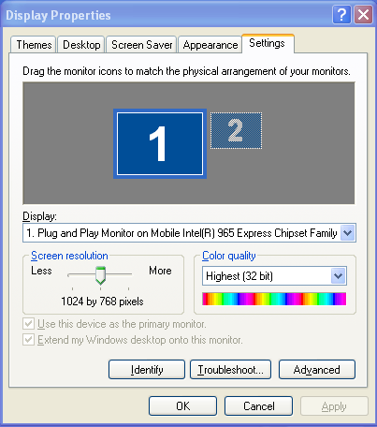

**3.2 Toolbar Settings:**

The tool is a fit screen design and the user is required to ensure that all tools are de-selected;

Normal view display: note the Formula Bar display is “on”, under Toolbars, Standard and Formatting is “on”,

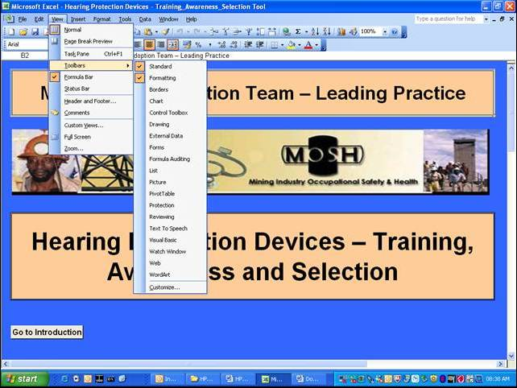

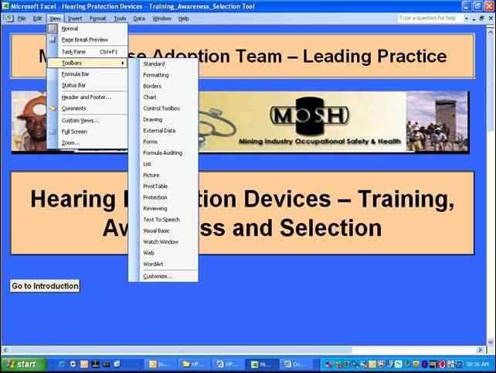Un-select the above mentioned to close all the tools as per Figure below;

**3.3 Security Level:**

The Tool is an Excel® software based version of SIM 05 05 01-NIHL Prevention Programme – Track C Training and Awareness and HPD selection report and contains macros and hyperlinks (action or a set of actions) used to automate tasks displayed as tabs throughout the tool. Changing the security level for macros to run the Tool:

**3.3.1 For Microsoft Office ………2003**

* On the Main Menu, select Tools;
* Under Tools, select Options;
* Under Options, select Security;
* Under Security, select Macro Security;
* Under Security Level, select low security level.

**3.3.2 For Microsoft Office ………2007**

* On the Main Menu, select Office;
* Under Office, select Excel Options;
* Under Excel Options Popular, select Trust Centre;
* Under Trust Centre, select Microsoft Excel Trust Centre Settings;
* Under Macro Settings, select Enable Macros.

**4. Installation**

If the programme is to be played from a computer (using Windows Media Player® or similar), it is best to copy files to the computer’s hard disk, to ensure proper playback. To avoid a reduction in the computer’s performance, save the files to the C or D drive, rather than to the Desktop. To do so, proceed as follows:

1. Place the Memory Stick/CD in the computer’s USB port/CD/DVD drive and select “Open folder to view files using Windows Explorer”. Right-click on the HPD_TAS_Tool folder and select copy or, alternatively, click on the folder, then on “Edit” in the Toolbar at the top of the screen and select “Copy”.
2. Right-click on the green START button at the bottom-left of the screen and select Explore. Select a folder on either the C or D drive in which to save the files. Alternatively, click on “File” at the top-left of the screen and select “New” and “Folder”. Over-type “New Folder” with the desired name, e.g. “HPD_TAS_Tool”. Alt-Tab back to the Memory Stick/CD/DVD (E) drive or select it from the Taskbar at the bottom of the screen. Right-click on the HPD_TAS_Tool folder and select “Copy”.
3. Alt-Tab back to Explore or select it from the Taskbar. Right-click on the folder created in Step 2) and select “Paste” or, alternatively, click on the folder then on “Edit” in the Toolbar at the top of the screen and select “Paste”.
4. Once all of the files have been copied to the selected folder (this may take several minutes), click on the folder, the files in the folder will be displayed as a list of file details or as icons, depending on which view has been selected in Explore. Right-click on the Hearing Protection Devices - Training_Awareness_Selection Tool file and select “Send to” and “Desktop (create shortcut.DeskLink).

**5. Primary Outputs**

Given the need to enhance the effectiveness of awareness and training materials and mine personal protection strategies while more systematic control measures are being implemented, this Tool has as its primary outputs;

1. Updated multimedia training, educational, awareness and motivational materials for the prevention/elimination of noise-induced hearing loss (NIHL), aimed at all levels of mine employees, particularly mineworkers comprising of a video programme in English, Xhosa, South Sotho and Zulu for coal, gold and platinum mines:
   * 1. Module 1: Educational/Motivational (15 minutes long), which conveys the message that loud noise is hazardous and illustrates the potential consequences of exposure;
     2. Module 2: HPD training (10 minutes long), which reinforces educational and motivational aspects from Module 1 and demonstrates the correct use and care of various types of hearing protection devices (HPDs);
2. Handouts for trainees in the form of 16-page A-5 self-cover booklets illustrating the risks of excessive noise exposure, as well as the correct use and care of HPDs, produced in English and Zulu;
3. Four volumes of guidelines for trainers, comprising:
   * 1. A script for induction talks on the noise hazard, with a demonstration of the benefits of using HPDs in noisy areas and their correct use and care, with four supporting overhead transparencies;
     2. Use of the training videos, with the scripts for Modules 1 and 2 appended;
     3. Use of the handout booklet, with a reproduction of the booklet appended; and
     4. Suggestions for ways of responding to reasons or excuses commonly given by mineworkers who neglect to use HPDs.
4. Compilation of frequency-specific attenuation data for all currently available HPDs (with manufacturers’ and suppliers’ contact details) for noise associated with various occupations, workplaces and machinery in the mining industry.
5. Other materials available from local and international sources comprising of;
   * 1. PowerPoint® presentation – Hearing Conservation – Stick to Basics
     2. The NIOSH Hearing Loss Simulator
     3. The NIOSH Noise Meter

**6. HPD selection tables**

Gen 011 (Franz et al., 1997) measured the noise exposure levels of employees in different occupations in the coal, gold and platinum mining industry. HPD selection tables were developed on the basis of the noise exposure levels of the occupations sampled. The HPDs that were listed in the selection tables were those available in South Africa in the mid-1990s. In order to make the NIHL prevention tools available to the mining industry relevant and up-to-date, the MHSC included the updating of this valuable HPD selection tool as part of the SIM 050501 Prevention of NIHL programme.

The research team used the web-based National Institute of Occupational Safety and Health (NIOSH) tool as the basis of the updating process. Information about all the HPDs on the NIOSH website that are available in South Africa were collected and used to develop an updated list of HPDs for 2009. The frequency-specific attenuation data supplied by the HPD manufacturers and suppliers was incorporated into the HPD selection tables available from GEN 011. The HPD selection tables were further updated by formulating the tables into a user-friendly Excel®-based version of a selection table for each occupation.

1. The HPD selection tables indicate:
2. the expected noise exposure levels as measured by GEN 011
3. the average effective attenuation for each HPD available
4. whether the resultant average noise exposure with HPDs will result in noise exposure levels of above the Occupational Exposure Level (OEL)
5. if the average expected attenuation is likely to interfere with speech communication as a result of overprotection by the HPD.
6. The tool includes;
7. A list of 97 HPDs available in South Africa in 2009, with tables indicating the effective attenuation that can be expected from each HPD at each central frequency;
8. Guidelines for the use of the HPD selection tables;
9. Coal mining occupations in surface workshops and general coal mining; and
10. Gold and platinum mining occupations, which include the surface workshops, surface plants and conventional or mechanized mining.
11. The effect of wear time;
    * 1. when considering HPD’s with High and Low NRR Values
      2. on the Percentage Risk of Obtaining NIHL
      3. Cost associated with Hearing Impairment

**7. Guide to All Features**

This section describes all of the Tool’s functions available through its screens and menus.

**7.1 Start-Up**

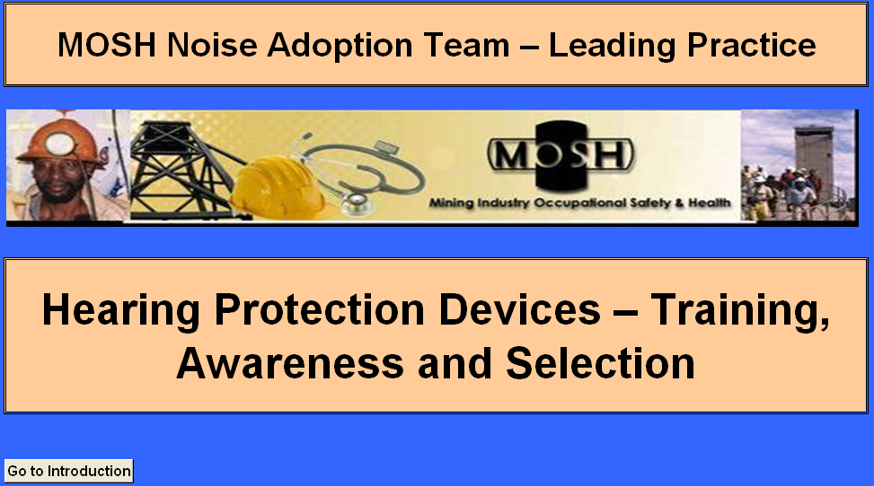

When the program is first started, this start-up screen is displayed. Selecting the tab within the screen will allow you to view the Introduction screen.

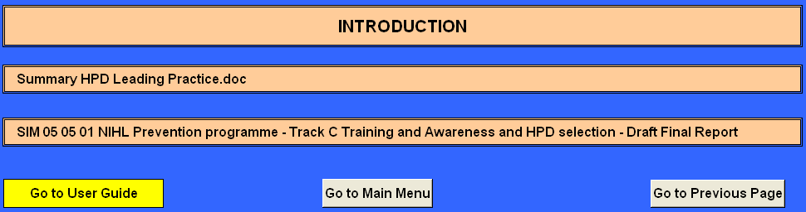**7.2 Introduction**

Selecting the tabs within the screen will allow you the following options;

* view a summary of the Leading Practice;
* view the SIM 05 05 01 NIHL…………………. Report
* view the User’s Guide (this document)
* go to the Main Menu screen
* go to the previous screen

**7.3 Main Menu**

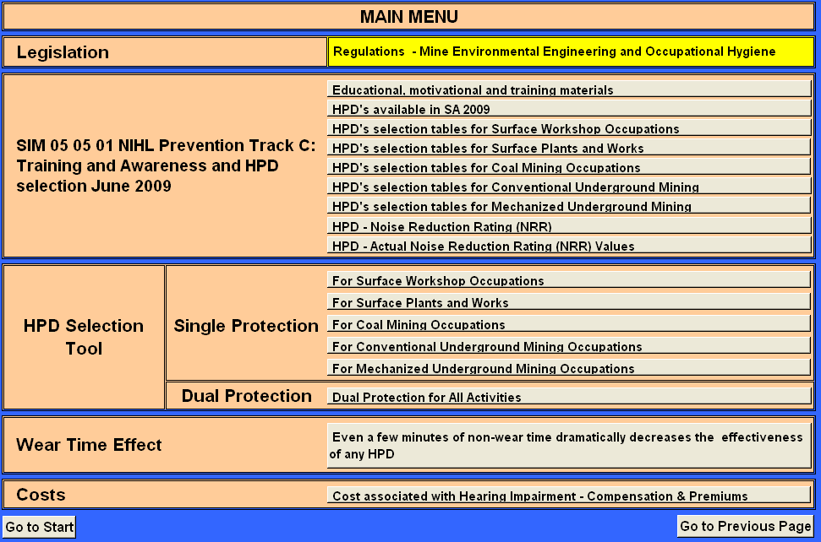

Selecting the tabs within the screen will allow you the following options;

* view the regulations pertaining to noise
* view the educational, motivational and training materials screen
* view the HPD’s available in SA 2009 screen
* view the HPD’s selection tables for Surface Workshop Occupations screen
* view the HPD’s selection tables for Surface Plants and Works Occupations screen
* view the HPD’s selection tables for Coal Mining Occupations screen
* view the HPD’s selection tables for Conventional Underground Mining screen
* view the HPD’s selection tables for Mechanized Underground Mining
* view the HPD - Noise Reduction Rating (NRR) screen
* view the HPD - Actual Noise Reduction Rating (NRR) Values screen
* view the HPD selection tool – single protection for Surface Workshop Occupations screen
* view the HPD selection tool – single protection for Surface Plants and Works Occupations screen
* view the HPD selection tool – single protection for Coal Mining Occupations screen
* view the HPD selection tool – single protection for Conventional Underground Mining Occupations screen
* view the HPD selection tool – single protection for Mechanized Underground Mining Occupations screen
* view the HPD selection tool – dual protection for All Activities screen
* view the effect of HPD wear time screen
* view the cost associated with Hearing Impairment - Compensation & Premiums screen

**7.4 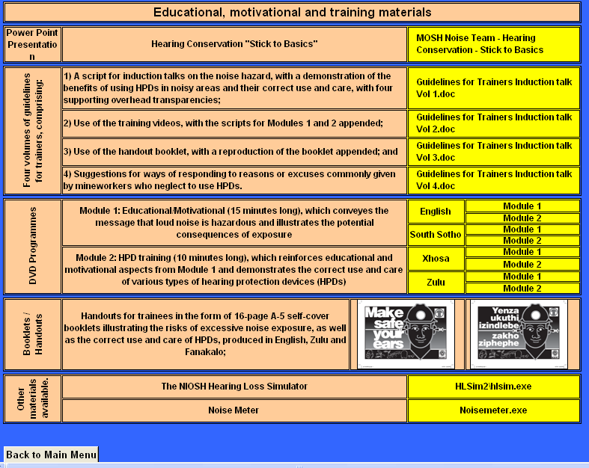Educational, motivational and training materials**

Selecting the tabs within the screen will allow you the following options;

1. view the MOSH Noise Team - Hearing Conservation - Stick to Basics Power Point Presentation
2. view the four volumes of guidelines for trainers, comprising of:
3. Guidelines for Trainers Induction talk Vol 1.doc, a script for induction talks on the noise hazard, with a demonstration of the benefits of using HPDs in noisy areas and their correct use and care, with four supporting overhead transparencies.
4. Guidelines for Trainers Induction talk Vol 2.doc, Use of the training videos, with the scripts for Modules 1 and 2 appended.
5. Guidelines for Trainers Induction talk Vol 3.doc, Use of the handout booklet, with a reproduction of the booklet appended.
6. Guidelines for Trainers Induction talk Vol 4.doc, Suggestions for ways of responding to reasons or excuses commonly given by mineworkers who neglect to use HPDs.
7. view the DVD Programmes in either English, South Sotho, Xhosa or Zulu comprising of;
   * 1. Module 1: Educational/Motivational (15 minutes long), which conveys the message
     2. that loud noise is hazardous and illustrates the potential consequences of exposure.
     3. Module 2: HPD training (10 minutes long), which reinforces educational and motivational aspects from Module 1 and demonstrates the correct use and care of various types of hearing protection devices (HPDs).
8. view the Handouts for trainees in the form of 16-page A-5 self-cover booklets illustrating the risks of excessive noise exposure, as well as the correct use and care of HPDs, produced in English and Zulu.
9. view the NIOSH Hearing Loss Simulator Tool
10. view the NIOSH Noise meter

**7.5 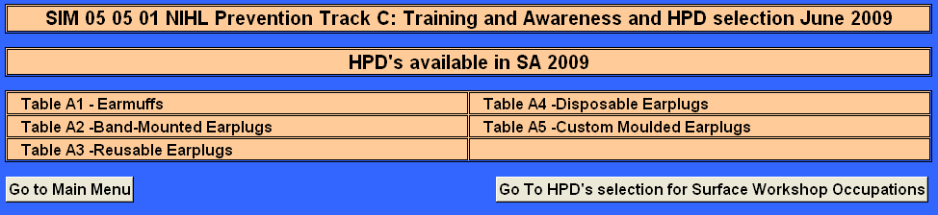HPD’s available in SA 2009**

The attenuation characteristics of HPDs listed in Tables A-1 through to A-5 were obtained directly from manufacturers/suppliers or their promotional literature. The attenuation characteristics were all documented as having been determined in accordance with one or more standards, some of which provide a more realistic indication than others of the level of protection that can be expected. These tables should not be interpreted as indicating that a particular HPD “passes” or “fails”. They are, however, intended to provide a means of comparing the suitability of the various HPDs for use by workers in a particular occupation. Devices that do not provide sufficient attenuation for an extreme noise source may well be suitable for more moderate applications and, in such cases, would be more appropriate than higher attenuation devices.

Selecting the tabs within the screen will allow you to view the frequency-specific mean attenuation and standard deviation values determined in accordance with various standards for;

1. Earmuffs
2. Band-Mounted Earplugs
3. Re-usable Earplugs
4. Disposable Earplugs
5. Custom Moulded Earplugs

**7.6 HPD’s selection tables for various Occupations**

By selecting the following screens you will be able to view the tables for the various occupations within that area/activity;

1. HPD’s selection for Surface Workshop Occupations

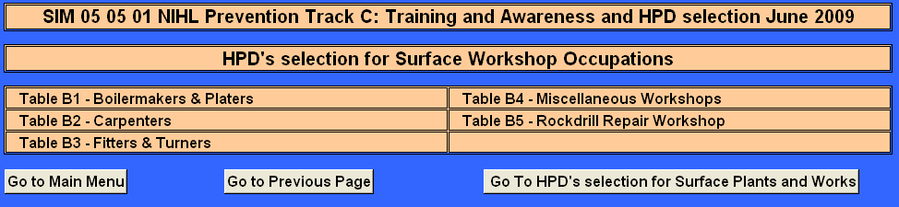

1. HPD’s selection for Surface Plants and Works Occupations

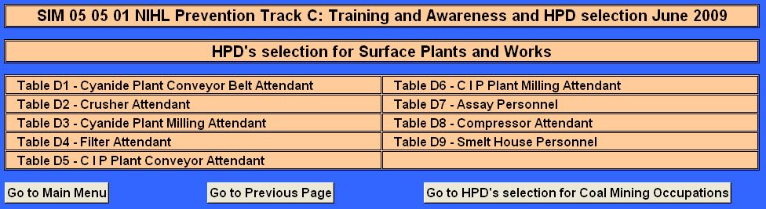

1. HPD’s selection for Coal Mining Occupations

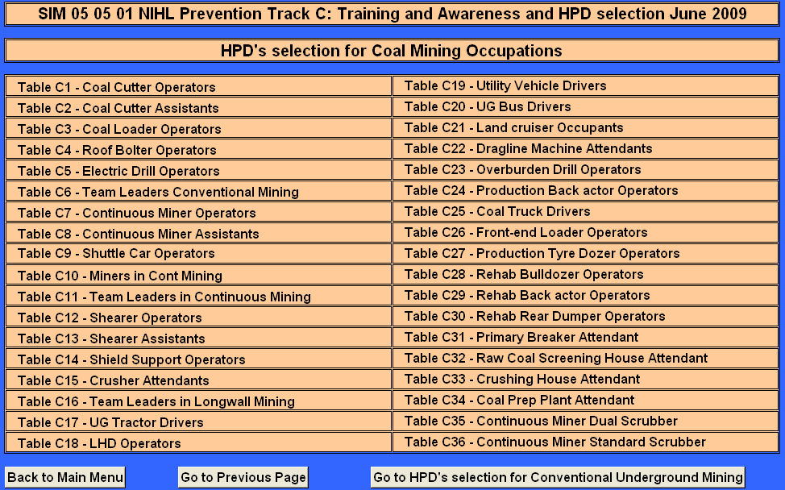

1. HPD’s selection for Conventional Underground Mining Occupations

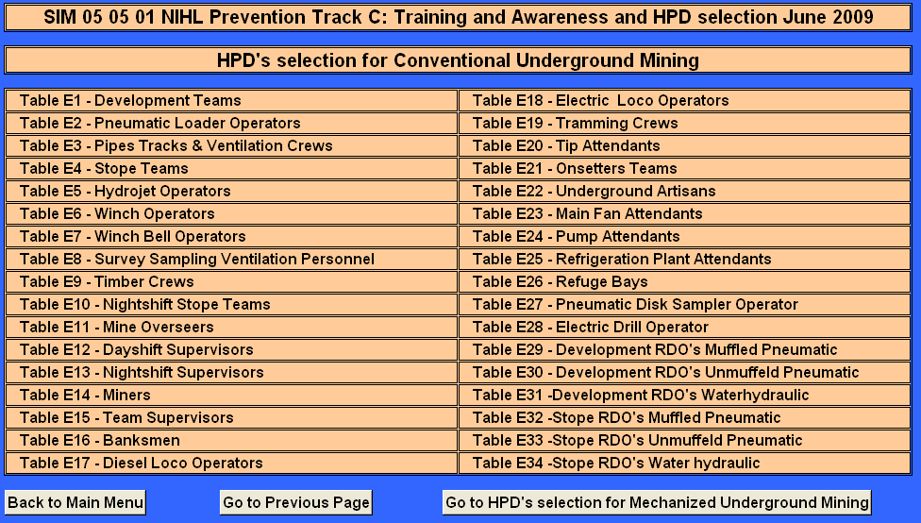

1. HPD’s selection for Mechanized Underground Mining Occupations

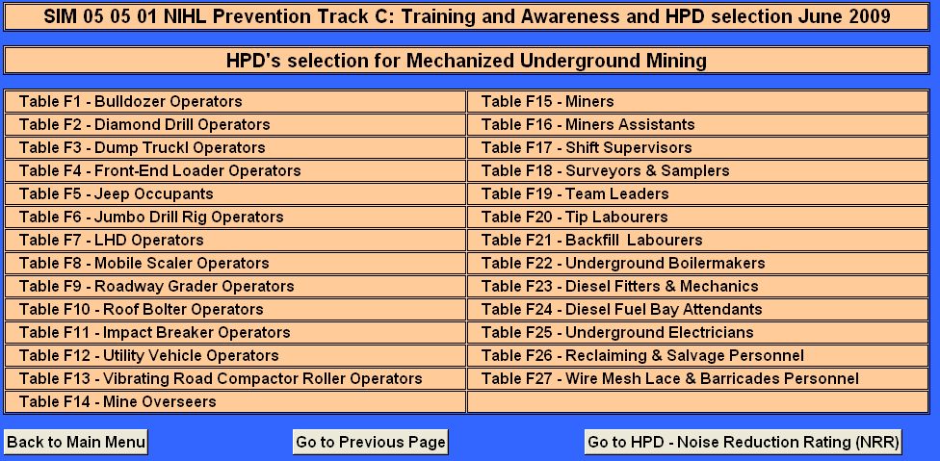

Each of the HPD selection tables relates to a specific occupation or workplace. Along the top row of each table is a summary of personal noise exposure results for the occupation or workplace being considered. The top row of the table shows the mean, maximum and minimum noise exposure values for the occupation and the number of workers whose exposure in that occupation were measured.

In the row labeled “without HPD” the mean value (LAeq) measured for each centre frequency is listed. These are the A-weighted sound pressure levels to which unprotected workers in that occupation or workplace are likely to be exposed. Under the column labeled “LAeq” along the row labeled “without HPD” is the mean equivalent continuous A-weighted sound pressure level for the occupation or workplace being considered.. In the last column (labeled Lavg ) along the same row, is the expected equivalent noise exposure for unprotected ears calculated from the noise exposure measurements and rounded to the nearest integer.

The subsequent rows (with the name of each HPD being considered) display the effective attenuated values calculated for workers wearing the particular HPD. Where the effective Lavg exceeds 85 dBA, an indication that the particular HPD is inadequate for the occupation or workplace being considered, the value is displayed as >nn<. Where effective Lavg is less than 70 dBA, an indication that the HPD may overprotect and interfere with communication, the value is displayed as ((nn)).

**7.7 Hearing Protection Devices - NRR Values**

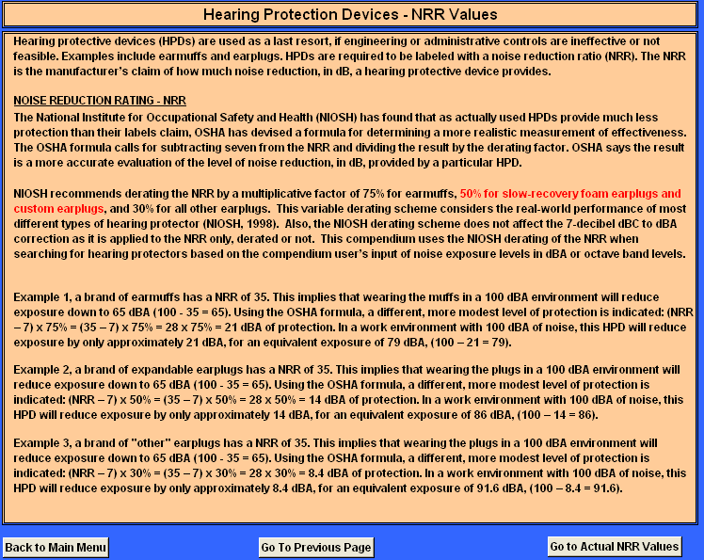

HPDs are required to be labeled with a noise reduction ratio (NRR). The NRR is the manufacturer’s claim of how much noise reduction, in dB, a hearing protective device provides. By viewing this screen you will be able to view an explanation on the variable derating scheme considering the real-world performance of most different types of hearing protectors.

**7.8 Hearing Protection Devices - Actual In Ear NRR Values**

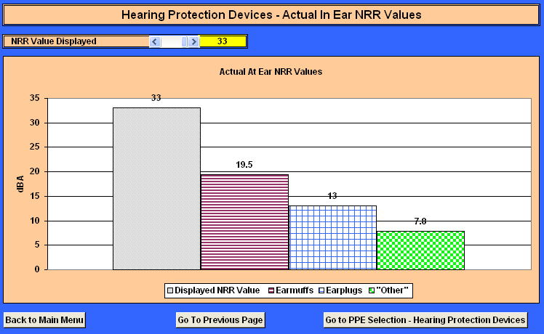

In this screen you will be able to view the actual effect of the variable derating scheme on the various HPD styles when selecting different NRR values. In this example the selected NRR value is 33. Applying the derating scheme the actual at/in ear protection value acquired are for;

Earmuffs – 19.5

Earplugs – 13

“Other” – 7

This implication is very important as it stipulates the “real word” scenario and on this basis the importance on correct application, type/style and availability of different types/styles for the user to choose from cannot be stressed enough.

**7.9 HPD Selection Tool - Single Protection for the various Activities/Areas**

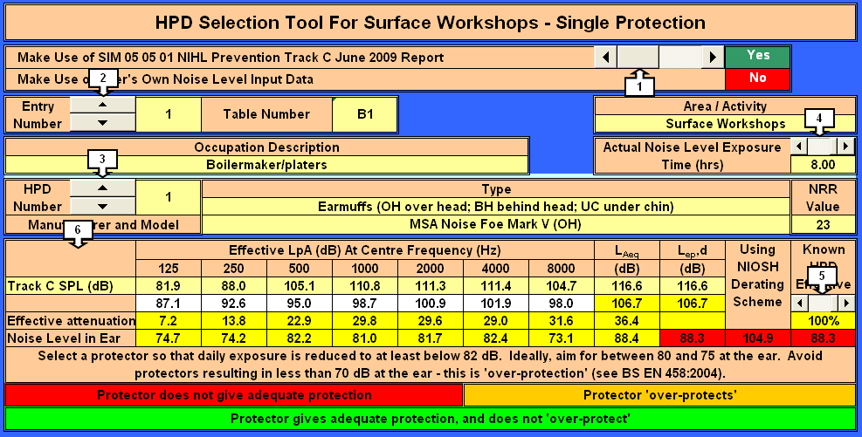These screens will allow you to select the correct single protection HPP style/type in the various activities/areas and occupations found in the mining industry.

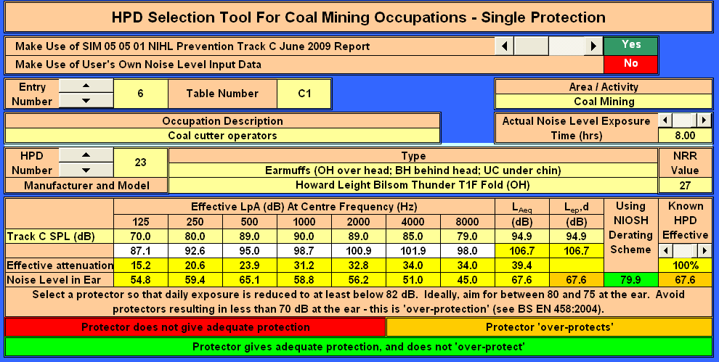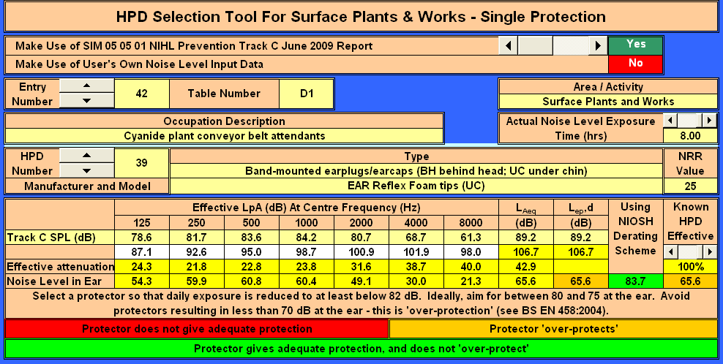

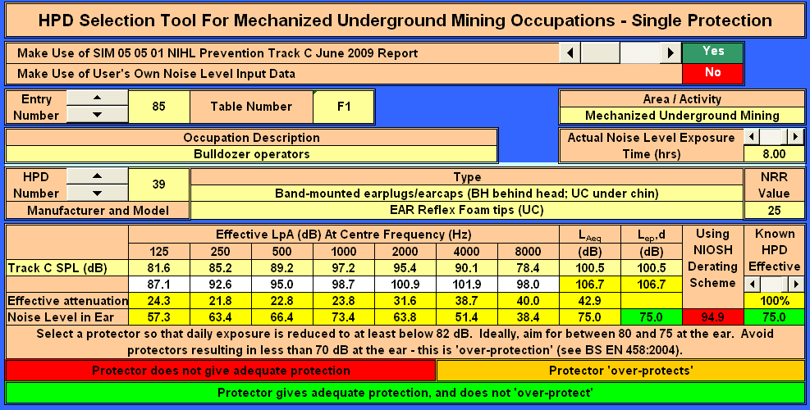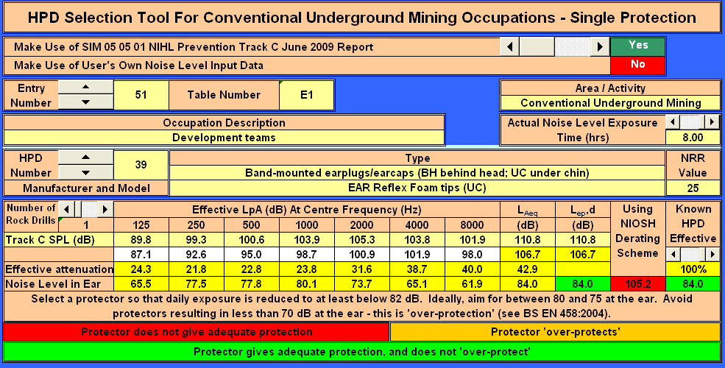

**7.10 Tab functions; the tab functions throughout these five screens are all similar.**

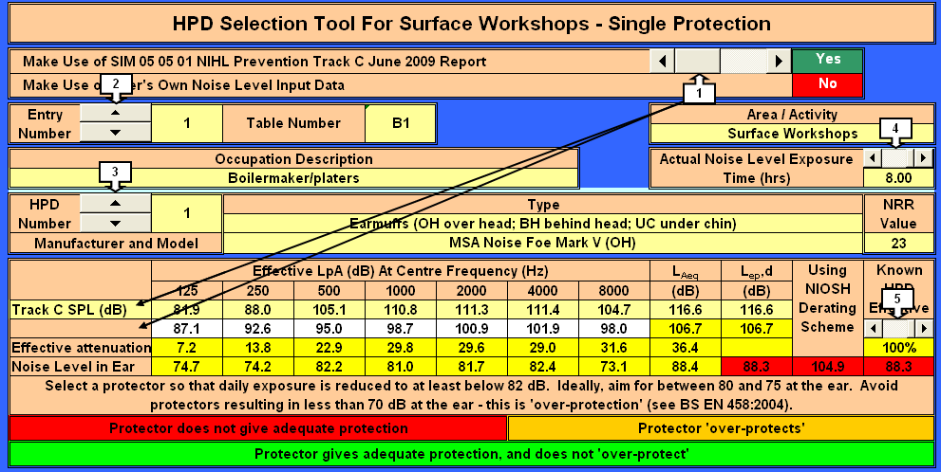Tab 1: This tab will allow you to choose using the SIM report frequency analysis or own input

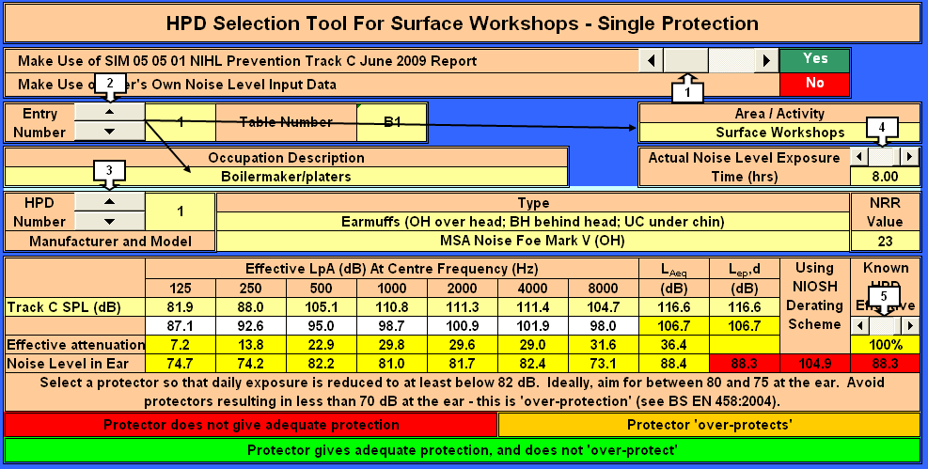Tab 2: This tab will allow you to select the mining type/activity and occupation.

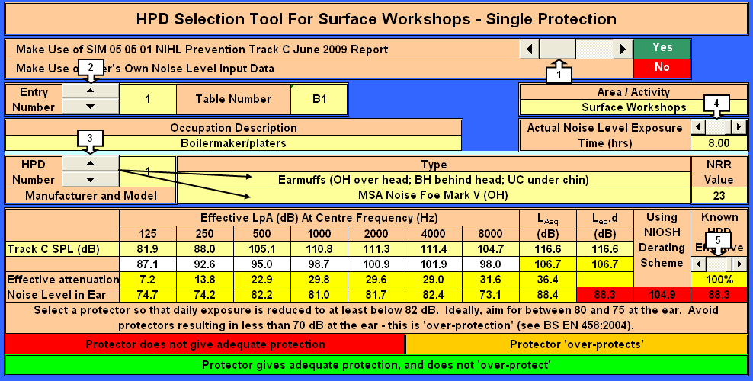Tab 3: This tab will allow you to select the HPD style/type.

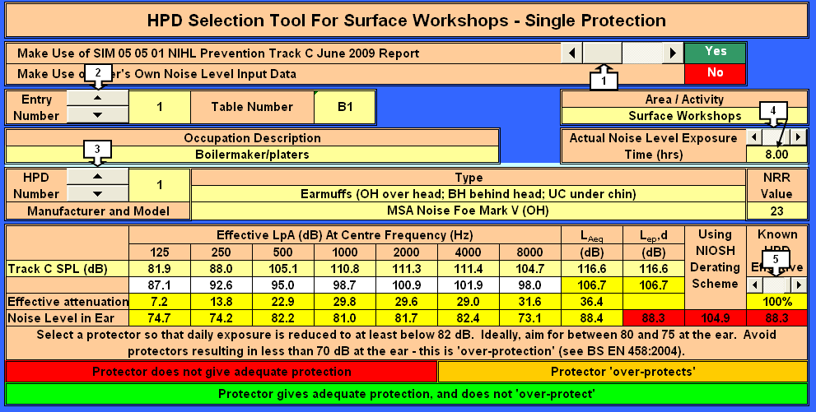Tab 4: This tab will allow you to set the expected noise exposure time for the selected occupation.

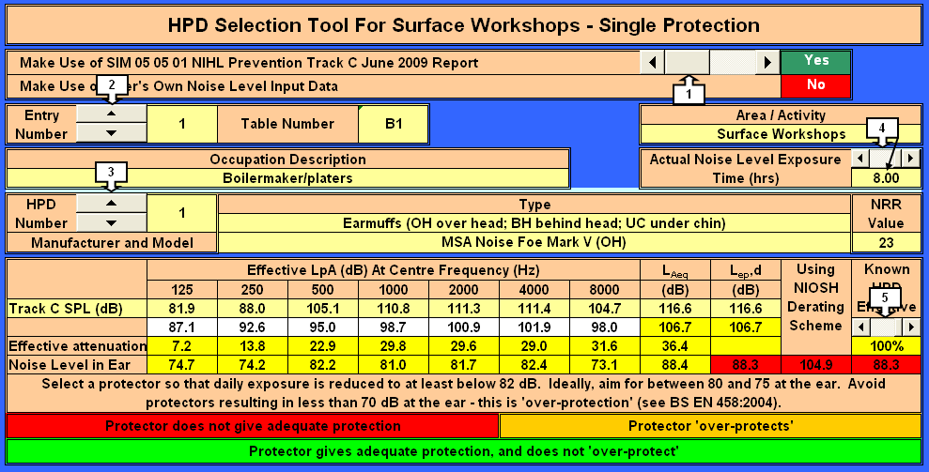

Tab 5: This tab will allow you to set the “known” HPD usage compliance/effectiveness.

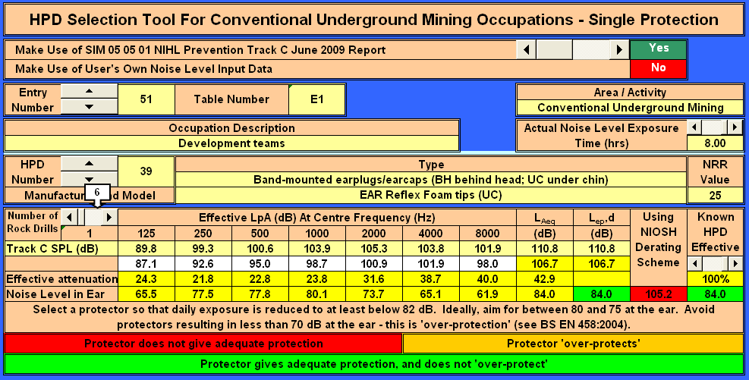Tab 6: This tab is only displayed in the conventional underground mining operations screen and is only functional for drilling occupations and you are able to set the number of rock drills from 1 to 6.

**7.11 HPD Selection Tool All Activities - Dual Protection**

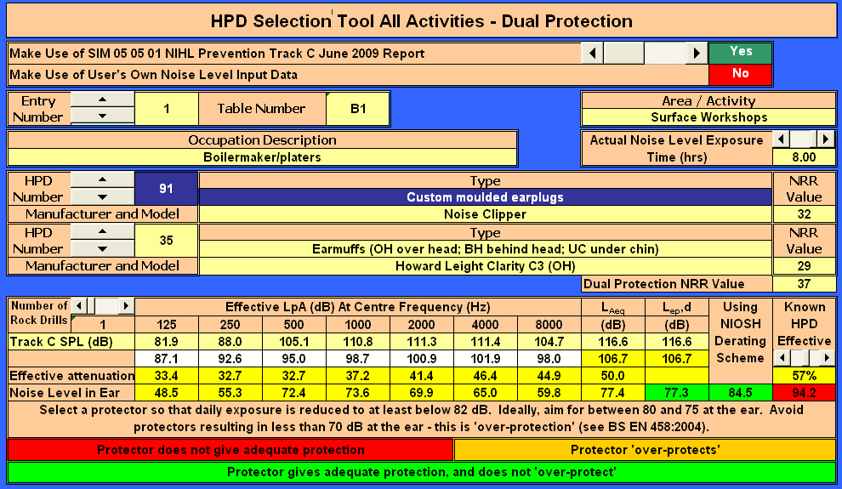

This screen will allow you to interrogate the effect of dual protection by selecting an earmuff and complimenting it with another style of HPD. The “Dual Protection NNR value” displayed would be the higher NRR value plus 5. Al other tab functions would remain the same a for the single protection screens.

**8. Outputs**

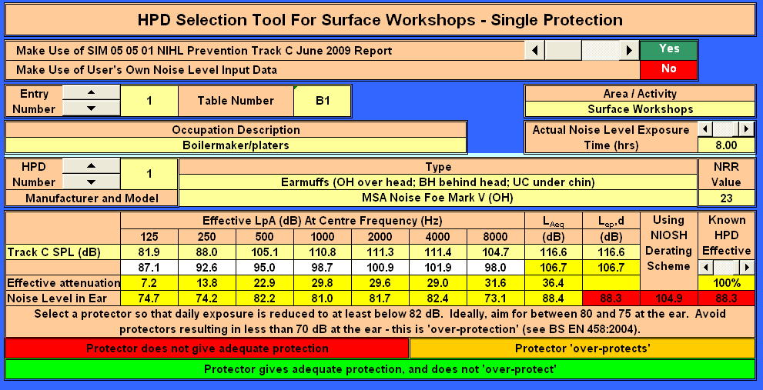

This value would indicate the effective in ear noise exposure based on the HPD frequency analysis.



This value would indicate the effective in ear noise exposure dose based on the HPD frequency analysis and exposure time.



This value would indicate the effective in ear noise exposure dose using the NIOSH derating scheme and based on the exposure time.



This value would indicate the effective in ear noise exposure dose set to the to “known” HPD usage compliance/effectiveness and based on the exposure time.

**9. Colour coding of output results:**

**Protector does not give adequate protection**

**Protector gives adequate protection, and does not ‘over-protect’**

**Protector ‘over-protects’**

**10. HPDs’ - Default Values to Demonstrate Wear Time Effect**

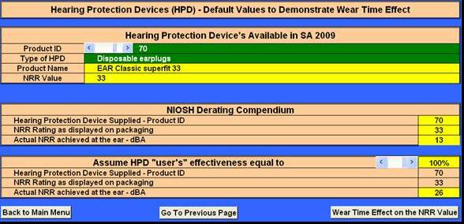

On this screen you will be able to view the implication on the actual at ear protection supplied by a specific style/type of HPD compared to the end user’s effective percentage application. The values submitted here will also serve as the default values to demonstrate the effect of HPD non-wear time.

**10.1 HPD Wearing Time (WT) Effect**

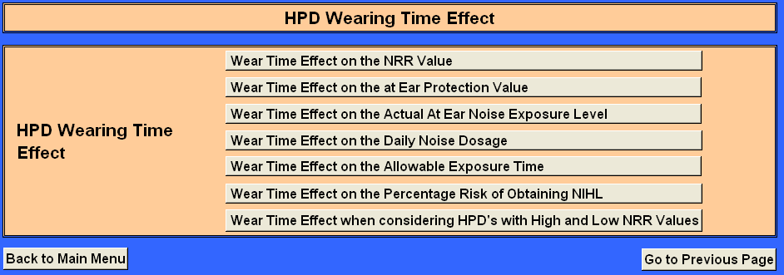

The tabs on this screen will allow you to demonstrate the effect of actual HPD non-wear time, i.e. the effect of not wearing HPD’s throughout the course of the users shift.

**10.2 HPD’s - the Effect of WT on the NRR Value**

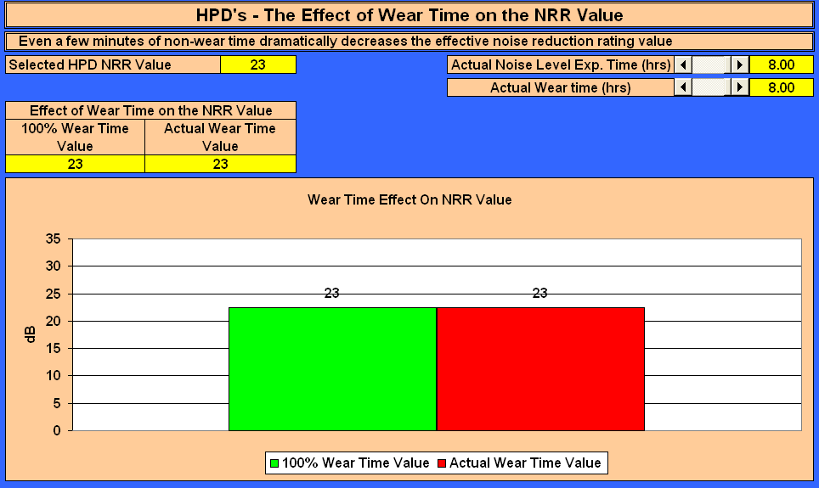

On this screen you will be able to demonstrate the effect of wear time on the NRR value.

The tabs on this screen will allow you to select the actual noise exposure time and the effective HPD wear time. The results will vary as the times are changed. You are not able to select an exposure time greater than the effective HPD time; an “error” message will be displayed.

**10.3 HPD’s - The Effect of WT on the at Ear Protection Value**

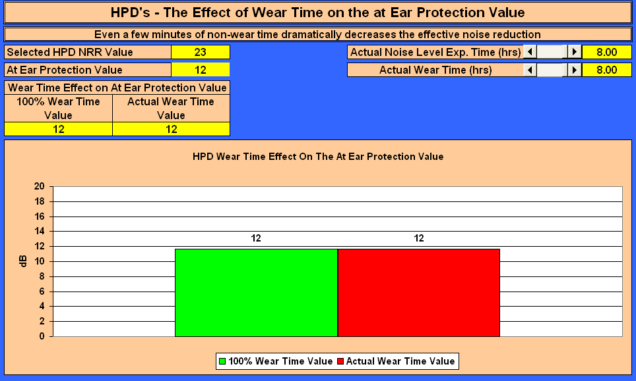

On this screen you will be able to demonstrate the effect of wear time on the at ear protection level.

The tabs on this screen will allow you to select the actual noise exposure time and the effective HPD wear time. The results will vary as the times are changed. You are not able to select an exposure time greater than the effective HPD time; an “error” message will be displayed.

**10.4 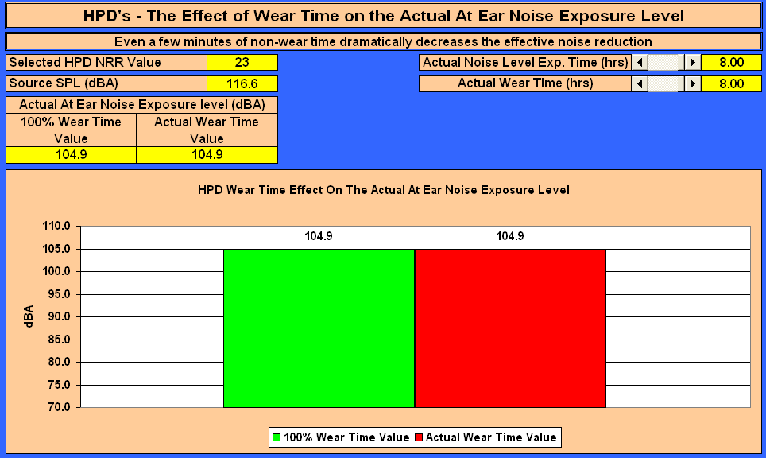HPD’s - the Effect of WT on the Actual at Ear Noise Exposure Level**

On this screen you will be able to demonstrate the effect of wear time on the actual at ear noise exposure level. The tabs on this screen will allow you to select the source SPL, the actual noise exposure time and the effective HPD wear time. The results will vary as the times are changed. You are not able to select an exposure time greater than the effective HPD time; an “error” message will be displayed.

**10.5 HPD’s - the Effect of WT on the Daily Noise Dosage**

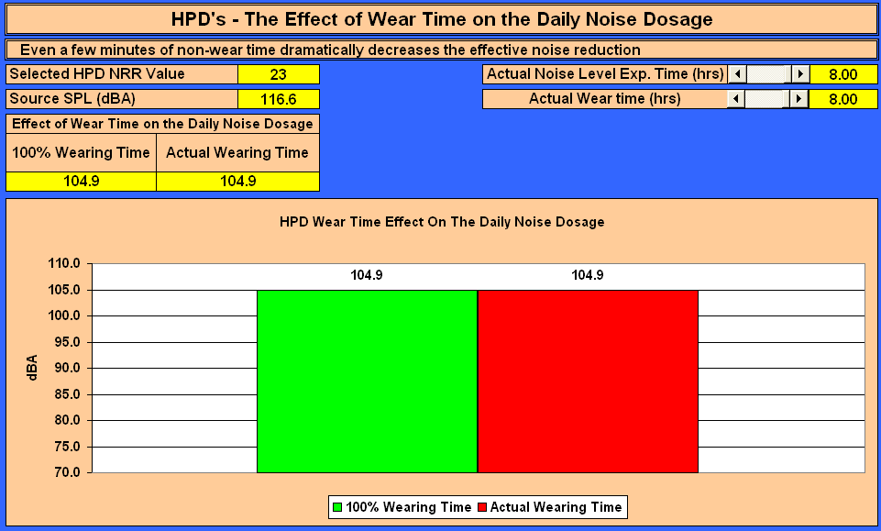

On this screen you will be able to demonstrate the effect of wear time on the daily noise dosage.

The tabs on this screen will allow you to select the source SPL, the actual noise exposure time and the effective HPD wear time. The results will vary as the times are changed. You are not able to select an exposure time greater than the effective HPD time; an “error” message will be displayed.

**10.6 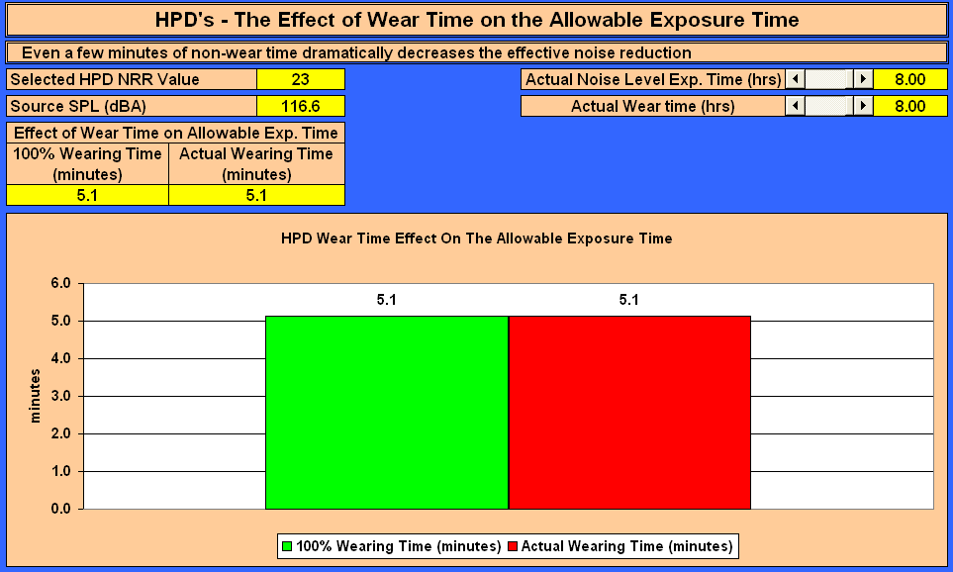HPD’s - the Effect of WT on the Allowable Exposure Time**

On this screen you will be able to demonstrate the effect of wear time on the daily allowable exposure time. The tabs on this screen will allow you to select the source SPL, the actual noise exposure time and the effective HPD wear time. The results will vary as the times are changed. You are not able to select an exposure time greater than the effective HPD time; an “error” message will be displayed.

**10.7 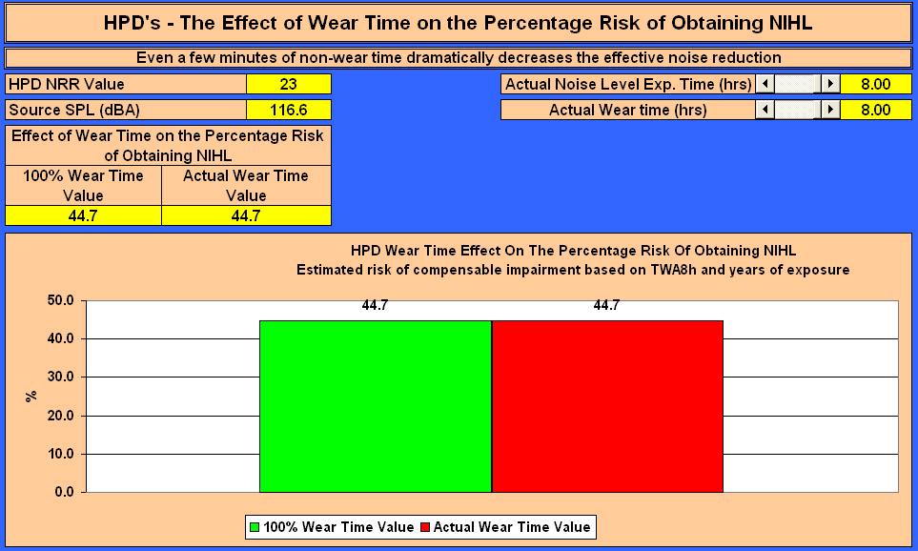HPD’s - The Effect of WT on the Percentage Risk of Obtaining NIHL**

On this screen you will be able to demonstrate the effect of wear time on the percentage risk of obtaining NIHL. The tabs on this screen will allow you to select the source SPL, the actual noise exposure time and the effective HPD wear time. The results will vary as the times are changed. You are not able to select an exposure time greater than the effective HPD time; an “error” message will be displayed.

**10.8 The Effect of WT when considering HPD’s with High and Low NRR Values**

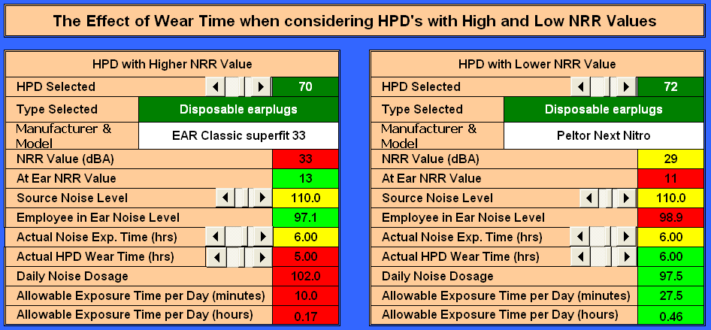

On this screen you will be able to demonstrate the effect of wear time when considering HPD’s with High and Low NRR Values, i.e. you will be able to demonstrate that a HPD with a higher comfort and acceptance level by the users although having a lower NRR value will supply more protection than a HPD with a higher NRR value but with lower comfort and acceptance levels.

**10.9 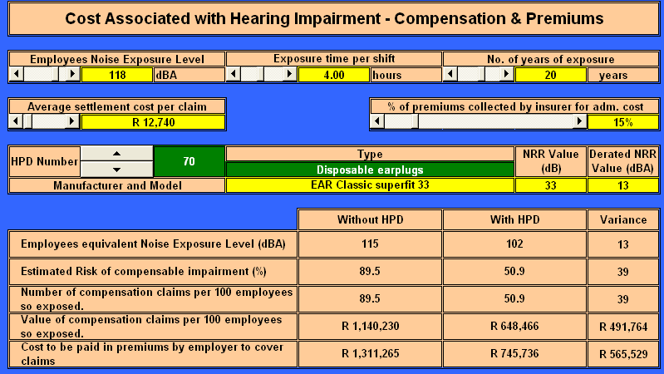Cost Associated with Hearing Impairment - Compensation & Premiums**

Following the tabs on this screen will allow you to demonstrate the cost associated with NIHL and the premiums payable to the insurer.

**11. Other materials available in the tool from local and international sources**

**11.1 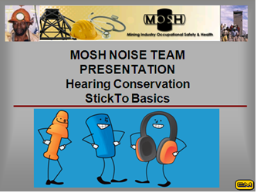PowerPoint® presentation – Hearing Conservation – Stick to Basics**

The PowerPoint® presentation allows the presenter to demonstrate, what sound is, what noise is, the working of the ear, how the ear is damaged and that noise induced damage is irreversible and totally isolates one from the world. The presentation also evaluates the various HPD styles available in the mining industry.

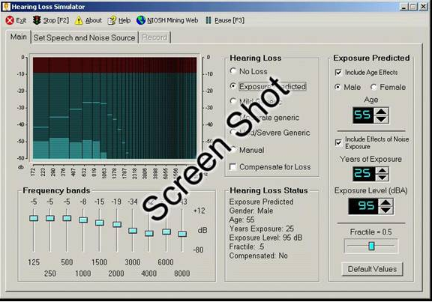**11.2 The NIOSH NIHL Simulator**

The NIOSH Hearing Loss Simulator is a software training and communication tool for promoting hearing conservation. It allows a user or trainer to demonstrate the effects of noise exposure on hearing without experiencing an actual noise-induced hearing loss. Estimates of the effects of different levels of noise exposure are based on the American National Standard Determination of Occupational Noise Exposure and Estimation of Noise-Induced Hearing Impairment otherwise known as ANSI S3.44. This standard specifies the predicted hearing loss for noise-exposed populations of individuals on the basis of risk factors that include sex, age, exposure levels (in A-weighted decibels or dBA), and years of exposure.

**11.3 The NIOSH Noise Meter**

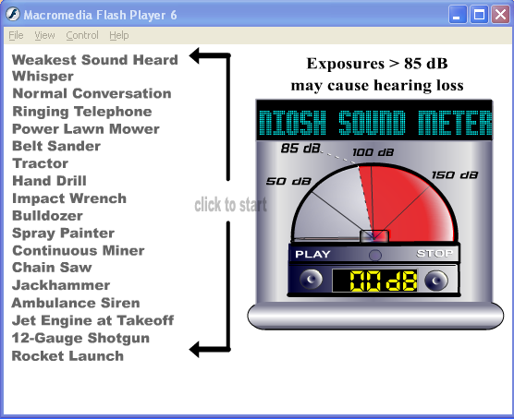The NIOSH Noise Meter is a software training and communication tool for promoting hearing conservation. It allows a user or trainer to demonstrate to the trainees the different sounds and sound intensities of everyday objects.

**12. The NIOSH Hearing Loss Simulator – Guide to All Features**

**12.1 Installation:**

Web: Download and run the simulator installation program from the NIOSH Web site: [www.cdc.gov/niosh/mining/products/product47.htm](http://www.cdc.gov/niosh/mining/products/product47.htm) Run the installer with administrator rights in Windows 2000, XP, or Vista. For both versions, follow the on-screen prompts. When complete, the program can be run from an icon in your Start menu or (optionally) on the desktop.

**12.2 Main Screen**

When the program is first started, this main screen showing the basic functions is displayed. From here you can use tabs below the menu bar to select other screens to change or record sounds played by the program. Adjust the volume on your computer so the spoken message is at a comfortable listening level that’s audible to every listener. Then select Exposure Predicted from the Hearing Loss list.

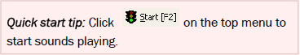

**12.3 Main Screen with Exposure**

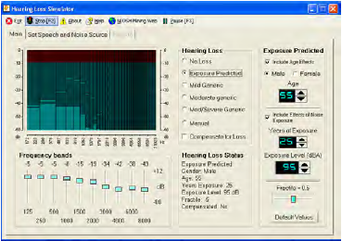Selecting the Exposure Predicted option changes the main screen by adding controls to adjust the amount of noise exposure being simulated.

In the sample screen shown here, the default exposure settings have been selected, and sound playback has started.

**12.4 Toolbar**

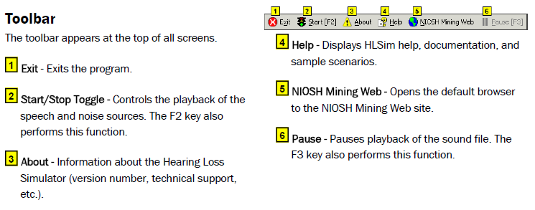

**12.5 Graphical Display**

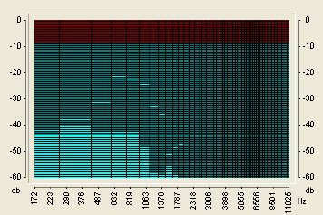This graphical display shows current instantaneous levels of sound across the frequency spectrum. This is useful for showing the amounts of low- and high-frequency sound in the recording. For instance, for the female voice the high-frequency bars toward the right side of the graph will show higher peak levels than the male voice. The display also demonstrates the loss of high-frequency information when a noise-induced hearing loss is simulated.

**12.6 Hearing Loss choices**

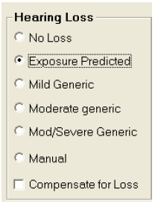This panel is used to select how the program simulates a hearing loss.

1. No Loss - Removes all hearing loss.
2. Exposure Predicted - High noise exposures cause much more hearing damage than lower exposures. This option applies the effect of different levels of noise exposure combined with age, gender, and other variables. When this option is selected, the main screen expands to show additional exposure controls.
3. Mild Generic - Applies a “mild” level of noise-induced hearing loss: 20 dB hearing level at 4000 Hz with surrounding frequencies impaired to a lesser extent.
4. Moderate Generic - Applies a “moderate” level of noise-induced hearing loss: 30 dB hearing level at 4000 Hz with surrounding frequencies impaired to a lesser extent.
5. Mod/Severe Generic - Applies a “moderate to severe” level of noise-induced hearing loss: 40 dB hearing level at 4000Hz with surrounding frequencies impaired to a lesser extent.
6. Manual - Activates the frequency band sliders so you can apply a hearing loss manually.
7. Compensate for Loss - Once a loss is simulated, it can be “compensated” for. This has the effect of boosting the sound by an amount equivalent to the loss. To an imperfect extent, the boosted playback can compensate for a hearing loss to give trainees an idea of what it would be like to regain their normal hearing.

The limitations of any mechanical playback system and the complexity of the auditory system make it impossible to exactly reverse a hearing loss. Also, in cases of severe hearing loss, boosting the sound enough to compensate for a large deficiency and playing the resulting sounds through a high-power loudspeaker or headphone system could potentially generate very loud and unpleasant sound levels. In extreme cases, the levels could even become hazardous, so use this feature with caution — turn the volume down first and bring it up gradually.

**12.7 Frequency Band Sliders**

These 10 sliders control different frequency bands. When the program is simulating a predicted hearing loss, these sliders are automatically adjusted to reflect a predicted hearing level as a result of noise exposure.

When you set the Hearing Loss to “Manual” you can manipulate the sliders directly. You might do this to enter the results of an actual audiogram. Then, others who have no hearing loss could, in effect, hear an approximation of the person’s hearing whose test results were entered. This is only an approximation. Individuals with sensory-neural hearing loss often have altered loudness perception and other subjective effects that are difficult to simulate accurately.

Also, since each slider can be manipulated independently, you can pinpoint the effects of hearing loss in each frequency band. For instance, a warning beeper may become much less audible as a result of a loss in a single frequency band.

**12.8 Hearing Loss Status**

This portion of the screen contains information about status of the Simulator, including current hearing loss settings.

**12.9 Exposure Predicted Loss Parameters**

1. Include Age Effects - When checked, the effects of age are included in the hearing loss calculation. This provides a convenient way to demonstrate the effect that noise alone has on hearing loss, apart from aging.
2. Gender - Males tend to have higher levels of hearing loss than females who have had the same noise exposure, so the program allows the user to specify the simulated worker’s sex.
3. Age - Some hearing loss occurs as people age, but deafness or even a severe hearing loss is not inevitable. One of the major lessons to be learned from the Simulator is that aging usually causes much less hearing loss than does noise exposure. The simulated individual’s age in years can be entered to show how older people tend to have a gradual loss in the high frequencies, i.e., an older worker who has not been exposed to loud noise will typically have worse hearing at 8000 Hz than at any lower frequency. On the other hand, a worker exposed to large amounts of noise will typically have a “notch” in their hearing sensitivity around 4000 Hz or 6000 Hz, and will have better hearing at 8000 Hz.
4. Include Effects of Noise Exposure - When checked, the effects of Years of Exposure, exposure level and fractile are included in the hearing loss calculation. This provides a convenient way to demonstrate the effect that age only has on hearing loss.
5. Years of Exposure - Time is the second major ingredient of exposure. This is set in years to represent a noisy period in the simulated individual’s life. It can cover just a noisy portion of a career (e.g., 10 years of working in a mill) or multiple noisy periods. The years represent working days, not continuous exposure. This value should be kept to the 0–40 year range for Exposure Level (dBA) - As expected; high-intensity sound levels cause much more hearing damage than lower levels. The effect of different levels of noise can be simulated by entering the desired A-weighted sound level in decibels. The A-weighting scale is used for all the key sound pressure level measurement standards in the Mine Safety and Health Administration (MSHA) and Occupational Safety and Health Administration (OSHA) regulations, so it should be familiar to both trainers and trainees. This value should be kept to the 75–100 dBA range for predictions supported by the data behind the ANSI S3.44 standard. For simplicity, a single dBA number is set in the simulator, although employees may correctly point out that the sound levels they are exposed to vary considerably over time. Because of this, the dBA value should represent an estimate of the average predictions supported by the data behind the ANSI S3.44 standard.
6. Exposure Level (dBA) - As expected, high-intensity sound levels cause much more hearing damage than lower levels. The effect of different levels of noise can be simulated by entering the desired A-weighted sound level in decibels. The A-weighting scale is used for all the key sound pressure level measurement standards in the Mine Safety and Health Administration (MSHA) and Occupational Safety and Health Administration (OSHA) regulations, so it should be familiar to both trainers and trainees. This value should be kept to the 75–100 dBA range for predictions supported by the data behind the ANSI S3.44 standard. For simplicity, a single dBA number is set in the simulator, although employees may correctly point out that the sound levels they are exposed to vary considerably over time. Because of this, the dBA value should represent an estimate of the average exposure over the simulated time period, commonly referred to as the “time-weighted average” (TWA).
7. Fractile (population distribution) - Noise does not affect everyone to the same extent. To account for variations within the population, the ANSI S3.44 standard specifies expected hearing loss for different population fractiles. The program allows the user to specify the 0.1, 0.25, 0.5, 0.75, and 0.9 fractiles. For instance, a worker at the 0.1 fractile would have more hearing loss than 90% of the equally exposed population. Those at the 0.75 fractile would have more hearing loss than just 25% of the population. By changing this control to the low (0.1 or 0.25) settings, a trainer can show that lower exposure levels can still be dangerous for some workers, even if they are relatively “safe” for the average worker. Since most workers do not have a way of knowing their individual susceptibility, this allows them to err on the side of caution.
8. Default Values - Sets all the exposure predicted variables to their default values.

**12.10 Set Speech and Noise Source**

This screen is reached by selecting the tab for “Set Speech and Noise Source.” You can return to the main screen at any time by selecting the “Main” tab.

1. 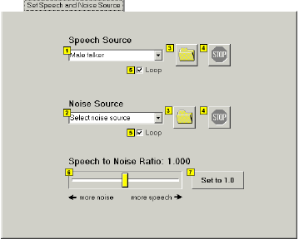Speech Source (foreground sound) - Human speech is provided as both the most complex and important foreground sound most workers need to perceive. You can choose either a male or female voice recording from the dropdown list.
2. Noise Source (background sound) - Background sounds often severely tax a listener’s ability to hear and/or comprehend the intended message. The simulator allows the choice of several types of background sounds, including some recorded worksite sounds (continuous miner, haulage machine, drill) and some more generic standard background noises (male or female “speech babble,” white noise, etc.).
3. Browse for a Sound File - Select a Windows WAV file for playback in place of one of the sounds in the dropdown list.
4. Stop Playback - Stop the playback of the sound file.
5. Loop - Makes the sound repeat indefinitely.
6. Speech to Noise Ratio - The Speech to Noise Ratio control affects the loudness of the background noise source relative to the foreground sound. Use this to demonstrate how increasing background noise interferes more with understanding the foreground speech recording.
7. Set to 1.0 - Resets the Speech to Noise Ratio to the default value of 1.0.

**12.11 Record Screen**

This screen is reached by selecting the “Record” tab. You can return to the main screen at any time by selecting the “Main” tab.

1. 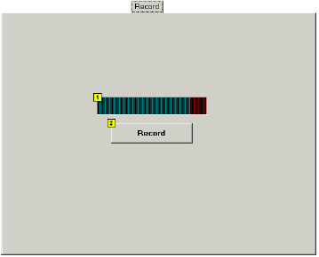Recording Level - Displays the input sound level while making a recording. Adjust the computer’s input controls so that the loudest peak levels stay below the red area to the right.
2. Record - Click this button to start recording a standard Windows WAV sound file for use as either foreground or background source.

This can be used to record a different foreground voice message customized for trainees or to record a special machine or warning signal that’s common at the trainees’ worksite.

The program will ask for a file name before saving the recording. This feature requires a microphone or other sound source attached to the PC sound input.

**13. The NIOSH Hearing Loss Simulator Training Scenario**

The NIHL simulator includes various devices used to convey the impact of NIHL as discussed in the sub-sections below.

**13.1 Instructive scenarios**

The full power of the simulator is shown by working through some instructive scenarios. Some of the scenarios suggested are:

* 1. Older worker, noise exposed – A hypothetical older worker is described. The program can simulate the range of 55 to 65 years old with 35 to 45 years of exposure to 90-100 dBA. Selection of numbers in these ranges can depend on what is typical in the user’s workplace or industry. The trainer can demonstrate the significant hearing loss this worker will have going into retirement.
  2. Older worker, no exposure – Immediately following a demonstration about a hypothetical noise-exposed older worker, the trainer can set the exposure years to zero and simulate an equivalent worker with no exposure. This will serve to counter any assumption that the first worker’s hearing loss was a natural consequence of aging. Instead, users will see that a relatively small amount of high frequency loss is expected in older workers, but that noise exposure is responsible for much more of the damage.
  3. Mid-career worker – Especially if there are a large number of mid-career trainees, a worker with 10 to 20 years of exposure may be simulated. On the basis of this worker, several progressions can be followed. For instance, additional exposure years can be added to show the accumulation of more hearing loss. The noise simulator also allows comparison with an older non-noise-exposed worker, which then allows the trainer to make the point that, with enough exposure, a 30-year-old worker may have, in effect, 50-year-old ears.
  4. Individualized – The simulator can also be used as an individualized training and counseling tool. The trainer can show a worker how his/her hearing test results can be entered directly into the simulator. Using the frequency band sliders and selecting the “invert loss” function, the trainee can be given a hint of what his/her hearing would be like if the hearing loss had been avoided. Switching back to the original loss profile, the trainer can then drag the sliders down to show the additional loss that would occur after further noise exposure.

Another useful aspect of the simulator is the graphical display that shows the current instantaneous levels of sound across the frequency spectrum. This shows the relative amounts of low- and high-frequency sound in the recording; for example, for the female voice the high-frequency bars toward the right side of the graph will show higher peak levels than for the male voice. The display also demonstrates the loss of high-frequency information when a noise-induced hearing loss is simulated. This may not be relevant for all levels of education nor for all workplace requirements and would need to be included only when necessary.

**13.2 Predicted loss on the basis of exposure**

Prediction of hearing loss is based on the ANSI S3.44 standard. Parameters used in the prediction include

1. Effects of age – Some hearing loss occur as people age, but deafness or even a severe hearing loss is not inevitable. One of the major lessons to be learned from the simulator is that aging usually causes much less hearing loss than does noise exposure. The simulated individual’s age in years can be entered to show how older people tend to have a gradual loss in the high frequencies, i.e. an older worker who has not been exposed to loud noise will typically have worse hearing at 8000 Hz than at any lower frequency.

2. Gender – Males tend to have higher levels of hearing loss than females who have had the same noise exposure, so the program allows the user to specify the simulated worker’s sex.

3. Years of exposure – Time is the second major ingredient of exposure. This is set in years to represent a noisy period in the simulated individual’s life. It can cover just a noisy portion of a career (e.g. ten years of working in a mill) or multiple noisy periods. The years represent working days, not continuous exposure.

4. Exposure level (dBA) – As expected, high-intensity sound levels cause much more hearing damage than lower levels. The effect of different levels of noise can be simulated by entering the desired A-weighted sound level in decibels. The value represents an estimate of the average exposure over the simulated time period, commonly referred to as the “time- weighted average” (abbreviated as TWA).

5. Fractile (population distribution) – Noise does not affect everyone to the same extent. To account for variations within the population, the ANSI S3.44 standard specifies expected hearing loss for different population fractiles. The program allows the user to specify the 0.1, 0.25, 0.5, 0.75 and 0.9 fractiles. For instance, a worker at the 0.1 fractile would have more hearing loss than 90 per cent of the equally exposed population. Those at the 0.75 fractile would have more hearing loss than just 25 per cent of the population. Most workers will have no way of knowing their susceptibility to noise, so this control should usually be set on the expected population median of 0.5.

**13.3 Predictive impact on the basis of the listening environment**

A “Speech and Noise Source” screen in the simulator takes into account the following aspects that will influence the impact of the hearing loss on the person’s quality of life:

1. Speech Source (foreground sound) – Human speech is provided as both the most complex and important foreground sound most workers need to perceive. The trainer can choose either a male or female voice recording from the dropdown list.
2. Noise Source (background sound) – Background sounds often severely tax a listener’s ability to hear and/or comprehend the intended message. The simulator allows the choice of several types of background sounds, including some recorded worksite sounds (continuous miner, haulage machine, drill) and some more generic standard background noises (male or female “speech babble”, white noise, etc.).
3. Speech-to-Noise Ratio – The speech-to-noise ratio control affects the loudness of the background noise source relative to the foreground sound. This can be used to demonstrate how increasing background noise interferes more with understanding the foreground speech recording.