

L E A R N I N G H U B

**MULTI-STAGE**

**FILTRATION**

**SYSTEMS**

**ADOPTION**

**BRIEF**

Draft one June 2013



**Draft 1**

**CHAMBER OF MINES OF SOUTH AFRICA**

*Putting South Africa First*



**BACKGROUND COMMENT**

The multi-stage filtration system offers a filter efficiency of ≥98.5% for contaminated air resulting from operations causing dust.

**The following guidance notes will assist adoption mines with their adoption of the SLP when installed at tipping points:**

The installation of tip doors will be an added advantage to reduce the so called “piston effect” when tipping occurs.

The Tip Attendant and Loco Driver must be made aware of the noise level created by the fan and that they must use hearing protection devices and in addition dust masks as per the mine standard when working in these areas. They must also be made aware not to switch off the fan while tipping operations are in progress

The fan used must be a filter type fan, low volume but high pressure and not a conventional axial flow fan used for development. The efficiency of the unit is specific designed to ensure a downcast velocity of 1.0 m/s in-tip area is achieved.

The discharge of the filtered air should be a minimum of 10 meters downstream of the tip.

The mine lock-out procedure must be enforced on the fan switch gear. This will ensure that the fan is not stopped or started when permitted to do so and this is important when tipping operations occur and when cleaning of the unit is in progress.

Frequency of changing the filters is largely dependent on the dust load.

Maintenance program is key to the sustainability of the filter efficiency.

**There should be NO reason why not**

**to consider adopting multi-stage filtration systems:**

1. **DESCRIPTION OF THE SIMPLE LEADING PRACTICE**

The Multi-stage Filtration System offers final filtration efficiencies of ≥98.5% at 0.5 micron (μ) and larger size particles discharged into the return airside of the system. The system assists in alleviating the problem by filtering contaminated air (respirable dust) to an acceptable level before it enters the fresh air system.

The Multi-Stage Filtration System was demonstrated at Phakisa mine where it was identified as a primary preventative practice at tipping points and entails exhausting contaminated air through various stages of filtration systems that remove dust and release clean air into the intake air system, since most of the dust is produced on the main tips during tipping activities.

The multistage filtration system at Phakisa mine offers a final efficiency of ≥98.5% at 0.5 micron (μ) and larger size particles discharged into the return airside of tipping points and ensures a downcast velocity in-tip of ≥1.0 meters per second (m/s). The downcast velocity is illustrated in the diagram below:

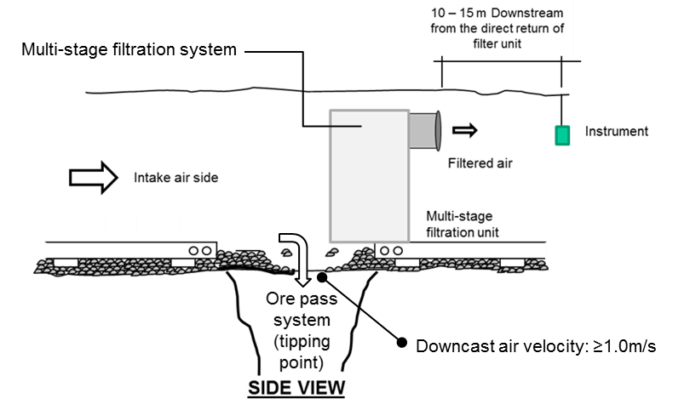The volume of the fan is determined by:

**Q = A x V**

Where:

Q = Quantity (m³/s)

A = Area (m²) and

V = Velocity = 1 (m/s)

The prevention of re-introduction of airborne dust into intake airways was documented to be more efficiently removed through a multi-stage filtration system, namely a combination of primary and secondary filters as opposed to using only a single system (source research outcome document MHSC: - SIMRAC 03-06-03 Track B project called environmental and engineering document).

In situations where the volume displacement in the ore pass exceeds the capacity of the filtration system due to the so called “piston effect” during tipping operations, secondary systems such as foggers/dry mist sprays can be considered in addition.

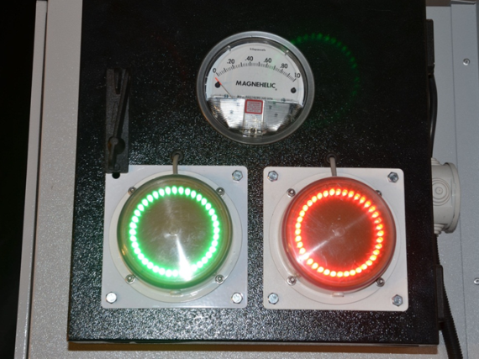To minimise the dependency of an individual on timing the necessity to change the filters and the frequency, the multi-stage filtration system is equipped with an indicator red and green light automation which flashes red once the operating pressure exceeds normal, indicating the need for the filters to be changed. However, under normal pressure the light will remain green. This is referred to as a predictive / preventative maintenance system.

-Robot system-

1. 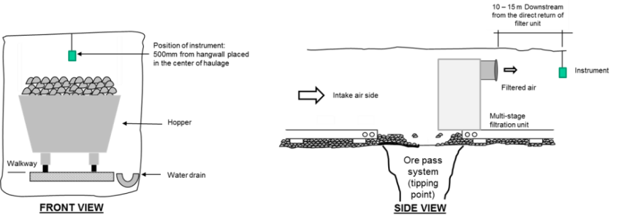**DOCUMENTED BENEFITS TO DATE**

Following the installation of the multi-stage filtration units an average improvement of 71 in the dust load (TWA) was observed.

Themeasurements were obtained using Gravimetric Tuff pumps that were placed at a distance of between 10-15 m on the direct return air side of the filtration unit at a height of 1.5 m from the footwall as depicted in the diagram above.

**75 Level**

**73 Level**

**66 Level**

-Graph 1-

However it was also observed that as a result of the implementation of the multi-stage filtration units the mine was able to address the 2008 MHSC Silicosis Milestone that state that: “By December 2008, 95% of all exposure measurement results will be below the occupational exposure limit for respirable crystalline silica of 0.1mg/m3 (these results are individual readings and not average results)”, as indicated in graph 2 below.

**COMPLIANCE TO 2008 DUST MILESTONE – Individual Sampling Results**

Graph 2

1. **SUMMARY OF GENERIC VALUE CASE**

**3.1 INITIAL COST TO INSTALL THE MULTISTAGE FILTRATION SYSTEM AT A TIP**

|  |  |  |
| --- | --- | --- |
| **Item** | **Cost/unit** |  |
| *Capital cost per unit | R275 000.00 |  |

*This includes the following: Multistage Filtration unit, pockets and filters, fan, ducting for fan installation, Red/Green LED lights, Installation CD

**3.2 OPERATIONAL COSTS-FILTERS**

|  |  |  |
| --- | --- | --- |
| **Item** | **Cost/unit/month** | **No. of filters** |
| Replace of filters | R2 160.00 | 18 |

*Maintenance costs normal replacement of pocket and envelope filters

**3.3. OTHER IMPACTS OF SIGNIFICANT BUSINESS VALUE**

|  |  |
| --- | --- |
| Detail | Comment |
| Improved stakeholder relationships internally and externally | Greater investor attraction |
| Buy-in and collaboration from all stakeholders | Tripartite involvement and approval |
| A more positive relationship between all levels at the mine | People generally want to know that their health are being looked after |
| Progress towards zero harm culture | Very much in line with industry commitment |
| Less risk of management Prosecution | Reducing the exposure of individuals will result in less risk of prosecution |
|  |  |
| Improved perceived of commitment to occupational lung diseases intervention from labour sending communities | Yes |
| A much healthier and productive workforce | Yes – refer to “Moral Obligation” below |

**3.4 MORAL OBLIGATION**

*The most important accomplishment of dust preventive measures is that silicosis is becoming a negligible factor, and that in the future it will largely be stamped out’* Wrabitz V, 1939cited in: Wagner (1995),the inexcusable persistence of silicosis. Many decades later, the optimistic views of Wrabitz (1939) are negated by the reality that silicosis is still prevalent. According to the Chief Inspector of Mines, respiratory diseases caused more deaths than mine accidents in 2003-2009 (7 800 versus 1 800). Whatever the numbers are, the most relevant take home message is that occupational lung diseases kill most workers and many others die a slow death.

The dominant components of the solution are substantial commitment to prevention and a culture of health rather than just more treatment and cure.

The health cost conundrum can be impacted by reducing the burden of occupational lung diseases and health risk in mining populations, thereby improving the health and productivity of the workforce, the health of the bottom line for engaged employers and ultimately the health of the mining industries’ economy. Ultimately, the broader value proposition of integrated mining population health and productivity enhancement should drive this approach by leveraging the value of health and the power of prevention.

1. **SUMMARY OF GENERIC BEHAVIOURAL ASPECTS (Generic book stuff and the mine as is)**

**4.1 Behavioural communication requirements**

|  |  |  |
| --- | --- | --- |
| No. | Issue / belief | Essence of required behavioural communication |
| 1 | No perceived personal benefit | The tip attendants observed that there was no visual dust during tip and believed that this will prevent silicosis to the entire work force. |
| 2 | Potential negative impact on production | There should be no negative impact on production. |
| 3 | Extra work effort | There is no extra work involved. |
| 4 | Short cuts to meet production targets | Not applicable |
| 5 | Trust and buy-in | Repeatedly emphasise to all supervisory levels the importance of regular dialogue with their staff |
| 6 | Leaders must lead by example | Leaders responsible for maintenance of the equipment must diligently ensure the equipment is maintained |
| 7 | Worker disregard for health and safety | Managers must regularly demonstrate their high regard for health and safety |
| 8 | Failure to implement training provided | Explain to supervisors that they must not allow sub-standard activity (maintenance) – they will get what they allow. They must provide constructive coaching or if necessary send the person for re-training |

**4.2 Leadership behaviour requirements**

|  |  |  |
| --- | --- | --- |
| Antecedents  (For desired behaviour) | Behaviours  (Desired for successful adoption) | Consequences  (For exhibited behaviour) |
| Operational adopters | | |
| * Operational training / instruction * Briefing before implementation * Regular SLP performance enquiries | * Operate Simple Leading Practice (SLP) as instructed * No short cuts * Report any problems with SLP * Request explanations to ensure understanding | * Immediate positive feedback from supervisor on observing desired behaviour * Constructive coaching to address observed problems (no abuse) * Special recognition / reward for exceptional performance |
| First level supervisors | | |
| * Operational training / instruction * Briefing before implementation * Regular meetings with next level supervisor | * Regularly check on SLP performance * Ensure operators receive any necessary training / instruction * No short cuts on any safety related issue * Prompt action on any reported SLP problems * Provide immediate positive feedback on observing desired behaviour * Provide constructive coaching on observing sub-standard behaviour | * Immediate positive feedback from next level supervisor on observing desired behaviour * Constructive coaching to address observed problems (no abuse) * Special recognition / reward for exceptional performance |
| Second level supervisors (and any other levels if applicable) | | |
| * Briefing before implementation * Regular meetings with next level supervisor | * No short cuts on any safety related issue * Ensure that operators and supervisors receive any necessary training / instruction * Enquiry about SLP performance at regular meetings with supervisors | * Immediate positive feedback from next level supervisor on observing desired behaviour * Constructive coaching to address observed problems (no abuse) * Special recognition / reward for exceptional performance |

1. **STEPS FOR ADOPTION OF THE SIMPLE LEADING PRACTICE**

The following steps need to be taken to ensure proper adoption:

1. Ensure buy in from the Mine Manager and all members of Executive upfront
2. Ensure buy in from all disciplines involved – that is recognition of the multi-disciplinary approach as a successful ingredient
3. Briefing of the Mine Health and Safety Committee during the plan to adopt
4. Briefing Environmental Engineering Managers and Engineering Managers
5. Communication to all union representatives
6. Address the entire workforce through the existing communication systems on the mine – for an example management briefs, posters, underground waiting place discussions etc.
7. Awareness training during induction of new employees and returnees from leave.

1. **GUIDANCE NOTES FOR ADOPTION OF THE SIMPLE LEADING PRACTICE**

The following guidance notes will assist adoption mines with their adoption of the SLP at tipping points:

1. The installation of tip doors and/or control chutes will be an added advantage to reduce the so called “piston effect” when tipping occurs. It must be noted that risk assessments and change management procedures must be done.
2. The Tip Attendant and Loco Driver must be made aware of the noise level created by the fan and that they must use hearing protection devices and in addition dust masks as per the mine standard when working in these areas. They must also be made aware not to switch off the fan while tipping operations are in progress.
3. The fan used must be a filter type fan, low volume but high pressure and not a conventional axial flow fan used for development. The efficiency of the unit is specific designed to ensure a downcast velocity of 1.0 m/s in-tip area is achieved.
4. The discharge of the filtered air should be a minimum of 10 meters downstream of the tip.
5. The mine lock-out procedure must be enforced on the fan switch gear. This will ensure that the fan is not stopped or started when permitted to do so and this is important when tipping operations occur and when cleaning of the unit is in progress.
6. Frequency of changing the filters is largely dependent on the dust load.
7. There must be a procedure for changing the filters. Phakisa Mine procedure covers the following key points for consideration:
8. The primary filters should be changed within a cycle of 6 weeks. However, in scenarios where dust loads are too high, the filters should be changed as soon as the indicator light turns red.
9. The secondary filters will be changed within a cycle of 6 months. However, in scenarios where dust loads are too high, the filters will be changed as soon as the indicator light turns red
10. The red/green Light-Emitting Diode (LED) indicator lights will assist to determine when filters need to be replaced.
11. Note: The indicator light installed on the filters will turn red if the filters need to be changed, the light will turn from green to red once the pressure exceeds 0.4 kilo Pascal (kPA). Once the light turns red, the filters must be changed within a period of 12 hours
12. The tip filters will only be changed on an off shift or before the commencement of a new shift to avoid overexposing employees to dust.
13. In order to avoid potential negative impacts it might be necessary to make the filter unit to stop automatically to avoid possible blow-up when the filters are full and no one is available to change them. This is not part of the design but can be considered.
14. It is important that a person be appointed to conduct daily visual inspections of the filter units and report his/her findings. In the case of the source mine the Shaft Timberman has been entrusted with this responsibility.
15. It must be clear which discipline is responsible for what for example: who is responsible for the capital and working cost budget, who orders the filter bags, who is responsible for the maintenance etc. Thus a multi-disciplinary approach is crucial to the success and sustainability of the adopted practice.
16. This practice might not be compatible to certain tipping designs. Alternative arrangements will then have to be considered for this practice to be adopted.