

L E A R N I N G H U B

**Part 1: Leading Practice Adoption Guide for:**

Continuous Real-time

Monitoring of Airborne

Pollutant Engineering

Controls

**(Abridged version)**

Rev 0

27 February 2015

**Prepared by:**

**MOSH Adoption Team - Dust**

Adoption Team Manager: G Pienaar

Adoption Specialist: Dr A Banyini

**CHAMBER OF MINES OF SOUTH AFRICA**

*Putting South Africa First*





**Note:** This draft guide is for use at the first of the adopter mines.

It will be updated to take account of experience gained and input received while securing successful adoption at the first adopter mine.

*Copyright in this guide is vested in the Chamber of Mines of South Africa. The guide may be used, without liability to the Chamber, members and by others who may see benefit in its use, provided that it may not be used or reproduced, in whole*

*or in part in any form, for the purpose of offering commercial services to any person or organisation, without the prior written permission of the Chamber. Use of the guide and its contents is the sole responsibility and liability of the user.*

**THE MOSH LEADING PRACTICE ADOPTION SYSTEM**

## Milestones in Health and Safety

In June 2003, at the third Mine Health and Safety Council (MHSC) Summit, the Chamber of Mines of South Africa and its social partners, government and labour, established occupational safety and health milestones to be attained over a 10 year period. This was followed in 2005, and later reinforced in 2008, by the Chief Executive Officers in the mining industry expressing the commitment of industry to achievement of the milestones and continuous improvement towards zero harm. In 2014 a new set of milestones for the next 10 years were established.

**The MOSH Leading Practice Adoption System**

The MOSH Leading Practice Adoption System is a process that identifies promising leading practice, selects the best of these, documents it (possibly with refinements) at the operational mine (the source mine) and identifies possible aids and barriers to its adoption at potential adoption mines. Technological details of the leading practice together with detailed leadership behaviour and behavioural communication plans, and procedures for their adoption are then compiled by the relevant MOSH Adoption Team into a Leading Practice Adoption Guide. This guidance is tested at the first adoption mine, or at a special demonstration mine, and then updated by the MOSH Adoption Team to take account of lessons learned. The MOSH Adoption Team facilitates dissemination of this guidance throughout industry by presenting details at a Leading Practice Adoption Workshop and establishing a Community of Practice for Adoption (COPA). The COPA includes key persons from all potential adoption mines and is then used as a forum for providing on going assistance to mines, and for mines to learn from each other in adopting and continuously improving the practice.

The MOSH Leading Practice Adoption System fully recognises that, while a technological or procedural solution may have demonstrated effectiveness, success in adoption of the leading practice at another operation will depend on the key people at that operation - at all levels of employment and leadership. It is the behavioural communication (to address knowledge gaps and misperceptions) and leadership behaviour (to facilitate desired behaviour) aspects of the MOSH Leading Practice that address this challenge. Without the buy-in and support of these key people at the mine, enforced “top down” implementation of the practice at the mine is likely to be short-lived.

The two distinguishing features of the Adoption System and why it is so different from past approaches are thus, in addition to the usual necessary technical detail about the practice, the inclusion of:

* a structured communication strategy to achieve appropriate behaviours of key people at the mine, and
* a leadership behaviour strategy to set out and achieve the desired behaviours of key people at all levels.

Fundamental to the development of leadership behaviour and behavioural communication strategies is an understanding of stakeholder and adopter perceptions (mental models) with regard to the risk/hazard being addressed by the recommended leading practice. The behavioural communication and leadership behaviour strategies that form part of the leading practices have been developed to align with and respond to these mental models of potential stakeholders and adopters of the leading practice at each mine that decides to adopt the practice.

Identify Leading Practice with greatest OHS potential

Identify all potential adoption mines

Direct inquiry investigation to identify prevailing mental models

Investigate value case for leading practice

Investigate details of leading practice at source mine

**L E A D I N G P R A C T I C E**

Value case details

**Leg 3:** Technical details

**Leg 2:** Leadership behavioural plan

**Leg 1:** Behavioural communication plan

Draft Leading Practice Adoption Guide

Conduct Leading Practice Adoption workshop for all potential adopters

Establish Community of Practice for Adoption (COPA) involving all potential adopters

Assist with adoption at first adoption mine and update draft adoption guide

Facilitate widespread adoption – across all potential adoption mines

**Simple schematic of MOSH Leading Practice Adoption System**

**EXECUTIVE SUMMARY**

The objective of this practice is to move away from reactive management mode into a proactive approach that will enable industry to do predictive and preventative maintenance management. This practice does not replace but broadens the conventional approach of personal sampling. It will also allow for immediate intervention when undesirable concentrations of dust are evident from the continuous real-time monitoring system (previously this was not possible).

**Key elements of the Leading Practice**

The leading practice on continuous real-time monitoring of the effectiveness of dust engineering controls is a system comprising of the following key elements:

* **Identification**: Identification of areas and activities and potential dust sources in these areas
* **Sampling methodology and process:** A detailed description of the methodology and process obtaining and analysing the necessary samples of respirable dust
* **Evaluation**: Procedures for analysing the dust data to identify intervention and control requirements.
* **Control:** Based on the outcome of the evaluation, guidance is provided on dust source elimination, control, and further monitoring.
* **Continuous real-time monitoring:** Guidance is provided for the design and implementation of an on-going sampling area based on a sampling and monitoring programme.
* **Reporting:** Guidance is provided on formats for data reporting.
* **Review:** Procedures and criteria for review and refinement of the practice are outlined.
* **Behavioural plans:** Behavioural communication and leadership behaviour plans to facilitate sustainable adoption make up this last element.

Industry experts (known as the MOSHIAT-D) identified Continuous Real-time Monitoring of Airborne Pollutant Engineering Controls as one of the leading practices for addressing the risk of harmful airborne pollutants. This system offered exceptional management of real-time monitoring of the effectiveness of engineering controls of airborne pollutants at source. It has broad applicability, offer easy maintenance and installation and has the potential to have a significant impact on a large number of affected employees.

The MOSH Dust Adoption Team, consisting of one full time Adoption Team Specialist and an Adoption Team Manager commenced with investigation at the source mine, AngloGold Ashanti’s Kopanang Mine, to determine the efficiency of the system in the reduction of respirable crystalline sillica (RCS) dust at source. Trends at Kopanang Mine indicate consistent reduction in respirable dust and suggest that a reduction in RCS dust is possible.

Continuous Real-time Monitoring of Airborne Pollutant Engineering Controls and associated behavioural communication and leadership behaviour strategy have now been developed within the guide for industry-wide adoption.

The strategic context of this work is one of continuous improvement towards zero harm from silica dust and other airborne pollutants to which Chief Executive Officers in the mining industry have duly committed. The objective of this document is to serve as a guide to decision makers and adopters to facilitate the adoption of technology whilst addressing the ‘people’ issues that aid the process. The scope of the identified leading practice is clearly defined.

The guideline is presented in three parts: the first part outlines the practice, the second part outlines the guidance on adoption of the leading practice at adoption mines and the third part provides any reference or example material considered vital to successful adoption.

**TABLE OF CONTENTS**

**Executive summary**

**Part 1 – The Practice**

1.1 Introduction

1.2 Summary description of the practice

1.3 The problem addressed

1.4 Summary of documented performance and impacts

1.5 The generic value case

1.6 Critical success factors

**Part 2 – Adoption Guide**

G1. Facilitate adoption decision

G2. Secure support for adoption

G3. Establish an effective mine adoption team

G4. Prepare initial plan for adoption

G5. Initiate baseline monitoring programme

G6. Establish effective relationship with COPA

G7. Update key stakeholders on progress

This version comprises of Part 1 one only.

Part 2, 3 and all Appendices are available on the mosh website: www.mosh .co.za

G8. Plan and conduct direct enquiries

G9. Customise generic behavioural plans

G10. Harmonise leading practice with mine standards

G11. Assess risks and develop final adoption plan for approval

G12. Develop training and communication materials

G13. Brief and train key mine persons

G14. Implement pilot adoption of the practice

G15. Monitor, evaluate and report on performance

G16. Finalise and implement mine-wide roll-out plan

**Part 3 – Behavioural plan**

3.1 Behavioural Plan

3.2 Behavioural Guidance Document

**Appendix A: Supporting work documents**

A1 One page summary of the Adoption Process

A2 Framework of overall adoption plan

A3 Adoption process checklist

A4 MOSH Brochure outlining the Adoption Process

A5 Guidance document for the eight-step customisation process

A6 Expert causal chain risk summary – for customisation expert model

A7 Likely key stakeholders and adopters

A8 Identification of adopters and stakeholders at the mine

A9 Guide to interviewers for direct enquiry interviews

A10 Questions for direct enquiry interviews at the mine

A11 Analysis worksheet for direct enquiry responses

A12 Generic mental models report

A13 Portfolio of evidence

**Appendix B: Supporting reference documents**

B1 Example documents e.g. communications and signage

B2 Example training material

**Part 1 – THE PRACTICE**

* 1. **INTRODUCTION**

There is a real need for a practice that provides consistent procedures and measurements for reliably identifying, implementing and monitoring appropriate engineering dust controls. This practice, which serves that purpose, allows for:

* Detecting working places or processes with unsatisfactory dust conditions
* Determining sources or causes of such conditions
* Indicating necessary control measures
* Determining the effectiveness of dust suppression methods or equipment
* Confirmation that satisfactory conditions have been achieved following remedial measures
* Confirmation that satisfactory conditions are being maintained
* On-going continuous real-time monitoring of the effectiveness of control measures
* Providing records of dust conditions so that trends can be determined
* Improve design of ventilation systems
* Determining risk levels ( through appropriate risk assessments)

AngloGold Ashanti’s practice incorporates work from the Mine Health and Safety Council (MHSC)’ Safety in Mining Research Advisory Committee (SIMRAC) Project ‘*03 06 03 Track B: Environmental and Engineering Controls’ where applicable.*

* 1. **DESCRIPTION OF PRACTICE**

Basic concept of real-time monitoring:

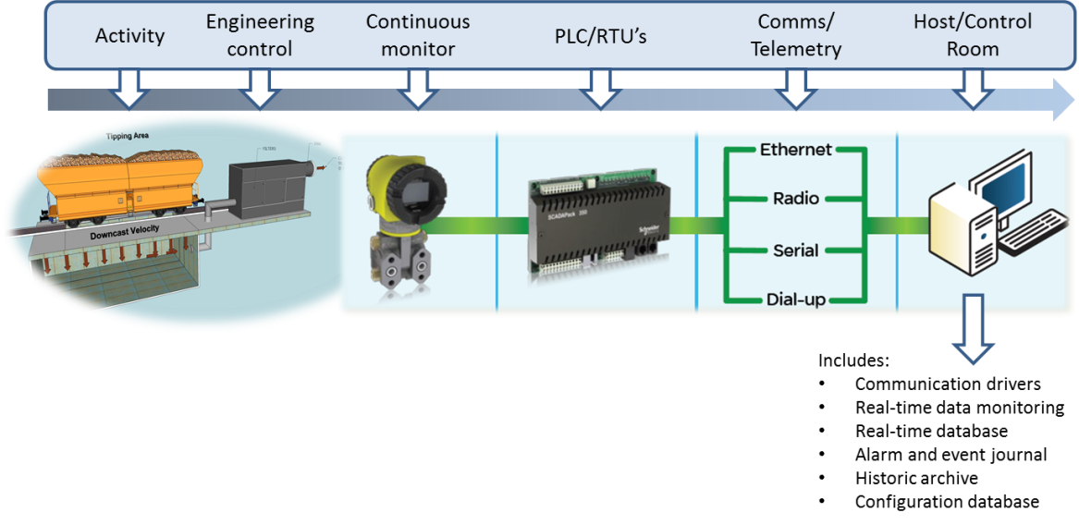

Following the identification process as described later in this document, continuous monitors are placed on the intake and direct return airside of an engineering control. The ambient air condition is then monitored continuously in real-time and transmitted to a surface control room. If a “dust alarm” occurs (instruments are calibrated to a set alarm level) the control room operator will initiate a call-out procedure to investigate the alarm. Following the investigation an action log will be put in place to rectify the condition thereby preventing people to be over exposed to harmful dust concentrations.

**DIAGRAMMATIC DESCRIPTION OF PRACTICE** *(basic principle of real-time monitoring)*

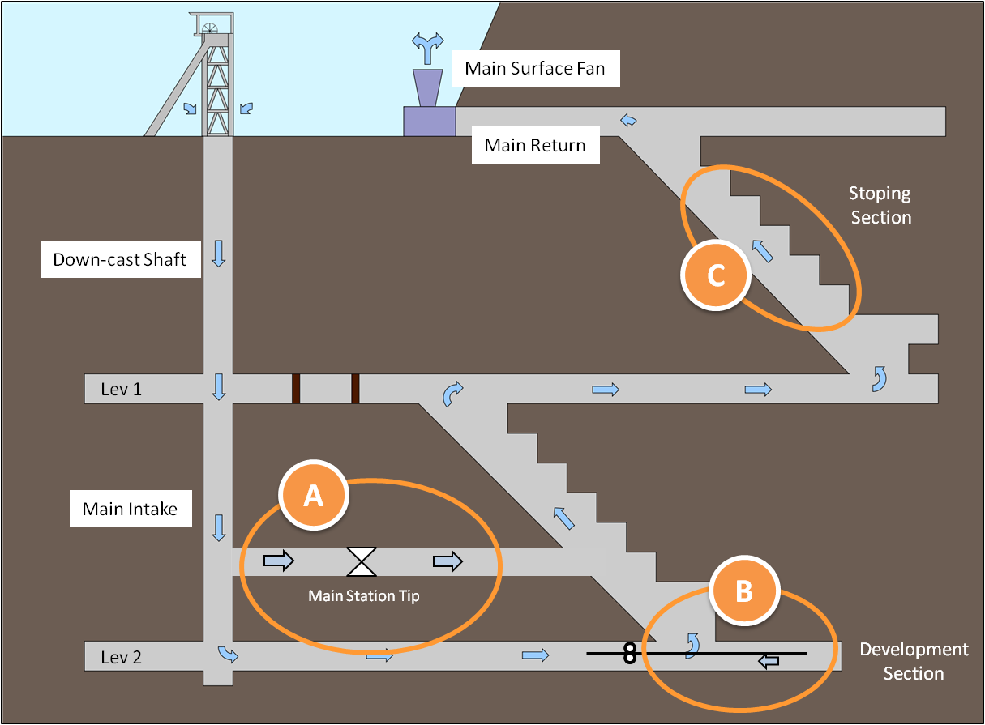

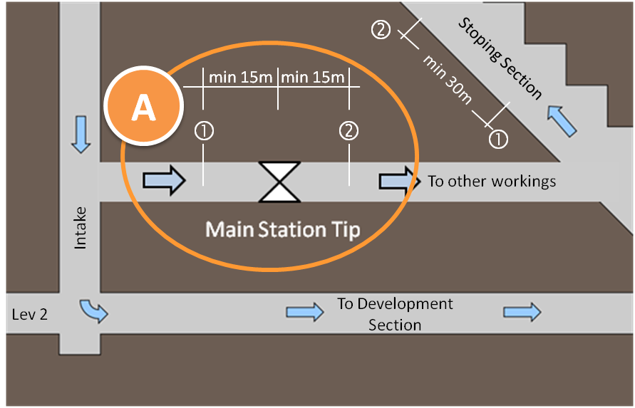

Kopanang - source mine

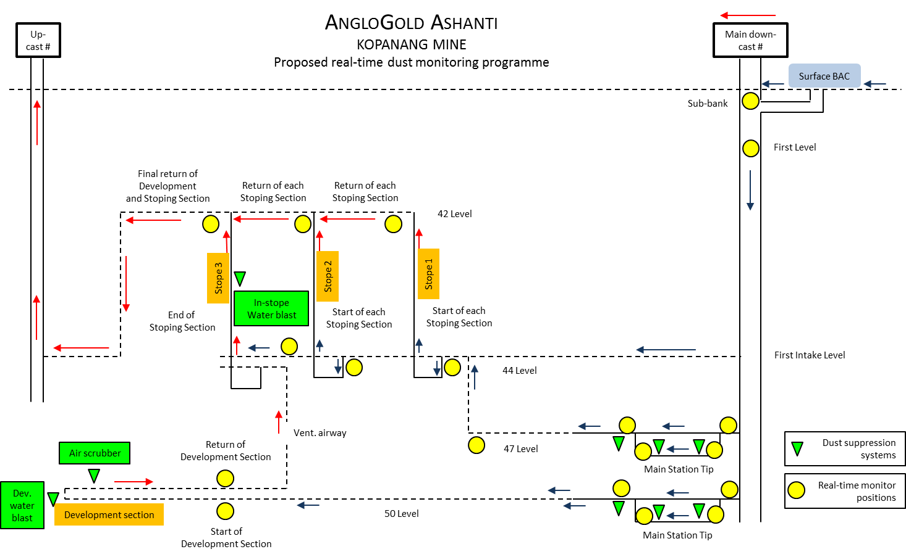

*“The diagram above depicts a typical underground gold mine operation however, the practice has huge potential at coal mines, platinum mines, diamond mines, processing mining plants or wherever there is a need of real-time monitoring. Therefore the design will differ from operation to operation. The important factor is to apply* ***the principle*** *of Continuous Real-time Monitoring of Airborne Pollutant Engineering Controls”.*

* 1. **PROBLEM ADDRESSED** (exposure to airborne pollutants)

In addressing the problem of exposure to airborne pollutants a risk based approach must be used as shown below taking cognisance of the dust “expert model”:

**BASIC DUST EXPERT MODEL**: (detailed version attached and explained later in *Part 3* in this document)

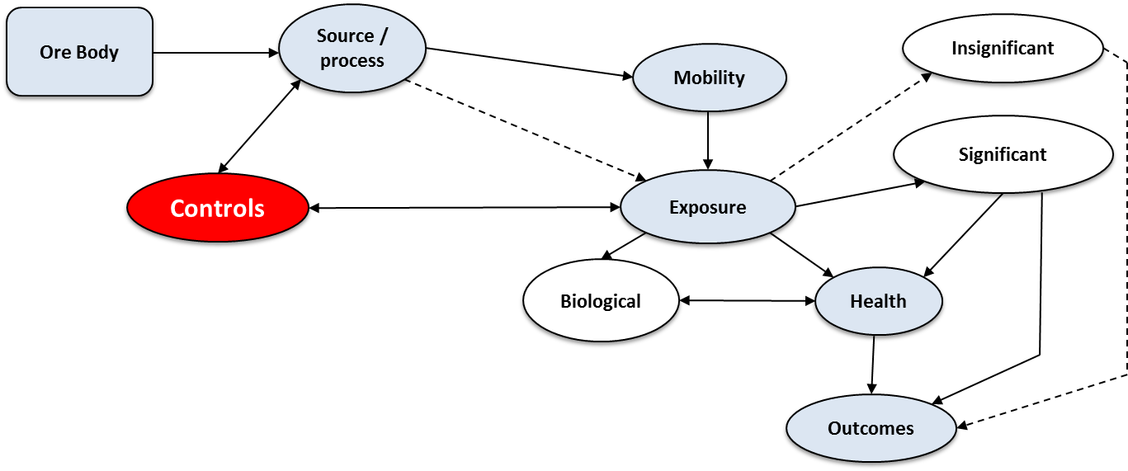

The industry expert grouping identified that:

* Controlling dust at source and
* Monitoring of engineering controls

will have the highest impact with the greatest potential.

Start

ID Area

ID Activity

ID potential source/s

**No significant exposure**

Report and Review

**Significant exposure**

Measure exposure

Compare to OEL or mine standard

No significant exposure

Significant exposure

Can the risk be eliminated?

Implement control

Compare to OEL or mine standard

Significant exposure

No significant exposure

Eliminate the risk

Are controls utilised:

* Maintain
* Inspect
* Test
* Follow-up

Continuous real-time monitoring

**IDENTIFICATION**

**EVALUATION and ANALYSIS**

**CONTROL**

**MONITORING**

Measure exposure

This practice incorporates work from the Mine Health and Safety Council (MHSC)’ Safety in Mining Research Advisory Committee (SIMRAC) Project ‘*03 06 03 Track B: Environmental and Engineering Controls’ where applicable.*

**THE RISK ASSESSMENT PROCESS**

The following process can be used to determine areas for continuous real-time monitoring:

**START**

Sub-divides mine into Area Sampling Districts

Sub-divides Districts into Activity Areas

Review existing controls in each Activity Area

Multiple airways - Air splits

Single airway

Compare results with legal limits or mine standard

Determine dust load at each split

Determine if continuous real-time monitoring required or not

Determine the cumulative dust load of airways

Determine the 1classification bands for area/activity

Determine the dust load for activity / area

Determine the 1classification bands for area/activity

**1Classification Bands**

**Category Personal Exposure Level**

**A** Exposures ≥ the OEL or mixtures of exposures ≥1 mg/m³

**B** Exposures ≥ 50% of the OEL and < OEL or mixtures of exposures ≥ 0,5 mg/m³ and <1 mg/m³

**C** Exposures ≥ 10% of the OEL and < 50% of the OEL or mixtures of exposures ≥ 0,1 mg/m³ and < 0,5 mg/m³

##### 1Ref: Mandatory Code of Practice for the Assessment of Personal Exposure to Airborne Pollutants (current)

* 1. **SUMMARY OF DOCUMENTED PERFORMANCE AND**

**IMPACTS**

**Kopanang - Source Mine**

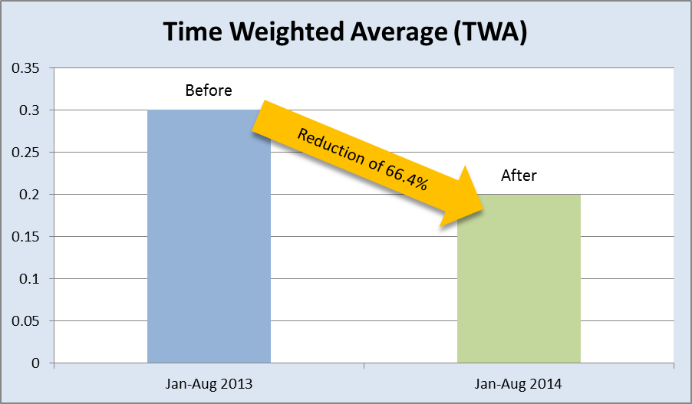

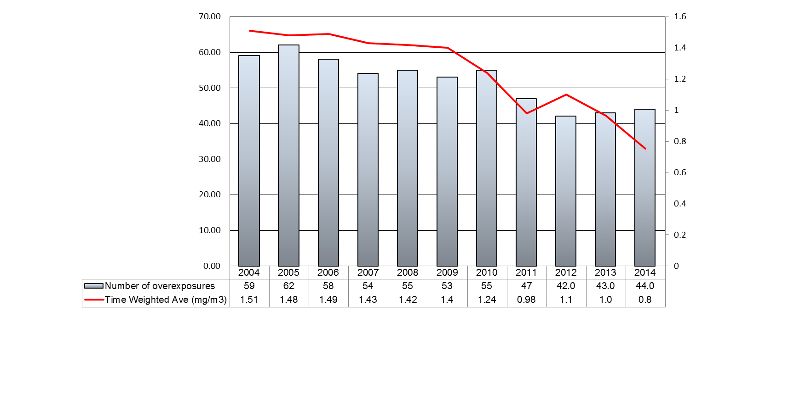

**New Vaal Colliery**

The average annual workers’ exposure to respirable coal dust is shown below. The improvement from 2010 on can be attributed to the introduction of the Real-time monitoring of the effectiveness of the dust controls at the Primary Tip. This is an 85% improvement between sampling results (annual averages) for 2010 and 2014. The 2014 figure is the average, year to date.

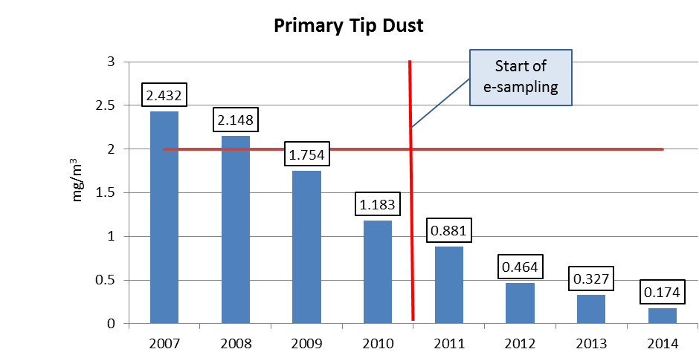

* 1. **SUMMARY OF THE GENERIC VALUE CASE**

|  |  |  |
| --- | --- | --- |
| **Issue** | | **Details**  *Note:*  *Costs will be influenced by the following factors:*  *Various instruments/monitors are available at different costs. The adoption mine/operation will determine the most suitable one to address their need. Price ranges between R45 000 to R105 000 per instrument/monitor excluding transmitter price.*  *Availability of “back-bone” on mine – this is the telemetry system (SCADA, fire detection**network, wireless etc).* |
| 1 | **Initial cost**  *(source mine)* | 18 Instruments were installed at a cost of R45 000 per instrument.  18 Transmitters had to be installed at a cost of R6 000 per 4 transmitters provided they are not more than 150m apart. (If more than 150m, a new transmitter is required).  Fire detection electric cable was installed at a cost of R28 p/m. |
| 2 | **Operational costs** | No measurable increase in operational costs have been identified |
| 3 | **OHS benefit** | The risk of silicosis to all underground employees who are most at risk will be very significantly reduced. The source mine has achieved a 66.4% reduction in total dust exposure. This is of real value to both workers and management. |
| 4 | **Progress towards zero harm** | Death from silicosis caused by excessive exposure to silica dust is the greatest cause of mortality in mine workers. Reducing this risk to underground employees will constitute a significant step towards achieving the ultimate goal of zero harm |
| 5 | **Improved working relationships** | Implementation of the behavioural communication and leadership behaviour plans has the potential to significantly improve the operational working relationship between supervisors and their staff |
| 6 | **Buy-in and support** | The mine-wide intervention in the interests of protecting the health of those most at risk will help engender buy-in and support for the intervention, and of employees for management  ***Extract from Mine Health and Safety Act:*** *section 5. (1)*  *As far as is* ***reasonably practicable****, every* ***employer*** *must provide and maintain a working environment that is safe and without* ***risk*** *to the* ***health*** *of e****mployees****.* |
| 7 | **Legal compliance** | The continuous real-time monitoring of engineering dust controls will assist in meeting regulated maximum dust exposure levels. It will also be a good case of management doing what is *reasonably practicable* to provide and maintain a working environment that is safe and without risk to the health of underground employees. |
| 8 | **Reduced compensation** | In the longer term the mining industry, including the mine, will benefit from a reduction in compensation and other costs associated with silicosis. |

**METHODOLOGY**

**PROCESS FLOW OF THE PRACTICE**

* 1. **CRITICAL SUCCESS FACTORS**

|  |  |  |  |  |
| --- | --- | --- | --- | --- |
| Identification of critical issues and potential unintended consequences at industry level | | | | |
| No | **Critical issues / Unintended consequences** | **Assessment of urgency for action (high – moderate – low)** | **Possible mitigating action** | **Possible pre-emptive communication** |
| Affecting workers | | | | |
| 1 | Early engagement | High | Ensure that workers are briefed through the Health and Safety Structures | We as a mine are serious about taking care of the health of our workers in terms of reducing the effect of airborne pollutants |
| Risk specific group (airborne pollutant team) | | | | |
| 2 | Lack of awareness and understanding of the problem | High | Establish sub teams within the mine Health and Safety Structure to assist with awareness and adoption plan  Give continuous feedback to workforce on progress and impact achieved (closing the loop) | Appoint people to form part of the sub-committee |
| Senior Management | | | | |
| 3 | Lack of commitment and support towards health related issues | High | Senior management should “walk the talk” and ensure a multi-disciplinary sustainable approach is embedded.  LIVE your company’s and personal values of caring | It is a requirement in terms of the MHSA and the CTF and the tri-partite milestones. |
|  |  |  |  |  |
|  |  |  |  |  |