

L E A R N I N G H U B

**WINCH COVERS**

**ADOPTION**

**BRIEF**

First Draft 31st May 2013



**Draft 1**

**CHAMBER OF MINES OF SOUTH AFRICA**

*Putting South Africa First*



**BACKGROUND COMMENT**

Winch operators have been identified across industry as the highest exposed occupation to silica dust. The winch cover specifically addresses the reduction in over exposure of this occupation by 50% by covering the winch guard drum.

**The following guidance notes will assist adoption mines with their adoption of the SLP:**

1. The dimensions of the winch covers must take into account the existing winch designs – winches are not of the same dimensions.
2. The Engineering department must take responsibility for determining the specifications.
3. Availability of water to wash the cover in order to remove clogged dust.
4. A properly aligned winch makes it easy for the Operator to see the drum and avoid the rope entangling.

**There should be NO reason why not to consider adopting winch covers to reduce over exposure to winch operators:**

1. **DESCRIPTION OF THE SIMPLE LEADING PRACTICE**

Scraper winch machinery, are generally considered to expose their operators to an increased dust load; and operating them is ranked among the top 6 occupations potentially at high risk for hard rock mines (Stanton et al, 2006).

The principle of winch cover ensures that the winch drum guard (Fig 1) of existing winches are covered using a non-flammable material (Fig 2) that conforms to SANS 971 and also with the DMR guideline for the compilation of a mandatory code of practice for the safe use of conveyor belt installations for the transportation of mineral, material or personnel (Reference number: DMR 16/3/2/2-A8).

Before After

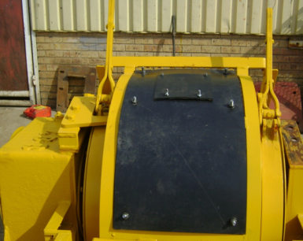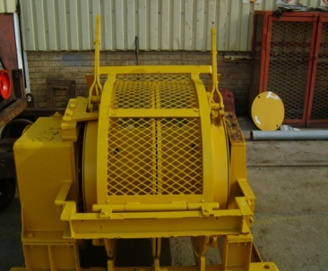

-Fig 1- -Fig 2-

Existing winces underground can be retro fitted with the cover by the Environmental Engineering Department. All replacement winches be it new or from maintenance is equipped with the cover according the mine specifications by the original equipment manufacturer prior to be sent underground.

1. **DOCUMENTED BENEFITS TO DATE**

Following the installation of the winch cover an average improvement of 50% reduction in aerosol particles was achieved using a spot sampling instrument (side pack). The samples were taken at the breathing zone of the operator over a ten minutes sampling period per samples.

The results are illustrated in graph below:

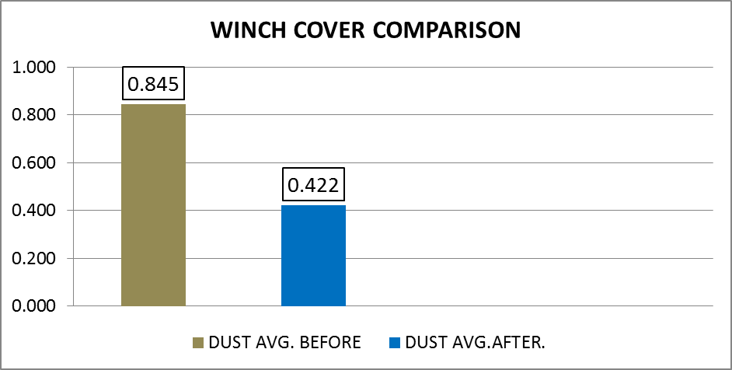

1. **SUMMARY OF GENERIC VALUE CASE**

**INITIAL COST TO IMPLEMENT THE PRACTICE**

This intervention is cost neutral as materials used are from mine stock (from source mine)

|  |  |  |  |
| --- | --- | --- | --- |
| **Item** | **Cost/unit/annum** | **No. of units installed** | **TOTAL COST per annum** |
| *Equipment maintenance costs (per unit) | Cost neutral | - | - |
| **Materials and other consumables (conveyor belt, bolts and nuts) | Cost neutral | - | - |
| **TOTAL** | | | **Cost neutral** |

*No maintenance costs have been incurred since the installation of the winch covers

** Redundant conveyor belt used – bolts and nuts are from mine stock

**Note:**

Should the supplier fit the winch cover to replacement and/or new winches the additional cost will be R2500 per winch.

**OTHER IMPACTS OF SIGNIFICANT BUSINESS VALUE**

|  |  |
| --- | --- |
| Detail | Comment |
| Improved stakeholder relationships internally | Improved health and safety relations and mines on diseases and simple intervention.  Greater investor attraction |
| Buy-in and collaboration from all stakeholders | Tripartite involvement and approval |
| A more positive relationship between all levels at the mine | People generally want to know that their health are being looked after |
| Progress towards zero harm culture | Very much in line with industry commitment |
| Less risk of management conviction | Reducing the exposure of individuals will result in less risk of conviction |
| Easier recruitment and retention of staff and customers | Operating a winch as an occupation will move from ranged as the highest occupation of contracting occupational lung diseases (e.g. silicosis) to medium and thus well being of operators. |
| Improved relationship with communities surrounding mines | Potential for better understanding and good relations among families of operators |
| A much healthier and productive workforce | Yes – refer to “Moral Obligation” below |

**MORAL OBLIGATION**

*The most important accomplishment of dust preventive measures is that silicosis is becoming a negligible factor, and that in the future it will largely be stamped out’* Wrabitz V, 1939cited in: Wagner (1995),the inexcusable persistence of silicosis. Many decades later, the optimistic views of Wrabitz (1939) are negated by the reality that silicosis is still prevalent. According to the Chief Inspector of Mines, respiratory diseases caused more deaths than mine accidents in 2003-2009 (7 800 versus 1 800). Whatever the numbers are, the most relevant take home message is that occupational lung diseases kill most workers and many others die a slow death.

The dominant components of the solution are substantial commitment to prevention and a culture of health rather than just more treatment and cure.

The health cost conundrum can be impacted by reducing the burden of occupational lung diseases and health risk in mining populations, thereby improving the health and productivity of the workforce, the health of the bottom line for engaged employers and ultimately the health of the mining industries’ economy. Ultimately, the broader value proposition of integrated mining population health and productivity enhancement should drive this approach by leveraging the value of health and the power of prevention.

1. **SUMMARY OF GENERIC BEHAVIOURAL ASPECTS (Generic book stuff and the mine as is)** 
   1. **Behavioural communication requirements**

|  |  |  |
| --- | --- | --- |
| No. | Issue / belief | Essence of required behavioural communication |
| 1 | No perceived personal benefit | The direct benefits to the operators of adopting the SLP must be clearly identified and communicated to them. The 50% reduction of silica dust inhalation must be clearly explained. |
| 2 | Potential negative impact on production | There should be no negative impact on production. |
| 3 | Extra work effort | There is no extra work involved |
| 4 | Short cuts to meet production targets | Not applicable |
| 5 | Trust and buy-in | Repeatedly emphasise to all supervisory levels the importance of regular dialogue with their staff |
| 6 | Leaders must lead by example | Leaders responsible for maintenance of the equipment must diligently ensure the equipment is maintained |
| 7 | Worker disregard for health and safety | Managers must regularly demonstrate their high regard for health and safety |
| 8 | Failure to implement training provided | Explain to supervisors that they must not allow sub-standard activity (maintenance) – they will get what they allow. They must provide constructive coaching or if necessary send the person for re-training |

**4.2 Leadership behaviour requirements**

|  |  |  |
| --- | --- | --- |
| Antecedents  (For desired behaviour) | Behaviours  (Desired for successful adoption) | Consequences  (For exhibited behaviour) |
| Operational adopters | | |
| * Operational training / instruction * Briefing before implementation * Regular SLP performance enquiries | * Operate SLP as instructed * No short cuts * Report any problems with SLP * Request explanations to ensure understanding | * Immediate positive feedback from supervisor on observing desired behaviour * Constructive coaching to address observed problems (no abuse) * Special recognition / reward for exceptional performance |
| First level supervisors | | |
| * Operational training / instruction * Briefing before implementation * Regular meetings with next level supervisor | * Regularly check on SLP performance * Ensure operators receive any necessary training / instruction * No short cuts on any safety related issue * Prompt action on any reported SLP problems * Provide immediate positive feedback on observing desired behaviour * Provide constructive coaching on observing sub-standard behaviour | * Immediate positive feedback from next level supervisor on observing desired behaviour * Constructive coaching to address observed problems (no abuse) * Special recognition / reward for exceptional performance |
| Second level supervisors (and any other levels if applicable) | | |
| * Briefing before implementation * Regular meetings with next level supervisor | * No short cuts on any safety related issue * Ensure that operators and supervisors receive any necessary training / instruction * Enquiry about SLP performance at regular meetings with supervisors | * Immediate positive feedback from next level supervisor on observing desired behaviour * Constructive coaching to address observed problems (no abuse) * Special recognition / reward for exceptional performance |

1. **STEPS FOR ADOPTION OF THE SIMPLE LEADING PRACTICE**

The following steps need to be taken to ensure proper adoption:

* Briefing of the Mine’s health and safety representatives.
* Address the entire workforce through the existing communication systems on the mine – management briefs, posters, underground waiting place discussions etc.
* Awareness training during induction of new employees and returnees from leave in particular the winch operator.

1. **GUIDANCE NOTES FOR ADOPTION OF THE SIMPLE LEADING PRACTICE**

The following guidance notes will assist adoption mines with their adoption of the SLP:

1. The dimensions of the winch covers must take into account the existing winch designs.
2. The Engineering department must take responsibility for determining the specifications.
3. Availability of water to wash the cover in order to remove clogged dust.
4. A properly aligned winch makes it easy for the Operator to see the drum and avoid the rope entangling.