MOSH Dust Adoption Team

Prepared by: Henry Moorcroft, Mike De Koker and Andries Mabona

**Reviewed by: ……………………………**

March 2011

REV 2

**Leading Practice Adoption Guide for the**

**Fogger Dust Suppression System**

***Eliminating Silicosis in South African Mines***

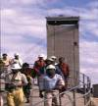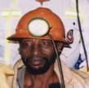

Copyright of the Chamber of Mines of South Africa

PO Box 1127

Marshalltown

2107

[www.bullion.org](http://www.bullion.org)

Qualification/Caution statement

Although the measures referred to in this document as “leading practice” have been demonstrated to provide health and safety benefits at some mines, it is important for every employer who considers adopting any of the practices in this document to do a proper risk assessment as envisaged in section 11 of the MHSA to ensure that any practices adopted will in fact be appropriate to address the relevant hazards and/or risks at that employer’s mine, having regard to the particular circumstances prevailing at the mine and at the locations where these practices will be adopted. The final decision on whether or not to adopt any practices set out in this document remains with the employer. It should also be noted that the practices in this document may only be aimed at addressing some of the aspects of a relevant hazard and/or risk and that the employer will need to have systems in place to ensure that the totality of the hazard or risk is addressed

**Executive Summary**

In December 2007, the Chamber of Mines of South Africa established the Mining Industry Occupational Safety and Health (MOSH) Leading Practice Adoption System to facilitate the achievement, by industry, of occupational safety and health targets and milestones. This process driven system approach identifies a potential leading practice at a mine (the source mine), tests and refines that leading practice, and then demonstrates it at another mine (the demonstration mine). Finally, the leading practice technology, together with a behavioural leadership and communication strategy, is disseminated throughout industry for adoption (at adoption mines) utilising the Community of Practice (COPA) mechanism.

In March 2008 industry experts identified an atomised water dust suppression system (the fogger dust suppression system) as one of the leading practices for addressing the risk of airborne respirable crystalline silica (RCS) dust. This system offered exceptional dust control at source, had broad applicability, offered easy maintenance and installation and had the potential to have a significant impact on a large number of employees when applied together with other silica dust controls.

The MOSH Dust Adoption Team, consisting of two full time members, secretariat and five part time members from different commodities and mining groups, commenced tests at the source mine, AngloGold Ashanti’s Great Noligwa Mine, to determine the efficiency of the system in reducing RCS dust. Trends since 2006 at Great Noligwa Mine had indicated a consistent reduction in respirable dust and suggested that a reduction in RCS dust was possible. During the source mine tests, a customised sampling protocol was designed to determine the reduction efficiency of the fogger dust suppression system and information was collated to support the value and business case.

This leading practice was then demonstrated at Gold Fields’ South Deep Mine, in terms of:

* the efficiency of the technology in reducing dust levels, and
* the effectiveness of a behavioural communication and leadership behaviour strategy in addressing the perceptions of key stakeholders and adopters about silica dust management, and thereby facilitating the adoption of the leading practice.

The fogger dust suppression system and associated behavioural communication and leadership behaviour strategy have now been established as a leading practice for industry-wide adoption.

The adoption process for the coal industry started after the establishment of the COPA and at the first meeting Matla Coal indicated that they would like to adopt this practice. The decision was taken the treat this adoption for Coal as a demonstration project similar to South Deep in order to take cognizance of the unique differences in the commodity.

The strategic context of this work is one of continuous improvement towards zero harm from silica dust to which Chief Executive Officers in the mining industry have duly committed. The objective of this document is to serve as a guide to decision makers and adopters to facilitate the adoption of technology whilst addressing the ‘people’ issues that aid the process. The scope of the identified leading practice is clearly defined.

The guideline is presented in four parts: the first part outlines the strategic context, the second part outlines the guidance on adoption of the leading practice at adoption mines and the third part provides the details of the leading practice that is to be adopted, including any reference or example material considered necessary. The fourth part documents the process and experience at Matla Colliery which potential adopters should take cognizance of.

**LEADING PRACTICE ADOPTION GUIDE: TABLE OF CONTENTS**

**Executive summary** 3

**Part 1 – Strategic Context** 9

**1.1** **The problem addressed** 9

**1.2** **Summary description of the practice** 13

**1.3** **Summary of documented performance and impacts** 16

**1.4** **The generic value case** 19

**Part 2 – Adoption Guide** 19

**2.1** **Ensure existence of a clear implementation decision by mine manager** 19

**2.2**  **Clarify potential for the mine to benefit – develop the value/business case for the mine** 21

**2.3** **Identify gaps and alignments (Mental Models)** 23

**2.4** **Identify project champion and team for implementation** 24

**2.5** **Identify adopters (supervisors/workers) and stakeholders (management/OHS Committee/Unions/Safety Reps)** 27

**2.6**  **Direct enquiry process** 29

2.7 Customisation of behavioural communication plan 31

2.8 Customisation of leadership behavioural plan 33

**2.9**  **Integration of behavioural communication and leadership behaviour plans into the implementation plan at the adoption mine** 35

**2.10** **Identify initial implementation site** 36

**2.11** **Briefing of adopters and stakeholders** 36

**2.12** **Visits to and or discussions with source and demo mines** 37

**2.13** **Arrangements for special assistance considered necessary** 37

**2.14** **Identification of any special training considered necessary** 38

**2.15** **Identification of key success factors** 38

**2.16** **Design of a monitoring programme** 38

**2.17** **Development of the implementation plan for the mine** 39

**2.18** **Implementation at the selected pilot site** 40

**2.19** **Identification and documentation of any customisation needed prior to extension across the mine** 40

**2.20** **Implementation of customisation** 40

**2.21** **Managing extension of the practice across the mine** 41

**2.22** **Completion of checklist to confirm adequate consideration of critical elements** 41

**Part 3 – Details of the leading practice** 41

**3.1** **Overview** 41

**3,2**  **Site Selection** 41

**3.3** **Equipment** 44

**3.4** **Installation of equipment** 45

**3.5** **Equipment maintenance** 49

**3.6** **Necessary supporting physical infrastructure** 50

**3.7** **Other Dust Control Measures** 51

**3.8** **Training** 51

**3.9** **Instruction documentation** 51

**3.10** **Signage** 52

**3.11** **Incentive arrangements** 52

**3.12** **Operational procedures** 52

**3.13** **Relevant mine standards** 53

**3.14** **Monitoring and reporting arrangements** 53

**3.15** **Performance measures** 53

3.16 Management of leading practice 53

**3.17** **Risk Management in implementing the system**. 54

**3.18** **Proprietary knowledge or technology** 55

**Appendix 13: Customising Leadership Behaviour and Behavioural Communication at Adoption Mines** 132

**Appendix 5: Behavioural Communication Plan for Adopters (Employees exposed to the Technology)** 148

**Appendix 7: Leadership Behaviour Plan** 149

**Appendix 12: Risk Analysis and the Preparation of Summary Risk Tables** 176

**Appendix 2: Mental Models Questionnaire** 181

Appendix 1: Project Charter 186

**Appendix 15: Mental Models established at the Demonstration Mine (South Deep Mine) for the Fogger-based Leading Practice** 187

**Appendix 6: Modalities of Communication** 193

**Appendix 3: Communication Brief** 199

**Appendix 4: Post On-site Communication Evaluation Questionnaire** 200

**Appendix 14: Integration of Behavioural Plans into the Overall Plan** 201

**Appendix 8: Implementation Project Checklist** 204

**Appendix 9: Modus Operandi – Standard Operating Procedure** 205

**Appendix10: Risk Assessment** 209

**LIST OF APPENDICES**

Appendix1:Behavioural Communication Pland for Adopters (Employees exposed to the Technology)143

Appendix 2: Leadership Behaviour Plan 144

Appendix 3: Customising Leadership Behaviour and Behavioural Communication at Adoption Mines 145

Appendix 4: Airborne Respirable Particulate Filtration Efficiency Test Protocol of GE Water & Process Technologies Spray System installed at Gold Fields South Deep Min 161

Appendix 5: Risk Analysis and the Preparation of Summary Risk Tables 169

Appendix 6: Mental Models Questionnaire 172

Appendix 7: Project Charter 177

Appendix 8: Mental Models established at the Demonstration Mine (South Deep Mine) for the Fogger-based Leading Practice 178

Appendix 9: Modalities of Communication 183

Appendix10: Communication Brief 189

Appendix 11:On-site Communication Evaluation Questionnaire 190

Appendix 12:Integration of Behavioural Plans into the Overall Plan 191

Appendix 13:Implementation Project Checklist 193

Appendix 14:Modus Operandi – Standard Operating Procedure 194

Appendix 15:Risk Assessment………………………………………………….………………...….196

**LIST OF TABLES**

Table 1: Levels of free crystalline silica dust content in South Africa mines 11

Table 2: Silica dust diseases certified by the MBOD for the period 1/01/2007–31/12/2007 12

Table 3: Milestones in the Leading Practice Adoption System 15

Table 4: Comparison between the reduction in respirable dust and quartzite with and

without the addition of a surfactant 22

Table 5: Value case for adoption the fogger dust suppression system at Great

Noligwa Mine (Courtesy JJ Havenga, December 2008) 29

**LIST OF FIGURES**

Figure 1: Silicosis at autopsy in gold miners, 1975 – 2006. The Surveillance Report:

Data and Disease Rates for January to December 2006 (produced by NIOH) 13

Figure 2: Scope of leading practice 18

Figure 3: Perceptions of workers about silica dust. (Adapted from SIM 030603, Track C) 19

Figure 4: Average TWA content and average silica dust content. (Source: Great Noligwa Mine OE Department, JJ Havenga) 21

Figure 5: Leading Practice Review Checklist. 26

Figure 6: Schematic representation of the seven steps in the behavioural communication process. 30

Figure 7: Summary of key points on Championship. 33

Figure 8: The schematic above shows a typical organisational structure for the adoption of a leading practice. Note the multidisciplinary nature of the team. 34

Figure 9: Schematic representation of stakeholders. 35

Figure 10: Eight step process developed for customising a behavioural and leadership communications strategy. The first step - identifying adopters and stakeholders - is highlighted. 36

Figure 11: Eight step process developed for customising a behavioural and leadership communications strategy. Steps 2 to 5 – the interview steps - are highlighted. 38

Figure 12: Eight step process developed for customising a behavioural and leadership communications strategy. Step 6 – customising the behavioural communication plan - is highlighted. 41

Figure13: Eight step process developed for customising a behavioural and leadership communications strategy. Step 7 – customising the leadership behaviour communication plan - is highlighted. 44

Figure 14: Eight step process developed for customising a behavioural and leadership communications strategy. Step 8 – integrating the customised plans - is highlighted. 45

Figure 15: Cross section showing typical fogger dust suppression system underground at a tip/ore pass installation. (Source: Envidroclear) 54

Figure 16: Plan view showing positioning of automatic detection units at a typical tip. (Source: Envidroclear) 55

Figure 17: A section of a vapour curtain with a close up of a nozzle. (Great Noligwa Mine; source Envidroclear) 58

Figure 18: Nozzles emitting fine water sprays. (South Deep Mine; source Envidroclear) 58

Figure 19: Fogger dust suppression system: schematic showing nozzle cluster configuration at a tip. (Source: Envidroclear). 59

Figure 20: Fogger dust suppression system: schematic showing fogger vapour curtain in a haulage for air scrubbing. (Source: Envidroclear) 59

Figure 21: Schematic showing nozzle configuration of clusters. (The above nozzle holders (risors) are omni-directional.) (Source: Envidroclear) 60

Figure 22: Plan view showing configuration of fogger dust suppression system in a small area opening tip. (Source: Envidroclear) 60

Figure 23: Plan view showing configuration of the fogger dust suppression system at a tip with a large opening area. (Source: Envidroclear) 61

Figure 24: Fogger dust suppression system pump, motor and mixing pump. (Source Envidroclear) 63

Figure 25: Zone demarcation signage for the fogger dust suppression system. 65

**LIST OF ACRONYMS**

|  |  |
| --- | --- |
| CEO | Chief Executive Officer |
| COPA | Communities of Practice for Adoption |
| DME | Department of Minerals and Energy |
| EXCO | Executive Committee |
| H&S | Health and Safety |
| ILO | International Labour Organisation |
| KPA | Key Performance Area |
| MBOD | Medical Bureau of Occupational Diseases |
| MHSA | Mine Health and Safety Act |
| MHSC | Mine Health and Safety Council |
| MHSI | Mine Health Safety Inspectorate |
| MOSH | Mining Industry Occupational Safety and Health |
| MSDS | Material Safety Data Sheet |
| NIOH | National Institute for Occupational Health |
| OE | Occupational Environment |
| OEL | Occupational Exposure Limit |
| OEM | Original Equipment Manufacturer |
| OH&S | Occupational Health and Safety |
| PPE | Personal Protective Equipment |
| RCS | Respirable Crystalline Silica |
| RPE | Respiratory Protective Equipment |
| SIMRAC | Safety In Mines Research Advisory Committee |
| TWA | Time Weighted Average |
| WHO | World Health Organisation |

**LIST OF DEFINITIONS**

Section 12 Appointee: *An occupational hygienist engaged in terms of section 12.1 of the Mine Health and Safety Act, and qualified in specified occupational hygiene techniques to measure levels of exposure to hazards in a mine.*

Time Weighted Average (TWA): *The average value of exposure over the course of a specified number of hours.*

Respirable Dust: *The proportion of an airborne contaminant which penetrates to the pulmonary alveolar (gas exchange) region of the lungs.*

Respirable Crystallline Silica (RCS): *Respirable crystalline silica that enters the body when dust containing a proportion of crystalline silica is inhaled****. Respirable crystalline silica*** *is the silica dust fraction which can be of concern to health when inhaled.*

Mental Models: *The tacit (working below the conscious level of thinking) webs of beliefs used by people to guide their decision-making and behaviour on various topics*.

Leadership: *All levels of employees in a supervisory capacity.*

**Part 1 – Strategic Context**

**1.1 The problem addressed**

As crystalline silica (quartz) is a component of nearly every mineral deposit and is at least a component of almost every rock type, exposure to silica dust is prevalent in many mining operations, but in varying degrees.

In particular, the respirable dust generated in gold mining often has higher quartz content than that experienced in other mining operations due to the nature of the gold bearing reef. Such reef has a hard conglomerate of quartz pebbles cemented together by an equally hard siliceous matrix. ***Table 1*** gives an indication of the levels of free crystalline silica dust content in South Africa mines. This shows that gold mines have the highest silica content levels which range between 9 % and 39 %, while, in platinum mines, the silica content of the ore is much lower (at less than 1 %). This finding is borne out by airborne respirable dust samples collected in the gold mines which have a silica content of between 5 % and 57 %, while those collected at platinum mines have less than 0.2 %.

***Table 1*** also shows that coal dust contains less than 5 % of quartz but this can increase up to 10 % in some coal mining processes. In South African diamond mines, airborne respirable dust generally has a low silica content, reported to be less than 5 % in drilling dust[1].

|  |  |  |  |  |
| --- | --- | --- | --- | --- |
|  | **Gold** | **Platinum** | **Coal** | **Diamond** |
| **Silica content in ore body** | 9-39 % | <1 % | < 3.5 % | - |
| **Silica content in airborne respirable dust** | 5-57 % | <.2 % | <5 %  Up to 10% under certain conditions | <5 % in drilling dust |

**Table 1:** **Levels of free crystalline silica dust content in South Africa mines.**

Furthermore, in the South African mining industry, there is a particularly vulnerable population as there is a strong association between silicosis and tuberculosis (TB), the latter being exacerbated by the high prevalence of HIV/AIDS as well as tobacco smoking. Both RCS dust exposure and established silicosis increases the risk of TB and this risk persists long after exposure to silica dust ends.

In 1995, the Leon Commission of Enquiry into Safety and Health in the Mining Industry stated: “The Commission is of the opinion that dust levels have remained roughly the same over a period of about 50 years. This constitutes *a priori* evidence that the absence of a downward trend in the official figures for certification is correctly interpreted as a failure to control dust related disease.”

The legacy of inadequate control of RCS dust is reflected in the number of silicosis cases and other silica dust diseases such as pulmonary tuberculosis (PTB) that are diagnosed and certified annually. ***Table 2*** presents the number of cases certified by the Medical Bureau of Occupational Diseases (MBOD) in 2007 and published by the Mine Health and Safety Inspectorate (MHSI). This shows more than 6000 certified cases of silicosis and TB, with the majority of cases being in the gold sector.

|  |  |  |  |
| --- | --- | --- | --- |
|  | **Silicosis** | **PTB** | **Silico-TB\*** |
| **Gold** | 1620 | 3812 | 518 |
| **Platinum\*\*** | 24 | 358 | 0 |
| **Coal\*\*** | 9 | 127 | 5 |
| **Diamond** | 9 | 9 | 0 |
| **Other** | 11 | 176 | 2 |
| **Total** | **1673** | **4482** | **525** |

*Table 2: Silica dust diseases certified by the MBOD for the period 1/01/2007 – 31/12/2007[2].*

*\* Pre-existing silicosis has a fourfold increased risk for acquiring TB, and when this occurs the condition is termed silico-TB.*

*\*\* Employers are liable to provide statistics on the number of occupational diseases submitted under the Occupational Diseases in Mines and Works Act (ODMWA) of 1973, to the DME on an annual basis. The MBOD subsequently assesses and certifies these cases.*

In 2008, the National Institute for Occupational Health (NIOH), in its Pathology Division’s Surveillance Report: Demographic Data and Disease Rates for January to December 2007, documented a rise in the prevalence of silicosis at autopsy in the country’s gold miners. It reported that the rate of silicosis at autopsy in gold miners had increased from 191 per 1000 miners in 2000 to 316 per 1000 miners in 2006, as illustrated in ***Figure 1***. This trend is attributed mainly to workforce stabilisation with workers converting from short term employment to longer term employment on the mines, resulting in increased exposure. Increasing age of workers also contributes in part to this trend. A similar trend could be demonstrated for prevalence rates of silicosis, estimated to be at approximately 20 % among older in-service mine workers, a significant “epidemic” in mining terms.



**Figure 1: Silicosis at autopsy in gold miners, 1975 – 2006. The Surveillance Report: Data and Disease Rates for January to December 2006 (produced by NIOH)**

**Chronology of events (summarised in Table 3):**

* In 2003, at the Mine Health and Safety Summit, the following targets and milestones were agreed upon for the mining industry in terms of silica dust measurements and silicosis:
* By December 2008, 95 % of all individual silica dust measurements must be below the occupational exposure limit of 0.1 mg/m3.
* After December 2013, there must be no new cases of silicosis in previously unexposed individuals, using current diagnostic methods.
* In 2004, in line with the International Labour Organisation (ILO) and the World Health Organisation’s (WHO) Global Programme for the Elimination of Silicosis, South Africa’s Labour Minister, Membathisi Mdladlana, launched the National Silicosis Control Programme which outlined the commitment of the South African Government to significantly reduce the prevalence of silicosis by 2015 and to totally eliminate silicosis in workplaces by 2030. The National Silicosis Control Programme comprises three elements: Part A: Dust Measurement and Reporting, Part B: Environmental Engineering / Dust Control, and Part C: Human Resources Training and Management.
* In 2005 the Chief Executive Officers in the mining industry signed an agreement through which they expressed the commitment of industry to continuous improvement towards zero harm from silica dust. This commitment was reinforced at the CEO Roundtable in September 2008.
* In 2006, a MOSH Task Force was established to determine the barriers and aids to the reduction of fatalities, occupational injuries and diseases on the mines and find sustainable solutions for the attainment of the 2013 targets and milestones.
* In 2007, the Task Force presented its findings that there were pockets of industry leading practice that had directly contributed to improved health and safety performance. If applied widely throughout the industry, they would contribute significantly to the achievement of the milestones.
* In 2008, the MOSH Leading Practice Adoption System was piloted. Three adoption teams were established to identify and facilitate the industry-wide adoption of leading practices to address the risk of dust, noise and falls of ground, respectively. Industry experts identified an atomised water dust suppression system (the fogger dust suppression system) as one of the leading practices for addressing the risk of RCS dust. This system, together with an appropriate behavioural communication and leadership behaviour strategy, was demonstrated at Gold Fields’ South Deep Mine, and is now established as a leading practice for the control of airborne RCS dust.
* In 2009, Communities of Practice for Adoption (COPAs) and a Learning Hub within the Chamber of Mines were established, the latter to serve as the vehicle to promote further adoption in industry.

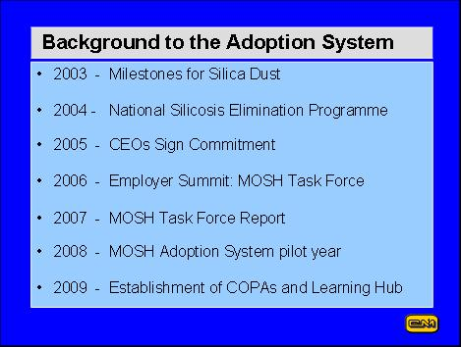

**Table 3: Milestones in the Leading Practice Adoption System.**

The historic and significant challenge of dust control in general is well documented in Kissels’ handbook for dust control in mining.[3]: “If controlling dust were a simple matter, dust problems in tunnels and mines would have been eradicated years ago. Unfortunately, most underground dust control methods yield only 25 % to 50 % reductions in respirable-sized dust. Often, 25 % to 50 % reductions are not enough to achieve compliance with dust standards. Thus, mine operators must use several methods simultaneously, usually without knowing for sure how well any individual method is working. In fact, given a 25 % error in dust sampling and day-to-day variations in dust generation of 50 % or more, certainty about which control methods are most effective can be wanting. Nevertheless, over the years, some consensus has emerged on the best dust control practices.”

The MOSH Dust Adoption Team acknowledges this historic legacy and is committed that, through the Adoption System, it will assist industry to make a difference to the working environment by managing RCS dust exposure and its impact on workers more effectively.

**1.2 Summary description of the practice**

In 2008, at a planning workshop attended by industry representatives, more than 15 potential leading practices for RCS dust reduction were identified and prioritised, based on difficulty of adoption and extent of impact. A specifically designed fogger dust suppression system emerged as holding the most potential at that time.

Dust suppression has historically and predominantly relied on various applications of water, either to water down and suppress dust or to facilitate airborne capture of dust particles. Deployment of technology that is based on the principle that fine water droplets will bond with dust particles has enhanced the application of water for dust control. As demonstrated by the fogger dust suppression system, this technology has the potential to reduce RQS dust at source by 90 %[4]. This system is not meant to be a stand-alone system and other dust control measures, such as footwall treatment, cleaning of shafts, tip doors and covers and consistent maintenance of the equipment, enhance RCS dust management.

Specific principles in applying the fogger dust suppression system were identified as:

* The design and efficiency of the system is site specific and this must be based on a comprehensive risk assessment in which environmental dynamics are taken into account.
* The specifications of the technology must be met, including the nozzle size and pressure, and concentration of the surfactants.
* The technology has broad application, including at conveyors, haulages, belt transfer points, crushers, both surface and underground, and across all commodities.
* The tip area may not necessarily be the most suitable application for all mines. While 90 % effectiveness was demonstrated at the source mine, Great Noligwa, this was applicable for that specific site and environmental conditions and is not necessarily repeatable.
* The application of this technology does not negate other controls at tips such as downcasting, filtration units and bypass control chutes; rather it complements these controls.
* Other controls such as shaft cleaning, foot/side/hangingwall treatment and washing down are also complementary to reducing silica dust in the intake airways.
* While safety of the chemical (surfactant) has been established as outlined in the Mine Safety Data Sheet (MSDS), the combination of the chemical with water, silica dust particles and other airborne pollutants (agglomerate) is unknown. In the absence of data, MOSH cannot prescribe the use or non-use of the surfactants, and individual mines must liaise with the supplier.
* The use of respiratory protective equipment (RPE) in the fog by the tip attendant, for example, should be mandatory.

The MOSH Dust Adoption Team fully recognises that, while this technological solution has demonstrated effectiveness in reducing RCS dust at source, its success as a leading practice will depend on people – people at all levels of employment and their leaders at all levels. Formal research supporting development of the Adoption System showed that decades of emphasis and effort on technology transfer to improve safety and health performance had, in fact, produced little true transfer of technology or significant improvement in performance. Research also showed that the need was to realise adoption – not transfer – of technology and leading practice.

Adoption is a human activity and the two most powerful influences on adoption are behavioural communication and leadership behaviour. These are the two distinguishing features of the Adoption System and why it is so different from past approaches. Therefore, an appropriate leadership behaviour and behavioural communication strategy, deployed together with the technology, comprise the ‘leading practice’ that is being recommended for adoption across industry, as depicted in ***Figure 2***.

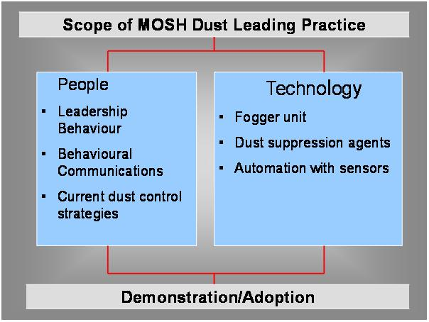

**ONE OF MANY LEADING PRACTICES**

**Figure 2: Scope of leading practice.**

Fundamental to the development of appropriate leadership behaviour and behavioural communication strategies is an understanding of stakeholder and adopter perceptions with regard to RCS dust controls.

In a comprehensive study of mine workers, mine managers and health and safety (H&S) representatives, SIM 030603[5] identified the following, as illustrated in ***Figure 3***:

* employees at all levels have various misunderstandings about RCS dust sources, prevention, control and effects.
* personal protective equipment (PPE) applicability, availability, accessibility and effectiveness can be and generally are poorly understood.
* H&S representatives are not effective and are under-utilised.

This report further highlighted a general lack of trust in mine management and health services. Workers clearly had a feeling of helplessness and powerlessness when it came to their ability to influence silica dust control activities, with some responding that “nothing can be done to control dust or to change their situation” and weak self efficacy[6] prevailed amongst them. They felt that there were barriers such as bonuses and targets that prevented them from exercising effective RCS dust control.

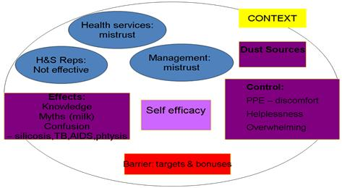

**Figure 3: Perceptions of workers about silica dust7. (Adapted from SIM 030603, Track C)**

On 26 August 2008, the Mine Health and Safety Council (MHSC) stakeholder seminar SIM 030603, Track C research outcomes were summarised as follows[7]:

* There is confusion regarding silicosis, TB, phthisis and HIV/ AIDS.
* There is a well established myth that ‘milk’ can flush out dust from the lungs.
* There is little understanding regarding the relationship between germs and disease.
* Workers feel powerless in the face of dust reporting that “there is no way to prevent it at all – dust will always be there”.
* The role of the health and safety representatives is unclear with only 8 % in the study reporting that dust control is a part of their job and only 3 % having been trained in dust control.
* There is a need for all employees to play a role in silica dust control.

In July 2008, MOSH conducted a mental models survey amongst all commodity groups and all levels of employees. Although a much smaller study sample (N=28), the results correlated well with the SIMRAC study. During the demonstration at Matla a new questionnaire was used to determine whether mental models have changed but the recorded results were similar and correlated with all previous work.

In summary, the findings of MOSH mental models survey and the SIMRAC research identified the following:

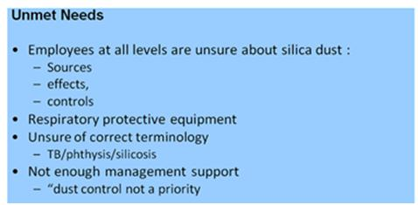

It follows that these perceptions must be addressed in any behavioural communication and leadership behaviour strategies. The strategies presented in ***Appendices 1 and 2*** have been developed to align with these research findings and respond to the unmet needs of the stakeholders and adopters of the demonstration mine. However, it cannot be assumed that these perceptions are a completely true reflection for all potential adoption mines. The perception of adopters and stakeholders at these mines must be determined in order to customise the behavioural communication and leadership behaviour strategies for the specific adoption mine. A direct enquiry process is presented in Part 2 and in ***Appendix 3*** of this guide in order to establish the perceptions specific to the adoption mine.

**1.3 Summary of documented performance and impacts**

The source mine, AngloGold Ashanti’s Great Noligwa Mine, had investigated and tested the fogger dust suppression system since 2000 following an increasing number of cases for silicosis. Following a number of refinements to the technology, they commenced, in 2006, documenting the results of the tests conducted at the mine, which revealed the following, as illustrated in ***Figure 4***[8]:

* A decreasing respirable dust trend; and
* Consistent occupational exposure levels (OEL) of silica dust below 0.1 mg/m3.

It was also reported that the application of fogger dust suppression system (used with a surfactant) resulted in a reduction in the respirable dust levels at the tip areas by between 35.7 % and 48.0 %. Furthermore, particle size analysis demonstrated the potential to remove airborne particulate in the range 0.766 µm – 26.11 µm at various efficiencies. These results strongly suggested that this system had the potential to reduce RCS dust at source at the tip area and the challenge was to prove this by conducting further tests at another site at Great Noligwa Mine.

***Figure 4*** shows a considerable decrease in the average Time Weighted Average (TWA) content and average silica dust content which, in the view of the mine, reflects the impact of the installation of the fogger dust suppression system at high risk sources (tipping and rock loading). However, cognisance must be taken of the fact that these results may also include the impact of an awareness strategy initiated by the mine in 2002.

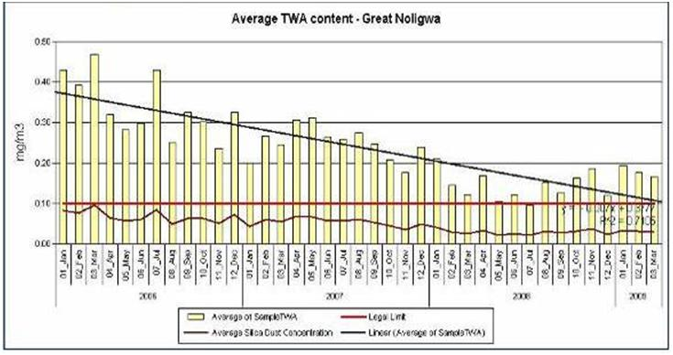

**Figure 4: Average TWA content and average silica dust content.**

**(Source: Great Noligwa Mine OE Department, JJ Havenga)**

In April 2008, a study was conducted by the MOSH Dust Adoption Team to determine the filtration efficiency of the fogger dust suppression system installed at the 70 level station tips at Great Noligwa Mine.

The objectives were to:

* establish the overall improvement in airborne respirable particulate concentrations, entering the 70 level main intake airway, and
* assess the performance of the fogger dust suppression system with and without the use of surfactants.

From the results, it was concluded that the utilisation of the currently installed fogger dust suppression system (with a surfactant added to the water) resulted in a reduction of:

* Respirable Dust Concentrations (RDC) by between 80.0 % and 86.2 %;
* Respirable Quartz Concentrations (RQC) by between 89.3 % and 90.5 %;
* Respirable Time-Weighted Average RQC by between 73.3 % and 76.6 %; and
* The particles in the range 0.0 μm to 10.097 μm by between 48.1 % and 50.1 %. (see footnote 4)

Functional specifications of the fogger dust suppression, that were required to achieve the demonstrated results at the tip area at Great Noligwa Mine, were established to be as follows:

* 0.2 mm orifice nozzles,
* 70 – 100 bar pressure.

These specifications resulted in a very fine water spray of a droplet size of 7 μm that enhanced the bonding between the water droplet and the silica dust particle. The addition of dust suppression agents to the fogger system, such as a surfactant, was demonstrated to minimally enhance the dust suppression efficiency (***Table 4***).

|  |  |  |  |
| --- | --- | --- | --- |
| **Measurement** | **No chemical added** | **Chemical added** | **Improvement** |
| Respirable Dust Concentrations  (RDC) | Between 68.3 % and 77.1 %  Average 73 % | Between 80.0 % and  86.2 %  Average 83 % | 10 % |
| Respirable Quartz Concentrations  (RQC) | Between 84.3 % and 89.2 %  Average 87 % | Between 89.3 % and  90.5 %  Average 90 % | 3 % |

**Table 4: Comparison between the reduction in respirable dust and quartzite with and without the addition of a surfactant. (Source: MOSH report: KDOHC. Final report 70 level Great Noligwa Mine. Airborne respirable particulate filtration efficiency test. 20 September 2008)**

Automation with sensors ensured that optimal airborne capture was possible with the unit starting to operate before a tip started, when the orepass upcasted or if rocks fell from a level above the tip, and continuing to operate for a short while thereafter.

Subsequently, the leading practice was demonstrated at South Deep Mine in terms of both the efficiency of the technology in reducing dust levels and the effectiveness of a behavioural communication and leadership behaviour strategy. This strategy was aimed at key stakeholders and adopters to address their perceptions about silica dust management and facilitate the adoption of the system.

The fogger dust suppression system was demonstrated at two sites at South Deep Mine. The first site was located at the tip on 95 level where a GE Betz unit was installed. Testing at this site yielded inconclusive results due to technical faults, fluctuating airflow in the tip, a low mass of dust captured in the samplers and a very low level of silica dust present in the intake air. However, a specifically designed sampling protocol (see ***Appendix 4***) was used for these tests and for the tests by the MOSH Dust Adoption Team at Great Noligwa Mine that is in itself a leading practice[9].

The second programme of tests was conducted using the Envidroclear fogger dust suppression system at a site on 100 level. The sampling methodology used for this study was based on the National Institute of Occupational Safety and Health (NIOSH) method 7500. The tests illustrated that the average dust concentration at the return side increased by 29.8 % with the fogger dust suppression system in operation, compared to 171.5 % when no fogger dust suppression system was in operation. The conclusion drawn was that the leading practice is effective in capturing and reducing a significant amount of respirable dust emanating from the station tips.

**1.4 The generic value case**

The value case for adopting technological and people solutions to eliminate silicosis by 2013 is a moral, reputational and ethical one. "There is no excuse for the persistence of these deadly diseases in the world," Dr Igor Fedotov, of the ILO’s SafeWork Programme, has said. “There are technologies and practices available to prevent the disease.”

The return on investment in occupational health is impossible to accurately quantify, as is the true cost of the burden of silicosis on the individual, families, communities, social services, health services and the employer, both from an economic and a human, ethical and moral point of view. It is a foregone conclusion that everyone must do everything they possibly can, consistently and well, to achieve continuous improvement towards zero harm from silica dust.

**Part 2 – Adoption Guide**

**2.1 Ensure existence of a clear implementation decision by mine manager**

The decision for the implementation of the leading practice must be actively endorsed by the mine manager. This endorsement can be demonstrated by a number of means, including:

* inclusion of the leading practice in the long term strategic/mine and budget plans.
* committing the resources required to implement the leading practice by signing off the budget and plan summary.
* nominating and appointing a project champion and team to drive the process.
* agreeing to the reporting mechanism.
* inclusion of the leading practice and its monitored performance as a permanent item on executive committee (EXCO) meetings.

Adoption of the silica dust leading practice must be presented as a major occupational health priority that has the potential to significantly improve the occupational health performance of the company. The motivation thereof must be driven by a strong value case which extends beyond the financial costs outlined in 2.2.

A risk analysis/summary, as provided in ***Appendix 5***, is a useful tool for motivating the implementation of the leading practice to the management team. This risk summary provides a table of related factors as a causal chain. The summary covers a description of the causal chain (that is the nature of the hazard, exposure to the hazard and outcomes of exposure) as Part A, and an identification and description of the current risk mitigation controls and strategies (with identified improvement possibilities) as Part B.

The Leading Practice Review Checklist, presented below as ***Figure 5***, also provides an easy-to-use aid in assessing the applicability and motivating the implementation of the fogger dust suppression system for a potential adoption mine.



**Figure 5: Leading Practice Review Checklist.**

**2.2 Clarify potential for the mine to benefit – develop the value/business case for the mine**

The preparation of a well stated case to justify an investment by the mine in the leading practice needs to cover all issues that have significant business value, even if such issues are not readily quantifiable. The following are considered to be the key components of the value case.

* Occupational health and safety performance improvements
* *Illness incidence (all occupational health effects)*
* *Key lead indicators (as silica-related illnesses have long latency periods)*
* Financial benefit of occupational health and safety improvements
* *Hospitalisation and other medical costs*
* *Time off work*
* *Risk premiums*
* *SIMRAC levies*
* *All forms of compensation*
* *Management time devoted to enquiries, reporting and other communication*
* Initial cost to implement the new practice
* *Capital costs of purchasing and installing new equipment*
* *Access to intellectual property (software and other)*
* *Creation of new infrastructure (physical facilities, training and communication aids, etc.)*
* *Initial training of management, supervisory staff and workers*
* Direct impact of the new practice on operational costs
* *Human resource costs*
* *Routine training costs*
* *Equipment maintenance costs*
* *Materials and other consumables*
* *Outsourced service providers*
* *Power and water costs*
* Indirect operational impacts of the new practice
* *Productivity, both positive and negative effects*
* *Absenteeism*
* *Staff turnover*
* *Cost of regulatory intervention*
* Other valued business impacts
* *Improved stakeholder relationships internally and externally*
* *Reduced pressure to compel change by rule-makers and other key players*
* *Buy-in and collaboration from all stakeholders*
* *A more positive relationship between all operational levels on mines*

In addition to technical efficiencies and occupational health improvements, the value case for the fogger dust suppression system can be built on a strong foundation of enhanced costs and minimal electrical and water consumption. In ***Table 5,*** such information is presented on the fogger dust suppression system, derived from its application at Great Noligwa Mine (the source mine).

In operation and during maintenance, the fogger dust suppression system does not impact on production with no sliping[10], fans or ventilation pipes required. The area required for the pump and dosing tank is only 2 m².

Another advantage is the great flexibility of the fogger dust suppression system, as it is suited to and can be customised for different areas and various dust sources in a mine and is applicable to the different commodities. For example, a system can be designed to suit an individual tip by varying the spray header to suit the opening size, increasing the number of sprays to suit the dust load, and using different horizontal spray curtains and different triggering devices.

|  |  |
| --- | --- |
|  | **Fogger Dust Suppression System**  *System comprising 125 nozzles* |
| **Energy consumption** | * Decreased * 6 kW @ 2.5 hrs / 24 hr day |
| **Water consumption** | * Minimal * 10 l/min @ 150 min/day = 1,500 l/24 hr day for 125 nozzles |
| **Application** | * + Very flexible: intake airways, at tips, orepasses, conveyor belts, or as spray curtains in haulages, stopes and development ends * All commodities |
| **Installation** | * For typical installation at a tip requires approximately 7 days working in non-operational hours * No impact on production as can be installed in downtime hours |
| **Operation** | * Does not operate continuously and is activated automatically using   - infrared and sound sensors when trucks are tipping  - flowmeter when upcast airflow in orepass   * Easy modification |
| **Impact on dust reduction** | * 35 % - 96 % reduction in respirable dust * Potential to reduce < 10 micron particles * 90 % reduction of RCS |
| **Maintenance** | * Critical * Less – unit not operating continuously * Maintenance contract available from supplier with nozzles cleaned and chemicals topped up twice a week * Nozzles unblocked with no impact on the environment * Maintenance of fogger dust suppression system does not interfere with its operation as system is cleaned when no tipping is occurring * System can withstand conditions underground as constructed from high pressure stainless steel piping with brass connectors |
| **Impact on occupational environment** | * Not a noise source (pump <85 dBA) * Visibility slightly impeded by fog * Automated cut-off system in pump in case of pipe burst * No dust released during cleaning |
| **Cost to purchase and install** | * Cheaper * Installation by supplier as part of purchase cost |
| **Total capital cost**  Filter Unit  Fan x2/Electrical  Site Preparation  Ducting | **R220,000.00** |
| **Operating costs per/yr**  Maintenance  Replacement  Power  Water | **R54,508.00** |

**Table 5*:* Value case for adoption of the fogger dust suppression system at Great Noligwa Mine. (Courtesy JJ Havenga, December 2008)**

The Leading Practice Review Checklist, presented in 2.1 as ***Figure 5***, also provides an easy-to-use aid in assessing the applicability of the fogger dust suppression system for a potential adoption mine.

**2.3 Identify gaps and alignments (Mental Models)**

The adopters should be ready for and receptive to the behaviour modification that will be expected from them. This readiness must be assessed and addressed before adoption to identify the knowledge, attitudes and perceptions that will operate as aids or as barriers to adoption of the leading practice. ***Appendix 6*** presents the questionnaire that was used by the MOSH team to assess the mental models of the adopters prior to developing the leadership and behavioural communications strategy tested at the demonstration mine and provided as a generic strategy in this guide.

A direct enquiry process for identification of the gaps and alignments at adoption mines is outlined in section 2.7 and detailed in ***Appendix 3***, and includes templates for the interview process.

The identification of the unmet needs (gaps and alignments) is therefore an important first step in the process to arrive at a customised leadership and behavioural communication strategy. This strategy identifies the objectives, key messages of communication and the choice of communication modalities that translate into the required actions, as depicted in ***Figure 6***. The customisation process is outlined in ***Appendix 3***.

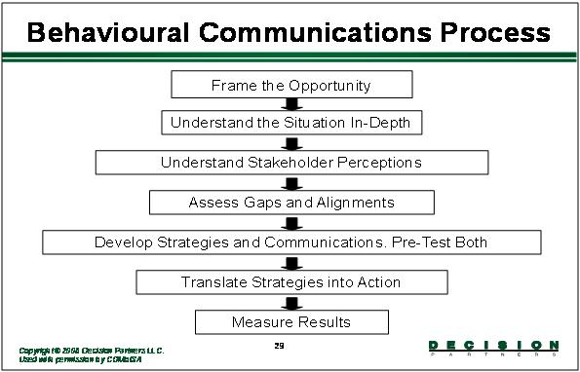

**Figure 6: Schematic representation of the seven steps in the behavioural communication process.**

As an example, based on previous mental models research (see 1.2) and the outlined behavioural communication process to be followed, some typical gaps and alignments are clear.

Gaps:

* Communication at all levels of employment is lacking.
* ‘Health’ issues are not high on the agenda.
* Leadership behaviours do not consistently promote a transformative culture when it comes to RCS dust control.

Alignments:

* People *and* technology are important.
* Top level executives are taking a firm stand.
* A culture of zero tolerance to silica dust control offences is beginning to creep into the workplace.
* Employees at all levels are eager and willing to be involved in their health as ‘health’ issues come to the fore.

The generic behavioural communication and leadership behaviour plans developed, and attached as ***Appendices 1 and 2,*** align with and respond to these research findings into the unmet needs of the stakeholders and adopters. This strategy is to be customised by the adoption mine in line with the findings of the direct enquiry process conducted on that mine and as outlined in ***Appendix 3.***

**2.4 Identify project champion and team for implementation**

A condition for adopting the leading practice should be that the mine will identify and appoint a person to champion application of the leading practice technology and people components. The mine should adequately free the appointed person from his/her operational responsibilities so that the role can be optimally fulfilled.

The primary purpose of appointing champions is to energise and spearhead the progressive growth in the adoption of the leading practice that they are championing. In essence, the mechanism of championship involves leadership to overcome implementation difficulties, as well as effective communication of relevant information to enable other operations to decide to adopt the leading practice.

A project champion should be appointed for the duration of the project. It is also recommended that the project champion undergo training in the adoption of a leading practice. This training programme developed for industry by the Learning Hub Adoption Team covers the concepts of the adoption system including behavioural communication and leadership behaviour.

The scope of work will be guided by a project charter as outlined in ***Appendix 7***. The mission, vision and objectives of the project will provide the framework for the key deliverables for the individual and the project team. A summary of the key points on championship is given in ***Figure 7.***

**2.4.1 Role profile of project champion[11]**

*Credibility:* An essential requirement for success is that the champion should be credible. This individual should preferably be someone linked directly to the Occupational Environment (OE) discipline and should be at a high level in the organisation. He/she should have good levels of knowledge, energy, leadership, communication skills and personal credibility.

*Involvement:* Having selected an individual with the right potential, it is essential that he/she be sufficiently released from normal operational responsibilities to adequately perform the function of championship. To do this, the person needs to become deeply involved in the details of the technology and people components of the leading practice, to appreciate the issues and problems, and to assist in, or be knowledgeable about their solution.

*Leadership:* An important role of the champion will be that of providing leadership in overcoming implementation problems that arise, and in particular to energise lagging aspects of the process. The champion should also provide input into the development of strategies and plans for the progressive adoption of the technology and or leading practice at both the mine and across industry.

*Communication:*  Perhaps the most important role that the champion needs to play is that of being an effective spokesperson for the leading practice being championed. To do this, the champion would accumulate key data and prepare appropriate documents and presentations to communicate such performance and technical data to interested parties. The champion would seek out opportunities to present such information, including workshops, conferences, technical journals, meetings of professional societies, internal meetings, and so on.

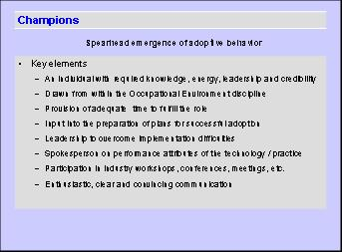

**Figure 7: Summary of key points on Championship4**.

**2.4.2 Project management team**

The adoption mine should appoint a project management team to plan and oversee the detailed execution of the project. The leader of the project team could be the champion, but this should not be a requirement. The champion should however be responsible for reporting progress on the project to all parties that have expressed an interest in receiving such information, particularly key people on the mine.

In 1958, DG Beadle at the Mine Ventilation Society Presidential Address stated that:  "...when we have found out ways of controlling or reducing all types of dust, when we are rigidly applying all these methods in all working places, when we have the active support of all mining personnel in tackling the dust problem - then I am convinced there will be no more pneumoconiosis in our mines." It follows that the project team must be multidisciplinary with OE specialists, engineers, occupational medical practitioners, training practitioners and labour representatives, as depicted in ***Figure 8***.

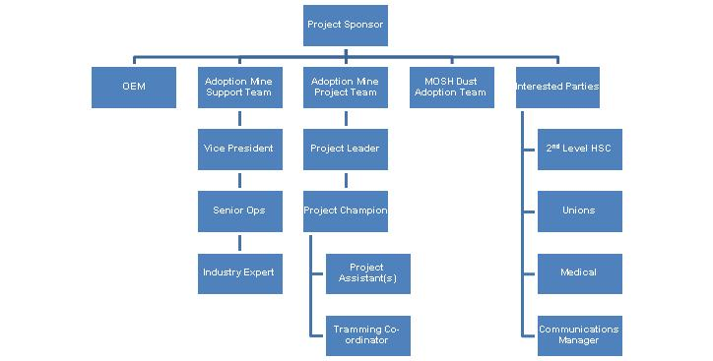

**Figure 8: The schematic above shows a typical organisational structure for the adoption of a leading practice. Note the multidisciplinary nature of the team.**

**2.5 Identify adopters (supervisors/workers) and stakeholders (management/OHS Committee/Unions/Safety Reps)**

In keeping with the principles of the leading practice adoption system, it is critical that people are involved at all levels of the adoption process. This includes the adopters (those people responsible for the technical aspects of the technology) and the key stakeholders (those people who will be impacted on by the technology).

The adopters of the technology are typically the mine managers, Section 12 Appointees, mine overseers, maintenance crew and workers. This category incorporates:

* those who have a primary or shared role in designing and implementing, and/or approving the design and implementation, of the implementation project. This includes the mine manager, Section 12 Appointee, engineering manager and supplier; and
* those who will be most affected by the system and could be involved in the management and/or the implementation of the implementation project. This includes the end users/adopters, who are those people who are responsible for the operational functionality of the technology.

The key stakeholders are those individuals or groups who have a stake in the issue but are not directly involved. These typically include the Department of Minerals Resources (DMR), labour organisations, Wellness Committees, H&S representatives, tertiary institutions and NIOH.

It is imperative that stakeholders and adopters are identified early in the process, as it is these people and groups who will be the focus of the behavioural communication and leadership behaviour efforts, and from whom commitment is required for the successful adoption of the leading practice. As is the case with any behaviour modification process, a change in attitude becomes a change in behaviour and, when sustained, becomes a new culture. It is this level of commitment that is required from adopters and stakeholders: to embrace the change that will lead to the elimination of silicosis.

Thus, in order to affect the desired paradigm shift, these stakeholders and adopters[12] as outlined above and in ***Figure 9,*** should first be identified. A shared understanding of their perceptions, attitudes and unmet needs regarding silica dust should then be gained, before designing and implementing a leadership and behavioural communication strategy to address these perceptions, attitudes and unmet needs.

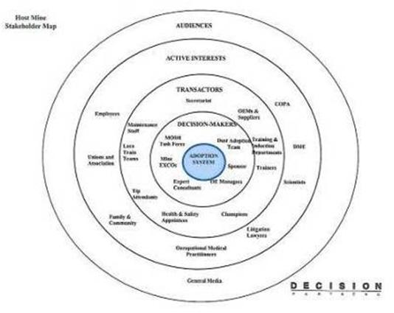

NIOH

**Figure 9: Schematic representation of stakeholders.**

The procedure for identifying adopters and stakeholders is the first step (see ***Figure 10***) in an eight step process developed for customising a behavioural and leadership communications strategy for implementation as part of the Leading Practice Adoption System. The process is described fully in ***Appendix 3.***

|  |  |  |  |
| --- | --- | --- | --- |
| **Step** | **What** |  | **Check – go/no-go decision question** |
|  |  |  |  |
| 1 | **Identify adopters and key stakeholders at the mine** |  | Do we have a good understanding and complete identification of potential adopters and stakeholders? |
|  |  |  |  |
| 2 | **Select people to be interviewed** |  | Have we chosen the appropriate people to interview? |
|  |  |  |  |
| 3 | **Identify and brief the interviewers** |  | Are the interviewers ready to interview? |
|  |  |  |  |
| 4 | **Conduct the interviews** |  | Have all the interviews been done and full worksheets completed and returned for processing? |
|  |  |  |  |
| 5 | **Summarise the interview results** |  | Have the interview results been systematically assessed and significant new findings clearly identified? |
|  |  |  |  |
| 6 | **Use the findings to customise the behavioural communication plan** |  | Are the customised plans coherent and properly understood by the mine team and can they be implemented and effectively monitored in behavioural terms? |
|  |  |  |  |
| 7 | **Use the findings to customise the leadership behaviour communication plan** |  | Are the customised plans coherent and properly understood by the mine team and can they be implemented and effectively monitored in behavioural terms? |
|  |  |  |  |
| 8 | **Integrate the customised plans into the implementation plan at the mine** |  | Is the overall implementation plan coherent and properly understood by the mine project team? |

**Figure 10: Eight step process developed for customising a behavioural and leadership communications strategy. The first step - identifying adopters and stakeholders - is highlighted.**

Key points for identifying adopters and stakeholders are as follows:

* The Adoption Mine Team should review the Risk Summary provided by the Lead Adoption Team (see ***Appendix 5***) and confirm or elaborate on the description of adopters and stakeholders.
* A list specifying the adopters and stakeholders who will be the focus of behavioural communication and leadership behaviour efforts in the adoption mine should be prepared by the Adoption Mine Team.

**2.6 Direct enquiry process**

Once the stakeholders and adopters have been identified, a shared understanding of their perceptions, attitudes and unmet needs regarding environmental management, and more particularly dust control, should be gained. This forms the basis for customising and implementing the leadership and behavioural communications strategy.

The only way to accurately understand people’s thinking is to directly enquire into it. A detailed description of how to conduct the enquiry process is provided in ***Appendix 3*** with key points highlighted below.

The interview process should consist of two parts that

* seek to establish the stakeholders/ adopters beliefs about the causes and outcomes of [the risk/hazard],
* about the best ways to protect people from [the risk/hazard], and
* about key leader behaviours and behavioural communication needs.

An appropriate type and number of persons should be interviewed using the final list of adopters and stakeholders at the adoption mine.

* The types of people selected should ensure good representation of those most likely to be most involved in accomplishing adoption of leading practice.
* The number of persons to be interviewed should be between 25 and 30 to obtain useful interview results.

Interviews with the selected adopters and stakeholders should be done confidentially and one-on-one with individuals.

Adoption mine teams should choose as interviewers those people whom interviewees are most likely to feel comfortable with in an interview setting. Interviewers should be self-briefed or trained in the interview to be conducted

The questions to be asked in the interview are provided in the example Worksheet #1 provided in ***Appendix 3***. Interview responses should be carefully documented at the time of the interview onto the Interview worksheet using the interviewee’s own words.

A simple analysis outlined in ***Appendix 3*** for summarising the interview results will allow the Adoption Mine Team to better understand the thinking of their stakeholders and adopters and to compare the thinking at their mine with the most informed understanding of the hazard, as summarised in the Risk Summary (see ***Appendix 5*** and the thinking of stakeholders at the demonstration mine (as summarised in ***Appendix 8***). The analysis worksheet is attached as worksheet #2 in ***Appendix 3,*** together with a recommended analysis procedure.

|  |  |  |  |
| --- | --- | --- | --- |
| **Step** | **What** |  | **Check – go/no-go decision question** |
|  |  |  |  |
| 1 | **Identify adopters and key stakeholders at the mine** |  | Do we have a good understanding and complete identification of potential adopters and stakeholders? |
| 2 | **Select people to be interviewed** |  | Have we chosen the appropriate people to interview? |
| 3 | **Identify and brief the interviewers** |  | Are the interviewers ready to interview? |
| 4 | **Conduct the interviews** |  | Have all the interviews been done and full worksheets completed and returned for processing? |
| 5 | **Summarise the interview results** |  | Have the interview results been systematically assessed and significant new findings clearly identified? |
|  |  |  |  |
| 6 | **Use the findings to customise the behavioural communication plan** |  | Are the customised plans coherent and properly understood by the mine team and can they be implemented and effectively monitored in behavioural terms? |
|  |  |  |  |
| 7 | **Use the findings to customise the leadership behaviour communication plan** |  | Are the customised plans coherent and properly understood by the mine team and can they be implemented and effectively monitored in behavioural terms? |
|  |  |  |  |
| 8 | **Integrate the customised plans into the implementation plan at the mine** |  | Is the overall implementation plan coherent and properly understood by the mine project team? |

**Figure 11: Eight step process developed for customising a behavioural and leadership communications strategy. Steps 2 to 5 – the interview steps - are highlighted.**

**2.7 Customisation of behavioural communication plan**

Behavioural communications[13] involves a process of skilful interaction or dialogue with identified adopters and stakeholders to attain a shared understanding of the problem. In doing so, the adopters and stakeholders can make better informed decisions and take appropriate actions to reduce risks. Communication modalities should explicitly focus on addressing people’s ‘mental models’ or people’s rationale for behaving in a specific way and in so doing effect behaviour change. Communication modalities that have the highest likelihood of encouraging desired health seeking behaviours should be endorsed.

Given the information, gaps and alignments established in previous research (see section 1.2) and for purposes of fast tracking adoption, the behavioural communication strategy must focus initially on the short term objective of10:

* Achieving 100 % awareness and understanding of silica dust sources, controls and effects amongst employees exposed to the technology.

In the medium to longer term, when more resources are available and where applicable, the following objectives can apply:

* To communicate the broad silica dust control strategy to 100 % of employees.
* To achieve 100 % awareness and understanding of the silica dust sources, controls and effects amongst all employees.
* To achieve 100 % awareness and understanding of the effectiveness and compliance with PPE usage.
* To achieve 100 % awareness of the technology and its context within the broad dust control strategy.

***Appendix 1*** provides a behavioural communication plan drafted by the MOSH Dust Adoption Team based on the research outlined in 1.2. The key modalities of communication were selected to address the stakeholders’ and adopters’ unmet needs and were either sourced or developed by the team; some examples (see ***Appendix 9***) include:

* MHSC milestones comic
* Gold Fields dust comic
* MHSC DVD
* Fogger dust suppression system signage
* Fogger dust suppression system pamphlet
* Comic page on the fogger dust suppression system
* Electronic learning slide

A Communication Brief is attached as ***Appendix 10*** for employees exposed to the technology, and is ideally circulated to the adopters by the Section 12 Appointee.

A post onsite communication evaluation survey is attached as ***Appendix 11*** for use in assessing the effectiveness of the behavioural communication strategy.

The generic plan provided in ***Appendix 1*** should be customised by each adoption mine based on the unique organisational culture and existing communication strategies at the operation.

The Adoption Mine Team should first ensure that they fully understand the plan developed for the demonstration mine, and its derivation, before proceeding with the process of customising the plan to suit their mine specific circumstances.

A detailed description of how to customise this plan is provided in ***Appendix 12,*** with key points highlighted below.

The Adoption Mine Team (or a designated plan preparer) should answer the following questions in customising the plan:

* What, if any, of the modes of communication in the demonstration mine’s behavioural communication plan should be included in the adoption mine’s plan?
* What, if any, of the content or key messages in the different modes in the demonstration mine’s behavioural communication plan should be kept in the adoption mine’s plan?
* What, if any, new content or key messages should be added to the behavioural communication plan for the adoption mine?
* Will these changes best match with the modes that should be used and key messages that should be conveyed in the adoption mine as revealed through the interview results?
* What is the best way to go about implementing the behavioural communication plan?

Considering the communication content of the new plan:

* From the interview results, what correct understandings about [the hazard] should be emphasised in communications?
* What incorrect beliefs or misunderstandings about [the risk/hazard] should be corrected through communications? What key messages should be emphasized in order to do so?
* What do people not know that is important to understand in order to fully appreciate the nature of [the hazard], and which should therefore be emphasised in communications?
* What information about [the risk/hazard] do people most want to know, and which should therefore be emphasised in communications?
* What sorts of messages should be emphasised to help people judge the trustworthiness and competence of their fellow employees and leaders involved in addressing [the risk/hazard]?

On the basis of the answers to the above questions, and the modes of communication available at the adoption mine, the Adoption Mine Team should adjust the modes and content of the base plan provided by the Lead Adoption Team.

Where new material is introduced into the plan, measurable objectives should be identified. These should be in the form of behavioural outcomes.

|  |  |  |  |  |  |
| --- | --- | --- | --- | --- | --- |
| **Step** | | **What** | |  | **Check – go/no-go decision question** |
|  |  | |  |  |  |
| 1 | | **Identify adopters and key stakeholders at the mine** | |  | Do we have a good understanding and complete identification of potential adopters and stakeholders? |
| 2 | | **Select people to be interviewed** | |  | Have we chosen the appropriate people to interview? |
| 3 | | **Identify and brief the interviewers** | |  | Are the interviewers ready to interview? |
| 4 | | **Conduct the interviews** | |  | Have all the interviews been done and full worksheets completed and returned for processing? |
| 5 | | **Summarise the interview results** | |  | Have the interview results been systematically assessed and significant new findings clearly identified? |
|  | |  | |  |  |
| 6 | | **Use the findings to customise the behavioral communication plan** | |  | Are the customized plans coherent and properly understood by the mine team and can they be implemented and effectively monitored in behavioral terms? |
|  | |  | |  |  |
| 7 | | **Use the findings to customise the leadership behavior communication plan** | |  | Are the customised plans coherent and properly understood by the mine team and can they be implemented and effectively monitored in behavioural terms? |
| 8 | | **Integrate the customised plans into the implementation plan at the mine** | |  | Is the overall implementation plan coherent and properly understood by the mine project team? |

**Figure 12: Eight step process developed for customising a behavioral and leadership communications strategy. Step 6 – customising the behavioral communication plan - is highlighted.**

**2.8 Customisation of leadership behavioral plan**

A leadership behavior plan (see ***Appendix 2***) was developed based on research findings outlined in 1.2, with the objectives:

* To ensure that health (silica dust in particular) is on every agenda of the mine EXCOs, and OE managers and supervisors.
* To achieve 100 % participation in and sustained drive for the MOSH Dust Leading Practice Adoption System.
* To achieve 100 % support of the broad silica dust control strategy.
* To achieve 100 % support by the employees for reporting non–conformance in dust control.

For purposes of the leadership behavior strategy, the stakeholders are identified as:

* EXCOs
* Section 12 Appointees
* Employees

These leaders should be engaged with at different levels, both informally and formally. The latter could comprise organised, scheduled meetings, held frequently at the beginning of the project to ensure and sustain buy in. Later in the project these meetings will serve as information forums. Supervisors at the workplaces should be informed about the project at first and second level H&S meetings.

A post site communication evaluation survey is attached as ***Appendix 11*** for use in assessing the effectiveness of the leadership behavior plan.

South Deep Experience

In communication evaluation surveys conducted at the demonstration mine, South Deep Mine, employees confirmed that they had heard about the milestones or the fogger dust suppression system from their supervisors. In fact, leadership was visible, such that employees reported that management was doing something to resolve the silica dust problem, contrary to previous research reports highlighting distrust in management11. Whether this was a direct result of MOSH or heightened awareness of silica dust problems is unknown.

A leadership behaviour plan developed for the demonstration mine is attached as ***Appendix 2*** to serve as the base plan to be customised by the adoption mine. The plan sets out the required antecedents, key leader behaviours and re-enforcing consequences for those behaviours. As with the behavioural communication plan, the Adoption Mine Team should ensure that they fully understand the plan developed for the demonstration mine, and its derivation, before proceeding with the process of customising the plan to suit their mine specific circumstances.

The adoption mine team (or a designated plan preparer) should answer the following questions in preparing the customised leadership behaviour plan:

* With respect to the stakeholders and adopters involved, who are considered to be the key leaders involved in accomplishing adoption of the leading practice?
* For each leader or type of leader, what key behaviours or actions must they perform to appropriately influence the decisions and actions of the stakeholders and adopters? (The set of Behaviours)
* What must the leaders be provided to enable them to perform these behaviours? (The set of Antecedents)
* What consequences – positive, immediate and certain – must follow performance of the key behaviours that will encourage them to be repeated and sustained? (The set of Consequences)
* What, if any, of the key behaviours, antecedents and consequences in the demonstration mine’s behavioural communication plan should be included in this mine’s behavioural communication plan?
* What, if any, of the key behaviours, antecedents and consequences in the demonstration mine’s behavioural communication plan should be omitted from this mine’s behavioural communication plan?
* What is the best way to go about implementing the leadership behaviour plan?

Where new material is introduced into the plan, measurable objectives should be identified.

|  |  |  |  |  |  |
| --- | --- | --- | --- | --- | --- |
| **Step** | | **What** | |  | **Check – go/no-go decision question** |
|  |  | |  |  |  |
| 1 | | **Identify adopters and key stakeholders at the mine** | |  | Do we have a good understanding and complete identification of potential adopters and stakeholders? |
| 2 | | **Select people to be interviewed** | |  | Have we chosen the appropriate people to interview? |
| 3 | | **Identify and brief the interviewers** | |  | Are the interviewers ready to interview? |
| 4 | | **Conduct the interviews** | |  | Have all the interviews been done and full worksheets completed and returned for processing? |
| 5 | | **Summarise the interview results** | |  | Have the interview results been systematically assessed and significant new findings clearly identified? |
| 6 | | **Use the findings to customise the behavioural communication plan** | |  | Are the customised plans coherent and properly understood by the mine team and can they be implemented and effectively monitored in behavioural terms? |
|  | |  | |  |  |
| 7 | | **Use the findings to customise the leadership behaviour communication plan** | |  | Are the customised plans coherent and properly understood by the mine team and can they be implemented and effectively monitored in behavioural terms? |
|  | |  | |  |  |
| 8 | | **Integrate the customised plans into the implementation plan at the mine** | |  | Is the overall implementation plan coherent and properly understood by the mine project team? |

**Figure13: Eight step process developed for customising a behavioural and leadership communications strategy. Step 7 – customising the leadership behaviour communication plan - is highlighted.**

**2.9 Integration of behavioural communication and leadership behaviour plans into the implementation plan at the adoption mine**

A list of envisaged key activities in implementing a leading practice at an adoption mine is given in ***Appendix 12***. Implementation of the customised leadership behaviour and behavioural communication plans needs to be either included as new activities or appropriately built into activities already identified as being necessary to implement the leading practice at the adoption mine.

A component of the integrated implementation plan should be a monitoring programme that includes appropriate checking and reporting on the occurrence of the desired observable behaviours, as well checking and reporting on provision of the necessary antecedents and re-enforcing consequences.

|  |  |  |  |
| --- | --- | --- | --- |
| **Step** | **What** |  | **Check – go/no-go decision question** |
|  |  |  |  |
| 1 | **Identify adopters and key stakeholders at the mine** |  | Do we have a good understanding and complete identification of potential adopters and stakeholders? |
| 2 | **Select people to be interviewed** |  | Have we chosen the appropriate people to interview? |
| 3 | **Identify and brief the interviewers** |  | Are the interviewers ready to interview? |
| 4 | **Conduct the interviews** |  | Have all the interviews been done and full worksheets completed and returned for processing? |
| 5 | **Summarise the interview results** |  | Have the interview results been systematically assessed and significant new findings clearly identified? |
| 6 | **Use the findings to customise the behavioural communication plan** |  | Are the customised plans coherent and properly understood by the mine team and can they be implemented and effectively monitored in behavioural terms? |
| 7 | **Use the findings to customise the leadership behaviour communication plan** |  | Are the customised plans coherent and properly understood by the mine team and can they be implemented and effectively monitored in behavioural terms? |
|  |  |  |  |
| 8 | **Integrate the customised plans into the implementation plan at the mine** |  | Is the overall implementation plan coherent and properly understood by the mine project team? |

**Figure 14: Eight step process developed for customising a behavioural and leadership communications strategy. Step 8 – integrating the customised plans - is highlighted.**

**2.10 Identify initial implementation site**

The selection of the initial implementation site is vital and must be based on a baseline risk assessment in terms of RCS dust levels, the organisational culture and the aids and barriers to implementation.

It is clear that the site that has the greatest impact on a large number of workers should be preferred. As an example, while the crushers may be a high RCS dust source, it could be the tip area that is situated close to the intake airway that could benefit more from the installation of a fogger dust suppression system.

**2.11 Briefing of adopters and stakeholders**

Briefing of stakeholders and adopters must be part of the customised behavioural and leadership plan and as such should be based on insights gained from the mental models. These models will have been derived from the direct enquiry research toidentify potential problems, attitudes, knowledge gaps and alignmentsand to acquire a shared understanding of what silica dust control and silicosis means to employees.

Workers who are exposed to the technology should be briefed by their supervisor and a member from the project team on silica dust sources, prevention and control methods, and the milestones for silica dust, using the communication brief in ***Appendix 10***. This communication brief has been developed based on previous research (outlined in 1.2).

A post onsite communication evaluation questionnaire (***Appendix 11***) should also be circulated to workers to identify whether the communication has been effective.

**2.12 Visits to and or discussions with source and demo mines**

To obtain a full understanding and address any knowledge gaps of all processes involved in the adoption of new technology, visits to the mines that have already implemented the new technology should be scheduled as an important part of a successful adoption process.

Such visits enable the project team (accompanied by the supplier if required) to view the installation in situ and discuss key success criteria and share learning points. (A team from South Deep Mine, the demonstration mine, visited the source mine, Great Noligwa Mine, and this experience enabled the supplier to actually redesign the unit at the demonstration mine in line with fogger dust suppression system specifications.)

**2.13 Arrangements for special assistance considered necessary**

The communities of practice for adoption (COPAs) mechanism should be utilised as an important network through which experience and knowledge can be shared in supporting adoption and project teams into the future. The COPA mechanism has been established with the objective that members adopt a generous approach to sharing their experience and expertise in the area of occupational health and safety. Such sharing will impact positively not only on overall industry performance, but also on a member’s own performance through feedback and reciprocal sharing.

The coordinator of COPA is a key individual though which special assistance and learning can be obtained as it is his/her role to provide all members with useful information that emerges out of, for example, the activities of the adoption teams, from interactions between members, etc. It is also his/her role to facilitate interaction, provision of assistance and personnel exchange between members. This could include visits, discussions and meetings, as well as member interaction in problem solving.

The COPA coordinator maintains a list of the mines and persons who have indicated that they would be prepared to provide such assistance, and or participate in a personnel exchange / secondment programme for a limited period.

All COPA members should therefore, at any time, advise the COPA coordinator of problems that they have been unable to satisfactorily deal with on heir own or through their own interaction with COPA members. The coordinator will then assist by identifying and facilitating contact with persons well positioned to advise or otherwise assist in dealing with the issue.

Methods through which assistance and expertise can be acquired via the COPA mechanism include the following:

* Direct communication with other members: a readily accessible register of member’s contact details, special expertise and interests is available to help direct an enquiry for assistance that a member may have.
* Visits to successfully operating sites to observe effective practices and for problem solving discussions: visits are and can be coordinated through the COPA coordinator
* The COPA web-site: Members are advised per e-mail of the new material that has been loaded onto the site. This website is designed to make available all information exchanged between members (vie email, etc), following discussions, visits, etc.; all key documents and information provided by members; an up-to-date version of the adoption guide; and items in newsletters and trade publications; and presentations at Association meetings.
* Participation in regular meetings on topics of key concern or interest: the COPA coordinator is continuously seeking to identify issues that are of common interest to groups of members with a view to arranging meetings between such people to collaboratively address the issue.
* Expert input: in some cases the problems encountered by mines may require expert input beyond that available at mines that have successfully adopted the practice. The coordinator will facilitate the provision of appropriate expert assistance.

**2.14 Identification of any special training considered necessary**

The following training may be required:

* interviewer skills training for conducting the mental models interviews as the questionnaires are not self administered.
* training on the adoption system for the project champion; this training programme developed for industry by the Learning Hub Adoption Team covers the concepts of the adoption system including behavioural communication and leadership behaviour.
* training of individuals selected to deliver the communication brief onsite for familiarity with the language, culture and literacy levels of the employees, as well as with the subject matter outlined in ***Appendix 10***.
* leadership and dialogue skills training for key team members.
* training by the supplier of the staff responsible for installation and maintenance.

**2.15 Identification of key success factors**

To facilitate the widespread adoption and success of the leading practice, the following critical success factors should be addressed:

* addressing the health gap in a way that is non-litigious to employers and non-accusatory nor fear-instilling to employees.
* simple and clear messaging in communications.
* sense of ownership by all stakeholders.
* focus by the adoption team on the objectives.

Some key success indicators should be:

* leading practice, that is technology, fogger dust suppression system, and behavioural communication and leadership behaviour strategy, adopted successfully.
* at least 50 % reduction in RCS dust levels per site.
* effective participation in community of practice for adoption (COPA).

**2.16 Design of a monitoring programme**

A monitoring programme should be established to monitor performance of the practice. It should include indicators such as performance of equipment, dust measurement results, maintenance schedules, surfactant used, breakdowns and failures, replacement of equipment, etc.

South Deep experience

Some examples of indicators tracked:

* Weekly maintenance report from supplier Section 12 Appointee
* Critical spares list identified in Risk Assessment to be kept at mine stores
* Feedback to employees on HIRA and exposure levels

**2.17 Development of the implementation plan for the mine**

The development of the implementation plan should be the responsibility of the project champion and members of the project team. Involvement from the adopters and unions should be obtained as it will ensure buy-in from all stakeholders and prepare members on the tasks and target dates.

Responsibilities should be mapped out clearly and smaller plans could be developed per responsible person. Ideally, this plan should be developed using an electronic programme, such as Microsoft Projects, which will assist in the updating and tracking of progress.

South Deep experience

Microsoft Excel was utilised for documenting the implementation plan at South Deep as below:

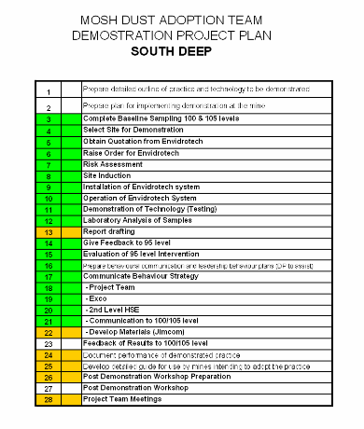

**2.18 Implementation at the selected pilot site**

Implementation at the selected pilot site should be done strictly in accordance with the implementation plan. Preparation should be done for all aspects including the electrical and water reticulation systems.

**2.19 Identification and documentation of any customisation needed prior to extension across the mine**

In most cases, especially during the risk assessment process and/or piloting phase, some customisation of the practice will be required in terms of site requirements and the specific application. Each fogger dust suppression system installation is different and there will be unique applications associated with each installation and in order to take cognisance of the environmental and geographic conditions. This could cover the location of the fogger dust suppression system’s mixing unit, the addition of a vapour curtain, etc.

**2.20 Implementation of customisation**

Once the customisation had been applied to the practice, it should be tested. All operating procedures and training material must be updated.

South Deep experience

Implementing the customisation changes:

Customisation of any equipment as it occurs will be implemented by keeping the crews working with the equipment abreast of these changes. These crews are in fact the most knowledgeable and innovative source for the suppliers to identify potential problems and possible solutions, as they work with the equipment on a daily basis.

**2.21 Managing extension of the practice across the mine**

One of the major components of extending the practice across the mine is the assurance from the supplier that adequate equipment will be available. Meetings should be set with the supplier to identify the requirements.

Crew behaviour training, with particular emphasis on sensitising the tramming and production crews towards the roll-out process for the fogger dust suppression systems, should be conducted.

Involvement of all stakeholders and effective communication is required.

As with the pilot site, all of the topics in Part 2 of the document should be addressed.

**2.22 Completion of checklist to confirm adequate consideration of critical elements**

Before the roll out can commence, it is necessary to determine whether the mine is “ready” for roll out and implementation and the checklist in ***Appendix 13*** is an example of the relevant questions that should be answered.

**Part 3 – Details of the leading practice**

**3.1 Overview**

The following basic specifications have been established for the successful operation of the fogger dust suppression system:

* 0.2 mm φ nozzle orifice,
* 70 – 100 bar pressure.

With the fogger dust suppression system as its core element, the Dust Leading Practice contains three main components:

* site selection and applicability,
* fogger dust suppression system, and
* footwall/sidewall dust control by washing down or treatment.

**3.2 Site Selection**

The fogger dust suppression system is highly flexible and is applied successfully in intake airways, at tips, orepasses, conveyor belts, or as spray curtains in the haulages, stopes and development ends.

The selection of the site should be guided by the presence of high RCS generating processes, namely rock breaking, rock handling and the applicable occupations. These should be identified through baseline risk assessments conducted as part of the routine mine dust monitoring strategy.

The site selection should the responsibility of the Section 12 Appointee who

* should incorporate it as part of his/her responsibility for the mine’s broad dust control strategy, and
* has overall responsibility for the mine’s dust monitoring programme.

The Section 12 Appointee should examine the site selected for installation of the fogger dust suppression system so as to cause the least impact on production by the siting of the pump.

The dust levels identified in the base line risk assessment and the geometry of the site should govern the number of nozzles to be used and configuration of the system. The benefit of the system is that it can be tailored to the specific application and site and, therefore, varying numbers of nozzles and different configurations should be tested by the supplier in conjunction with the Section 12 Appointee. This should ensure that the required reduction in dust levels is achieved without significant impediment to visibility.

Typically, no more than 125 nozzles should be required although one pump can supply up to 460 nozzles. As a guide, for a 20 ton hopper, 125 nozzles are required and for an 8 ton hopper, 80 nozzles are required

The final design of the system should be based on the results obtained from the initial testing, with the supplier being requested to submit an appropriate installation design for approval by the Section 12 Appointee.

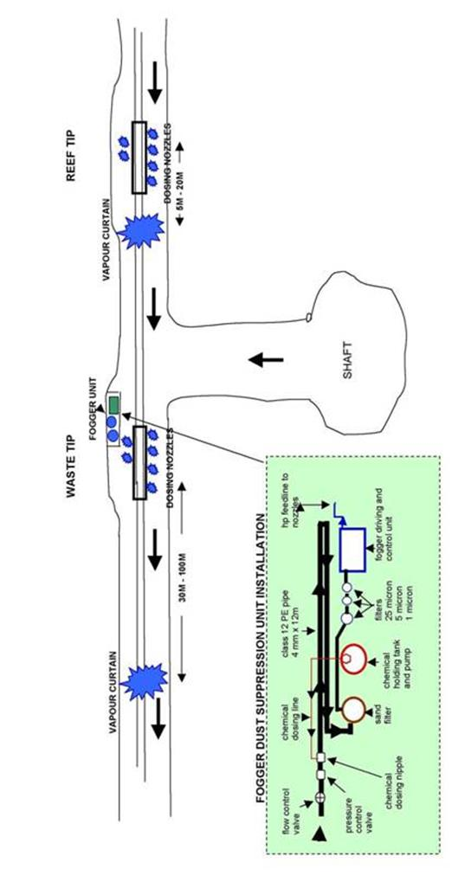

**Figure 15: Cross section showing typical fogger dust suppression system underground at a tip/ore pass installation. (Source: Envidroclear)**

**3.3 Equipment**

The fogger dust suppression with addition of surfactants consists of:

* a control cabinet which contains the chemical tank and chemical dosing pump, solenoid valves for each fogger system, an electrical panel controlling the chemical dosing, solenoid operation and safety cut-off device, and the pressure booster pump operation.
* in-line filtration vessels to reduce particulate size to >1 µm which reduces the maintenance requirement on the nozzles.
* a pressure booster pump which delivers up to 100 bar pressure; this results in a maximum delivery of 21 litres/minute water.
* a high pressure feed line to the fogger arrays.
* spray nozzles of 0.2 mm orifice diameter giving 0.8 litres/minute per nozzle at 70 bar pressure.
* sliplock assembly for easy maintenance.

Sensors

* An important part of the fogger dust suppression system are sensors detecting changes in airflow, sonic microphones, infra-red beams and switches, all of which automatically initiate the fogger dust system when a change is detected.
* The sensors allows the fogger dust suppression system to be operational when a possible source of dust is detected.

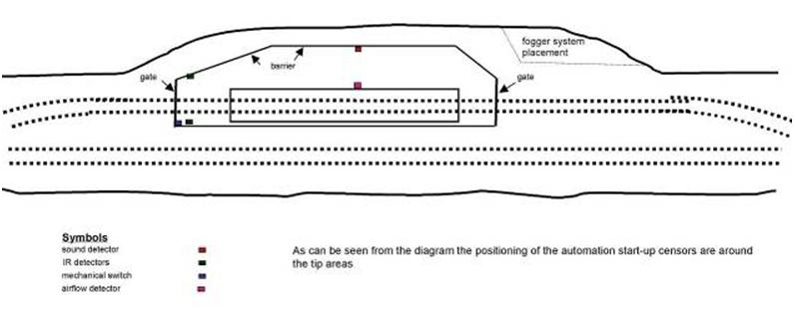

**Figure 16: Plan view showing positioning of automatic detection units at a typical tip. (Source: Envidroclear)**

* Sound detection is the preferred method to activate the fogger dust suppression system as this method allows the fogger dust suppression system to start whenever rock movement (noise) from the top levels of a ore pass system is detected.

Operational time

* In finalising the design, the mine should decide whether the fogger system needs

to be switched on and off for intermittent operation, or whether it needs to run continuously.

Dosing rate of surfactant

* The water can be dosed with a chemical additive (surfactant) to reduce the surface tension of the water after it passes the filter.
* The surfactant is released into the water with a control valve controlling the flow of the surfactant to ensure the correct ratio of surfactant to water.
* The consumption at a dosing rate of 3 - 5 ppm amounts to 25 kg of product per month per fogger dust suppression system installation.

Filtration of water

* Source water filtration is required and this is supplied by the supplier as part of the installation cost.
* The comprehensive filtration system comprises a sand filter, a 25 μm cartridge filter, a 5 μm cartridge filter and a 1 μm cartridge filter.

Supplier

* All the components of the fogger dust suppression system are supplied by the manufacturer/supplier as part of the design, supply and installation package.
* Full contact details of current suppliers can be obtained from the MOSH Dust Adoption Team.
* Other suppliers should be required to first demonstrate that they have the necessary competence and that their equipment produces equivalent results.

**3.4 Installation of equipment**

All the equipment is supplied and installed by the supplier.

* The distance from the pump to the fogger arrays can be **500 m plus.**
* The fogger system requires an area of about 2 m2.

The installation of the equipment by the supplier should:

* take about seven days per tip installation, and
* be carried out when tipping is not in operation, thereby not impacting on production.

Water and power supply

* The mine supplies a water and power connection within 10 m of the fogger unit.
* Qualified electricians from the mine should connect the fogger dust suppression system to the mine’s electricity supply which should take approximately two days to make the system power ready.

Suspension

The system is supplied through a steel circular feed pipeline. The suspension of the nozzles is as follows:

* when located in the haulage they are suspended in stainless steel frames (vapour curtains).
  + at ore passes the nozzle clusters/spray arrays are attached to flexible high pressure hydraulic hoses and are lowered into the tip cavities through either

- the floor grating, or

- 40 mm diameter holes drilled through the concrete floor if the tip design restricts easy nozzle cluster insertion into a tip.

The use of flexible high pressure hydraulic hoses greatly facilitates maintenance as each steel pipe can be easily pulled out for the nozzles to be cleaned.

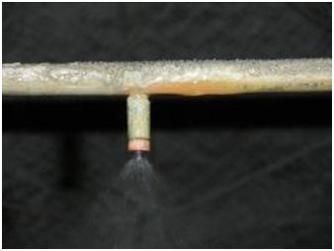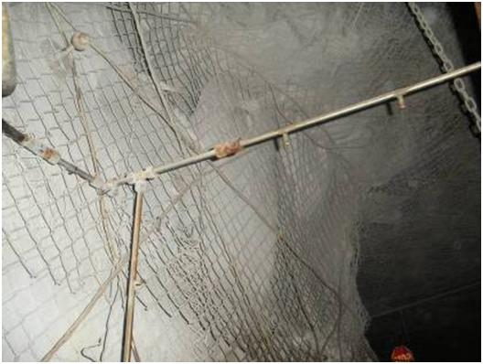

**Figure 17: A section of a vapour curtain with a close up of a nozzle. (Great Noligwa Mine; source Envidroclear)**

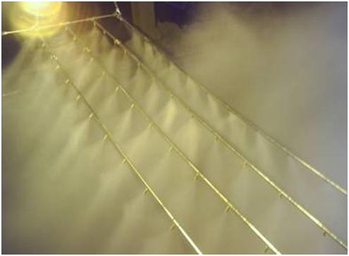

**Figure 18: Nozzles emitting fine water sprays. (South Deep Mine; source Envidroclear)**

System configuration

* When installed in ore passes, care should be taken to prevent damage to the nozzles and steel piping from falling rock.
* As shown in ***Figures 22 and 23*** below, the configuration varies for tips with small area openings and tips with large area openings.

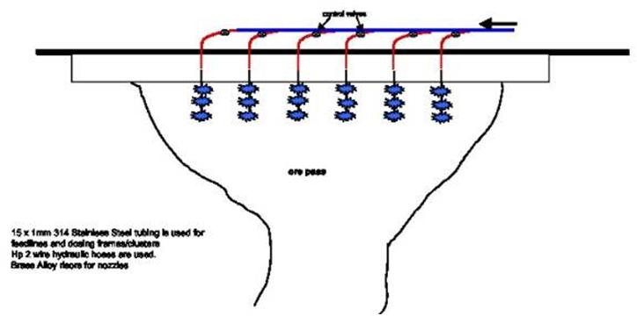

**Figure** **19:** **Fogger dust suppression system: schematic showing nozzle cluster configuration at a tip. (Source: Envidroclear).**

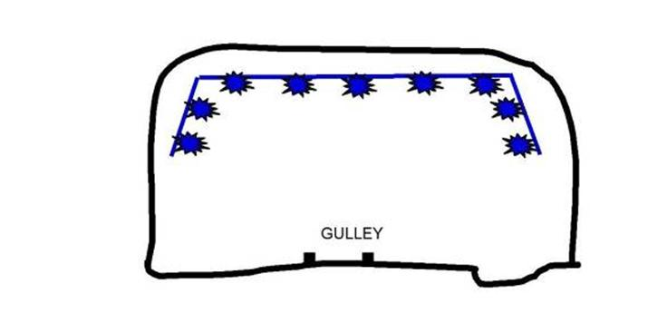

**HAULAGE**

**Figure 20: Fogger dust suppression system: schematic showing fogger vapour curtain in a haulage for air scrubbing. (Source: Envidroclear)**

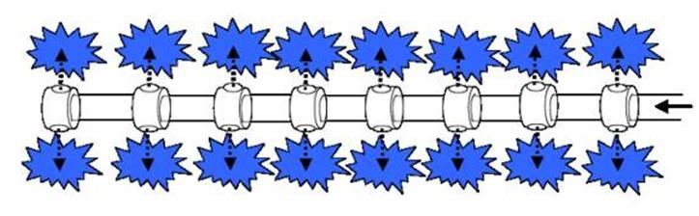

**Figure 21: Schematic showing nozzle configuration of clusters. (The above nozzle holders (risors) are omni-directional.) (Source: Envidroclear)**

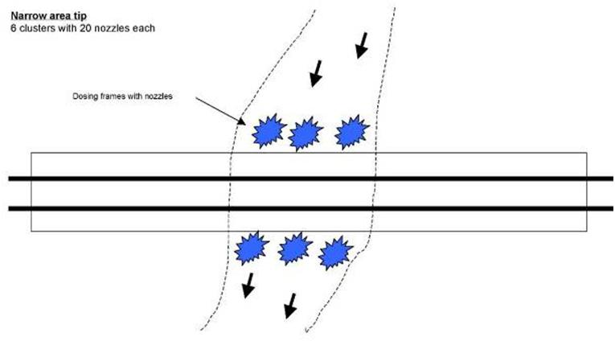

***Small area opening tip***

***6 clusters with 20 nozzles each***

**Figure 22: Plan view showing configuration of fogger dust suppression system in a small area opening tip. (Source: Envidroclear)**

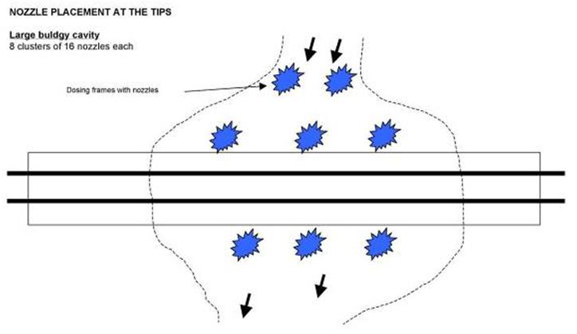

***Large area opening tip***

***8 clusters with 16 nozzles each***

**Figure 23: Plan view showing configuration of the fogger dust suppression system at a tip with a large opening area. (Source: Envidroclear)**

**3.5 Equipment maintenance**

The primary constraint of the fogger dust suppression system is that spray nozzles may easily be blocked with particulates in the water and by dust. Hence intensive source water filtration and regular preventative maintenance are required.

Supplier/Original Equipment Manufacturer (OEM) responsibility

* A maintenance contract is concluded as part of the ori*gin*al order so that the involvement of mine employees for the successful operation of the system is not required.
* A typical maintenance contract should include a maintenance technician usually on site on a daily basis, with each installation checked and serviced two to three times per week.
* The maintenance technician is responsible for
* unblocking the nozzles
* topping up the chemicals, and
* cleaning and replacing the filters.
* The maintenance can be carried out while the system remains operational.
* Filter cartridges are generally replaced once every two months as regular cleaning and back washing results in premature cartridge damage. Maintenance and cleaning of the filtration system is however directly related to the condition of the feed water.
* The mine is not required to hold any spares for the system as these are held by the supplier as part of the maintenance contract.
* Signage should be displayed on the equipment providing an emergency short dialling code that will reach the supplier or his representative 24 hours a day so that remedial action can be instituted immediately.

Section 12 Appointee’s responsibility:

* Typically, the Mine’s Commercial Services should be responsible for negotiating, signing and annually reviewing the maintenance contract with the supplier.
* The Section 12 Appointee should ensure that the maintenance contract is carried out according to the agreement.
* The supplier’s technicians should record their visits daily in a record book held in the Section 12 Appointee’s office, noting what actions have been taken.
* The Section 12 Appointee should also carry out spot checks on the systems to ensure that they have been maintained in working order.
* Once a month, the daily records of the technicians should be summarised on a spreadsheet by the supplier and the data should be analysed by the Section 12 Appointee to ensure that each installation has been checked sufficiently during the month. (See also 3.14.)
* The Section 12 Appointee should ensure any malfunctioning of the system is identified timeously through:
* regular dust monitoring,
* a campaign to encourage workers to report non-operational systems they encounter, and
* spot checks by the Section 12 Appointee and the Mine Overseer for that section.
* The Section 12 Appointee should review the effectiveness of the system monthly by analysing the results of daily gravimetric sampling programme. The OEL has been set by the DME at 0.1 mg/ m3 RCS.

**3.6 Necessary supporting physical infrastructure**

The fogger dust suppression system is an independent, self-contained system.

* It comprises an electrically-powered pump driving a dosing system connected to the mine’s raw water supply.
* The sensors are connected electronically and are powered from the unit.
* There is no requirement for any additional supporting infrastructure such as compressed air.

The mine is required to supply 4 bar water pressure and 525 V electrical supply.

* Typically, a job instruction should be given to the mine electrician by the mine overseer, following briefing from the Section 12 Appointee, for electricity and water to be taken from the nearest source to the site of the fogger dust suppression system.

No special excavation is required for the fogger dust suppression system.

* Due to its size, it is small enough to be sited in the cubby, next to the tip excavations or between the tips without interfering with the tramming.
* The contractor/supplier in agreement with the Section 12 Appointee should select its location.

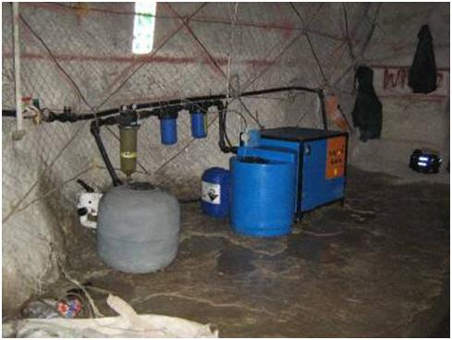

**Figure 24: Fogger dust suppression system pump, motor and mixing pump. (Source Envidroclear)**

**3.7 Other Dust Control Measures**

* + 1. **Cleaning of intake airway**

The cleaning of the intake airways can be done by

* routine washing down of the footwall, sidewalls, hangingwall and crushed rock. This is an important part of the leading practice as it assists in preventing the dust captured as agglomerated water/dust particles from becoming airborne again, or
* treatment of the footwall, sidewalls, hangingwall where applicable.

As part of the mine’s routine operation, the entire shaft area is washed down continually by workers during their shift to keep the area clean.

* This ensures that a distance of at least 50 m on either side of the fogger dust suppression system is cleaned.
* The contaminated water is washed away via the drains to the settlers.

At the tip installations, a tip attendant is responsible for the washing down.

* + 1. **Respiratory Protective Equipment**

Respiratory protective equipment (RPE) must be worn in the vicinity (100 m either side) of the fogger dust suppression system.

Signage should be displayed alerting all workers, including the tip attendant, loco drivers and assistants, to wear RPE.

**3.8 Training**

The Standard Operating Procedure (SOP) provided in ***Appendix 14*** includes material that may be utilised for training purposes.

**3.9 Instruction documentation**

The Standard Operating Procedure (SOP) provided in ***Appendix 14*** includes instructions for use.

**3.10 Signage**

Required signage includes signs for visibility, PPE, etc.:

* zone demarcation signage installed in the vicinity of the fogger dust suppression system installation. An example is provided in **Figure 25**.
* signage providing an emergency number (short dialling code) that connects to the supplier or his representative on a 24 hour basis, provided by the supplier.
* signage alerting all workers, including the tip attendant, loco drivers and assistants, to wear RPE in the vicinity of the fogger dust suppression system.

Other signage could be considered to raise awareness of the system and general dust awareness as part of the leading practice.

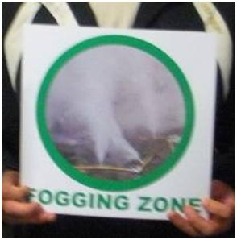

**Figure 25: Zone demarcation signage for the fogger dust suppression system.**

**3.11 Incentive arrangements**

The fogger dust suppression system should not have any impact on the production performance of the mine.

* It is expected that no incentives in terms of production should be necessary for the introduction of the fogger dust suppression system.

The reduction in respirable dust levels due to the implementation of the fogger dust suppression system should however be covered by Management’s key performance indicators (KPI’s) that deal with specific occupational health matters. Relevant KPI’s are:

* the number of dust over-exposures,
* the average dust level of the mine, and
* the number of dust sources on the mine equipped with functioning dust allaying systems.

Although somewhat indirect, this arrangement introduces important career advancement and financial benefit incentives.

**3.12 Operational procedures**

Operational procedures for the fogger dust suppression system are based on a standard operating procedure provided in ***Appendix 14.***

**3.13 Relevant mine standards**

All relevant mine standards in the case of the source mine as well as the demonstration mine have been updated and will be made available on request.

**3.14 Monitoring and reporting arrangements**

**3.14.1 Daily maintenance record**

* Typically, the maintenance technicians should sign a record book on a daily basis noting what actions they have taken that day with regard to the fogger dust suppression system installations.
* The daily record book should be summarised on a spreadsheet for the Section 12 Appointee’s office on a monthly basis to ensure that all installations are regularly checked and repairs carried out immediately. (See 3.5)

**3.14.2 Sampling**

* As part of the mine’s sampling strategy, personal dosimetry readings should be taken daily in all affected ore handing areas with samples according to the sampling strategy drawn up annually by the Section 12 Appointee.
* This strategy covers sampling areas, occupations to be sampled and number of samples to be taken.

**3.14.3 Reporting**

* Monthly reports on the performance and maintenance of the fogger dust suppression systems and on the average dust levels in all affected ore handing areas should be submitted by the Section 12 Appointee to the Mine/General Manager and mine EXCO.

**3.15 Performance measures**

In terms of operational performance, the effectiveness of the fogger dust suppression system will be determined in the monthly personal dust sampling programme.

Unit costs in the current economic state are also important and, with the proper resources, data capturing in terms of total consumables should be part of the implementation process.

In terms of the behavioural element, which is measureable by observation, regular meetings and feedback sessions with the tramming personnel should be conducted. This is true from all stakeholders' points of view, both from the mine and supplier’s side, as this is good feedback not only on personnel impressions but also on equipment performance.

## 3.16 Management of leading practice

No changes to the management structure should be necessary, with the Section 12 Appointee reporting to the General Manager, but allocation of new responsibilities is required as well as the identification of a project champion.

Typically, the roles and responsibilities of the key players in the adoption and operation of the system are as follows:

**Mine/General Manager**

* Holds overall legal responsibility for health and safety of his workforce and makes legal appointment of senior management to carry out appropriate occupational health strategies.
* Motivates, to head office, capital expenditure and business plan, co-ordinated by the Engineering Manager, for phasing in system.
* Approves purchase order for installation of system.
* Monitors performance of system via monthly reports submitted to him by Section 12 Appointee.

**Engineering Manager**

* Co-ordinates capital expenditure business plan with input from Section 12 Appointee and submits to General Manager.
* Approves spending of capital according to business plan.
* Signs off all engineering drawings for system before implementation.
* Approves payment of supplier once Section 12 Appointee has signed off installation by supplier.

**Section 12 Appointee**

* Identifies installation required and suitable for implementation of fogger dust suppression system.
* Draws up business plan and capital expenditure in conjunction with and for submission to Engineering Manager.
* Submits order to Mine Commercial Services, indicating preferred supplier.
* Checks and signs off installation by supplier.
* Monitors service provided by maintenance technicians using daily record book and spot in situ checks of installations.
* Takes responsibility for mine’s annual and daily dust sampling strategy.
* On monthly basis, assesses results of strategy as well as maintenance records to identify problem areas and ensure all dust allaying systems are regularly checked.
* Submits monthly report on dust levels and performance of dust allaying systems to General Manager, Engineering Manager and EXCO of the mine.

**Shaft Mine Overseer**

* Responsible for providing uninterrupted power and water for system.
* Monitors performance of system through spot checks.

**Commercial Services**

* Invites tenders and places orders for installation and maintenance contracts.

**3.17 Risk management in implementing the system Error! Reference source not found.**

A risk assessment on the operation and maintenance of the fogging dust suppression system should be carried out by the mine’s risk management department, often with the supplier, before the first unit is installed.

The risk assessment**:**

* determines the risk of the exercise,
* analyses the potential hazards,
* reviews the existing controls and current safeguards, and
* makes recommendations to eliminate, control and minimise the risk.

To minimise the risk, installation crews should also undergo a short term induction and the maintenance crew should attend a full induction programme organised by the supplier.

The risk assessment conducted at South Deep Mine is attached as an example as ***Appendix 15***.

**3.18 Proprietary knowledge or technology**

Both the source mine and demonstration mine management have agreed that any relevant information on the fogger dust suppression system, its performance and/or any other indicators will be freely available.

Part 4 Part 4 Details of Matla experience

4.1 OBJECTIVE 55

4.2 MINE BUSINESS AND VALUE CASE 55

4.3 METHODOLOGY 55

4.3.1 Instrumentation 55

4.3.1.1 Gravimetric dust sampling 55

4.3.1.2 Environmental conditions monitoring 56

4.3.1.3 Test duration 56

4.3.1.4 Water quantity 56

4.3.1.5 Water quality …………………………………………………………………………….56

4.3.1.5 Tonnages 56

4.3.2 Sampling positions 56

4.3.3 Tests 56

4.3.3.1 Test 1 - Control not operating 56

4.3.3.2 Test 2 - Control operating and chemicals added to water 56

4.3.3.3 Test 2 - System operating and chemicals added to water……………………….....57

4.4 SAMPLE ANALYSIS 57

4.4.1 Gravimetric dust sampling filter weighing 57

4.4.2 Silica content analysis 57

4.5 GRAVIMETRIC SAMPLING RESULTS 57

4.5.1 Environmental conditions monitoring 57

4.5.2 Respirable Dust Results 58

4.5.3 Total Dust Results 59

4.5.4 System Improvement Results 59

4.5.5 Problems encountered during the sampling process 59

4.6 SILICA CONTENT RESULTS 60

4.6.1 Respirable Dust Results 60

4.6.2 Total Dust Results 61

4.6.3 System Improvement Results 61

4.7 WATER QUALITY RESULTS 61

4.7.1 Mine 2 and Mine 3 Water Quality Results (30 April 2010) 62

4.7.2 Mine 2 Water Quality Results (24 May 2010) 62

4.7.3 Mine 2 Water Quality Results (25 May 2010) 62

4.7.4 Mine 2 Water Quality Results (01 June 2010) 62

4.8 EXPERIENCES ON THE OPERATION OF THE FOGGER SYSTEM 62

4.8.1 Definition of the Fogger System 63

4.8.2 Envidroclear Vapor Fogger Dust Suppression System at Matla 63

4.8.3 Operation Specifications of the Fogger System at Matla 66

4.8.3.1 Condition of the Fogger System – before sampling 66

4.8.3.2 Condition of the Fogger System – during sampling 66

4.8.3.3 Condition of the Fogger System – after sampling 67

4.8.4 OEM Risk Assessment on the Installation of the Fogger System 70

4.8.5 Matla Risk Assessment on the Installation & Operation of the Fogger System 95

4.8.6 MSDS OF SUDSPERSE WA of the Fogger System 109

List of Tables and Figures

Annexure 1: Mine 2 – 2 Seam Shaft Area (sampling positions) 113

Figure 1: Schematic diagram of sampling positions in an Intake Airway 114

Figure 2: Mine 2 Respirable Dust Results 115

Figure 3: Mine 2 Total Dust Results 116

Figure 4: Mine 2 Respirable Silica Dust Results 117

Figure 5: Mine 2 Total Dust Silica Results 118

**GLOSSARY OF ABBREVIATIONS, SYMBOLS AND TERMS**

**CSIR-NRE**

Council for Scientific and Industrial Research – Natural Resources and the Environment

**Diameter (µm)**

Representative particle size in the particle size column. The value is calculated by (lower limit particle size in this particle size column  upper limit particle size in this particle size column) ^0.5.

**L/min**

Litres per minute

**MDHS 101**

Methods for the Determination of Hazardous Substances. Health and Safety Laboratory (UK). Crystalline silica in respirable airborne dusts. Direct-on-filter analysis by infrared spectroscopy and X-ray diffraction.

### 4.1 OBJECTIVE

The objective of the study is to determine:

* the airborne respirable particulate filtration efficiency, and
* the airborne total dust filtration efficiency,

of the currently installed MOSH Fogger Dust Suppression system, installed at Matla Coal.

**4.2 MINE VALUE AND BUSINESS CASE**

### 4.2.1 OBJECTIVE

The objective of installing new dust suppression systems at Matla Coal is to:

* To reduce the exposure of employees from coal dust to below the OEL of 2 mg/m3 as required by the DMR
* To comply with the elimination of silicosis and other lung diseases as required by the MHSC Milestones, and
* To comply with Exxaro Health and Hygiene vision.

### EXXARO HEALTH & HYGIENE VISION

Exxaro’s Health and Hygiene Vision is:

To have or enable a work environment that has no adverse health effects on our employees and affected communities.

### KEY COMPONENTS OF THE VALUE CASE

* The preparation of a well stated case to justify an investment by the mine in the leading practice needs to cover all issues that have significant business value, even if such issues are not readily quantifiable.
* The following are considered to be the key components of the value case:

**4.2.3.1 Occupational health and safety performance improvements**

**High dust at the belts in the Intake Airways/Surface Plant**

* **Prevention of mine stoppages with Section 54s by the Inspectorate.**
* **Reduction of potential long term liabilities**
* **Meeting the Milestones committed to by the CEO**
* Decrease exposure risks by a significant amount
* Improve morale of the workforce
* Decrease the work load – cleaning (stonedusting at belt roads), investigations (e.g. 50 per month)
* Remove safety risks – coal dust explosion in the conveyor belts
* Minimize social responsibility

**The introduction of this technology will**:

Reduce the overall dust load by 41.5% (90% for the production sections)

Business Case

15 x fogger units for u/g installation and 2 x micro system =

Capital Expenditure = 15 x R240 000 = R3,600 000 + R260 067 = R3860067 (inclusive of installation & sampling equipment costs)

Operational Expenditure:

1. Maintenance contract = R17500 x 12 x 15 = R3,150 000
2. Utilities (power & water)
3. Nett Value = Total Operation costs x Nett present value @ 10% for 10 yrs = 6.495

History of Health Cases with dust as a contributing factor

**Certified Health Cases (Lung Diseases) at Matla from 2007 to 2009**

|  |  |  |  |  |
| --- | --- | --- | --- | --- |
| **Lung Disease** | 2007 | 2008 | 2009 | 2010 |
| Tuberculosis | 6 | 12 | 9 | 11 |
| Pneumoconiosis | 2 | 1 | 2 | 0 |
| Silicosis | 0 | 1 | 0 | 0 |
| Asbestosis | 1 | 0 | 0 | 0 |
| COAD | 1 | 0 | 1 | 1 |

**4.2.3.2 Financial benefit of this technology**

Take the issues raised at the top and put potential costs to these

* **Prevention of mine stoppages with Section 54s by the Inspectorate.**

**Based on the 40 000 tons mined per day at R101.82 Rand/ton and the 3 day stoppage by the DMR due to high dudt levels, it will cost the mine R12 million**

* **Reduction of potential long term liabilities**
* Decrease the work load – cleaning (stonedusting at belt roads), Total distance to be stonedusted per month is 1575 meters at the rate of stonedusting at R75/meter = R118 125 per month. When using the fogger system, the stonedusting will then take place once per quarter and will cost about R(785,5 meter x R75/meter) = R58 912.50
* investigations (e.g. 8 per month) Cost for each investigation is significant
* Remove safety risks – coal dust explosion in the conveyor belts The potential is if you have a coal dust explosion you will loose the whole mine.According to the mine risk register, A coal dust explosion is a very high riak (A rating)
  + - * 1. **Other valued business impacts**
* **Meeting the Milestones committed to by the CEO It impacts on the reputational risk and shareholder perception**
* Decrease exposure risks by a significant amount
* Improve morale of the workforce Reduce the number of respirators and people are more comfortable not to use respirators
* Minimize social responsibility by reducing dust plumes in surface installation
  + - * 1. **Communication system out of this project**

Better communication between management and employees

* + - * 1. **Commitment of leadership out of this project**

Leadership commitment

Labour relationship improvement

Improve communication

* + - * 1. **Training and awareness of dust to the workforce**

An investigation on the training material was conducted after the behaviour communication interviews with employees.

In future Occupational Hygienists will be involved with:

* The review of the computer training programme on dust
* The lecturing or facilitation on dust training

### 4.3 METHODOLOGY

Selection of testing area underground at Matla

Previous measurements at Matla indicated high dust levels in Intake airways at Mine 2

* Incline,
* Sub Incline,
* Main West 1 conveyor (split 10)

Please refer to Annexure1 for assistance with study methodology explanation.

### 4.3.1 Instrumentation

### 4.3.1.1 Gravimetric dust sampling

Each sampling position will consist of six Gillian gravimetric dust sampling trains, fitted with 37 mm diameter filter cassette units, equipped with 37mm cellulose nitrate sampling filters with a pore size of 0,8 µm.

Two gravimetric dust sampling trains, tied back to back, will be positioned at each sampling position (> 500 mm apart), at a height of between 1.6m and 1.8m. One sample train will measure the respirable dust and the other will measure total dust.

The respirable dust sampling cassette will be fitted with a respirable dust selective cyclone.

The total dust sampling cassette will have an open face and will not be fitted with any size selective cyclone

The number of gravimetric dust sampling pumps per test will be placed as indicated in Figure1

### 4.3.1.2 Environmental conditions monitoring

Continuous environmental conditions monitoring will be conducted by means of a Kestrel 4000 instrument. The following environmental conditions will be monitored:

* Dry-bulb temperature (ºC);
* Wet-bulb temperature (ºC);
* Humidity (%);
* Air flow velocity (m/s);
* Barometric pressure; and
* Airway dimensions (height and width) at the sampling and measuring positions.

### 4.3.1.3 Test duration

Each test (pre- and post-test) will be conducted for all 3 x shifts cycle (i.e. Day; Afternoon and Night Shift). Total number of sampling days = 15

### 4.3.1.4 Water quantity

The Envidrotech Fogger water spray system water flow rate and water pressure will be recorded at the start and completion of each study. These results will be recorded on the Project Survey Sheet (Appendix A).

### 4.3.1.5 Water quality

The water quality analysis is to be performed before and after the Fogger dosing system to determine the effects of the chemical on the blockage of the system. These results will be recorded on the Project Survey Sheet (Appendix B).

### 4.3.1.6 Tonnages

The tonnage will be recorded for each testing day.

### 4.3.2 Sampling positions

Sampling positions will be selected at pre-determined intake airways, as indicated in Annexure1 and Figure 1. This is done to establish the overall respirable particulate filtration efficiency of the currently installed system.

### 4.3.3 Tests

### 4.3.3.1 Test 1 – System not operating

Test 1 will be conducted with theEnvidrotech Fogger water spray system NOT operating. This is done to determine the respirable particulate concentration if theGE Water & Process Technologies water spray system is not operating. The airborne respirable silica concentration generated by the dust generating operation will then be quantified.

### 4.3.3.2 Test 2 – System operating and chemicals added to water

Test 2 will be conducted with theEnvidrotech Fogger water spray system operating and the chemicals ADDED. This is done to determine the respirable particulate concentration if theEnvidrotech Fogger water spray system is operating and the chemicals added. The airborne respirable silica concentration generated by the dust generating operation will then be quantified.

### 4.3.3.3 Test 2 – System operating and no chemicals added to water

Test 2 will be conducted with theEnvidrotech Fogger water spray system operating and NO chemicals added. This is done to determine the respirable particulate concentration if theEnvidrotech Fogger water spray system is operating and no chemicals added. The system dosing pump will be switched off. The airborne respirable and total dust concentration generated by the dust generating operation will then be quantified.

### 4.4 SAMPLE ANALYSIS

### 4.4.1 Gravimetric dust sampling filter weighing

All gravimetric dust sampling have been done in accordance with the requirements of GME Method No. 16/2/3/2/3 (Gravimetric Method).

### 4.4.2 Silica content analysis

Silica content analysis will be conducted in accordance with the requirements of the CECS Standard Method 3:1988. Please refer to Appendix Page 74 for the scope and field of application, apparatus used and procedure followed.

### 4.5 GRAVIMETRIC SAMPLING RESULTS

### 4.5.1 Environmental conditions monitoring

The following environmental conditions were recorded over the 15-day sampling period:

* **Airway dimensions**
  + - Incline Shaft = 2.5m x 3.9m = 9.75 m2
    - Sub-Incline = 2.5m x 3.9m = 9.75 m2
    - Main West 1 Conveyor (split 10) = 2.13m x 4.46m = 9.5 m2
* **Average Dry-bulb temperature** (ºC)
  + - Incline Shaft = 15.19
    - Sub-Incline = 15.84
    - Main West 1 Conveyor (split 10) = 16.44

* **Average Wet-bulb temperature** (ºC)
  + - Incline Shaft =11.36
    - Sub-Incline = 13.15
    - Main West 1 Conveyor (split 10) = 13.38
* **Average Humidity** (%)
  + - Incline Shaft = 66.98
    - Sub-Incline = 78.37
    - Main West 1 Conveyor (split 10) = 74.47

* **Average Air flow velocity** (m/s)
  + - Incline Shaft = 3.11
    - Sub-Incline = 4.72
    - Main West 1 Conveyor (split 10) = 4.16

* **Average Air Quantity** (m3/s)
  + - Incline Shaft = 30.32
    - Sub-Incline = 46.02
    - Main West 1 Conveyor (split 10) = 39.58
* **Average Barometric pressure** (mbar)
  + - Incline Shaft = 848.95 Sub-Incline = 848.95
    - Sub-Inc line = 848.21
    - Main West 1 Conveyor (split 10) = 848.28

### 4.5.2 Respirable Dust Results

Test 1 – Control not operating (12 x sampling days)

* Incline Shaft = number of samples = 12
* Sub-Incline = number of samples = 12
* Main West 1 Conveyor (split 10) = number of samples = 12

Test 2 – Control operating (15 x sampling days – 3 x sampling pumps per area)

* Incline Shaft = number of samples = 45
* Sub-Incline = number of samples = 45
* Main West 1 Conveyor (split 10) = number of samples = 45

**Respirable Dust Results** (mg/m3)

|  |  |  |  |  |
| --- | --- | --- | --- | --- |
|  | **Inc line Shaft** | **Sub-Incline** | **Main West 1** | **AVERAGE** |
| Average Dust Results – Test 1 | 2.01 | 1.18 | 1.07 | **1.42** |
| Average Dust Results – Test 2 | 1.16 | 0.43 | 0.89 | **0.83** |

### 4.5.3 Total Dust Results

Test 1 – Control not operating (12 x sampling days)

* Incline Shaft = number of samples = 12
* Sub-Incline = number of samples = 12
* Main West 1 Conveyor (split 10) = number of samples = 12

Test 2 – Control operating (15 x sampling days – 3 x sampling pumps per area)

* Incline Shaft = number of samples = 45
* Sub-Incline = number of samples = 45
* Main West 1 Conveyor (split 10) = number of samples = 45

**Total Dust Results** (mg/m3)

|  |  |  |  |  |
| --- | --- | --- | --- | --- |
|  | **Inc line Shaft** | **Sub-Incline** | **Main West 1** | **AVERAGE** |
| Average Dust Results – Test 1 | 3.15 | 1.59 | 1.68 | **2.14** |
| Average Dust Results – Test 2 | 1.9 | 0.86 | 1.35 | **1.37** |

Test 1 – Fogger System not operating

Test 2 – Fogger System operating

### 4.5.4 System Improvement Results

**System Improvement** (%)

|  |  |  |  |  |
| --- | --- | --- | --- | --- |
|  | **Inc line Shaft** | **Sub-Incline** | **Main West 1** | **AVERAGE** |
| Respirable Dust | 43.2 | 63.6 | 16.8 | **40.9%** |
| Total Dust | 39.7 | 39.6 | 19.6 | **33%** |

### Problems Encountered during the Sampling Process

The following problems were encountered during Test 2 – Sampling with the system in operation. Total number of sampling pumps used per shift was 37

* + - 1. **Sampling Filters**
* Number of sampling filters lost during the sampling process was five (5), this was caused by the incorrect diameter of the filter that caused the adaptor not to fit easily into the filter. Most lost filters are filters for Total Dust Sampling.
* Number of contaminated filters was four (4), this contamination was caused by water accumulation on the conveyor during the belt start up.
* Number of sampling filters with “**no dust**” during the sampling process was three (3),

**4.5.5.2 Sampling Days**

* On the 13th and 17th of May 2010, No sampling was carried out at Sub-Incline and Main West 1 Conveyor (split 10) due to the shortage of filters (12 filters short on the 13th and 2 filters on the17th of May). This was caused by miscommunication between mine personnel and the service provider.
* On the 21st of May 2010, no sampling took place. The Fogger was switched off at the Incline Substation by mine personnel as the result of discomfort experience.

### 4.6 SILICA CONTENT RESULTS

**4.6.1 Respirable Silica Dust Results**

**Incline Shaft Silica Results (%)**

|  |  |  |  |  |
| --- | --- | --- | --- | --- |
|  | **Sample 1** | **Sample 2** | **Sample 3** | **AVERAGE** |
| Silica Results – Test 1 | 1.38% | 0.62% | 1.39% | **1.13%** |
| Silica Results – Test 2 | 0.13% | 0.13% | 0.13% | **0.13%** |
| **System Improvement** | 90.6% | 79% | 90.6% | **86.7%** |

Test 1 – Fogger System not operating

Test 2 – Fogger System operating

**Sub-Incline Shaft Silica Results (%)**

|  |  |  |  |  |
| --- | --- | --- | --- | --- |
|  | **Sample 1** | **Sample 2** | **Sample 3** | **AVERAGE** |
| Silica Results – Test 1 | 1.32% | 1.1% | 2.4% | **1.61%** |
| Silica Results – Test 2 | 0.3% | 0.3% | 0.3% | **0.3%** |
| **System Improvement** | 77.3% | 72.7% | 87.5% | **79.2%** |

**Main West 1 Conveyor Silica Results (%)**

|  |  |  |  |  |
| --- | --- | --- | --- | --- |
|  | **Sample 1** | **Sample 2** | **Sample 3** | **AVERAGE** |
| Silica Results – Test 1 | 1.36% | 1.41% | 0.68% | **1.15%** |
| Silica Results – Test 2 | 0.15% | 0.15% | 0.15% | **0.15%** |
| **System Improvement** | 89.0% | 89.4% | 77.9% | **85.4** |

**The Overall System Improvement on Respirable Silica Dust is 83.8%**

**4.6.2 Total Dust Silica Results**

**Incline Shaft Silica Results (%)**

|  |  |  |  |  |
| --- | --- | --- | --- | --- |
|  | **Sample 1** | **Sample 2** | **Sample 3** | **AVERAGE** |
| Silica Results – Test 1 | 2.05% | 1.85% | 1.83% | **1.91%** |
| Silica Results – Test 2 | 0.11% | 0.11% | 0.11% | **0.11%** |
| **System Improvement** | 94.6% | 94.1% | 94.0% | **94.2%** |

Test 1 – Fogger System not operating

Test 2 – Fogger System operating

**Sub-Incline Shaft Silica Results (%)**

|  |  |  |  |  |
| --- | --- | --- | --- | --- |
|  | **Sample 1** | **Sample 2** | **Sample 3** | **AVERAGE** |
| Silica Results – Test 1 | 1.6% | 1.85% | 1.83% | **1.91%** |
| Silica Results – Test 2 | 0.19% | 0.19% | 0.19% | **0.19%** |
| **System Improvement** | 88.1% | 89.7% | 89.6% | **89.1%** |

**Main West 1 Conveyor Silica Results (%)**

|  |  |  |  |  |
| --- | --- | --- | --- | --- |
|  | **Sample 1** | **Sample 2** | **Sample 3** | **AVERAGE** |
| Silica Results – Test 1 | 1.19% | 0.65% | 2.15% | **1.33%** |
| Silica Results – Test 2 | 0.19% | 0.19% | 0.19% | **0.19%** |
| **System Improvement** | 84.0% | 70.8% | 91.2% | **82%** |

**The Overall System Improvement on Respirable Silica Dust is 88%**

### 4.7 WATER QUALITY RESULTS

**4.7.1 Mines 2 and Mine 3 Drinking Water Quality Results (30 April 2010)**

Water samples were taken at Mine 2 and Mine 3 main water supply columns in order to compare with the water qualities at Mine 2 Incline area where the Fogger system is installed.

|  |  |  |  |
| --- | --- | --- | --- |
|  | **Mine 2** | **Mine 3** | **LIMIT** |
| Suspended Solids (mg/L) | 0.400 | 0.400 | **< 25** |
| Total Dissolved Solids (mg/L) | 135 | 141 | **< 1000** |

These water results are clear and within the legal limits

**4.7.2** **Mine 2 Drinking Water Quality Results (24 May 2010)**

* Mine 2 Drinking water is also used for the Fogger Dust Suppression System.
* Water samples were taken at the “Inlet of the Fogger System” and at the “Outlet of the Fogger System”. This exercise was done after there were complains on the blockages of water sprays.
* This was done to check on the influence of the chemical on the water quality before reaching the water sprays.

|  |  |  |  |
| --- | --- | --- | --- |
|  | **Inlet of System** | **Outlet of System** | **LIMIT** |
| Suspended Solids (mg/L) | 0.400 | 0.800 | **< 25** |
| Total Dissolved Solids (mg/L) | 140 | 165 | **< 1000** |

**4.7.3** **Mine 2 Drinking Water Quality Results (25 May 2010)**

* Additional water samples were taken on the 25th of May and 1st of June 2010 to verify the previous results.

|  |  |  |  |
| --- | --- | --- | --- |
|  | **Inlet of System** | **Outlet of System** | **LIMIT** |
| Suspended Solids (mg/L) | 0.400 | 0.800 | **< 25** |
| Total Dissolved Solids (mg/L) | 125 | 125 | **< 1000** |

**4.7.4**  **Mine 2 Drinking Water Quality Results (01 June 2010)**

|  |  |  |  |
| --- | --- | --- | --- |
|  | **Inlet of System** | **Outlet of System** | **LIMIT** |
| Suspended Solids (mg/L) | 3.6 | 1.2 | **< 25** |
| Total Dissolved Solids (mg/L) | 130 | 131 | **< 1000** |

These water results are clear and within the legal limits

### 4.8 Experiences on the operation of the fogger system

**4.8.1** **Definition of the fogger system**

**Envidroclear fogger vaporizing dust suppression system**

Limitations of the micro/macro dust suppression spraying systems, especially for underground applications, lead to the development of the Envidroclear Fogger Vaporizing Systems.

So called vaporizing dust suppression systems currently available on the market were evaluated and tested but discarded due to the non conformance to the high standards in terms of vapour production we required. Our own robust effective Fogger Vaporizing system was developed in conjunction with a company in Italy who is the current market leader in terms of nozzle and high pressure technologies.

**The principle modus operandi of the fogger system**

The finer the droplet size of the water mist / vapour employed, the greater are the absorption and attraction forces of the medium (water) molecules to airborne dust, smoke and gas particles.

This is achieved by pressurizing water at the nozzles to 70 bar pressure

The smarter way of dust suppression and or fire prevention is to create mist / vapour curtains applied at the source of the emissions and friction areas where potential fire hazards are identified.

**How droplet size can affect agglomeration. Reference**

If a droplet diameter is much greater than the dust particle, the dust particle simply

follows the air stream lines around the droplet and little or no contact occurs.

**Dust particle impacts**

**And agglomerates**

**FOG DROPLET**

**SPRAY DROPLET**

If the water droplet is the same size or smaller comparable to that of the dust

particle, contact occurs as the dust particle tries to follow the air stream lines.

The probability of impaction increases as the size of the water droplets decreases

The coagulation and absorption rate of the mist / vapour is further enhanced by the addition of specific blends of wetting / surfactant agents. Improvements of up to 98% removal rate of specific airborne pollutants were possible this way.

**Characteristics of the mist/ vapour.**

**The following are unique characteristics of the vapour mainly from the fact that the volume of one drop of water is increased by 1640 times!!**

* Faster coagulation of suspended particles in the air.
* Faster cleanup of airborne dust particles.
* Removal of soluble gas particles in the air.

**4.8.2** **Envidroclear vapour fogger dust suppression system at Matla Coal**

**Appendix 2**

**THE ENVIDROCLEAR VAPOUR FOGGER DUST SUPPRESSION SYSTEM**

SITE : MATLA MINE 2

Frames installed : 12

Number nozzles : 420

The following basic specifications have been established for the successful operation of the Fogger dust suppression system

* 0.2mm nozzle orifice
* Operating pressures of between 70 and 90 bar
* Addition of surfactant
* Regular maintenance and service of all the components of the fogger namely:
  + - * High Pressure pump
      * Chemical dosing pump
      * Filtration plant
* Regular inspection of all feed lines, hydraulic hoses, ball valves, nozzle body holders (risers) and nozzle tips
* Clean water (or as clean as possible)

**Equipment**

The complete dust suppression system unit installed at Matla Mine 2 consists of the following components

1. Envidroclear Fogger control unit which includes a electronic panel, reservoir tank
2. 380VAC, 7.5kW Electrical Motor
3. 40L per minute, high pressure pump (machine rated up to 120 bar)
4. Mini Filtration units , that consists of the following:
   1. Sand Filter unit complete with sand and regulating valves
   2. 50uF (micron) Centripur Filter housing complete with pressure gauges
   3. 50uF Centripur Filter cartridge
   4. 10uF BB - Cartridge Filter housings
   5. 10uF Filter Cartridges
   6. 5uF BB - Cartridge Filter housings
   7. 5uF Filter Cartridges.
5. Pressure Regulating Valve
6. Flock Rack
7. Chemical Dozing pump 220VAC
8. 150L step down Chemical holding tank containing Sudsperse WA (see attached MSDS Sheet)
9. Various Hydraulic pipes and fittings
10. Ball valves
11. Various Stainless Steel (Grade 316) Feed pipes
12. Various brass nozzles and tips
13. 15mm dual brass risers complete with viton seals

The electronic control panel enables the fogger to be switched on and off by means of manual or automation. The specific unit at Matla Mine is connected to run on Auto in conjunction with the incline conveyor PLC

The complete Fogger and filtration unit is installed in a closed off area of 2 x 3

Meters

The feed line distance from the pump up to the last dozing point is no more than

300 meters (the feed lines are placed in such a way that is the shortest route

from the driving unit to the last point)

**Daily Maintenance and service scope of work**

The primary constraint of the Fogger dust suppression system is that the nozzles may easily be blocked with particles in the water and by dust. It is therefore vital to have an intensive maintenance plan

A maintenance technician is usually on site on a daily basis

The maintenance can be carried out while the system is operational

1. Complete Mini HIRA
2. Daily Inspections of Fogger unit
3. Daily inspection of Chemical Tank (level, quality of chemical)
4. Daily inspection of all Filtration units
5. Daily inspection of All Feed pipe and frames
6. Daily inspection of all nozzles and tips
7. Daily inspections of all pressure gauges and valves
8. Clean all Vapor Fogger units daily
9. Clean Filters daily
10. Clean nozzles daily
11. Clean workplace daily
12. Clean chemical holding tanks weekly
13. Calibrate Chemical dosing pump weekly
14. Calibrate High Pressure Pump weekly
15. Clean / Flush all pipes weekly
16. Change Oil on High Pressure Pump once a month or every 500 running hours
17. Refill Chemical holding tanks if and when necessary.
18. Replace damaged or blocked nozzles if and when necessary
19. Replace damaged pipes and fittings if and when necessary
20. Write reports daily
21. Ensure that our equipment is clean and working properly at all times.
22. Complete daily report sheet pertaining to the service of the unit.

**Installation of new dust suppression systems**

1. Deliver all necessary equipment to site
2. Install filtration units
3. Install booster pumps – when necessary
4. Install Chemical dozing pump
5. Install chemical holding tank
6. Install Vapor Fogger driving unit
7. Install and fit all pipes and fittings
8. Install all nozzles and tips
9. Install all pressure gauges
10. Calibrate all equipment
11. Fill all water and chemical tanks

**4.8.3** **Operating specifications of the fogger system at Matla Coal**

**4.8.3.1 Fogger Operation on commissioning of system – 03 May – 7 May 2010**

TOTAL NUMBER OF FRAMES INSTALLED: 16

TOTAL NUMBER OF NOZZLES: 420

Frames positioning: Incline area (4)

1 x Frame over belt on Incline

1 x Frame at Feeder Head

2 x Frames in Feeder on I beam

MW1 Area (4)

2 x Frames on Feeder

2 x Frames next to belt ± 20meters away from feeder

Sub inline area (2)

1 x Frame next to belt at middle of incline

1 x Frame next to belt at top of incline

Seam 4 Feeders and chutes area (6)

4 x Frame at first chute

2 x Frames at final chute

Fogger unit was operating, generating sufficient vapour in all treated areas.

**4.8.3.2 Fogger Operating during sampling stage**

TOTAL NUMBER OF FRAMES INSTALLED: 16

TOTAL NUMBER OF NOZZLES: 420

Sampling period: 10-14 May 2010 – Morning shift

17-21 May 2010 – Afternoon Shift

24-28 May 2010 – Night shift.

**Week 1 (10-14 May 2010)**

Envidroclear’s technician was onsite early in the mornings to ensure systems running smoothly while sampling was conducted.

Incline feeder area – Operators complained about impaired visibility so they closed the valves on the frames at the feeder. A decision was made to remove 2 out of the 3 frames on the feeder. That left only 2 frames operating in the incline area which resulted in an improved visibility.

MW1 drive section: Operators complained about visibility – operators also closed the valves. The technician on investigation asked them not to close the frames. On investigation it was found that some of the frames were closed on a daily basis.

Sub incline: The issue of visibility was once again raised and remedial action was taken.

**Week 2 (17-21 May 2010)**

Envidroclear’s technician was onsite late mornings to ensure systems running smoothly while sampling was conducted during the afternoon shift.

Incline area**:** Operators started to close the remaining frame at the feeder. When our technician removed the valve handle, they made use of hand tools to close the valves.

MW 1 drive section: Operators still closed the frames

Sub incline area: Operators leaves the frames open, but complain about visibility and the cold temperature.

When the issue of impaired visibility was raised a team consisting of mine personnel and the supplier investigated and prepared a report.

* The possibility of installing fog lights and warning lights was discussed.
* A decision was reached to re install a mist frame at the incline feeder tail – to try and better the sampling results.
* The frames at the sub incline belt can be moved if the mine puts structures on the roof for the frames. To move the frames to the other site of the belt would be impractical, as access is a problem because of spillage

**Week 3 (24-28 May 2010)**

Envidroclear’s technician was onsite late afternoons to ensure systems running smoothly while sampling was conducted during thee night shift.

24 & 25 May test was done – Fogger running with no chemicals

On the Monday morning 24/05/2010 the Fogger was switched off on the technician’s arrival.

Incline area: Incline frame was open. Frames on feeder closed.

Mw 1: Frames were closed by operators.

When the technician asked the operators who closed the frames and why, he was told that the Operators themselves closed it, because the foreman told them to do so.

Sub incline area: Technician found most of the frames closed.

Nozzle blockages: During the time that the testing was done without chemicals we found significantly more blocked nozzles through out the system.

On 27/05/2010 upon technician’s arrival – Fogger was switched off again. He found that most of the risers and nozzles on the frames were moved intentionally. This would cause the system to trip on low level, but the complete unit was switched off at the isolator.

On 28/05/2010 all the frames at the sub incline was closed and the ones that wasn’t closed, had risers moved so that there would be no fog. The operators then told the technician that unless they get better lighting they will continue to either switch off the system, close frames or move the risers.

All of the above has been reported to Matla 2 mine.

During the sampling period we found the frames closed, risers moved and Fogger switched off on a daily basis.

This was brought under the attention of Molefi Tshabalala (Vent Sup – Matla2), who inform Jan Botha (Envidroclear Technician) that he is aware that the Fogger was switched off on days that the sampling was carried out.

It was our experience that our Technician switched on the Fogger to service the system, but as soon as he left the operators switched off the Fogger.

**Summary:**

During the sampling process we found the following:

During the sampling period numerous problems were experienced, for example, people tampering, people closing the main water feeding line,etc.

When our technician asked the people working in the vicinity of the misting frames why they closed the frames, the response was always one of the following:

“We were cold”

“We were told to do so by the foreman”

“We were wet”

All of the problems and tampering with the system continued through out this sampling period.

A positive change only transpired after the issue of the Fogger was discussed with mine employees during the pre-shift safety meetings.

**4.8.3.3 Fogger Operation after sampling stage**

TOTAL NUMBER OF FRAMES INSTALLED: 13

TOTAL NUMBER OF NOZZLES: 380

Frames positioning: Incline area (2)

1 x Frame over belt on Incline

1 x Frame at Feeder Tail end

MW1 Area (3)

2 x Frames on Feeder

2 x Frames next to belt ± 20meters away from feeder

Sub inline area (2)

1 x Frame next to belt at middle of incline

1 x Frame next to belt at top of incline

Seam 4 Feeders and chutes area (6)

4 x Frame at first chute

2 x Frames at final chute

Envidroclear has an extensive service and maintenance plan for the Fogger units, but without the co-operation of any mine or host it is an impossible task to ensure the smooth running of any system.

# 4.8.4 oEM rISK ASSESMENT FOR THE INSTALLATION OF THE FOGGER SYSTEM

# RISK ASSESSMENT RECORDING SHEET – FORM CP11C

Discipline i.e. HSEC: ------------------------------------------ DATE: 04/08/2009

Activity (Context) / Scope: **Service Fogger dust suppression systems in plant areas.**

|  |  |  |  |  |  |  |  |  |  |  |  |
| --- | --- | --- | --- | --- | --- | --- | --- | --- | --- | --- | --- |
| **TASK / ACTIVITY** | **HAZARD / ASPECT / IMPACT** | **SEVERITY**  **i.e. Level 1-5** | **LIKELIHOOD**  **i.e. L; M; H; E.** | **IRR: - i.e. L; M; H; E.** | **POTENTIAL INCIDENTS** | **POTENTIAL CAUSES** | **CONTROLS / MITIGATION ACTIONS**  **(Including Legal Controls)** | **HIERARCHY OF CONTROL** | **SEVERITY**  **i.e. Level 1-5** | **LIKELIHOOD**  **i.e. L; M; H; E.** | **RR: - i.e. L; M; H; E.** |
| Medical Examination | Medically unfit people | 5 | H | H | Property Damage  Personal Injury  Possible Fatality | 1.1 Unauthorised and medically unfit people | 1) Workers to perform medical exam once a year  1) Mine to appoint subordinate manager | EL  AD | 4 | M | M |
| Mine Induction / Training | Failure to do mine induction and proper training | 5 | H | H | Property Damage  Personal Injury  Possible Fatality | Not adhering to mine standards | * 1. Mine to assist with medical exam   2. On the job induction   3. Daily safety discussions   4. Risk assessment training and inspections   5. Mine to assist with environmental procedure | EL  AD | 4 | M | M |
| On the job induction | 1) Not using correct PPE  2) Not adhere to mine SOP’s  3) Intoxication and drugs  4) Poor housekeeping  5) Spillage  6) Contact with Skin | 4 | H | H | Property Damage  Personal Injury | 1) People not following mine rules and regulation  2) Un trained people  3) Horseplay  4) Negligence  5) Not wearing correct PPE | 1) Correct PPE as per BHP Standard at all times  2) Follow correct instructions and standards  3) Random test to be carried out by mine  4) Supply mine with MSDS Sheets, adhere to  warning signs  5)Follow instructions on MSDS  6) Good housekeeping, frequent PTO’s | EL  PPE  AD | 3 | H` | H |
| Mobile Equipment | 1) Overtaking  2) Speeding  3) Weather conditions  4) Incorrect Signage  5) Unlicensed operator  6) Poor road conditions  7) unroad worthy vehicle | 5 | E | E | Property Damage  Personal Injury  Possible Fatality | 1) Ignorance to mine SOP’s  2) Untrained people  3) Unlicensed drivers  4) Illegal drivers | 1) No overtaking allowed on mine roads – training  2) No Speeding allowed on mine roads – training  3)Drive according to conditions , safe following  distance  4) Proper training, follow mine rules  5) Driver must be licensed, proper training  6) Drive according to road conditions  7) Pre check on vehicles, test monthly  **ALL DRIVERS MUST BE LICENSED**  **HAZARD AWARENESS** | EL  AD | 3 | H | H |

|  |  |  |  |  |  |  |
| --- | --- | --- | --- | --- | --- | --- |
| Hierarchy of Control Applied – Legend | EL | Eliminate | SE | Separate | AD | Administrative |
| SU | Substitute | RE | Redesign | PPE | Personal Protective Equipment |

# RISK ASSESSMENT RECORDING SHEET – FORM CP11C

Discipline i.e. HSEC: ------------------------------------------ DATE: 04/08/2009

Activity (Context) / Scope: **Service Fogger dust suppression systems in plant areas.**

|  |  |  |  |  |  |  |  |  |  |  |  |
| --- | --- | --- | --- | --- | --- | --- | --- | --- | --- | --- | --- |
| **TASK / ACTIVITY** | **HAZARD / ASPECT / IMPACT** | **SEVERITY**  **i.e. Level 1-5** | **LIKELIHOOD**  **i.e. L; M; H; E.** | **IRR: - i.e. L; M; H; E.** | **POTENTIAL INCIDENTS** | **POTENTIAL CAUSES** | **CONTROLS / MITIGATION ACTIONS**  **(Including Legal Controls)** | **HIERARCHY OF CONTROL** | **SEVERITY**  **i.e. Level 1-5** | **LIKELIHOOD**  **i.e. L; M; H; E.** | **RR: - i.e. L; M; H; E.** |
| Site establish-ment | Incompetent and unauthorised people | 3 | M | M | Personal Injury | 1) Negligence  2) Illegal access  3) Not trained properly | All personnel must be cleared by security | AD | 1 | L | L |
|  | Defective Equipment | 3 | M | M | Personal Injury  Property Damage | 1) Negligence  2) Untrained to use  Equipment.  3) Not inspected | 1) Pre use check list completed before use  2) Equipment inspected regularly  3)People must be trained to use equipment | AD | 1 | L | L |
|  | Moving Machinery | 5 | H | H | Personal Injury  Property Damage | 1) Negligence  2) Illegal people  3) Untrained people  4) Lock out SOP not followed. | 1) Isolate and lock out SOP’s to be followed.  2) Proper lock out training | EL  AD | 2 | L` | L |
|  | Dust, Gas , Fumes | 4 | H | H | Suffocations  Poisoning  Fire, Explosion | 1) Not wearing correct PPE  2) Negligence  3) Not adhering to SOP’s | 1) Trained people  2) Wear correct PPE  3) Follow SOP’s | PPE | 1 | L | L |
|  | Noise | 4 | H | H | Hearing Loss | 1) Ignorance to warning signs  2) Not wearing correct PPE | 1) Wear correct PPE,  2) Adhere to warning sings and rules | PPE | 2 | M | M |
|  | Slip and Fall | 2 | M | M | Personal Injury | 1) Horse Play  2) Uneven ground  3) Slippery ground  4) Walkway blocked | 1) Wear correct PPE  2) 3 point contact  3) Good housekeeping  4) Hazard awareness | EL | 1 | L | L |

|  |  |  |  |  |  |  |
| --- | --- | --- | --- | --- | --- | --- |
| Hierarchy of Control Applied – Legend | EL | Eliminate | SE | Separate | AD | Administrative |
| SU | Substitute | RE | Redesign | PPE | Personal Protective Equipment |

Activity (Context) / Scope: **Service Fogger dust suppression systems in plant areas.**

|  |  |  |  |  |  |  |  |  |  |  |  |
| --- | --- | --- | --- | --- | --- | --- | --- | --- | --- | --- | --- |
| **TASK / ACTIVITY** | **HAZARD / ASPECT / IMPACT** | **SEVERITY**  **i.e. Level 1-5** | **LIKELIHOOD**  **i.e. L; M; H; E.** | **IRR: - i.e. L; M; H; E.** | **POTENTIAL INCIDENTS** | **POTENTIAL CAUSES** | **CONTROLS / MITIGATION ACTIONS**  **(Including Legal Controls)** | **HIERARCHY OF CONTROL** | **SEVERITY**  **i.e. Level 1-5** | **LIKELIHOOD**  **i.e. L; M; H; E.** | **RR: - i.e. L; M; H; E.** |
| Slip and Fall | Fall from heights | 5 | H | H | Personal Injury  Possible fatality | 1) Horse play  2) Tools and equipment blocking work area  3) Not wearing PPE  4) Ignorance | 1) Competent person to perform task  2) Wear safety harness  3) Use life line where necessary  4) 3-pt contact | EL  PPE | 2 | M | M |
|  | Wet Floor conditions | 3 | H | H | Personal Injury | 1) Ignorance  2) Uneven Ground | 1) Don’t climb onto stell in wet conditions  2) 3-pt contact | EL | 2 | M | M |
|  | Fall into moving machinery | 5 | H | H | Personal Injury  Possible fatality  Property damage | 1) Untrained people 2) Horse play  3) No correct PPE  4) Uneven ground | 1) Only trained people  2) No horse play  3) Wear correct PPE  4) 3-pt contact | AD  EL  PPE | 4 | H | H |
|  | Falling due to loose lying objects | 3 | H | H | Personal Injury  Property Damage | 1) Uneven grounds  2) Ignorance  3) bad housekeeping | 1) Good housekeeping  2) Hazard awareness | El | 1 | M | M |

|  |  |  |  |  |  |  |
| --- | --- | --- | --- | --- | --- | --- |
| Hierarchy of Control Applied – Legend | EL | Eliminate | SE | Separate | AD | Administrative |
| SU | Substitute | RE | Redesign | PPE | Personal Protective Equipment |

Activity (Context) / Scope: **Service Fogger dust suppression systems in plant areas.**

|  |  |  |  |  |  |  |  |  |  |  |  |
| --- | --- | --- | --- | --- | --- | --- | --- | --- | --- | --- | --- |
| **TASK / ACTIVITY** | **HAZARD / ASPECT / IMPACT** | **SEVERITY**  **i.e. Level 1-5** | **LIKELIHOOD**  **i.e. L; M; H; E.** | **IRR: - i.e. L; M; H; E.** | **POTENTIAL INCIDENTS** | **POTENTIAL CAUSES** | **CONTROLS / MITIGATION ACTIONS**  **(Including Legal Controls)** | **HIERARCHY OF CONTROL** | **SEVERITY**  **i.e. Level 1-5** | **LIKELIHOOD**  **i.e. L; M; H; E.** | **RR: - i.e. L; M; H; E.** |
| Working at Heights | Fall from Heights | 5 | H | H | Property Damage  Personal Injury  Possible Fatality | 1) Slip and fall  2) Not wearing PPE  3) Bad housekeeping  4) Horse play  5) Untrained people | 1) Wear safety harness when higher that 1.5m  2) Trained person to perform task  3) 3-pt contact  4) Wear life line where necessary  5) Make area safe before working | El  PPE | 2 | M | M |
|  | Fall into moving machinery | 5 | H | H | Personal Injury  Possible fatality  Property damage | 1) Untrained people 2) Horse play  3) No correct PPE  4) Uneven ground | 1) Only trained people  2) No horse play  3) Wear correct PPE  4) 3-pt contact | AD  EL  PPE | 4 | H | H |
|  | Falling Material | 4 | H | H | Personal Injury  Possible fatality | 1) Ignorance  2) Not wearing PPE | 1) Wear Correct PPE  2) Hazard awareness | PPE  EL | 3 | H | H |
|  | Weather conditions | 4 | H | H | Personal Injury  Possible fatality | 1) Ignorance  2) Not wearing PPE | 1) Wear Correct PPE  2) Hazard awareness  3) Don’t climb on stell in wet conditions | PPE  El | 2 | M | M |
|  | Area not barricaded | 5 | H | H | Personal Injury  Possible fatality | 1) Ignorance  2) Not wearing PPE | 1) Follow SOP to barricade area  2) Wear correct PPE  3) Awareness | PPE  EL | 3 | M | M |
|  | Moving Machinery | 5 | H | H | Property Damage  Personal Injury  Possible Fatality | 1)Ignorance  2) No lock outs  3) Person not trained | 1) Isolate & Lockout  2) Hazard awareness  3) Good housekeeping  4) Trained people | EL | 3 | M | M |

|  |  |  |  |  |  |  |
| --- | --- | --- | --- | --- | --- | --- |
| Hierarchy of Control Applied – Legend | EL | Eliminate | SE | Separate | AD | Administrative |
| SU | Substitute | RE | Redesign | PPE | Personal Protective Equipment |

Activity (Context) / Scope: **Service Fogger dust suppression systems in plant areas.**

|  |  |  |  |  |  |  |  |  |  |  |  |
| --- | --- | --- | --- | --- | --- | --- | --- | --- | --- | --- | --- |
| **TASK / ACTIVITY** | **HAZARD / ASPECT / IMPACT** | **SEVERITY**  **i.e. Level 1-5** | **LIKELIHOOD**  **i.e. L; M; H; E.** | **IRR: - i.e. L; M; H; E.** | **POTENTIAL INCIDENTS** | **POTENTIAL CAUSES** | **CONTROLS / MITIGATION ACTIONS**  **(Including Legal Controls)** | **HIERARCHY OF CONTROL** | **SEVERITY**  **i.e. Level 1-5** | **LIKELIHOOD**  **i.e. L; M; H; E.** | **RR: - i.e. L; M; H; E.** |
| Electrical Shock | Defective Equipment | 4 | H | H | Personal Injury  Possible fatality | 1) Ignorance  2) Incompetent Person  3) Equipment not inspected | 1) Competent Person  2) Pre use checks  3) Inspection once a month  4) Proper Training | EL  AD | 2 | M | M |
|  | Working close to main power supply | 5 | E | E | Property Damage  Personal Injury  Possible Fatality | 1) Untrained people 2) Ignorance  3) No PPE | 1) Proper Isolation Lockout  2) Hazard awareness  3) Correct PPE  4) Good Housekeeping  5) Trained people only | PPE  AD  El | 4 | H | H |

|  |  |  |  |  |  |  |
| --- | --- | --- | --- | --- | --- | --- |
| Hierarchy of Control Applied – Legend | EL | Eliminate | SE | Separate | AD | Administrative |
| SU | Substitute | RE | Redesign | PPE | Personal Protective Equipment |

# RISK ASSESSMENT RECORDING SHEET – FORM CP11C

Discipline i.e. HSEC: ------------------------------------------ DATE: 04/08/2009

Activity (Context) / Scope: **Service Fogger dust suppression systems in plant areas.**

|  |  |  |  |  |  |  |  |  |  |  |  |
| --- | --- | --- | --- | --- | --- | --- | --- | --- | --- | --- | --- |
| **TASK / ACTIVITY** | **HAZARD / ASPECT / IMPACT** | **SEVERITY**  **i.e. Level 1-5** | **LIKELIHOOD**  **i.e. L; M; H; E.** | **IRR: - i.e. L; M; H; E.** | **POTENTIAL INCIDENTS** | **POTENTIAL CAUSES** | **CONTROLS / MITIGATION ACTIONS**  **(Including Legal Controls)** | **HIERARCHY OF CONTROL** | **SEVERITY**  **i.e. Level 1-5** | **LIKELIHOOD**  **i.e. L; M; H; E.** | **RR: - i.e. L; M; H; E.** |
| Service & Maintenance of Fogger unit | Working next to moving machinery | 5 | E | E | 1) Personal Injury  2) Property Damage  3) Possible Fatality | 1) Ignorance  2) Incompetence  3) Horse play  4) Untrained people | 1) Isolate and lockout to SOP  2) Trained Personnel only  3) Correct PPE  4) Good Housekeeping  5) Hazard awareness | EL  AD  PPE | 4 | H | H |
|  | Working next to high pressure water lines | 1 | H | H | 1) Personal Injury  2) Property Damage | 1) Untrained People  2) Ignorance  3)Not Wearing PPE | 1) Trained People only  2) Hazard awareness  3) Correct PPE  4) Good Housekeeping | EL  AD  PPE | 1 | M | L |
|  | Defective & incorrect use of tools | 2 | M | M | 1) Personal Injury  2) Property Damage | 1) Untrained People  2) Tools not inspected  3) Ignorance | 1) Trained People only  2) Pre use check list  3) Tools inspected regularly  4) Good Housekeeping | EL  AD | 1 | L | L |
|  | Using Defective Electrical Equipment | 3 | H | H | 1) Personal Injury  2) Property Damage | 1) Untrained people  2) Ignorance  3) Equipment not inspected  4) Incorrect PPE | 1) Trained People only  2) Good Housekeeping  3) Pre checks and regular inspections  4) Wear Correct PPE | EL  AD  PPE | 2 | M | M |
|  | Defective Electrical Coupling on Fogger | 1 | L | L | 1) Personal Injury  2) Property Damage | 1) Untrained people  2) Ignorance | 1) Trained people only  2) Get Electrician to do proper electrical test  3) Isolate & Lockout | AD  EL | 1 | L | L |
|  | Poor visibility | 3 | H | H | 1) Personal Injury  2) Property Damage | 1) Ignorance  2) In a rush to work  3) Not wearing PPE | 1) Hazard awareness  2) Wear correct PPE  3) Wait for visibility to clear | PPE  EL | 1 | M | L |
|  | Open Control unit | 2 | M | M | 1) Personal Injury  2) Property Damage | 1) Untrained people  2) No PPE  3) Horse Play | 1) Trained people only  2) Wear correct PPE  3)Use correct Tools | EL  AD | 1 | L | L |
|  | Check Water level | 1 | L | L | Personal Injury  Property Damage | 1) Untrained people  2) Incorrect Tools | 1) Trained people only  2) Use correct tools | AD  EL | 1 | L | L |

|  |  |  |  |  |  |  |
| --- | --- | --- | --- | --- | --- | --- |
| Hierarchy of Control Applied – Legend | EL | Eliminate | SE | Separate | AD | Administrative |
| SU | Substitute | RE | Redesign | PPE | Personal Protective Equipment |

# RISK ASSESSMENT RECORDING SHEET – FORM CP11C

Discipline i.e. HSEC: ------------------------------------------ DATE: 04/08/2009

Activity (Context) / Scope: **Service Fogger dust suppression systems in plant areas.**

|  |  |  |  |  |  |  |  |  |  |  |  |
| --- | --- | --- | --- | --- | --- | --- | --- | --- | --- | --- | --- |
| **TASK / ACTIVITY** | **HAZARD / ASPECT / IMPACT** | **SEVERITY**  **i.e. Level 1-5** | **LIKELIHOOD**  **i.e. L; M; H; E.** | **IRR: - i.e. L; M; H; E.** | **POTENTIAL INCIDENTS** | **POTENTIAL CAUSES** | **CONTROLS / MITIGATION ACTIONS**  **(Including Legal Controls)** | **HIERARCHY OF CONTROL** | **SEVERITY**  **i.e. Level 1-5** | **LIKELIHOOD**  **i.e. L; M; H; E.** | **RR: - i.e. L; M; H; E.** |
| Cleaning & Servicing of dosing frames and nozzles | Working next to moving machinery | 5 | E | E | 1) Personal Injury  2) Property Damage  3) Possible Fatality | 1) Ignorance  2) Incompetence  3) Horse play  4) Untrained people | 1) Isolate and lockout to SOP  2) Trained Personnel only  3) Correct PPE  4) Good Housekeeping  5) Hazard awareness | EL  AD  PPE | 4 | H | H |
|  | Working next to high pressure water lines | 1 | H | H | 1) Personal Injury  2) Property Damage | 1) Untrained People  2) Ignorance  3)Not Wearing PPE | 1) Trained People only  2) Hazard awareness  3) Correct PPE  4) Good Housekeeping | EL  AD  PPE | 1 | M | L |
|  | Defective & incorrect use of tools | 2 | M | M | 1) Personal Injury  2) Property Damage | 1) Untrained People  2) Tools not inspected  3) Ignorance | 1) Trained People only  2) Pre use check list  3) Tools inspected regularly  4) Good Housekeeping | EL  AD | 1 | L | L |
|  | Working at heights | 5 | E | H | 1) Personal Injury  2) Possible Fatality | 1) Untrained people  2) Horseplay  3) No life line & Harness  4) Ignorance | 1) Hazard awareness  2) Wear safety harness  3) Wear life lines where necessary  4) 3 pt contact  5) Make area safe before working  6) Trained people only | EL  AD  PPE | 4 | H | H |
|  | Wet Floor conditions | 2 | M | M | 1) Personal Injury  2) Possible Fatality | 1) Untrained people  2) Ignorance  3) Not wearing PPE | 1) Do not climb onto stell in wet conditions | EL | 1 | L | L |
|  | Slip & Fall | 2 | M | M | 1) Personal Injury  2) Possible Fatality | 1) Untrained people  2) Ignorance  3) No PPE | 1) Trained people only  2) Hazard awareness  3) Correct PPE  3 pt contact | PPE  EL  AD | 1 | L | L |

|  |  |  |  |  |  |  |
| --- | --- | --- | --- | --- | --- | --- |
| Hierarchy of Control Applied – Legend | EL | Eliminate | SE | Separate | AD | Administrative |
| SU | Substitute | RE | Redesign | PPE | Personal Protective Equipment |

# RISK ASSESSMENT RECORDING SHEET – FORM CP11C

Discipline i.e. HSEC: ------------------------------------------ DATE: 04/08/2009

Activity (Context) / Scope: **Service Fogger dust suppression systems in plant areas.**

|  |  |  |  |  |  |  |  |  |  |  |  |
| --- | --- | --- | --- | --- | --- | --- | --- | --- | --- | --- | --- |
| **TASK / ACTIVITY** | **HAZARD / ASPECT / IMPACT** | **SEVERITY**  **i.e. Level 1-5** | **LIKELIHOOD**  **i.e. L; M; H; E.** | **IRR: - i.e. L; M; H; E.** | **POTENTIAL INCIDENTS** | **POTENTIAL CAUSES** | **CONTROLS / MITIGATION ACTIONS**  **(Including Legal Controls)** | **HIERARCHY OF CONTROL** | **SEVERITY**  **i.e. Level 1-5** | **LIKELIHOOD**  **i.e. L; M; H; E.** | **RR: - i.e. L; M; H; E.** |
| Refilling Chemical holding tanks | Working next to moving machinery | 2 | M | M | 1) Personal Injury  2) Property Damage | 1) Ignorance  2) Untrained People  3) Not locked out | 1) Isolate and Lock out  2) Trained people only  3) Hazard awareness | EL  AD | 2 | L | L |
|  | Spillage | 1 | M | M | 1) Personal Injury  2) Environmental Pollution | 1) Ignorance  2) Untrained people  3) No PPE | 1) Trained people only  2) Submit MSDS Sheets  3) Wear correct PPE | EL  AD  PPE | 1 | L | L |
|  | Slip & Fall | 2 | M | M | 1) Personal Injury  2) Property Damage | 1) Untrained people  2) Wet floor conditions  3) Ignorance  4) Objects in work way | 1) Trained people only  2) Hazard awareness  3) 3 pt contact  4) Good Housekeeping | EL  AD PPE | 1 | L | L |
|  | Material Handling | 1 | M | M | 1) Personal Injury | 1) Incorrect PPE  2) Ignorance | 1) Wear correct PPE  2) Hazard awareness | PPE  EL | 1 | L | L |
|  | Inhallation | 1 | M | M | 1) Personal discomfort | 1) Not well ventilated area  2) Units not marked properly | 1) Study MSDS Sheets  2) Have clear display signage | AD | 1 | L | L |

|  |  |  |  |  |  |  |
| --- | --- | --- | --- | --- | --- | --- |
| Hierarchy of Control Applied – Legend | EL | Eliminate | SE | Separate | AD | Administrative |
| SU | Substitute | RE | Redesign | PPE | Personal Protective Equipment |

# RISK ASSESSMENT RECORDING SHEET – FORM CP11C

Discipline i.e. HSEC: ------------------------------------------ DATE: 04/08/2009

Activity (Context) / Scope: **Service Fogger dust suppression systems in plant areas.**

|  |  |  |  |  |  |  |  |  |  |  |  |
| --- | --- | --- | --- | --- | --- | --- | --- | --- | --- | --- | --- |
| **TASK / ACTIVITY** | **HAZARD / ASPECT / IMPACT** | **SEVERITY**  **i.e. Level 1-5** | **LIKELIHOOD**  **i.e. L; M; H; E.** | **IRR: - i.e. L; M; H; E.** | **POTENTIAL INCIDENTS** | **POTENTIAL CAUSES** | **CONTROLS / MITIGATION ACTIONS**  **(Including Legal Controls)** | **HIERARCHY OF CONTROL** | **SEVERITY**  **i.e. Level 1-5** | **LIKELIHOOD**  **i.e. L; M; H; E.** | **RR: - i.e. L; M; H; E.** |
| Refilling Chemical holding tanks | Working next to moving machinery | 2 | M | M | 1) Personal Injury  2) Property Damage | 1) Ignorance  2) Untrained People  3) Not locked out | 1) Isolate and Lock out  2) Trained people only  3) Hazard awareness | EL  AD | 2 | L | L |
|  | Spillage | 1 | M | M | 1) Personal Injury  2) Environmental Pollution | 1) Ignorance  2) Untrained people  3) No PPE | 1) Trained people only  2) Submit MSDS Sheets  3) Wear correct PPE | EL  AD  PPE | 1 | L | L |
|  | Slip & Fall | 2 | M | M | 1) Personal Injury  2) Property Damage | 1) Untrained people  2) Wet floor conditions  3) Ignorance  4) Objects in work way | 1) Trained people only  2) Hazard awareness  3) 3 pt contact  4) Good Housekeeping | EL  AD PPE | 1 | L | L |
|  | Material Handling | 1 | M | M | 1) Personal Injury | 1) Incorrect PPE  2) Ignorance | 1) Wear correct PPE  2) Hazard awareness | PPE  EL | 1 | L | L |
|  | Inhalation | 1 | M | M | 1) Personal discomfort | 1) Not well ventilated area  2) Units not marked properly | 1) Study MSDS Sheets  2) Have clear display signage | AD | 1 | L | L |

|  |  |  |  |  |  |  |
| --- | --- | --- | --- | --- | --- | --- |
| Hierarchy of Control Applied – Legend | EL | Eliminate | SE | Separate | AD | Administrative |
| SU | Substitute | RE | Redesign | PPE | Personal Protective Equipment |

# RISK ASSESSMENT RECORDING SHEET – FORM CP11C

Discipline i.e. HSEC: ------------------------------------------ DATE: 04/08/2009

Activity (Context) / Scope: **Service Fogger dust suppression systems in plant areas.**

|  |  |  |  |  |  |  |  |  |  |  |  |
| --- | --- | --- | --- | --- | --- | --- | --- | --- | --- | --- | --- |
| **TASK / ACTIVITY** | **HAZARD / ASPECT / IMPACT** | **SEVERITY**  **i.e. Level 1-5** | **LIKELIHOOD**  **i.e. L; M; H; E.** | **IRR: - i.e. L; M; H; E.** | **POTENTIAL INCIDENTS** | **POTENTIAL CAUSES** | **CONTROLS / MITIGATION ACTIONS**  **(Including Legal Controls)** | **HIERARCHY OF CONTROL** | **SEVERITY**  **i.e. Level 1-5** | **LIKELIHOOD**  **i.e. L; M; H; E.** | **RR: - i.e. L; M; H; E.** |
| Material Handling | Falling Material | 2 | M | M | 1) Personal Injury  2) Property Damage | 1) Incorrect PPE  2) Ignorance  3) Untrained people | 1) Wear correct PPE  2) Hazard awareness & JSA  3) Trained people only | EL  AD  PPE | 1 | L | L |
|  | Falling from heights | 5 | H | H | 1) Personal Injury  2) Possible Fatality  3) Property Damage | 1) Untrained people  2) Ignorance  3) No PPE  4) Horse play | 1) Trained people only  2) Hazard awareness  3) 3 pt contact  4) Correct PPE, Safety harness & Life line  5) Good Housekeeping  6) DO JSA  7) No horseplay | EL  AD  PPE | 3 | L | L |
|  | Slip & Fall | 3 | M | M | 1) Personal Injury  2) Property Damage | 1) Wet conditions  2) Objects blocking way  3) Untrained people  4) Ignorance  5) Incorrect PPE | 1) Do JSA first  2) Good housekeeping  3) Hazard awareness  4) Wear Correct PPE  5) 3pt contact | EL  AD  PPE | 2 | L | L |
|  | Carry too heavy things | 3 | M | M | 1) Personal Injury  2) Property Damage | 1) Ignorance  2) Untrained people | 1) Buddy buddy system  2) Get people to help carry  3) Use correct rigging equipment | EL | 2 | L | L |

|  |  |  |  |  |  |  |
| --- | --- | --- | --- | --- | --- | --- |
| Hierarchy of Control Applied – Legend | EL | Eliminate | SE | Separate | AD | Administrative |
| SU | Substitute | RE | Redesign | PPE | Personal Protective Equipment |

# RISK ASSESSMENT RECORDING SHEET – FORM CP11C

Discipline i.e. HSEC: ------------------------------------------ DATE: 04/08/2009

Activity (Context) / Scope: **Service Fogger dust suppression systems in plant areas.**

|  |  |  |  |  |  |  |  |  |  |  |  |
| --- | --- | --- | --- | --- | --- | --- | --- | --- | --- | --- | --- |
| **TASK / ACTIVITY** | **HAZARD / ASPECT / IMPACT** | **SEVERITY**  **i.e. Level 1-5** | **LIKELIHOOD**  **i.e. L; M; H; E.** | **IRR: - i.e. L; M; H; E.** | **POTENTIAL INCIDENTS** | **POTENTIAL CAUSES** | **CONTROLS / MITIGATION ACTIONS**  **(Including Legal Controls)** | **HIERARCHY OF CONTROL** | **SEVERITY**  **i.e. Level 1-5** | **LIKELIHOOD**  **i.e. L; M; H; E.** | **RR: - i.e. L; M; H; E.** |
| Use of Oxygen and Acetylene | Fire / Explosion | 5 | H | H | 1) Personal Injury  2) Property Damage  3) Possible Fatality` | 1) Untrained people  2) Ignorance  3) No PPE  4) Equipment not inspected  5) Horse play | 1) Trained people only  2) Barricade Area  3) Ensure fire extinguisher is close  4) Use Correct SOP’s  5) Correct PPE  6) No horseplay  7) Good Housekeeping  8) Pre use check list  9) Regular inspections  10) Do JSA before starting. | AD  EL  PPE | 4 | H | H |
|  | Burning` | 5 | H | H | 1) Personal Injury  2) Property Damage  3) Possible Fatality | 1) Untrained people  2) Defective equipment  3) Not wearing correct PPE  4) Horse play  5) Ignorance | 1) Trained people only  2) Barricade Area  3) Ensure fire extinguisher is close  4) Use Correct SOP’s  5) Correct PPE  6) No horseplay  7) Good Housekeeping  8) Pre use check list  9) Regular inspections  10) Do JSA before starting. | AD  EL  PPE | 4 | H | H |

|  |  |  |  |  |  |  |
| --- | --- | --- | --- | --- | --- | --- |
| Hierarchy of Control Applied – Legend | EL | Eliminate | SE | Separate | AD | Administrative |
| SU | Substitute | RE | Redesign | PPE | Personal Protective Equipment |

# RISK ASSESSMENT RECORDING SHEET – FORM CP11C

Discipline i.e. HSEC: ------------------------------------------ DATE: 04/08/2009

Activity (Context) / Scope: **Service Fogger dust suppression systems in plant areas.**

|  |  |  |  |  |  |  |  |  |  |  |  |
| --- | --- | --- | --- | --- | --- | --- | --- | --- | --- | --- | --- |
| **TASK / ACTIVITY** | **HAZARD / ASPECT / IMPACT** | **SEVERITY**  **i.e. Level 1-5** | **LIKELIHOOD**  **i.e. L; M; H; E.** | **IRR: - i.e. L; M; H; E.** | **POTENTIAL INCIDENTS** | **POTENTIAL CAUSES** | **CONTROLS / MITIGATION ACTIONS**  **(Including Legal Controls)** | **HIERARCHY OF CONTROL** | **SEVERITY**  **i.e. Level 1-5** | **LIKELIHOOD**  **i.e. L; M; H; E.** | **RR: - i.e. L; M; H; E.** |
| Welding | Stored Energy | 3 | M | M | 1) Personal Injury | 1) Defective equipment | 1) Trained people only  2) Log Book  3) Monthly inspections | EL  AD | 2 | L | L |
|  | Burning | 3 | M | M | 1) Personal Injury | 1) Untrained people  2) Defective equipment  3) Not wearing correct PPE  4) Horse play  5) Ignorance | 1) Trained people only  2) Barricade Area  3) Ensure fire extinguisher is close  4) Use Correct SOP’s  5) Correct PPE  6) No horseplay  7) Good Housekeeping  8) Pre use check list  9) Regular inspections  10) Do JSA before starting. | AD  EL  PPE | 2 | L | L |
|  | Electrical Shock | 3 | M | M | 1) Personal Injury | 1) Defective equipment  2) Untrained people  3) Ignorance | 1) Make sure equipment is working properly  2) Keep Log Book  3) Monthly Inspections  4) Trained people only | El  AD | 2 | L | L |

|  |  |  |  |  |  |  |
| --- | --- | --- | --- | --- | --- | --- |
| Hierarchy of Control Applied – Legend | EL | Eliminate | SE | Separate | AD | Administrative |
| SU | Substitute | RE | Redesign | PPE | Personal Protective Equipment |

# RISK ASSESSMENT RECORDING SHEET – FORM CP11C

Discipline i.e. HSEC: ------------------------------------------ DATE: 04/08/2009

Activity (Context) / Scope: **Service Fogger dust suppression systems in plant areas.**

|  |  |  |  |  |  |  |  |  |  |  |  |
| --- | --- | --- | --- | --- | --- | --- | --- | --- | --- | --- | --- |
| **TASK / ACTIVITY** | **HAZARD / ASPECT / IMPACT** | **SEVERITY**  **i.e. Level 1-5** | **LIKELIHOOD**  **i.e. L; M; H; E.** | **IRR: - i.e. L; M; H; E.** | **POTENTIAL INCIDENTS** | **POTENTIAL CAUSES** | **CONTROLS / MITIGATION ACTIONS**  **(Including Legal Controls)** | **HIERARCHY OF CONTROL** | **SEVERITY**  **i.e. Level 1-5** | **LIKELIHOOD**  **i.e. L; M; H; E.** | **RR: - i.e. L; M; H; E.** |
| Grinding | Slip & Fall | 3 | M | M | 1) Personal Injury  2) Property Damage | 1) Untrained people  2) Uneven Ground  3) Objects in working area  4) No correct PPE | 1) Trained people only  2) 3 pt contact  3) Hazard awareness  4) Correct PPE  5) Do JSA  6) Good House keeping | EL  AD  PPE | 2 | L | L |
|  | Incorrect Tools | 3 | M | M | 1) Personal Injury  2) Property Damage | 1) Untrained people  2) Uneven Ground  3) Objects in working area  4) No correct PPE  5) Using the wrong tools for application | 1) Trained people only  2) Monthly Inspections  3) Awareness  4) Use correct Tool for application | EL  AD | 2 | L | L |
|  | Defective Equipment | 3 | M | M | 1) Personal Injury  2) Property Damage | 1) Equipment not inspected  2) Ignorance | 1) Monthly Inspections  2) Daily pre use check list  3) Good house keeping | EL  AD | 2 | L | L |

|  |  |  |  |  |  |  |
| --- | --- | --- | --- | --- | --- | --- |
| Hierarchy of Control Applied – Legend | EL | Eliminate | SE | Separate | AD | Administrative |
| SU | Substitute | RE | Redesign | PPE | Personal Protective Equipment |

# RISK ASSESSMENT RECORDING SHEET – FORM CP11C

Discipline i.e. HSEC: ------------------------------------------ DATE: 04/08/2009

Activity (Context) / Scope: **Service Fogger dust suppression systems in plant areas.**

|  |  |  |  |  |  |  |  |  |  |  |  |
| --- | --- | --- | --- | --- | --- | --- | --- | --- | --- | --- | --- |
| **TASK / ACTIVITY** | **HAZARD / ASPECT / IMPACT** | **SEVERITY**  **i.e. Level 1-5** | **LIKELIHOOD**  **i.e. L; M; H; E.** | **IRR: - i.e. L; M; H; E.** | **POTENTIAL INCIDENTS** | **POTENTIAL CAUSES** | **CONTROLS / MITIGATION ACTIONS**  **(Including Legal Controls)** | **HIERARCHY OF CONTROL** | **SEVERITY**  **i.e. Level 1-5** | **LIKELIHOOD**  **i.e. L; M; H; E.** | **RR: - i.e. L; M; H; E.** |
| Use of hand Tools | Faulty Hand Tools | 1 | M | M | 1) Personal Injury | 1) Ignorance  2) Tools not inspected | 1) Log Book  2) Pre use check list  3) Inspections1 | EL  AD | 1 | L | L |
|  | Incorrect use | 1 | M | M | 1) Personal Injury | 1) Ignorance  2) Untrained people | 1) Trained people only  2) Awareness | AD  EL | 1 | L | L |

|  |  |  |  |  |  |  |
| --- | --- | --- | --- | --- | --- | --- |
| Hierarchy of Control Applied – Legend | EL | Eliminate | SE | Separate | AD | Administrative |
| SU | Substitute | RE | Redesign | PPE | Personal Protective Equipment |

# RISK ASSESSMENT RECORDING SHEET – FORM CP11C

Discipline i.e. HSEC: ------------------------------------------ DATE: 04/08/2009

Activity (Context) / Scope: **Service Fogger dust suppression systems in plant areas.**

|  |  |  |  |  |  |  |  |  |  |  |  |
| --- | --- | --- | --- | --- | --- | --- | --- | --- | --- | --- | --- |
| **TASK / ACTIVITY** | **HAZARD / ASPECT / IMPACT** | **SEVERITY**  **i.e. Level 1-5** | **LIKELIHOOD**  **i.e. L; M; H; E.** | **IRR: - i.e. L; M; H; E.** | **POTENTIAL INCIDENTS** | **POTENTIAL CAUSES** | **CONTROLS / MITIGATION ACTIONS**  **(Including Legal Controls)** | **HIERARCHY OF CONTROL** | **SEVERITY**  **i.e. Level 1-5** | **LIKELIHOOD**  **i.e. L; M; H; E.** | **RR: - i.e. L; M; H; E.** |
| Working next to moving machinery | Negligence | 5 | H | H | 1) Personal Injury  2) Property Damage | 1) Ignorance  2) Untrained people  3) No PPE | 1) Hazard awareness  2) Proper Training  3) Correct PPE  4) Good Housekeeping | EL  AD  PPE | 4 | M | M |
|  | Tripping & Falling | 5 | H | H | 1) Personal Injury  2) Property Damage | 1) Ignorance  2) Untrained people  3) No PPE  4) Too close to machinery  5) Wet conditions | 1) 3 pt contact  2) Hazard awareness  3) Only trained people  4) Wear correct PPE  5) Keep safe distance | EL  AD  PPE | 4 | M | M |
|  | Nip Points | 5 | H | H | 1) Personal Injury  2) Property Damage | 1) Ignorance  2) Untrained people  3) No PPE  4) Too close to machinery | 1) 3 pt contact  2) Hazard awareness  3) Only trained people  4) Wear correct PPE  5) Keep safe distance | EL  AD  PPE | 4 | M | M |

|  |  |  |  |  |  |  |
| --- | --- | --- | --- | --- | --- | --- |
| Hierarchy of Control Applied – Legend | EL | Eliminate | SE | Separate | AD | Administrative |
| SU | Substitute | RE | Redesign | PPE | Personal Protective Equipment |

# RISK ASSESSMENT RECORDING SHEET – FORM CP11C

Discipline i.e. HSEC: ------------------------------------------ DATE: 04/08/2009

Activity (Context) / Scope: **Service & Maintain Vapor Jet Fans @ R.O.M Tip**

|  |  |  |  |  |  |  |  |  |  |  |  |
| --- | --- | --- | --- | --- | --- | --- | --- | --- | --- | --- | --- |
| **TASK / ACTIVITY** | **HAZARD / ASPECT / IMPACT** | **SEVERITY**  **i.e. Level 1-5** | **LIKELIHOOD**  **i.e. L; M; H; E.** | **IRR: - i.e. L; M; H; E.** | **POTENTIAL INCIDENTS** | **POTENTIAL CAUSES** | **CONTROLS / MITIGATION ACTIONS**  **(Including Legal Controls)** | **HIERARCHY OF CONTROL** | **SEVERITY**  **i.e. Level 1-5** | **LIKELIHOOD**  **i.e. L; M; H; E.** | **RR: - i.e. L; M; H; E.** |
| Driving LDV | 1) LDV interaction with  Surface ME and other  LDV’s  2) Overtaking  3) Weather Conditions  4) Poor road conditions  5) Unroadworthy vehicles  6) Fatigue  7) Re-Fuelling | 3 | M | M | 1) Personal Injury  2) Property Damage | 1) Negligence  2) Ignorance  3) Speeding  4) Unlicensed driver  5) Not wearing seatbelts  6) Not following SOP’s | 1) Driver must be correctly licensed & authorised  2) Endurance to SOP – MG01  3) JSA  4) PTO  5) EISH Observation  6) Follow speed limit  7) Wear seat belts  8) No eating, drinking or talking on cell phones  9) Monthly inspections  10) Pre use check list` | EL  AD  PPE | 2 | L | L |
| Inspect & Clean Equipment | 1) Slip & Fall  2) Fall from height  3) Burning  4) Nip Points  5) Dust fumes  6) Noise  7) Electrical Shock  8) Fatigue | 3 | H | H | 1) Personal Injury  2) Property Damage  3) Environmental Impact  4) Health Risk  5) Hearing Loss | 1) Ignorance  2) Untrained people  3) Not wearing PPE  4) Not wearing harness  5) Horse play | 1) Trained people only  2) Isolation and lock out when removing motors  3) Spray area and equipment down with water  4) Stick to dedicated walkways  5) Good housekeeping  6) No horse play  7) Wear proper PPE  8) Use safety harness | EL  AD PPE | 3 | M | M |
| Clean, Repair, replace nozzles, pipes and fittings | 1) Slip & Fall  2) Fall from height  3) Burning  4) Nip Points  5) Dust fumes  6) Noise  7) Electrical Shock  8) Fatigue  9) Incorrect use of tools | 3 | H | H | 1) Personal Injury  2) Property Damage  3) Environmental Impact  4) Health Risk  5) Hearing Loss | 1) Ignorance  2) Untrained people  3) Not wearing PPE  4) Not wearing harness  5) Horse play  6) Incorrect tools  7) Wet conditions | 1) Trained people only  2) Isolation and lock out when removing motors  3) Spray area and equipment down with water  4) Stick to dedicated walkways  5) Good housekeeping  6) No horse play  7) Wear proper PPE  8) Use safety harness  9) Inspections on tools & Equipment | EL  AD  PPE | 3 | M | M |

|  |  |  |  |  |  |  |
| --- | --- | --- | --- | --- | --- | --- |
| Hierarchy of Control Applied – Legend | EL | Eliminate | SE | Separate | AD | Administrative |
| SU | Substitute | RE | Redesign | PPE | Personal Protective Equipment |

# RISK ASSESSMENT RECORDING SHEET – FORM CP11C

Discipline i.e. HSEC: ------------------------------------------ DATE: 04/08/2009

Activity (Context) / Scope: **Service & Maintain Vapor Jet Fans @ R.O.M Tip**

|  |  |  |  |  |  |  |  |  |  |  |  |  |  |  |  |  |  |
| --- | --- | --- | --- | --- | --- | --- | --- | --- | --- | --- | --- | --- | --- | --- | --- | --- | --- |
| **TASK / ACTIVITY** | | **HAZARD / ASPECT / IMPACT** | | **SEVERITY**  **i.e. Level 1-5** | **LIKELIHOOD**  **i.e. L; M; H; E.** | **IRR: - i.e. L; M; H; E.** | **POTENTIAL INCIDENTS** | | **POTENTIAL CAUSES** | | **CONTROLS / MITIGATION ACTIONS**  **(Including Legal Controls)** | | | **HIERARCHY OF CONTROL** | **SEVERITY**  **i.e. Level 1-5** | **LIKELIHOOD**  **i.e. L; M; H; E.** | **RR: - i.e. L; M; H; E.** |
| Cleaning, calibrating and replacing chemical dozing pump | | 1) Slip & Fall  2) Fall from height  3) Burning  4) Nip Points  5) Dust fumes  6) Noise  7) Electrical Shock  8) Fatigue  9) Incorrect use of tools  10) Spillage / inhalation | | 3 | H | H | 1) Personal Injury  2) Property Damage  3) Environmental Impact | | 1) Ignorance  2) Untrained people  3) Not wearing PPE  4) Not wearing harness  5) Horse play  6) Incorrect tools  7) Wet conditions | | 1) Trained people only  2) Isolation and lock out when removing motors  3) Spray area and equipment down with water  4) Stick to dedicated walkways  5) Good housekeeping  6) No horse play  7) Wear proper PPE  8) Use safety harness  9) Inspections on tools & Equipment  10) Follow instructions on MSDS Sheet | | | EL  AD  PPE  SE | 3 | M | M |
| Cleaning & refilling chemical holding tank | | 1) Slip & Fall  2) Fall from height  3) Burning  4) Nip Points  5) Dust fumes  6) Noise  7) Electrical Shock  8) Fatigue  9) Incorrect use of tools  10) Spillage / inhalation | | 3 | H | H | 1) Personal Injury  2) Property Damage  3) Environmental Impact | | 1) Ignorance  2) Untrained people  3) Not wearing PPE  4) Not wearing harness  5) Horse play  6) Incorrect tools  7) Wet conditions | | 1) Trained people only  2) Isolation and lock out when removing motors  3) Spray area and equipment down with water  4) Stick to dedicated walkways  5) Good housekeeping  6) No horse play  7) Wear proper PPE  8) Use safety harness  9) Inspections on tools & Equipment  10) Follow instructions on MSDS Sheet | | | EL  AD  PPE  SE | 3 | M | M |
| Working at Heights | | 1) Slip & Fall  2) Fall from height  3) Burning  4) Nip Points  5) Dust fumes  6) Noise  7) Electrical Shock  8) Fatigue  9) Incorrect use of tools  10) Lifting operations  11) Welding’  12) Cutting & Grinding | | 3 | H | H | 1) Personal Injury  2) Property Damage  3) Possible Fatality | | 1) Ignorance  2) Untrained people  3) Not wearing PPE  4) Not wearing harness  5) Horse play  6) Incorrect tools  7) Wet conditions | | 1) Trained people only  2) Isolation and lock out when removing motors  3) Spray area and equipment down with water  4) Stick to dedicated walkways  5) Good housekeeping  6) No horse play  7) Wear proper PPE  8) Use safety harness  9) Inspections on tools & Equipment | | | EL  AD  PPE  SE | 3 | M | M |
| Hierarchy of Control Applied – Legend | | EL | | Eliminate | | | SE | | Separate | | AD | Administrative | | | | | |
|  | | SU | | Substitute | | | RE | | Redesign | | PPE | Personal Protective Equipment | | | | | |

# RISK ASSESSMENT RECORDING SHEET – FORM CP11C

Discipline i.e. HSEC: ------------------------------------------ DATE: 04/08/2009

Activity (Context) / Scope: **Service & Maintain Vapor Jet Fans @ R.O.M Tip**

|  |  |  |  |  |  |  |  |  |  |  |  |
| --- | --- | --- | --- | --- | --- | --- | --- | --- | --- | --- | --- |
| **TASK / ACTIVITY** | **HAZARD / ASPECT / IMPACT** | **SEVERITY**  **i.e. Level 1-5** | **LIKELIHOOD**  **i.e. L; M; H; E.** | **IRR: - i.e. L; M; H; E.** | **POTENTIAL INCIDENTS** | **POTENTIAL CAUSES** | **CONTROLS / MITIGATION ACTIONS**  **(Including Legal Controls)** | **HIERARCHY OF CONTROL** | **SEVERITY**  **i.e. Level 1-5** | **LIKELIHOOD**  **i.e. L; M; H; E.** | **RR: - i.e. L; M; H; E.** |
| Material Handling | 1) falling Material  2) Falling from heights  3) Slip & Fall  4) SME | 3 | H | H | 1) Personal Injury  2) Property damage | 1) Ignorance  2) Untrained people  3) Wet conditions  4) Uneven ground | 1) Isolation and lockout  ‘2) Trained people only  3) Hazard awareness  4) 3 pt contact  5) Wear correct PPE  6) Wear safety harness  7) Do JSA | EL  AD  PPE  SE | 3 | M | M |
| Welding, Grinding & Cutting | 1) Stored Energy  2) Burning  3) Electrical shock | 3 | H | H | 1P Personal Injury | 1) Untrained people  2) Ignorance  3) Defective equipment  4) Not wearing PPE  5) Horse play | 1) Trained people only  2) Hazard awareness  3) Keep fire extinguisher close  4) Do JSA  5) Equipment in sections  6) Pre use Check List  7) Good Housekeeping | EL  AD  PPE  SE | 3 | M | M |

|  |  |  |  |  |  |  |
| --- | --- | --- | --- | --- | --- | --- |
| Hierarchy of Control Applied – Legend | EL | Eliminate | SE | Separate | AD | Administrative |
| SU | Substitute | RE | Redesign | PPE | Personal Protective Equipment |

**4.8.5 Matla coal risk assessment for the installation & operation of the fogger system**

Safety Risk Assessment Matrix and Recording Sheet

Area: MINE 2 Date: 13 April 2010

Headline Risk / Scope: Installation of the Fogger System at Mine 2 – Incline Shaft; Sub-Incline and Main West 1 Drive

INTRODUCTION

2 SEAM FOGGING SYSTEM

**1. Aim:**

* 1. The aim of the study is to determine risks associated with the installation of the fogging system at Mine 2 - 2 Seam Incline Shaft; Incline Feeders, Sub-Incline and Main West 1 Drive.

**2. Objective:**

* 1. The objective of the study is to conduct a SWIFT study to determine the risk of the exercise.
  2. Analyze potential hazards, reviewing existing controls and current safe guards and make recommendations to eliminate, control, minimize the risk

**3. Scope:**

* 1. The risk assessment covers the risks during the operation and maintenance of the system.

**4. Methodology**

* 1. Members from the Matla Coal – Mine 2 VOHE Department, Mine 2 Safety Officer, Matla Full Time Health & Safety Rep and Envidroclear personnel were involved.
  2. A risk matrix, included in this report, was used to prioritise all risks identified.
  3. Recommendations were made, where existing controls were found according to the team to be insufficient for control and eliminating existing hazards. See the risk assessment sheets attached to this document.

### 5. Hazards identified

5.1 See attached risk assessment.

###### TEAM MEMBERS:

###### RISK ASSESSMENT: INSTALLATION OF THE FOGGING SYSTEM AT 2 SEAM INCLINE SHAFT

###### MAIN WEST 1 DRIVE

|  |  |  |  |
| --- | --- | --- | --- |
| Name | **Mine** | **Designation** | **Years Experience** |
| Chris Steyn | Envidroclear | CEO | 11 yrs |
| Christel Gemurr | Envidroclear | Operations Manager | 7 yrs |
| Jan Botha | Envidroclear | Supervisor Technician | 7 yrs |
| Andries Mabona  (Project Leader) | Matla Coal | Head VOHE | 8 yrs |
| Molefi Tshabalala | Matla Coal | Mine 2 VOHE Supt | 2 yrs |
| Geoff Sander  (Solidarity Rep.) | Matla Coal | Safety Officer (Mining) | 13 yrs |
| Lucky Dzondzi | Matla Coal | Full Time Health & Safety | 6 yrs |
| Grace Mathebula | Matla Coal | Safety Superintendent | 2 yrs |
| B Makhalemele | Matla Coal | Safety officer (Electrical) | 1 yr |
| Weekend Manda | Matla Coal | Boilermaker | 5 yrs |
| Robert Monareng | Matla Coal | Electrician | 2 yrs |

Safety Risk Assessment Matrix and Recording Sheet

|  |  |  |  |  |  |  |  |  |  |  |  |  |  |  |  |  |  |  |  |
| --- | --- | --- | --- | --- | --- | --- | --- | --- | --- | --- | --- | --- | --- | --- | --- | --- | --- | --- | --- |
| |  |  |  | | --- | --- | --- | | **Index significant priority** | | | | **(28-14)** |  | **High** | | **(16-27)** |  | **Medium** | | **(1-15)** |  | **Low** | | | **More than 100 events per year** | **Between 100 and 10 events per year** | **Between 10 and 1 event per year** | **Between 1 event per year and 1 events in 10 years** | **Between 1 event in 10 years and 1 event in a 100 years** | **Less than 1 event per 100 years** |
| **Probable events more than 100 per year** | **Probable events between 100 and 10 per year** | **Probable events between 10 and 1 per year** | **Probable events between 1 per year and 1 in 10 years** | **Probable events between 1 in 10 years and 1 in 100 years** | **Probable events less than 1 in 100 years** |
|
| **Frequency**    **Severity** | | **6 .** | **5** | **4** | **3** | **2** | **1** |
| Multiple fatalities >6000 Shifts lost | **8** | **48** | **47** | **45** | **42** | **38** | **33** |
| 1 Fatal ± 6000 shifts lost | **7** | **46** | **44** | **41** | **37** | **32** | **27** |
| 600-5999 Shifts lost | **6** | **43** | **40** | **36** | **31** | **26** | **21** |
| 60- 599 Shifts lost | **5** | **39** | **35** | **30** | **25** | **20** | **15** |
| 6-59 Shifts lost | **4** | **34** | **29** | **24** | **19** | **14** | **10** |
| 1- shift lost | **3** | **28** | **23** | **18** | **13** | **9** | **6** |
| No time loss | **2** | **22** | **17** | **12** | **8** | **5** | **3** |
| “Near” Miss | **1** | **16** | **11** | **7** | **4** | **2** | **1** |

**Hazard = The potential for something to cause harm**

**Risk = The likelihood that harm from a hazard will occur**

| **Objective** | | **Identify the Hazard and the event** | **Gross Risk** | | **Score** | **Controls** | **Net Risk** | | **Score** | **Short Comings** | **Control Enhancements** |
| --- | --- | --- | --- | --- | --- | --- | --- | --- | --- | --- | --- |
| **S** | **F** | **S** | **F** |
| **1.** | Ensure that all people who are involved in this task are medically fit for this task. | **Unfit/ incompetent persons**   1. Pre-existing illness 2. Failure to adhere to mine standards & procedures 3. Failure to use PPE 4. Unauthorized use of equipment and machinery   **Event/consequence**   * NIHL * Lung diseases * Personal injuries/ injury to other persons * Damage to property | **4** | **6** | **34** | **Medical exam &** – All people who will be working on the project to be examined and declared fit by Matla OMP  **COP09 Contractor management**  Supplier & subcontractors to see Contractor Manager and compile contractors pack.  Mine 2 to compile legal appointment letters  **Risk Assessment**  Supplier to supply risk assessment and all people who will be involved in this installation be part of the Matla risk assessment  **MS15 Personal Protective Equipment –** PPE used must conform to Matla standard  **Safety training and hazard awareness**   * Matla induction and Mine 2 site specific induction * Supervision * PTO’s * Inspections & Over Inspections * Safety file * Mini HIRA * 10 Minute safety review | **4** | **2** | **12** |  | Training on completion of a mini HIRA must be done by the Safety Department |
| **3.** | Prevent accidents due to contact with moving machinery and transport | **At risk behaviours**   1. Failure to fill in pre-use check list 2. Unlicensed operators 3. Failure to lock-out 4. Speeding 5. Failure to adhere to traffic rules and signs 6. Use drugs & alcohol 7. Horseplay   **At risk conditions**   1. Vehicle not road worthy 2. Weather conditions 3. Poor road conditions 4. Lack of training   **Event/consequence**   * Fatalities * Serious injuries * Work delays * Damage to property | **8**  **8** | **6**  **5** | **48**  **44** | **ETP40 Operate Non-flameproof bakkie**  **ES10 Licensing of operators -** Matla licensing procedure and process to be adhered to  **MP16 Use of pre-use checklists –**  **ETP09 Testing of brakes on all diesel driven underground vehicles**  **ETP16 coupling and uncoupling of trailers -** Vehicles found to be not up to standard must not be used. Stop, report and fix.  **Vehicle has a right of way**   * Move out of the way when a vehicle approaches. * The blind spot is on the red light side. Always walk on the green light side to be visible to operator * Keep eye contact with operator * Underground by-passing procedure: stop and hoot to vehicle passing by * Safe following distance   **MS15 Personal Protective Equipment -** Overall with reflective strips to be worn or a reflective vest to be used on top  **Exxaro Vehicle Standard –**   * Lights to be on while driving on Matla property * Use of seatbelt at all times * Weekly Contractor vehicle inspection * No use of cell phone while driving | **5**  **4** | **3**  **3** | **25**  **19** |  |  |
| **3.** | Transport equipment safely to the underground workings | **Falling material**   * If material is not supported and stacked properly   **Event/consequence**   * Hand /finger injuries * Work delays * Damage to property | **4** | **4** | **24** | **MTP35 Handle and transport pipes**   * Material must be secured tightly * Trailer must be logged in a logbook and inspected regularly. * People must not be transported together with equipment * Plan route and ensure it is not obstructed before commencing the transporting | **3** | **1** | **4** |  | The equipment must be transported by tractor and trailer as far as possible. |
| **4.** | Ensure that tools used are safe and used correctly | **Sub-standard tools**   1. Incorrect tools 2. Damaged/broken tools 3. Using tools of poor quality and standard   **Event/consequence**   * Hand and finger injuries * Work delays * Damage to property | **4** | **5** | **29** | **ETP19 Operate hand tools and hand held power tools –** tools to be inspected when brought on site and prior to being used.   * Tool logbook * Tool inspection check lists * Use tools of good quality & standard   **MS15 Personal Protective Equipment –** Hand gloves to be used   * Goggles to be used when using hammers | **2** | **4** | **12** |  |  |
| **5.** | Lifting and material handling | **Heavy objects**   1. Incorrect lifting objects can lead to back strains 2. Objects can fall on persons is not handled with care 3. Objects can fall if people do not communicate properly   **Slip and fall**   1. Due material or tools lying around 2. Water and mud on ground will make place slippery   **Event/consequence**   * Hand and finger injuries * Leg and foot injuries * Back injuries * Muscle strains * Damage to property | **5**  **4** | **4**  **4** | **30**  **24** | **ETP11 Lifting and support of equipment**  **ES08 Manual handling of material and equipment**   * Lifting capacity 25 kg for men & 15 kg for women. Get assistance when lifting heavy loads. * Lift with your knees and not your back. * Use correct lifting equipment and ensure correct load limits.   **Mini HIRA** –   * Inspect the area and make safe * Only trained people to do the job * Ensure good housekeeping in the area where work is conducted * Communicate continuously with your team * No horseplay is allowed at work * Only 1 person to give instructions * Water to be pumped out * Good housekeeping   **MS15 Personal Protective Equipment**  Use the correct PPE at all times | **4**  **2** | **3**  **3** | **19**  **8** | Mini HIRA completion not up to standard. | Training on Mini HIRA completion to be given by the safety department. And quality to be monitored and feedback given. |
| **6.** | Working at height | **Fall from heights**   1. Failure to use safety harness 2. Failure to use appropriate anchor point 3. Use of substandard ladders/scaffolding 4. Unauthorised persons performing work 5. Failure to use 3 point contact when climbing up   **Falling objects**   1. Platforms not kept clear of tools, material and debris 2. Persons knocked by objects falling from above 3. Barricade not used to prevent entry below 4. If tools are thrown from   **Event/consequence**   1. Fatalities 2. Serious injuries | **7**  **6** | **3**  **4** | **37**  **36** | **MP15 Use of ladders to work in elevated areas**   * Ensure 3 point contact when climbing up * Ladder/scaffolding to be logged in logbook and inspected regularly * Tools to be lifted up in carry bags * Ensure there is a life-line and anchor point * Barricade area and ensure that no person work underneath * Ladder to be supported * Unsafe ladder/scaffolding should to tagged to prevent use * Only trained people to do work   **MS15 Personal Protective Equipment**   * Use a safety harness when working at heights above 1.8m | **5**  **4** | **2**  **2** | **20**  **14** | Not all contractors trained in fall protection |  |
| **7.** | Conduct work in the vicinity of the conveyor belt | 1. Loose clothing and long hair can be caught in moving parts of machinery 2. Failure to lock out conveyor 3. In-operative start up alarms | **7** | **3** | **37** | **MHSA Reg 20.4 Loose clothing –** no loose clothing and long hair when working near moving parts of machinery  **Reg 8.9(1) & Managerial instruction PSM7 –** No work is to be conducted in the vicinity of a moving conveyor belt.  Belt bridges to be used to cross over  **EP03 Electrical lock out procedure for underground conveyor drives**   * Do 3-phase lock-out * Each person to put on own lock | **5** | **2** | **20** |  |  |
| **8.** | Work on electrical equipment and connections | 1. Use of defective equipment 2. Failure to do maintenance & inspections 3. Unauthorised use/lack of training   **Event/consequence**   * Electrocution * Burns, fatalities, * Injuries * Damage to property | **7** | **3** | **37** | **EP08 Safe working on electrical circuits –** Always request for Mine BB electrician to assist with electrical connections   * Only qualified, competent and authorised and appointed electrician to do task * Mine procedures to be followed at all times * Equipment to be logged and inspected | **4** | **2** | **14** |  |  |
| **9.** | Safe use of chemical substances | 1. Spillages will cause environmental contamination and slip and fall 2. Unauthorised access and use 3. Inhalation of chemicals   **Event/consequence**   * Ill health/injuries * Leg and foot injuries | **8** | **2** | **38** | **COP04 Emergency preparedness paragraph 6.**  **ENVP02 Hazardous chemical substances**   * Always store chemical in sealed container in approved chemical storage areas * Lock out and issue control * MSDS available at place where chemical is stored & used * Proper storage and stacking | **3** | **2** | **9** |  |  |
| **10.** | Welding , cutting | **Fires and explosions**   1. Failure to ensure proper ventilation   **Stored energy**   1. Improper handling of gas cylinders 2. Noise 3. Leaking gas cylinder may lead to gas accumulation leading to injuries/illness   **Event/consequence**   1. Fatalities 2. Serious injuries 3. Damage to property | **8**  **8** | **2**  **2** | **38**  **38** | **ES04 Use of cutting and welding equipment**  **MS14 Underground temporary welding bays**   * Remove all people from area to intake air * Water area down * Stone dust * Ensure adequate ventilation * Fire Extinguishers in place * Complete necessary permits and welding register | **4**  **4** | **2**  **2** | **14**  **14** |  |  |
| **11.** | Ensure safety while grinding | 1. Grinding disk can come out if not connected properly 2. Burning due to heat energy generated during operation 3. Use of damaged, cracked grinding disks 4. Flying objects getting in eyes 5. Long hair and loose clothing can get caught in rotating parts 6. Noise and Fumes   **Event/consequence**   * Serious injuries * NIHL | **6** | **3** | **31** | **ETP21 Operate workshop machines**   * Grinder logbook * Inspection check lists   **MS15 Personal Protective Equipment –** Hand gloves , ear plugs and Goggles to be used. Ensure gloves are not caught in rotating parts of machine  Dust masks to be used  **MHSA Reg 20.4 Loose clothing –** no loose clothing and long hair when working near moving parts of machinery   * Annual medical examination at Matla Health Centre | **4** | **2** | **14** |  |  |
| **12.** | Service and maintain the fogger system to ensure proper functioning | 1. Unauthorised person may tamper with the forger system 2. Untrained people 3. Failure to use PPE   **Event/consequence**   * Injuries * Damage to property | **5** | **4** | **30** | * Follow lock-out procedures * Use correct PPE * Good housekeeping * PTOs * Inspections and over inspections * Supervision | **4** | **2** | **14** | Project not communicated properly to people. **(Safety Department to Communicate & give feedback)** | Risk assessment to be used to check all the hazard and control measure mentioned in preceding paragraphs above. |
| **13.** | Prevent fall of ground accidents while working underground | 1. Failure to inspect and make safe 2. Improper support | **8** | **4** | **45** | **MTP13 Examine face and make safe**   * Inspect area 3 times as per standard * No person is allowed to enter under unsupported roof | **8** | **3** |  |  |  |
| **14** | System operating | 1. **Visibility** – poor visibility due to dense fog causing injury to people and damage to equipment 2. **High pressure** 3. **Dust –** working in dust area if system fails. Detrimental to the health of employees 4. **Legionella –** Legionella inhaled through service water vapour, causing injury to workers 5. **Corrosion** – corrosion of steel work resulting in equipment failure 6. **Scaling of ribsides** – scaling of ribsides due moist air from the Fogger system | **4** | **4** | **24** | a) Sprayers moved  b) Regular inspections of the condition of the pipes are done  c) Pump is interlocked with the movement of the conveyor.   1. Disinfect the water 2. Chemical MSDS Neutral product   f) Regular inspections of the roof and ribsides are done | **3** | **2** | **9** |  | a) Supplier to provide proof of the quality of the pipes etc to be used. (maximum pressure)  b)Take regular water samples for Bacteriological analysis |

4.8.6 MATERIAL SAFETY DATA SHEET

**SUDSPERSE WA**

**kl**

INTERNATIONAL STANDARD MATERIAL SAFETY DATA SHEET FOR CHEMICAL PRODUCTS WHICH CONFORMS TO ISO 11014-1 1994

**SECTION 1. IDENTIFICATION OF THE SUBSTANCE/PREPARATION**

**Name : SUDSPERSE WA Code : 0265 / GHS MSDS ref : 104/010**

**In emergency contact: Süd-Chemie South Africa at (27) 11 929-5800/929-5940 Head Office: No.1 Horn Street, Chloorkop Ext. 1 Gauteng Province, RSA**

**SECTION 2. COMPOSITION/INFORMATION ON INGREDIENTS**

**Substance/Preparation:** Preparation **Common Name:** Propynol

**Synonyms: None**

# HAZARDOUS COMPONENTS

|  |  |  |
| --- | --- | --- |
| **CAS. No.** | **COMPONENT** | **RANGE % CONTENT** |
|  |  |  |
|  |  |  |
| **71 – 23 - 8** | Mixture of n-Propyl Alcohol & sec. Butyl Alcohol | **13%** |
| **71 – 36 - 3** |  |  |
|  |  |  |
|  |  |  |

**SECTION 3. HAZARDS IDENTIFICATION**

**Listing as per SABS 0265: 1999 KEY**

**Inhalation : 1 – Harmful GHS: No listing 4 : Very toxic.**

**Skin : 0 – Normal material GHS: No listing 3 : Toxic.**

**2 : Harmful.**

**Ingestion : 0 – Normal material GHS: No listing 1 : Slight risk.**

**Environmental : 0 – Normal material GHS: No listing 0 : Normal material.**

**SECTION 4. FIRST AID MEASURES**

**Inhalation** **:** Move patient to fresh air. Administer oxygen if necessary. Obtain medical attention without delay.

**Skin** **:** Immediately wash affected area. If necessary obtain medical attention.

**Eyes** **:** Immediately flush with water. Seek medical attention.

**Ingestion** **:** Non hazardous, if necessary obtain medical attention**.**

**SECTION 5. FIRE FIGHTING MEASURES**

**This product is flammable, not explosive.**

Where drums of this product are involved in a fire, regular foam, water or carbon dioxide/dry chemical may be used to cool them off until the fire is extinguished.

Contain and collect water. Do not discharge to drains or sewers.

**SECTION 6. ACCIDENTAL RELEASE MEASURES**

**Personal :** Persons not wearing protective equipment should be excluded from the area.

**Environmental :** Prevent run-off to sewers, streams or other bodies of water.

**SECTION 7. HANDLING AND STORAGE**



**Handling :** Follow all relevant precautions.

**Ventilation :** General room ventilation is expected to be satisfactory.

**Storage :** Store separately from any reactive substances.

**SECTION 8. EXPOSURE CONTROLS/PERSONAL PROTECTION**

**Inhalation** **:** In case of insufficient ventilation, use suitable respiratory protection.

**Skin** **:** Use barrier cream and impervious gloves. Wear suitable overall.

**Eyes** **:** Use face shield or goggles. Avoid direct contact.

**Ingestion** **:** Observe the rules of hygiene. Wash before eating or drinking.

**Appropriate hand protection and protective clothing must always be used.**

**SPECIFIC HAZARD**

**HEALTH HAZARD**

**REACTIVITY**

**FLAMMABILITY**

**0**

**0**

**3**

**Most Hazardous : Flammability**

**SECTION 9. PHYSICAL AND CHEMICAL PROPERTIES**

**Chemical Class :** Liquid **Description** **:** Preparation. **Boil. Pt** **:** 95°C

**Flash p**t.: 26 ° C **GHS: Cat. 3 - Warning** **Autoignition Temp :** 400˚C **Explosive Prop**. **:** N/A

**Sol. in water :** Soluble  **pH :** 12 - 13pH units. **Decomposition Temp** **:** 100˚ C+

**SECTION 10. STABILITY AND REACTIVITY**

**Stable under normal conditions :** Yes **Will react with oxidizers :** Yes

**Reaction with water :** Soluble **Decomposition Products :**  Noxious fumes.

**Conditions to avoid :** Mixtures with Potassium tert butoxide, heat and open flame.

**SECTION 11. TOXICOLOGICAL INFORMATION. MAJOR TOXICOLOGICAL COMPONENT**

**Acute Toxicity (Formulation) LD 50 :** 10000 + mg/Kg. **GHS: No listing.**

**Sensitisation :** Yes **Inhalation – Ceiling – TWA (Rat) :** 326 gm/m3  **GHS: No listing. Skin : Rabbit :**  **LC 50** **:** 2000+ mg/kg. **Ingestion (Formulation MTC) :** 10000 + mg/Kg.

**GHS: No listing.**

**SECTION 12. ECOLOGICAL INFORMATION. MAJOR TOXICOLOGICAL COMPONENT**

**Mobility** : **Bio-Accumulation : No (100% in 28 days.)**

**Ecotoxicity** **GHS: No listing.**

**LC 50 :** 1250 mg/l Fish 96 hrs. **ECo :** 700 mg/l Ps. Putida 16 hrs.

**EC 50 :** 1800 mg/l Daphnia magna 24 hrs.

**SECTION 13. DISPOSAL INFORMATION**

**Use reputable waste disposal contractors. Exercise caution in disposal of used containers.**

**SECTION 14. TRANSPORT INFORMATION**

**Cas No. : 71-23-8 71-36-3 UN Number : 1274 Class :** 3 **Sub Risk :** Nil.

**EMS No. :** F-E, S-D **IMDG Code :** pp 55 **MFAG Table :** **Pack Group :** 111

**Marine Pollutant :** No **Label : Flammable Flash Point : 26˚ C.**

**UN Technical Listing: Propanol.**

**SECTION 15. REGULATORY INFORMATION**

**R: 10 -- Flammable / Combustible S: 1/2: --** Keep locked up and out of the reach

of children.

**S: 16: --** Keep away from sources of ignition.

**S: 24/25: --** Avoid contact with skin and eyes.

**S: 62: --** If swallowed, do not induce vomiting:

Seek medical advice and show the

container.

**SECTION 16. OTHER INFORMATION**

Any discomfort, always seek medical advice. All chemical products may be hazardous, therefore wear protective equipment and do not reuse container for any purpose whatsoever.

**Refer Emergency Response Handbook – 129.**

The information, provided in this Safety Data Sheet, is to the best of our knowledge, correct as of the date of publication. The information is designed only as a guide for safe handling, use, storage, transportation, disposal and release.

**If serious risk is incurred please contact: Poisons Emergency Control Phone: RSA 082911.**

**ANNEXURE 1** (Mine 2 – 2 Seam Shaft Area)

2mine shaft

Positions where Fogger System

is installed

Positions where Fogger System

is installed

Positions where Fogger System

is installed

Positions where Fogger System

is installed

**Main West Belt Road**

**Split 10**

**Sub-Incline Shaft**

**Incline Shaft**

Intake Air

Return Air

Belt Road

Fogger Unit

**Figure1. Schematic diagram of a Sampling Positions in an Intake Airway**

Fogger installed here

2 x Pumps – tied back to back

Airflow Direction

20 meters

Sampling position “A”

Sampling position “B”

20 meters

***Incline Shaft***

Fogger installed here

2 x Pumps – tied back to back

Airflow Direction

20 meters

Sampling position “A”

Sampling position “B”

20 meters

***Incline Shaft***

**FIGURE 2**

**RESPIRABLE DUST RESULTS**

**FIGURE 3**

**TOTAL DUST RESULTS**



**FIGURE 4**

**MINE 2 RESPIRABLE SILICA DUST RESULTSFIGURE 5**

**TOTAL DUST SILICA RESULTS**



**MOSH Adoption System**

**Dust Demonstration Project**

**AIRBORNE RESPIRABLE PARTICULATE FILTRATION EFFICIENCY TEST PROTOCOL**

**of**

**Dust Away Micro Dust Suppression System**

**Installed at EXXARO MATLA COAL**

**5. SURFACE PLANT**

**TABLE OF CONTENT**

Page

5. 1 OBJECTIVE 120

5.2 METHODOLOGY 120

5.2.1 Instrumentation 120

5.2.1.1 Gravimetric dust sampling 120

5.2.2 Sampling positions 121

5.2.3 Tests 121

5.2.3.1 Test 1 - Control not operating 121

5.2.3.2 Test 2 - Control operating and chemicals added to water 121

5.3 SAMPLE ANALYSIS 121

5.3.1 Gravimetric dust sampling filter weighing 121

5.3.2 Silica content analysis 121

5.4 GRAVIMETRIC SAMPLING RESULTS 121

5.4.1 Respirable Dust Results 122

5.4.2 Total Dust Results 122

5.5 SILICA CONTENT RESULTS 123

5.5.1 Respirable Dust Results 123

5.5.2 Total Dust Results 124

5.5.3 System Improvement Results 126

5.5.4 Problems encountered during the sampling process 126

5.6 EXPERIENCES ON THE OPERATION OF THE MICRO DUST SUPPRESSION SYSTEM 126

5.6.1 Technical Specifications of the DustAway Suppression System 261

5.6.2 DustAway System Operating Procedure 129

5.6.3 OEM Risk Assessment on the Installation of the system 132

5.6.4 Matla Risk Assessment on the operation of the system 136

List of Figures

Figure 1: Graph for Matla Surface SiO2 Results 141

Figure 2: Matla Coal Flow Diagram 142

### 5.1 OBJECTIVE

The objective of the study is to determine:

* the airborne respirable particulate filtration efficiency, and
* the airborne total dust filtration efficiency,

of the currently installed Dust Away Micro Dust Suppression system, installed at Matla Coal Surface Plant Secondary Crushers.

### 5.2 METHODOLOGY

Selection of testing area at Surface Plant Secondary Crushers at Matla

Previous measurements at Surface Plant indicated high dust levels at the bottom of the Secondary Crushers

Please refer to Annexure1 and Figure 1 for assistance with study methodology explanation.

### 5.2.1 Instrumentation

### 5.2.1.1 Gravimetric dust sampling

Each sampling position will consist of six Gillian gravimetric dust sampling trains, fitted with 37 mm diameter filter cassette units, equipped with 37mm cellulose nitrate sampling filters with a pore size of 0,8 µm.

Two gravimetric dust sampling trains, tied back to back, will be positioned at each sampling position (> 500 mm apart), at a height of between 1.6m and 1.8m. One sample train will measure the respirable dust and the other will measure total dust.

The respirable dust sampling cassette will be fitted with a respirable dust selective cyclone.

The total dust sampling cassette will have an open face and will not be fitted with any size selective cyclone

Each test (pre- and post-test) will be conducted in the Afternoon Shift, where a full production shift will be utilized. Total number of sampling days = 4

### 5.2.2 Sampling positions

Sampling positions will be selected at pre-determined positions around the crushers, as indicated in Annexure1 and Figure 1. This is done to establish the overall respirable particulate filtration efficiency of the currently installed system.

### 5.2.3 Tests

### 5.2.3.1 Test 1 – System not operating

Test 1 will be conducted with the DustAway Micro Dust Suppressionsystem NOT operating. This is done to determine the respirable particulate concentration if theDustAway Micro Dust Suppression system is not operating. The airborne respirable silica concentration generated by the dust generating operation will then be quantified.

### 5.2.3.2 Test 2 – System operating and chemicals added to water

Test 2 will be conducted with theDustAway Micro Dust Suppression system operating and NO chemicals ADDED. This is done to determine the respirable particulate concentration if theDustAway Micro Dust system is operating and NO chemicals added. The airborne respirable silica concentration generated by the dust generating operation will then be quantified.

### 5.3 SAMPLE ANALYSIS

### 5.3.1 Gravimetric dust sampling filter weighing

All gravimetric dust sampling have been done in accordance with the requirements of GME Method No. 16/2/3/2/3 (Gravimetric Method).

### 5.3.2 Silica content analysis

Silica content analysis will be conducted in accordance with the requirements of the CECS Standard Method 3:1988. Please refer to Appendix for the scope and field of application, apparatus used and procedure followed.

### 5.4 GRAVIMETRIC SAMPLING RESULTS

### 5.4.1 Respirable Dust Results

Test 1 – Control not operating (4 x sampling days – 2 x sampling pumps per area)

* “A” Conveyor Belt – top of crushers = number of samples = 8
* “A” Conveyor Belt – bottom of crushers = number of samples = 8
* “B” Conveyor Belt – top of crushers = number of samples = 8
* “B” Conveyor Belt – bottom of crushers = number of samples = 8

Test 2 – Control operating (4 x sampling days – 2 x sampling pumps per area)

* “A” Conveyor Belt – top of crushers = number of samples = 8
* “A” Conveyor Belt – bottom of crushers = number of samples = 8
* “B” Conveyor Belt – top of crushers = number of samples = 8
* “B” Conveyor Belt – bottom of crushers

**5.4.1.1 “A” Conveyor Belt**

**Respirable Dust Results** (mg/m3)

|  |  |  |  |  |  |
| --- | --- | --- | --- | --- | --- |
|  | **“A” Belt**  **top of crusher - LHS** | **“A” Belt**  **top of crusher - RHS** | **“A” Belt**  **bottom of crusher - LHS** | **“A” Belt**  **bottom of crusher - RHS** | **AVERAGE** |
| Average Dust Results Test 1 | 1.21 | 0.7 | 6.45 | 19.36 | **6.93** |
| Average Dust Results Test 2 | 0.17 | 0.11 | 0.24 | 0.22 | **0.19** |
| **System Improvement** | 86% | 84% | 96% | 99% | **91%** |

Test 1 – Fogger System not operating

Test 2 – Fogger System operating

**5.4.1.2 “B” Conveyor Belt**

**Respirable Dust Results** (mg/m3)

|  |  |  |  |  |  |
| --- | --- | --- | --- | --- | --- |
|  | **“B” Belt**  **top of crusher - LHS** | **“B” Belt**  **top of crusher - RHS** | **“B” Belt**  **bottom of crusher - LHS** | **“B” Belt**  **bottom of crusher - RHS** | **AVERAGE** |
| Average Dust Results Test 1 | 1.38 | 1.69 | 6.57 | 2.88 | **3.13** |
| Average Dust Results Test 2 | 0.12 | 0.15 | 0.51 | 0.35 | **0.28** |
| System Improvement | 85% | 91% | 92% | 88% | **89%** |

### 5.4.2 Total Dust Results

Test 1 – Control not operating (4 x sampling days – 2 x sampling pumps per area)

* “A” Conveyor Belt – top of crushers = number of samples = 8
* “A” Conveyor Belt – bottom of crushers = number of samples = 8
* “B” Conveyor Belt – top of crushers = number of samples = 8
* “B” Conveyor Belt – bottom of crushers = number of samples = 8

Test 2 – Control operating (4 x sampling days – 2 x sampling pumps per area)

* “A” Conveyor Belt – top of crushers = number of samples = 8
* “A” Conveyor Belt – bottom of crushers = number of samples = 8
* “B” Conveyor Belt – top of crushers = number of samples = 8
* “B” Conveyor Belt – bottom of crushers

**5.4.2.1 “A” Conveyor Belt**

**Total Dust Results** (mg/m3)

|  |  |  |  |  |  |
| --- | --- | --- | --- | --- | --- |
|  | **“A” Belt**  **top of crusher - LHS** | **“A” Belt**  **top of crusher - RHS** | **“A” Belt**  **bottom of crusher - LHS** | **“A” Belt**  **bottom of crusher - RHS** | **AVERAGE** |
| Average Dust Results Test 1 | 1.42 | 2.09 | 14.99 | 17.39 | **8.97** |
| Average Dust Results Test 2 | 0.34 | 0.24 | 0.41 | 0.29 | **0.32** |
| System Improvement | 76% | 89% | 97% | 98% | **90%** |

**5.4.2.2 “B” Conveyor Belt**

**Total Dust Results** (mg/m3)

|  |  |  |  |  |  |
| --- | --- | --- | --- | --- | --- |
|  | **“A” Belt**  **top of crusher - LHS** | **“A” Belt**  **top of crusher - RHS** | **“A” Belt**  **bottom of crusher - LHS** | **“A” Belt**  **bottom of crusher - RHS** | **AVERAGE** |
| Average Dust Results Test 1 | 3.35 | 2.18 | 9.37 | 6.49 | **5.35** |
| Average Dust Results Test 2 | 0.27 | 0.29 | 1.38 | 0.4 | **0.59** |
| System Improvement | 92% | 87% | 85% | 94% | **90%** |

### 5.4.3 System Improvement Results

**System Improvement** (%)

|  |  |  |  |
| --- | --- | --- | --- |
|  | **“A” Belt Crushers** | **“B” Belt Crushers** | **AVERAGE** |
| Respirable Dust | 91% | 89% | **90%** |
| Total Dust | 90% | 90% | **90%** |

### 5.5 SILICA CONTENT RESULTS

**5.5.1 Respirable Silica Dust Results**

**“A” Belt Crushers Silica Results (%)**

|  |  |  |  |  |  |
| --- | --- | --- | --- | --- | --- |
|  | **Top of Crusher LHS** | **Top of Crusher RHS** | **Bottom of Crusher LHS** | **Bottom of Crusher RHS** | **AVERAGE** |
| Silica Results – Test 1 | 6.23% | 6.22% | 13.18% | 27.0% | **13.16%** |
| Silica Results – Test 2 | 5.88% | 5.45% | 11.67% | 16.67% | **9.92%** |
| **System Improvement** | 0.35% | 0.77% | 1.51% | 1.51% | **3.24%** |

Test 1 – Dust Suppression System not operating

Test 2 – Dust Suppression System operating

**“B” Belt Crushers Silica Results (%)**

|  |  |  |  |  |  |
| --- | --- | --- | --- | --- | --- |
|  | **Top of Crusher LHS** | **Top of Crusher RHS** | **Bottom of Crusher LHS** | **Bottom of Crusher RHS** | **AVERAGE** |
| Silica Results – Test 1 | 3.93% | 3.25% | 5.45% | 4.89% | **4.38%** |
| Silica Results – Test 2 | 6.67% | 5.45% | 2.55% | 2.0% | **4.17%** |
| **System Improvement** | -2.74% | -2.2% | 2.9% | 2.89% | **0.21%** |

**The Overall System Improvement on Respirable Silica Dust is 1.73%**

**5.5.2 Total Dust Silica Results**

**5.5.2.1 “A” Conveyor Belt**

|  |  |  |  |  |  |
| --- | --- | --- | --- | --- | --- |
|  | **Top of Crusher LHS** | **Top of Crusher RHS** | **Bottom of Crusher LHS** | **Bottom of Crusher RHS** | **AVERAGE** |
| Silica Results – Test 1 | 7.54% | 4.72% | 9.83% | 3.73% | **6.46%** |
| Silica Results – Test 2 | 4.12% | 3.75% | 11.9% | 10.71% | **7.62%** |
| **System Improvement** | 3.42% | 0.97% | -2.07% | -6.98% | **-1.165%** |

**5.5.2.2 “B” Conveyor Belt**

|  |  |  |  |  |  |
| --- | --- | --- | --- | --- | --- |
|  | **Top of Crusher LHS** | **Top of Crusher RHS** | **Bottom of Crusher LHS** | **Bottom of Crusher RHS** | **AVERAGE** |
| Silica Results – Test 1 | 1.65% | 3.01% | 7.42% | 3.98% | **4.02%** |
| Silica Results – Test 2 | 4.12% | 3.75% | 11.9% | 10.71% | **7.62%** |
| **System Improvement** | -2.47% | -0.74% | -4.48% | -6.73% | **-3.605%** |

**The Overall System Improvement on Respirable Silica Dust is -2.29%**

**5.5.2.3 Analysis of Silica Dust Results**

**“A” BELT**

High Silica Dust Results were recorded (above 5%) at “A” Belt

* Average Baseline Silica Results = 13.16%
* Average Silica Results (system operating) = 9.92%
* Overall system improvement = 3.24%

**Respirable Dust**

High Silica Dust Results were recorded (above 5%) at “A” Belt

* Average Baseline Silica Results = 6.46%
* Average Silica Results (system operating) = 7.62
* Overall system improvement = **- 3.605%**

**Total Dust**

**“B” BELT**

High Silica Dust Results were recorded (above 5%) at “B” Belt

* Average Baseline Silica Results = 4.38%
* Average Silica Results (system operating) = 4.17%
* Overall system improvement = **0.21%**

**Respirable Dust**

High Silica Dust Results were recorded (above 5%) at “A” Belt

* Average Baseline Silica Results = 4.02%
* Average Silica Results (system operating) = 7.62
* Overall system improvement = **- 3.605%**

**Total Dust**

**5.5.2.3 Remedial Actions to rectify this situation**

**Investigate the high silica dust results by doing the following:**

* Take additional samples from all operations to determine where the silica content is coming from.
* Check for wind speeds and direction during the sampling days
* Check for the conditions of the surrounding areas – housekeeping
* Test the Fall-out-dust results at the Plant Area for silica content
* Test the coal samples from each area for silica content
* Test the daily dust sampling on the continuous miners for silica content.

### Problems Encountered during the Sampling Process

The following problems were encountered during Test 2 – Sampling with the system in operation. Total number of sampling pumps used was 16

**5.5.3.1 Sampling Filters**

* Number of sampling filters with “**no dust**” during the sampling process was four (4),

**5.5.3.2 Sampling Days**

* On the 4th and 5th of May 2010, No sampling was carried out at “B” Conveyor Belt. The conveyor belt was on stop.

### 5.6 Experience on the operation of the dust away micro dust suppression system

**5.6.1 Technical Specifications of Dust Away Dust Suppression System**

|  |  |
| --- | --- |
| **DustAway Micro Dust Suppression System** | |
| Energy consumption | * 11 kW 525 Volts |
| Water consumption | * 25 Nozzels x 0.47 l/pm = 11.75 l/pm per line |
| Application | * Atomised mist at 18 – 25” bar pressure produced by means of a positive displacement pump. |
| Installation | * PUMPSET: Positive Displacement pump driven 11 kW electric motor 15mm galvanised pipe work, filters and spray bars with misting nozzles**.** |
| Operation | * The system is activated automatically by means of a Conflow valve on the conveyor. When the pump is activated atomised mist is produced through the spray bars fitted with atomised misting nozzles. |
| Impact on dust reduction | * Visual Dust is reduced by 99.9 % * Test conducted will also produce test results |
| Maintenance | * Weekly**:** 2 day per week visual inspection and as per DustAway S.O.P |
| Impact on occupational environment | * Yes, Reduced dust emissions * Dust levels within OEL limits was determined by DMR |
| Cost to purchase and install | R234,408-45 |
| Operating costs:   * Maintenance * Replacement | * R18, 500-00 |

**MOSH Adoption System**

**Dust Demonstration Project**

**AIRBORNE RESPIRABLE PARTICULATE FILTRATION EFFICIENCY TEST PROTOCOL**

**of**

**DustAway Micro Dust Suppression System**

**Installed at**

**EXXARO MATLA COAL**

**SURFACE PLANT**

**5.6.2 Standard Operating Procedure of DustAway Dust Suppression System**

**Appendix 3: Customising Leadership Behaviour and Behavioural Communication at Adoption Mines**

*Background and purpose*

Research and experience have shown that communications of all kinds and the actions (and inactions) of leaders at all levels are the most powerful influence on people’s decision-making, judgement and behaviour. Tellingly, communications and leaders’ behaviour occur continuously every day in mines. It is impossible to get anything done in the course of a day without communications and leaders’ behaviour of various sorts and combinations: *Persons cannot not communicate; Leaders cannot not act.*

A leading practice within the Adoption System is described in three parts involving inextricably linked and interdependent activities. They are: 1) technology, knowledge or procedure; 2) communication to achieve desired behaviours; and 3) leadership behaviour to evoke and re-enforce desired behaviours for adoption. These three elements have been documented and developed by the *Learning Hub Adoption Team* at the source and demonstration mines respectively and the challenge is to ensure that these key elements of the leading practice are customised by the *Adoption Mine Team* to appropriately take account of mine specific circumstances at the adoption mines. In respect of leadership behaviour and behavioural communication, this is the challenge addressed in this appendix.

The purpose of this appendix is to:

* Present a simple illustration, outlining the steps involved in customising the behavioural communication and leadership behaviour plans developed for the demonstration mine to meet the needs of a mine adopting the practice.
* Provide guidance on conducting and using a direct enquiry process to identify insight-based adjustments to the behaviour-based plans developed for the demonstration mine.
* Provide guidance on integration of the customised plans into the overall plan for implementing the leading practice at the adoption mine.

*Key considerations*

* 1. **Implementation of the customisation process should be kept as simple as possible:** The key elements of the customisation process are presented in the following simple diagram, which identifies what needs to be done in an eight step process, along with the quality checks that need to be implemented to ensure a quality outcome.

**Include A Comment about On- line Risk Assessment as Being Similar to South Deep**

**Appendix 1**

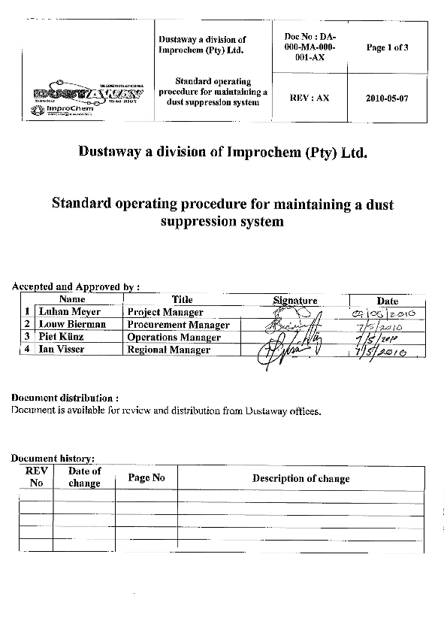

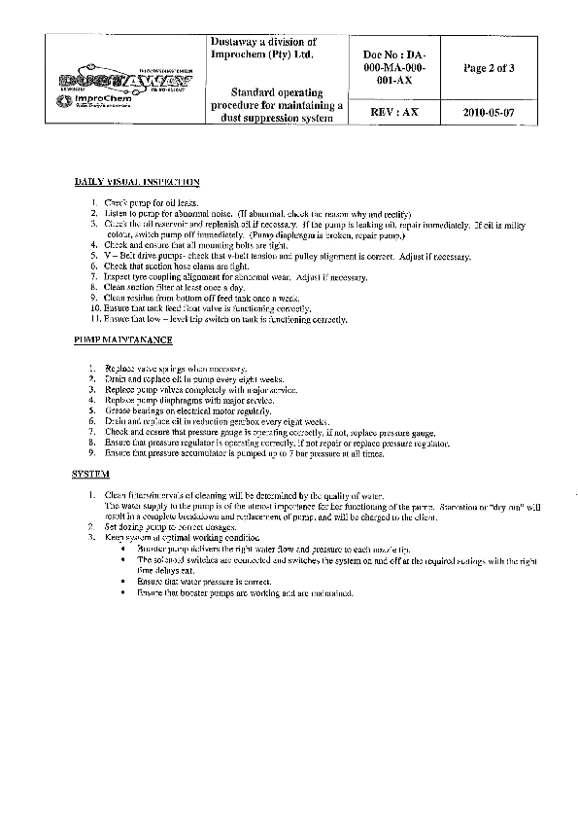

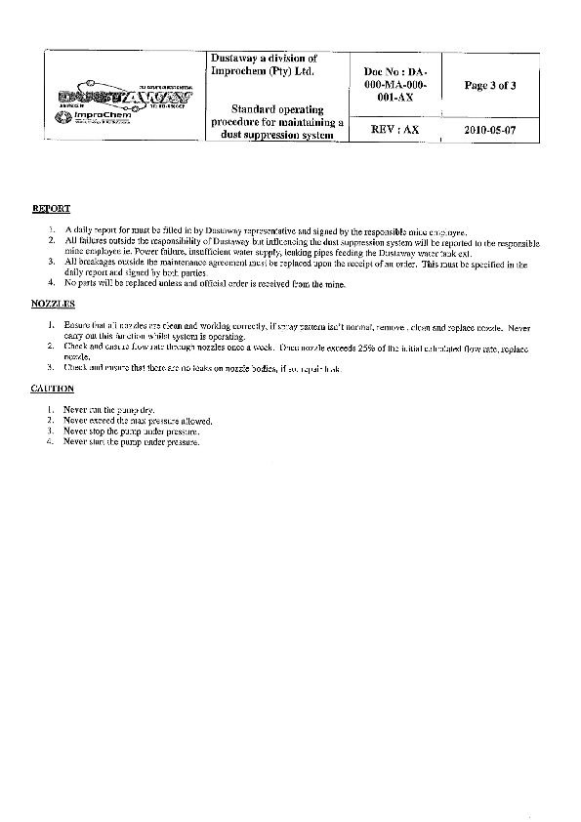

**5.6.3 OEM Risk Assessment of the Installation of DustAway Dust Suppression System**

**Appendix 2**

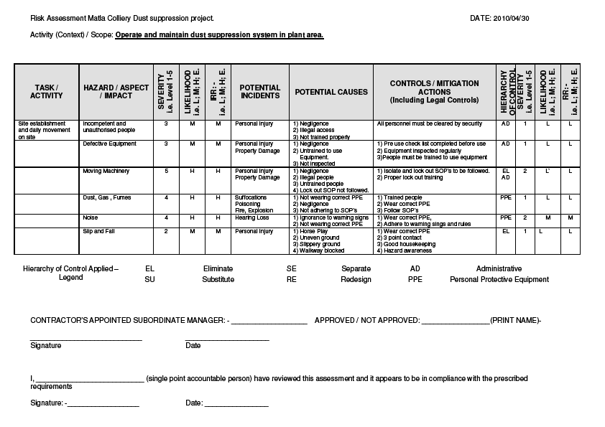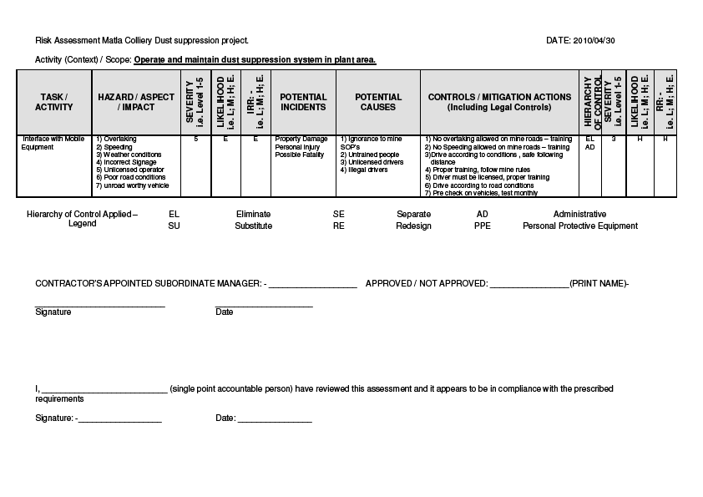

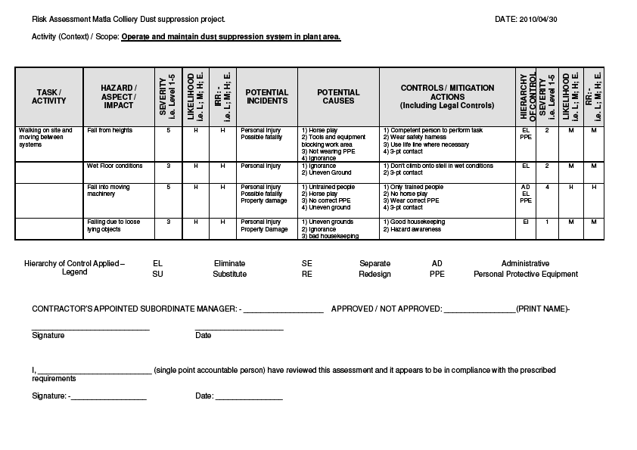

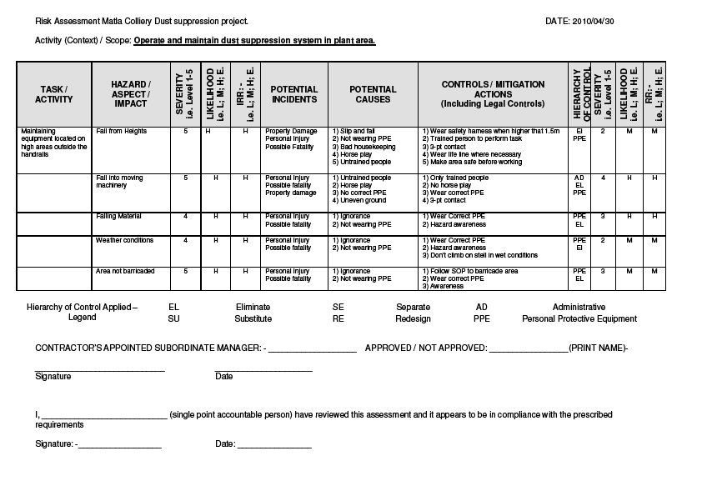

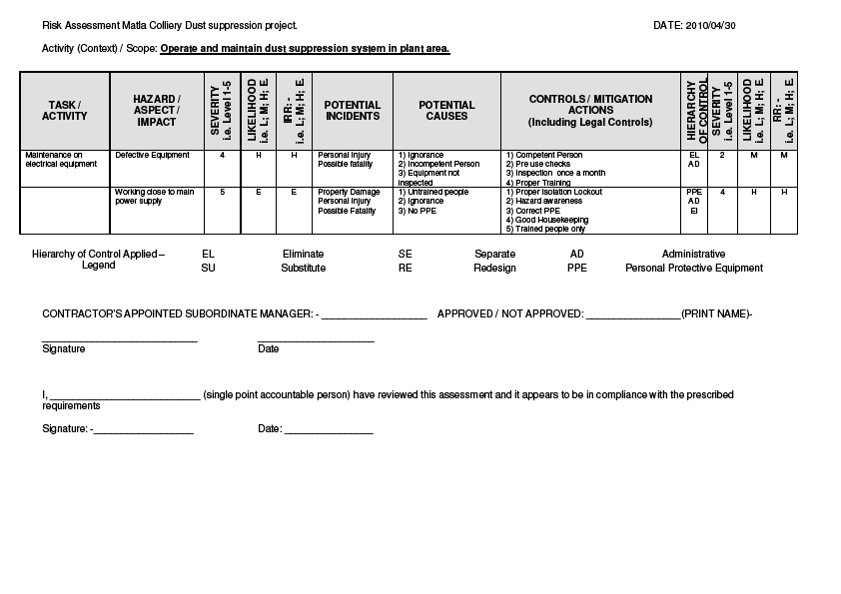

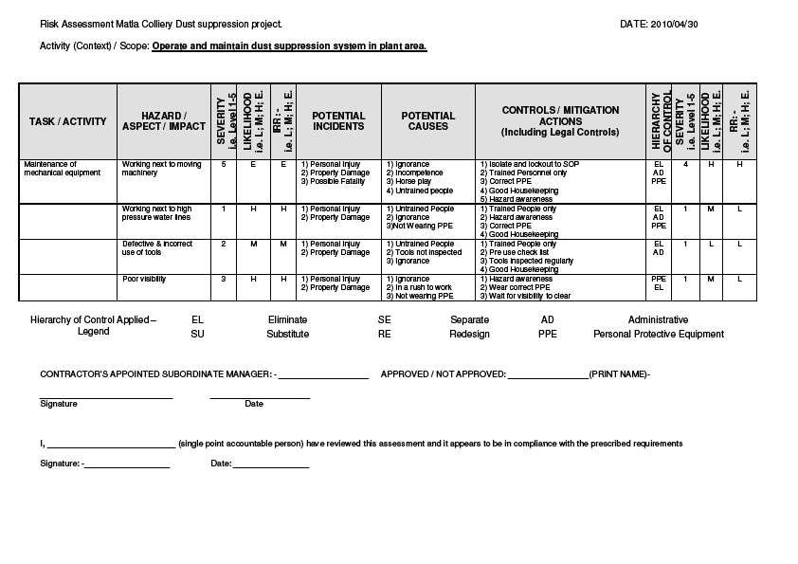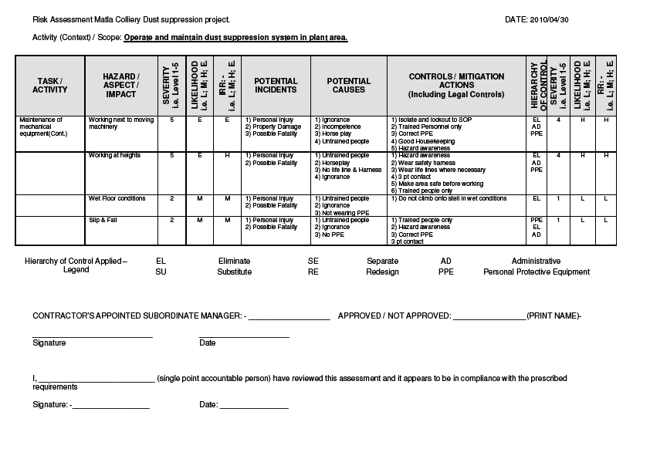

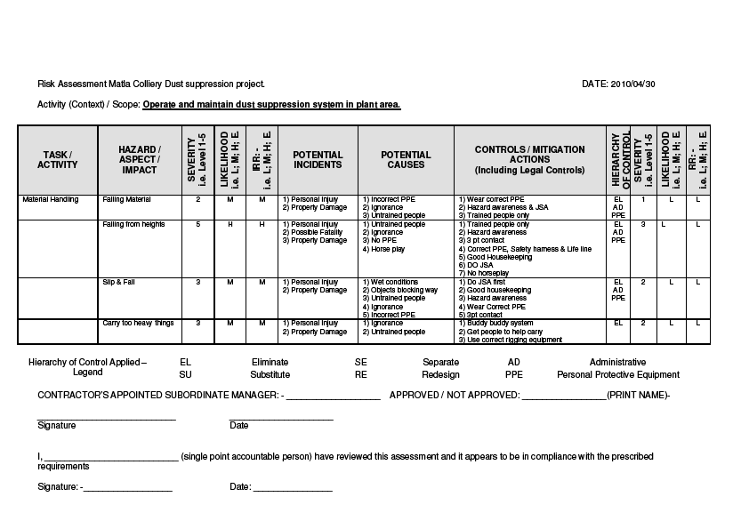

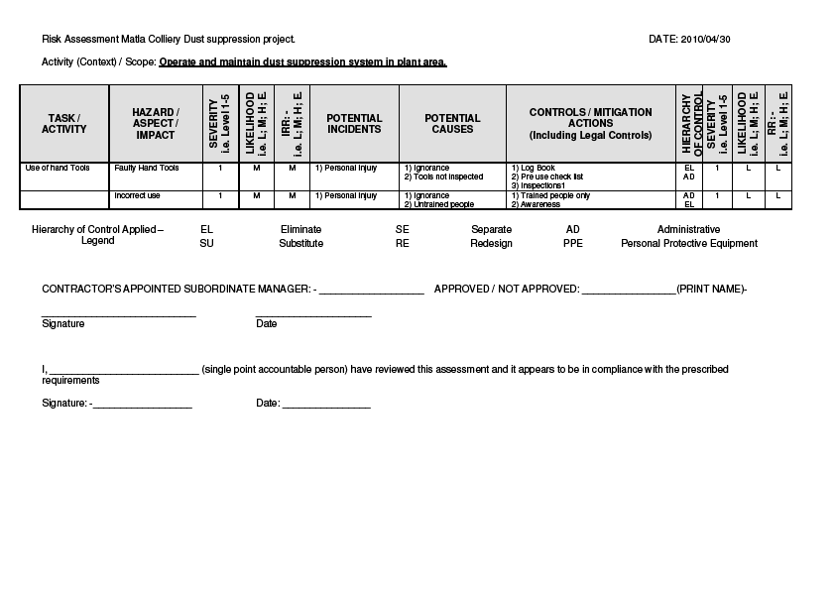

**Matla Coal Risk Assessment of the Operation of DustAway Dust Suppression System**

**Appendix 2**

Safety Risk Assessment Matrix and Recording Sheet

Area: Central Engineering – Plant Date: 12 July 2010

Headline Risk / Scope: SAFE OPERATION OF DUST SUPPRESION SYSTEM AT PLANT SECONDARY CRUSHERS

INTRODUCTION

**1. Aim:**

* 1. The aim of the study is to determine risks associated with the safe operation of the dust suppression system at Plant Secondary Crushers.

**2. Objective:**

* 1. The objective of the study is to conduct a SWIFT study to determine the risk of the exercise.
  2. Analyze potential hazards, reviewing existing controls and current safe guards and make recommendations to eliminate, control, minimize the risk

**3. Scope:**

* 1. The risk assessment covers the risks during the operation and maintenance of the system.

**4. Methodology**

* 1. Members from Matla Coal – Head VOHE Supt, Head of Safety, Plant Foreman & Artisan and Dust Away Operations Manager were involved.
  2. A risk matrix, included in this report, was used to prioritise all risks identified.
  3. Recommendations were made, where existing controls were found according to the team to be insufficient for control and eliminating existing hazards. See the risk assessment sheets attached to this document.

### 5. Hazards identified

5.1 See attached risk assessment.

###### TEAM MEMBERS:

###### RISK ASSESSMENT: SAFE OPERATION OF DUST SUPPRESION SYSTEM AT PNAT SECONDARY CRUSHERS

|  |  |  |  |
| --- | --- | --- | --- |
| Name | **Mine** | **Designation** | **Years Experience** |
| Hendrik Venter | Matla Coal | Acting Head of Safety | 8 yrs |
| Jan Ehlers | Matla Coal | Central Engineering Safety Supt | 14 yrs |
| Piet Kunz | Dust Away | Operations Manager | 6 yrs |
| Andries Mabona  (Project Leader) | Matla Coal | Head VOHE | 8 yrs |
| Eddie du Plessis | Matla Coal | Plant Foreman | 6 yrs |
| Piet Swart | Matla Coal | Acting Fitter Foreman | 16 yrs |

|  |  |  |  |  |  |  |  |  |  |  |  |  |  |  |  |  |  |  |  |
| --- | --- | --- | --- | --- | --- | --- | --- | --- | --- | --- | --- | --- | --- | --- | --- | --- | --- | --- | --- |
| |  |  |  | | --- | --- | --- | | **Index significant priority** | | | | **(28-14)** |  | **High** | | **(16-27)** |  | **Medium** | | **(1-15)** |  | **Low** | | | **More than 100 events per year** | **Between 100 and 10 events per year** | **Between 10 and 1 event per year** | **Between 1 event per year and 1 events in 10 years** | **Between 1 event in 10 years and 1 event in a 100 years** | **Less than 1 event per 100 years** |
| **Probable events more than 100 per year** | **Probable events between 100 and 10 per year** | **Probable events between 10 and 1 per year** | **Probable events between 1 per year and 1 in 10 years** | **Probable events between 1 in 10 years and 1 in 100 years** | **Probable events less than 1 in 100 years** |
|
| **Frequency**    **Severity** | | **6 .** | **5** | **4** | **3** | **2** | **1** |
| Multiple fatalities >6000 Shifts lost | **8** | **48** | **47** | **45** | **42** | **38** | **33** |
| 1 Fatal ± 6000 shifts lost | **7** | **46** | **44** | **41** | **37** | **32** | **27** |
| 600-5999 Shifts lost | **6** | **43** | **40** | **36** | **31** | **26** | **21** |
| 60- 599 Shifts lost | **5** | **39** | **35** | **30** | **25** | **20** | **15** |
| 6-59 Shifts lost | **4** | **34** | **29** | **24** | **19** | **14** | **10** |
| 1- shift lost | **3** | **28** | **23** | **18** | **13** | **9** | **6** |
| No time loss | **2** | **22** | **17** | **12** | **8** | **5** | **3** |
| “Near” Miss | **1** | **16** | **11** | **7** | **4** | **2** | **1** |

**Hazard = the potential for something to cause harm**

**Risk = the likelihood that harm from a hazard will occur**

Safety Risk Assessment Matrix and Recording Sheet

RA P 068

Safety Risk Assessment Matrix and Recording Sheet - RA P 068

Area: Central Engineering – Plant Date: 12 July 2010

Headline Risk / Scope: SAFE OPERATION OF DUST SUPPRESION SYSTEM

|  |  |  |  |  |  |  |  |  |  |  |
| --- | --- | --- | --- | --- | --- | --- | --- | --- | --- | --- |
| **Objective** | **Identify Hazard and Event** | **Gross Risk** | | **Score** | **Controls** | **Net Risk** | | **Score** | **Shortcomings** | **Control Enhancements** |
| **S** | **F** | **S** | **F** |
| 1. SAFE OPERATION OF DUST SUPPRESION SYSTEM | Wet surface causing Slip & Fall injuries | 4 | 4 | 24 | * Good housekeeping * Was area on a regular basis * Non slip strips on steps at screen house * Induction | 3 | 4 | 18 | Ignorance | * Induction * Onsite Induction |
| 2. | Water pipes can burst | 4 | 4 | 24 | * Daily visual inspections |  |  |  |  | * Induction * Onsite Induction * Low pressure (+- 20 bar) * Pump shuts off if pressure drops |
| 3. | System defective | 2 | 3 | 8 | * Daily visual inspections | 2 | 2 | 5 |  | * Indication if system is defective |

|  |  |  |  |  |  |  |  |  |  |  |
| --- | --- | --- | --- | --- | --- | --- | --- | --- | --- | --- |
| 4. | Water tank burst | 4 | 3 | 19 | * Weekly service * Daily visual inspections | 4 | 2 | 14 |  |  |
| 5. | Electrocution due to excessive water | 7 | 3 | 37 | * Ensure that IP ratings of motor and electrical panels is correct * Earth leakage | 7 | 1 | 15 |  | * Emergency stop * Earth Leakage test |



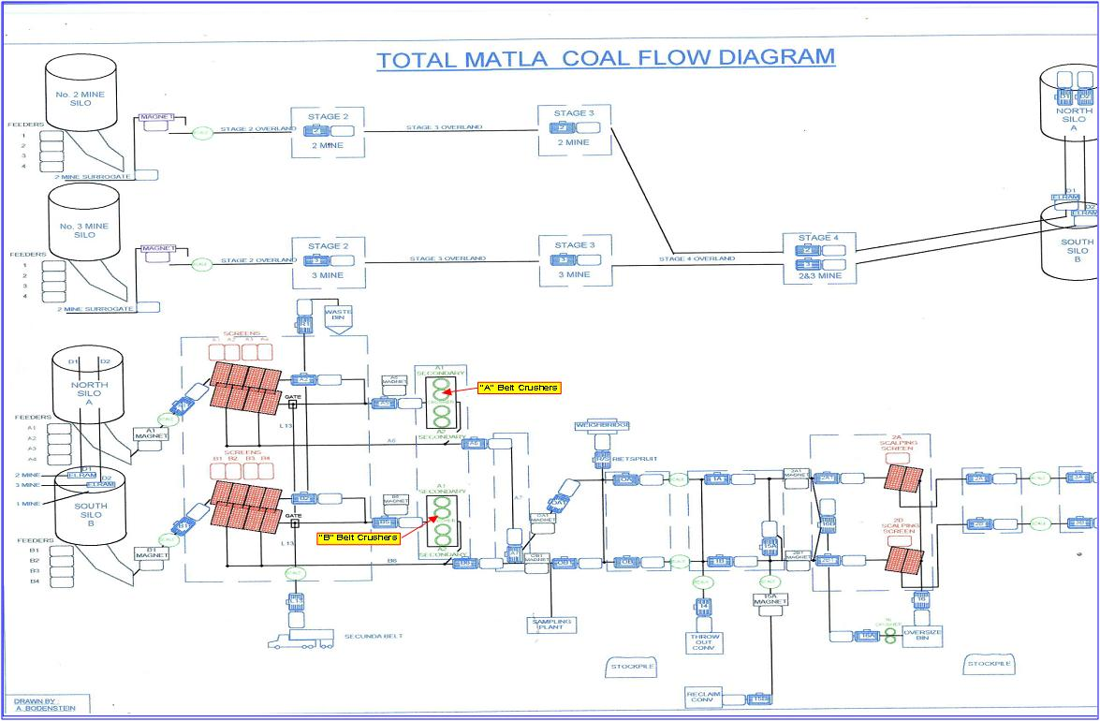

**Appendix 1: Behavioural Communication Plan for Adopters (Employees exposed to the Technology)**

|  |  |  |  |  |  |
| --- | --- | --- | --- | --- | --- |
| **BEHAVIOURAL COMMUNICATION PLAN FOR EMPLOYEES17** | | | | | |
| **Key messages** | **Modes/media options** | **Measure** | | | **By when?** |
| **Activity and Outcome** | **By whom?** | **How?** |

|  |  |  |  |  |  |
| --- | --- | --- | --- | --- | --- |
| Leading practice technology adoption | Fogger tunnel outside the shaft  Site visits  Track C awareness materials  Simulation  DVD  Industrial theatre  Signage – zone /RPE demarcation | Understanding demonstrated or tested  Behaviour observation | Section 12 Appointee  Supervisor  Induction and training  H&S representatives | By observation | Year 1 and ongoing |
| Dust sources, prevention, control and effects to include:   * Appropriate and inappropriate use of RPE * Enabling appropriate use of RPE | Focused dialogue between supervisors and workers  Track C awareness raising materials  Comics  Posters  DVDs  Industrial theatre  Signage - zone / RPE  Board games  Road shows  Campaigns Dummies/mannequins | Knowledge/understanding survey  Observed desired behaviours  Dialogues conducted.   * Consistent appropriate use of RPE * Compliance audits and enforcement * Usage reporting | Section 12 Appointee  Supervisor  Induction and training  H&S representatives Selected/key supervisors  RPE controller | One-on-one dialogues,  Questionnaire  Telephone  Competition Dialogue in meetings, or one-on-one  By observation  Stock control | Year 1 – employees  exposed to the technology; mine management teams; tripartite structures  Year 2 – all employees  Ongoing |

**Appendix 2: Leadership Behaviour Plan**

|  |  |  |  |  |  |
| --- | --- | --- | --- | --- | --- |
| **LEADERSHIP BEHAVIOUR PLAN FOR MINE MANAGEMENT / OE MANAGERS/ SUPERVISORS / TRAINING MANAGERS** | | | | | |
| **Key messages** | **Modes/media options** | **Measure**  **(Activity and Outcome)** | **By whom?** | **How?** | **By when?** |
| Broad silica dust control strategy on the agenda | Focused dialogue between leaders and employees | Dialogues conducted.  Recorded minutes Behaviour observation | Mine management teams  OE Manager  Supervisor  Induction and training | By observation  Dialogue in meetings  One-on-one  On-site visits  Dust control strategies in learning material  Adoption of leading practices  Frequent public announcement at major events  Published in local newsletters and the media | Year 1  Ongoing |
| Employees reporting non-conformances | Focused dialogue between leaders and employees | Dialogues conducted.  Behaviour observation Recorded minutes | Mine management teams  OE Manager  Supervisor  Induction and training | By observation  Report on non-conformances  Dust control strategies in learning material | Year 1  Ongoing |
| Acceptance of leading practices to eliminate ‘not invented here’ syndrome | Focused dialogue between leaders and employees | On-site visits  Behaviour observation | Mine management teams  OE Manager  Supervisor  Induction and training | Behaviour observation  Technology value case in learning material | Year 1  Ongoing |

|  |  |  |  |  |  |  |
| --- | --- | --- | --- | --- | --- | --- |
| **Step** |  | | **What** | |  | **Check – go/no-go decision question** |
|  | |  | |  |  |  |
| 1 |  | | **Identify adopters and key stakeholders at the mine** | |  | Do we have a good understanding and complete identification of potential adopters and stakeholders? |
|  |  | | |  |  |  |
| 2 |  | | | **Select people to be interviewed** |  | Have we chosen the appropriate people to interview? |
|  |  | | |  |  |  |
| 3 |  | | | **Identify and brief the interviewers** |  | Are the interviewers ready to interview? |
|  |  | | |  |  |  |
| 4 |  | | | **Conduct the interviews** |  | Have all the interviews been done and full worksheets completed and returned for processing? |
|  |  | | |  |  |  |
| 5 |  | | | **Summarise the interview results** |  | Have the interview results been systematically assessed and significant new findings clearly identified? |
|  |  | | |  |  |  |
| 6 |  | | | **Use the findings to customise the behavioural communication plan** |  | Are the customised plans coherent and properly understood by the mine team and can they be implemented and effectively monitored in behavioural terms? |
|  |  | | |  |  |  |
| 7 |  | | | **Use the findings to customise the leadership behaviour communication plan** |  | Are the customised plans coherent and properly understood by the mine team and can they be implemented and effectively monitored in behavioural terms? |
|  |  | | |  |  |  |
| 8 |  | | | **Integrate the customised plans into the implementation plan at the mine** |  | Is the overall implementation plan coherent and properly understood by the mine project team? |

A key point about the process outlined above is that it enables the behavioural communication and leadership behaviour plans to be customised on the basis of insight and not guesswork about the thinking, key beliefs and values of the adopters and stakeholders. This allows the communication and leaders’ actions to be tailored to the critical behaviours needed to accomplish adoption of the leading practice.

An expanded diagram indicating how the various steps would be implemented and the practical implications of who needs to do what is provided at the end of the appendix. More detailed guidance is set out in the points that follow.

* 1. **Attention must be focused on ensuring that the key tasks in each step are completed as described in order to produce a quality result:** Behavioural communication and leadership behaviour plans typically have goals, or desired outcomes, that are expressed in behavioural terms. They are expressed in the form of what a person could observe happening in the workplace, or hear in a conversation or interview in the workplace. Both should be as a clear result of communications implemented and the behaviour of leaders. Accomplishing desirable goals of this nature is what is needed to achieve the adoption being sought. This can best be done by following the guidance provided.
  2. **Responsibilities for stewarding the process to completion must be clearly assigned as must responsibilities for completing the requisite individual tasks:** Implementation responsibilities should be clearly set within the Adoption Mine Team in order to ensure that the entire process outlined in this appendix is appropriately stewarded. This will ensure that individual tasks are completed as required, and that the outcomes for plans are appropriately measured and reported. This could involve spreading the tasks across many individuals, or perhaps concentrating the process in a small number of key individuals. While the use of a small number of key individuals may be more manageable, the group should be large enough to reduce the risk of personal bias and to spread the benefits derived from meaningful interaction with staff on a matter that is of direct concern to them.

The Adoption Mine Team should however ensure that a single person with appropriate skill and orientation takes on the responsibility for overseeing the process. The selected person should be experienced in interacting effectively with a wide variety of people, be at ease with and be able to effectively listen to people, and to correctly interpret conversations with people. The training department at mines is likely to have a few such people, but other functions should also be considered. Other persons providing the support needed to execute the required tasks may require special training in order to be effective in undertaking the work, and such training should be provided. The Adoption Mine Team Leader should be consulted on this point as necessary.

* 1. **The eight-step customisation process must be systematically executed:** To facilitate easy application of the process at adoption mines, each of the eight steps describes an essential task and a small number of sub-tasks. The steps and sub-tasks should be completed in the recommended order without any skipping or reordering of tasks. Guidance on how to complete the tasks is typically offered in the form of key questions to be answered by those at the adoption mine responsible for preparing and implementing the plans.

At the end of each step, a checkpoint question and action is indicated. The checkpoint question is intended to act as a “go/no-go” decision point for the Adoption Mine Team. If the Adoption Mine Team cannot satisfactorily answer the checkpoint question, then they should not go to the next step. Instead, they must take steps to rectify the matter.

**Step one - Identify adopters and key stakeholders at the adoption mine.**

Adopters and stakeholders are those people and groups who will be the focus of behavioural communication and leadership behaviour efforts. Key points for identifying adopters and stakeholders are as follows:

* + The Learning Hub Adoption Team has provided the adoption mine project team with a simple summary of the risk “story” being addressed by the leading practice, based on the risk summary table finalised during their planning workshop. This is included in this adoption guide as Appendix 5. In some cases the Adoption Mine Team may need to modify the risk story to take account of special circumstances at the mine.
  + The Adoption Mine Team should review the risk story summary and confirm or elaborate on the description of adopters and stakeholders to ensure that:
    - * All members of the team have the same understanding of the risks being addressed by the leading practice, and
      * They have identified the particular adopters and stakeholders at the adoption mine that will be involved in achieving implementation of the leading practice.

A list of the identified adopters and stakeholders who will be the focus of behavioural communication and leadership behaviour efforts in the adoption mine should be prepared by the Adoption Mine Team.

The Adoption Mine Team should address the checkpoint question of whether the team has a good understanding and has a complete identification of the potential adopters and stakeholders in order to make a “go/no-go” decision in respect of proceeding to the next step in the process.

**Step two - Select people to be interviewed**

The only way to accurately understand people’s thinking is to directly enquire into it. People are complicated and their thinking is unpredictable. One cannot successfully guess or predict people’s thinking and their information needs. The process of direct enquiry requires that an appropriate number of persons be interviewed, as follows:

* + From the prepared list of adopters and stakeholders at the adoption mine, the persons to be interviewed should be selected. The people selected should range across the various categories of adopters and stakeholders in such a way as to ensure good representation of those most likely to be most involved in accomplishing adoption of leading practice. The number of persons to be interviewed should be between 25 and 30. This has been shown to be an appropriate number to obtain useful interview results.

The Adoption Mine Team should address the checkpoint question of whether the appropriate people have been chosen to be interviewed in order to make the “go/no-go” decision in respect of proceeding to the next step in the process.

**Step three – Identify and brief interviewers.**

Interviews with the selected adopters and stakeholders should be done confidentially and one-on-one. No interviews of people in groups or in a group setting should be done because of challenges in accurately interpreting their results. Also, the circulation of printed questionnaires where people are asked to fill in answers to questions is to be avoided because of challenges in producing satisfactory insights into people’s thinking. Key points in selecting and training the interviewers are as follows:

* + The Adoption Mine Team should choose as interviewers those people who:
    - * interviewees are most likely to feel comfortable with in an interview setting, that is, to feel free to speak openly and candidly with the person conducting the interview, and
      * are most likely to complete each assigned interview in the manner prescribed.
  + Interviewers should ensure that they are well equipped to conduct the interviews by:
    - * studying and discussing the risk summary / simple risk story with an appropriate member of the Adoption Mine Team to ensure that they have a thorough understanding of the risks being addressed by the leading practice,
      * reading the interviewer’s briefing on the list of questions to be asked in the interview, as well as guidance on conducting a one-on-one interview properly. The latter is available from the Learning Hub Adoption Team.
      * practicing the interview at least once (perhaps with an adoption mine team member), and
      * reviewing with the Adoption Mine Team their understanding of the interview and how it should be conducted and documented.

The Adoption Mine Team should check that the interviewers are ready to conduct the interviews in order make a “go/no-go” decision in respect of proceeding to the next step in the process.

**Step four – Conduct the interviews.**

The interview process consists of two parts which seek to establish the following:

* Stakeholders/ Adopters beliefs about the causes and outcomes of [the risk/hazard],
* Stakeholders/ Adopters beliefs about the best ways to protect people from [the risk/hazard], and

* Stakeholders/Adopters beliefs about key leader behaviours and behavioural communication needs.

In these points the term beliefs should be taken to include attitudes and views that form part of a person’s mental model. Similarly, use of the term [the risk/hazard] means the risk associated with the particular hazard that is under consideration. It encompasses the complete picture of the risks associated with a specific hazard in a way that is consistent with the treatment of both concepts in the risk summary.

* + Each interviewer should schedule all of their allotted interviews to be conducted one-on-one in a place suitably private and free from noise and other distractions. The interviews should be conducted as planned and as practiced. Interviewers should ask all questions fully, prompting for as complete and in-depth answers as possible. This is a particular aspect of the interviewing procedure that should be focused upon in the practice sessions.
  + Interview responses should be carefully documented at the time of the interview using the Interview Worksheet and the Interviewee’s own words. An example worksheet is attached as Worksheet #1. Immediately following conclusion of the interview, the brief notes taken during the interview should be expanded upon in the interview worksheets to fully document the detail of the interviewee’s responses. One Interview Worksheet should be completed for each interview conducted. Worksheets should be collected into sets for reading and analysis.

The questions to be asked in the interview are provided in the worksheet and are as follows:

*Part A: Adopter/Stakeholder beliefs about* [the risk/hazard] *(Causes and Outcomes)*

* Please describe your role and responsibilities at the mine.
* Please describe [the hazard] in your own words.
* How may [the hazard] occur? *or* What are the possible causes of [the risk/hazard]?
* What happens as a result of [the risk/hazard]?
* How might you be affected by [the risk/hazard]?
* Who else may be most affected by [the risk/hazard]? What may happen to people who are affected by [the risk/hazard]?
* How important do you think it is to find a way to better protect people from [the risk/hazard]? Why do you say that?

*Part B: Adopter/Stakeholder Beliefs about Leading Practices*

* What do you think could be done to better protect people from [the risk/hazard]? Why?
* This mine is currently working to bring about leading practices to better protect people from [the risk/hazard]. The interviewer should describe the proposed leading practice in simple neutral terms.
* What should leaders and supervisors in the mine do to help make sure that these practices are successful?
* What should leaders not do in order to make sure that these practices are successful?
* What other kinds of things might stand in the way of the leading practice being successful at this mine? How should these things be addressed?
* What information would be important for people like you to know about how people can be affected by the risk and what is being done to protect them?
* What is the best way for people like you to receive this information?

Before going to the next step, the Adoption Mine Team should check that all the interviews have been done and that full worksheets have been completed and returned for processing in order to make a “go/no-go” decision in respect of proceeding to the next step in the process.

**Step five – Summarise the interview results.**

The simple analysis outlined below is designed to allow the Adoption Mine Team to better understand the thinking of their stakeholders and adopters and to compare the thinking at their mine with:

* The most informed understanding of the hazard, as summarised in the Risk Story provided by the Learning Hub Adoption Team, as adjusted by the Adoption Mine Team – see step 1, and
* The thinking of adopters and stakeholders at the demonstration mine, and to this end the Learning Hub Adoption Team have included in this leading practice adoption guide a summary of the mental models that they have previously identified for these persons at the demonstration mine. (See Appendix 8.)
  + Persons capable of reliably summarising the interview results must be chosen to undertake this work. The Adoption Mine Team should find the analysis process relatively straightforward. In essence, the analyst will need to carefully read each set of interview notes and make observations against key questions provided in an analysis worksheet. The analysis worksheet is attached as worksheet #2.
  + Members of the Adoption Mine Team could be selected as analysts. This would have the advantage of ensuring that some or all of the adoption team members would have a first hand understanding of the interview results. Alternatively, the task may be assigned to two or more individuals associated with the team and adoption effort, but not to only one person. In any event, each analyst should have a sound understanding of the risk summary in order to properly interpret the interview results.
  + Working alone, each analyst should read and note their observations against questions posed in the analysis worksheet. Once all interviews have been analysed in this way, the analysts should meet in a group session to share and compare the results of their analyses. The analysts should identify where their individual analyses agree, and why, and where they disagree and why. Disagreements between analysts should be noted. As a group,the analysts should address the main questions in the worksheet for analysis, writing detailed answers to the questions, and identifying the most influential beliefs and their underlying rationale in the process of doing so.
  + As a final check, the group should re-read the interviews to ensure that the group has adequately captured and described the key beliefs on the questions asked of the stakeholders and adopters.

The questions in the analysis worksheet, Worksheet #2, that form the basis of the analysis are as follows:

*Part A: Adopter/Stakeholder Beliefs about [the risk/hazard] (Causes and Outcomes)*

* What are the most frequently mentioned causes of [the risk/hazard]?
* Which, if any, of these causes agree with the Risk Summary?
* Are there causes that disagree with the Risk Summary? Describe any areas where people may have a difference in their thinking.
* Is there any information on causes that they say they want to know?
* What are the most frequently mentioned outcomes of [the risk/hazard]?
* Repeat Prompts above

*Part B: Adopter/Stakeholder Beliefs about Leading Practices*

* What are the most frequently mentioned opportunities to better protect people from [the risk/hazard].
* What reasons do they give?
* Which, if any, of these ways agree with the features of the leading practice?
* Are there any ways mentioned that differ from the features of the leading practice? Explain the possible reasons for this disagreement.
* What are the most frequently mentioned leadership behaviours that should be done, and should not be done.
* Repeat Prompts above.
* What information do people say they want? What are the most frequently mentioned best ways to communicate with people.
* Repeat Prompts above.
  + Using Worksheet #2, analysts should then compare the results of their analyses of adopter and stakeholder interview findings with the results of interviews conducted with similar individuals at the demonstration mine. This analysis should note where adoption mine results are similar to those noted at the demonstration mine and where they are different. These similarities and differences are to serve as the basis for customising the behavioural communication and leadership behaviour plans to address the particular circumstances identified at the adoption mine.

The questions in the analysis worksheet that guide the comparison process are as follows:

*Part A: Adopter/Stakeholder Beliefs about* [the risk/hazard] *(Causes and Outcomes)*

* What, if any, are the key similarities between the results in Part A and those of the demonstration mine that should be emphasised?
* What, if any, are the key differences between the results in Part A and those of the demonstration mine that should be emphasised?

*Part B: Adopter/Stakeholder Beliefs about Leading Practices*

* What, if any, are the key similarities between the results in Part B and those of the demonstration mine that should be emphasised?
* What, if any, are the key differences between the results in Part B and those of the demonstration mine that should be emphasised?

Before going to the next step, the adoption mine should check whether all of the interview results have been systematically reviewed and all of the significant differences clearly identified as a basis for making a “go/no-go” decision in respect of proceeding to the next step in the process.

**Step six – Customise the behavioural communication plan.**

A detailed behavioural communication plan has been developed by the Learning Hub Adoption Team to serve as the base plan to be customised by the adoption mine. This is the plan developed for the demonstration mine modified as necessary to take account of the experience gained in implementing it. The plan is attached as Appendix 1 to this Adoption Guide.

The Adoption Mine Team should ensure that they fully understand the plan developed for the demonstration mine, and its derivation, before proceeding with the process of customising the plan to suit their mine specific circumstances.

The Adoption Mine Team, and not just a single person, should prepare the customised behavioural communication plan based strictly on answers to the following guiding questions:

*Guiding questions for customisation of the behavioural communications plan.*

* What, if any, of the modes of communication in the demonstration mine’s behavioural communication plan should be included in the adoption mine’s plan? Can any be removed without affecting the overall quality of the plan?
* What, if any, of the content or key messages in the different modes in the demonstration mine’s behavioural communication plan should be kept in the adoption mine’s plan?
* What, if any, new content or key messages should be added to the behavioural communication plan for the adoption mine?
* Will these changes best match with the modes that should be used and key messages that should be conveyed in the adoption mine as revealed through the interview results?
* What is the best way to go about implementing the behavioural communication plan?

*Additional questions that should be answered in considering the communication content of the new plan are as follows:*

* From the interview results, what correct understandings about [the hazard] should be emphasised in communications?
* What incorrect beliefs or misunderstandings about [the risk/hazard] should be corrected through communications? What key messages should be emphasised in order to do so?
* What do people not know that is important to understand in order to fully appreciate the nature of [the hazard], and which should therefore be emphasised in communications?
* What information about [the risk/hazard] do people most want to know, and which should therefore be emphasised in communications?
* What sorts of messages should be emphasised to help people judge the trustworthiness and competence of their fellow employees and leaders involved in addressing [the risk/hazard]? (The creation of trust is a fundamental aspect of all behavioural communication plans.)
  + In respect of the modes of communication and the contents of each communication, on the basis of the answers to the above questions, and the modes of communication available at the adoption mine, the Adoption Mine Team should adjust the modes and content of the base plan provided by the Learning Hub Adoption Team (see Appendix 1).
  + Where new material is introduced into the plan, measurable objectives should be identified. These should be in the form of behavioural outcomes. This means that they should be expressed as actions that can be observed as the intended outcome from the communication in question. (What could people be seen to do?) They could also be understandings, concepts or beliefs expressed in conversations or interviews that clearly follow from the communications, as intended. (What could people be heard to say?) While the objectives preserved from the base plan should provide examples of what is required, they should also be checked, and modified if necessary to ensure consistency.
  + The Adoption Mine Team should explore the possibility of reviewing their customised plan with one or other of the following: the relevant Learning or Programme Manager at the Learning Hub, the Behavioural Specialist at the Learning Hub, the project team leader at a mine that has successfully adopted the practice, or a qualified external resource with assistance of the Learning Hub. The input received should be used to adjust the plan as appropriate.

The Adoption Mine Team should then check whether the customised plans are coherent and properly understood, that they have readily measurable behavioural goals for communication, and that they can be readily implemented, as a basis for making a “go/no-go” decision in respect of proceeding to the next step in the process.

**Step seven – Adjust the leadership behaviour plan.**

In a manner similar to that for customising the behavioural communication plan, a detailed leadership behaviour plan, developed by the Learning Hub Adoption Team, is provided in this adoption guide to serve as the base plan to be customised by adoption mines. The plan sets out the required antecedents, key leader behaviours and re-enforcing consequences for those behaviours. Again, this is the plan developed for the demonstration mine, modified as necessary to take account of the experience gained in implementing it.

As with the behavioural communication plan, the Adoption Mine Team should ensure that they fully understand the plan developed for the demonstration mine, and its derivation, before proceeding with the process of customising the plan to suit their mine specific circumstances. The plan is attached as Appendix 2.

The Adoption Mine Team should prepare the customised leadership behaviour plan based on answers to the following guiding questions:

*Guiding questions for customisation of the Leadership Behaviour Plan.*

* With respect to the stakeholders and adopters involved, who are considered to be the key leaders involved in accomplishing adoption of the leading practice?
* For each leader or type of leader, what key behaviours or actions must they perform to appropriately influence the decisions and actions of the stakeholders and adopters? (The set of Behaviours)
* What must the leaders be provided with to enable them to perform these behaviours? (The set of Antecedents)
* What consequences – positive, immediate and certain – must follow performance of the key behaviours that will encourage them to be repeated and sustained? (The set of Consequences)
* What, if any, of the key behaviours, antecedents and consequences in the demonstration mine’s behavioural communication plan should be included in this mine’s behavioural communication plan?
* What, if any, of the key behaviours, antecedents and consequences in the demonstration mine’s behavioural communication plan should be omitted from this mine’s behavioural communication plan?
* What is the best way to go about implementing the leadership behaviour plan?
  + Where new material is introduced into the plan, measurable objectives should be identified. These should be in the form of behavioural outcomes. That is, they should be expressed as actions of leaders that can be observed and which clearly follow from the leadership behaviour plan, as intended. (The key desired behaviours - What could leaders be seen to do?) They could also be understandings, concepts or beliefs expressed in conversations or interviews with leaders or others that clearly follow from the leadership behaviour plans, as intended. (What could leaders be heard to say or what could they be accurately reported to say?) While the objectives preserved from the base plan should provide examples of what is required, they should also be checked, and modified if necessary to ensure consistency.
  + As with the behavioural communication plan, the Adoption Mine Team should explore the possibility of reviewing their customised plan with one or other of the following: the relevant Learning or Programme Manager at the Learning Hub, the Behavioural Specialist at the Learning Hub, the project team leader at a mine that has successfully adopted the practice, or a qualified external resource. The input received should be used to adjust the plan as appropriate.

The adoption mine project team should then check whether the customised leadership behaviour plans are coherent and properly understood, and that they can be readily implemented as a basis for making a “go/no-go” decision in respect of proceeding to the next step in the process.

**Step eight – Integrate behavioural communication and leadership behaviour plans into the implementation plan at the adoption mine.**

* + Based on the experience gained at the demonstration mine, the Learning Hub Adoption Team has included guidance in this adoption guide as Appendix 12 to assist the Adoption Mine Team in integrating their customised behavioural communication and leadership behaviour plans into the overall implementation plan at the adoption mine.
  + A component of the integrated implementation plan is a monitoring programme that includes appropriate checking and reporting on the occurrence of the desired observable behaviours, as well checking and reporting on provision of the necessary antecedents and re-enforcing consequences.

Before beginning implementation, the Adoption Mine Team should check whether the overall implementation plan is coherent and properly understood by the team, as a basis for making a “go/no-go” decision in respect of proceeding implementation of the adoption plan.

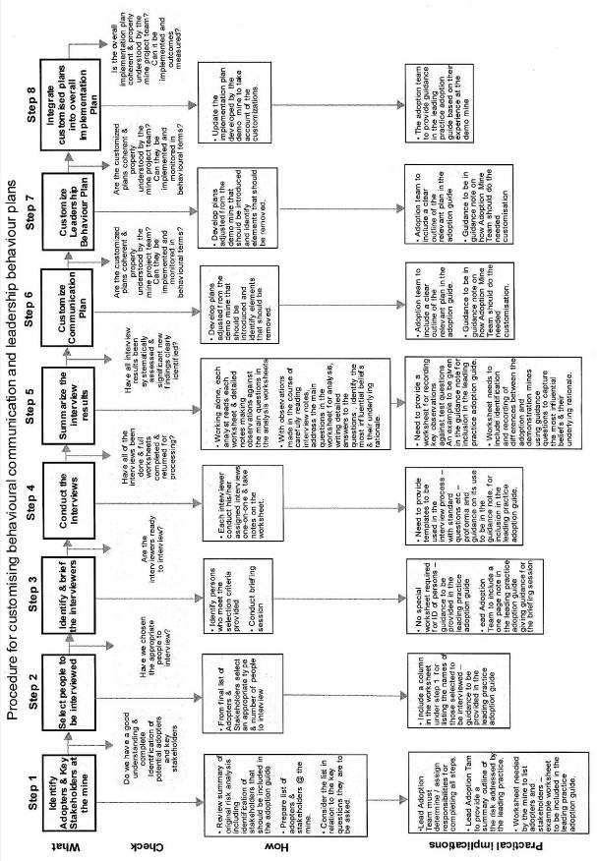

**Worksheet #1: Questions for use in conducting interviews**

|  |  |  |  |  |  |
| --- | --- | --- | --- | --- | --- |
| **Name of Leading Practice:** | | | | | |
| **Instructions:** Indicate any particular instructions that need to be followed | | | | | |
| **Unique Interview Reference Number** | | **Interview Date** | | **Name of Mine** | **Name of Worker Position** |
| [ example: *DUST* ] | | [ example: *12 April 2010* ] | | [ example: *Exxaro Matla Coal* ] | [ example: *Mine Overseer* [ |
| **Part A: Adopter/Stakeholder beliefs about [the hazard] (Causes and outcomes)** | | | | | |
| 1 | Please describe your role and responsibilities at the mine. | |  | | |
| 2 | Please describe [the risk/hazard] in your own words.   * How may [the risk/hazard] occur? * What are the possible causes of [the risk/hazard]? | |  | | |
| 3 | What happens as a result of [the hazard]?   * How might you be affected by [the risk/hazard]? * Who else may be most affected by [the risk/hazard]? * What may happen to people who are affected by [the risk/hazard]? | |  | | |
| 4 | How important do you think it is to find a way to better protect people [the risk/hazard]?   * Why do you say that? | |  | | |
| **Part B: Adopter/Stakeholder Beliefs about Leading Practices** | | | | | |
| 5 | What do you think could be done to better protect people from [the risk/hazard]?  Why? | |  | | |
| ***Interviewer say***: This mine is currently working to bring about leading practices to better protect people from [the risk/hazard]. Describe the proposed leading practice in simple neutral terms. | | | | | |
| 6 | What should leaders and supervisors in the mine do to help make sure that these practices are successful?  Why should they do this? | |  | | |
| 7 | What should leaders not do in order to make sure that these practices are successful?  Why should they not do this? | |  | | |
| 8 | What other kinds of things might stand in the way of the leading practice being successful at this mine?  How should these things be addressed? | |  | | |
| 9 | What information would be important for people like you to know about how people can be affected by the risk and what is being done to protect them?  Why is this important? | |  | | |
| 10 | What is the best way for people like you to receive this information?  Why is this the best way? | |  | | |

**Worksheet #2: Analysis of results from interviews**

|  |  |  |  |
| --- | --- | --- | --- |
| **Name of Leading Practice** | | | |
| **Instructions:** To be used to summarise results of individual interviews from the Interview Worksheet – Worksheet #1. See guidance provided in the guidance note. | | | |
| **Part A: Adopter/Stakeholder beliefs about [the risk/hazard]** **(Causes and impacts)** | | | |
| 1 | List and tabulate Interviewees’ roles and responsibilities. | | |
| 2 | List and tabulate mentioned *causes* of [the risk/hazard] | * Which, if any, of these causes agree with the Risk Summary? * List any causes that disagree with the Risk Summary. Describe how people who were interviewed may be wrong in their thinking about the hazard and risk. | |
| List any information on causes that Interviewees say they want to know. | | |
| 3 | * List and tabulate mentioned *impacts* of [the risk/hazard]. Include description of *who* may be affected. | * Which, if any, of these impacts agree with the Risk Summary?      * List impacts that may disagree with the Risk Summary? Describe any areas where people who were interviewed may be wrong in their thinking about possible impacts. | |
| * List any information on impacts that Interviewees say they want to know. | | |
| 4 | * Summarise Interviewees’ comments on the importance and value of better protecting people from [the risk/hazard]? | | |
| **Summary of Part A.** Compare the results above to the mental models results of the demonstration mine project. | | | |
| What, if any, are the key similarities between the results in Part A and those of the demonstration mine that should be emphasised in behavioural communications and leadership behaviour plans? | | | * What, if any, are the key differences between the results in Part A and those of the demonstration mine that should be emphasised in behavioural communications and leadership behaviour plans? |

**Worksheet #2 Continued**

|  |  |  |
| --- | --- | --- |
| **Part B: Adopter/Stakeholder Beliefs about Leading Practices** | | |
| 5 | List and tabulate mentioned opportunities to better protect people from the hazard. Describe why, in the Interviewees’ words. | * Which, if any, of these ways agree with the features of the leading practice?      * Are there any ways mentioned that differ from the features of the leading practice? Explain the possible reasons for this disagreement. |
| 6 | List and tabulate mentioned leadership behaviours that should be done to ensure the success of leading practice. Describe why, in the Interviewees’ words. | * Which, if any, of these ways agree with the features of the leading practice? * Are there any ways mentioned that differ from the features of the leading practice? Explain the possible reasons for this disagreement. |
| 7 | List and tabulate mentioned leadership behaviours that should not be performed to ensure the success of leading practice. Describe why, in the Interviewees’ words. | * Which, if any, of these ways agree with the features of the leading practice? * Describe any ways mentioned that differ from the features of the leading practice? Explain the possible reasons for this disagreement. |
| 8 | List and tabulate mentioned potential barriers to the success of the leading practice at this mine? Describe Interviewees’ perceptions on how should these things be addressed? | * Which, if any, of these barriers and possible solutions agree with the features of the leading practice? * Describe any barriers and possible solutions mentioned that differ from the features of the leading practice? Explain the possible reasons for this disagreement. |
| 9 | List and tabulate the information people need. Describe why, in the Interviewees’ words. | * Which, if any, of these ways agree with the features of the leading practice? * Describe any ways mentioned that differ from the features of the leading practice? Explain the possible reasons for this disagreement. |
| 10 | List and tabulate the mentioned best ways to communicate to people. Describe why, in the Interviewees’ words. | * Which, if any, of these ways agree with the features of the leading practice?      * Describe any ways mentioned that differ from the features of the leading practice? Explain the possible reasons for this disagreement. |
| **Summary of Part B.** Compare the results above to the mental models results of the demonstration mine project. | | |
| * What, if any, are the key similarities between the results in Part B and those of the demonstration mine that should be emphasised in behavioural communications and leadership behaviour plans? | | * What, if any, are the key differences between the results in Part B and those of the demonstration mine that should be emphasised in behavioural communications and leadership behaviour plans? |

**Worksheet #3: Customisation of behavioural communication and leadership behaviour plans**

|  |
| --- |
| **Name of Leading Practice** |
| **Instructions:** To be used to customise the behavioural communication and leadership behaviour plans. See guidance provided in the guidance note. Provide adequate space for responding to the various questions and any other instructions that should be followed. |
| **Guiding questions for customisation of the behavioural communication plan** |
| * What, if any, of the modes of communication in the demonstration project’s behavioural communication plan should be included in this mine’s plan? Can any be removed without affecting the overall quality of the plan? * What, if any, of the content or key messages in the different modes in the demonstration project’s behavioural communication plan should be kept in this mine’s plan? * What, if any, new content or key messages should be added to the behavioural communication plan for this mine? * Will these changes best match with the modes that should be used and key messages that should be conveyed in the adoption mine as revealed through the interview results? * What is the best way to go about implementing the behavioural communication plan? |
| **Guiding questions for customisation of the leadership behaviour plan:** |
| * With respect to the stakeholders and adopters involved, who are considered to be the key leaders involved in accomplishing adoption of the leading practice? * For each leader or type of leader, what key behaviours or actions must they perform to appropriately influence the decisions and actions of the stakeholders and adopters. (The set of Behaviours) Why? * What must the leaders be provided to enable them to perform these behaviours? (The set of Antecedents). Why? * What consequences – positive, immediate and certain – must follow performance of the key behaviours that will encourage them to be repeated and sustained? (The set of Consequences). Why? * What, if any, of the key behaviours, antecedents and consequences in the demonstration mine’s leadership behaviour plan should be included in this mine’s leadership behaviour plan? Why? * What, if any, of the key behaviours, antecedents and consequences in the demonstration mine’s leadership behaviour plan should be omitted from this mine’s leadership behaviour plan? Why? * What is the best way to go about implementing the leadership behaviour plan? |

**Appendix 4: Airborne Respirable Particulate Filtration Efficiency Test Protocol of GE Water & Process Technologies Spray System installed at Gold Fields South Deep Mine**

**CHAMBER OF MINES OF SOUTH AFRICA**

**MOSH Adoption System**

**Dust Demonstration Project**

**AIRBORNE RESPIRABLE PARTICULATE FILTRATION EFFICIENCY TEST PROTOCOL**

**of**

**GE Water & Process Technologies Spray System**

**Installed at**

**Gold Fields South Deep Mine**

**GLOSSARY OF ABBREVIATIONS, SYMBOLS AND TERMS**

**CSIR-NRE**

Council for Scientific and Industrial Research – Natural Resources and the Environment

**Diameter (µm)**

Representative particle size in the particle size column. The value is calculated by (lower limit particle size in this particle size column  upper limit particle size in this particle size column) ^0.5.

**GME**

Government Mining Engineer

**L/min**

Litres per minute

**MDHS 101**

Methods for the Determination of Hazardous Substances. Health and Safety Laboratory (UK). Crystalline silica in respirable airborne dusts. Direct-on-filter analysis by infrared spectroscopy and X-ray diffraction.

### 1 OBJECTIVE

The objective of the study is to determine:

* the airborne respirable particulate filtration efficiency, and
* the airborne ammonia reduction potential,

of the currently installed GE Water & Process Technologies water spray system, installed at Gold Fields South Deep Mine.

### 2 METHODOLOGY

Please refer to figure 2.1 for assistance with study methodology explanation.

### 2.1 Instrumentation

### 2.1.1 Gravimetric dust sampling

Each sampling position will consist of two Gillian gravimetric dust sampling trains, fitted with 25 mm diameter cellulose nitrate sampling filters, with a pore size of 0,8 µm.

Two gravimetric dust sampling trains will be positioned at each sampling position (> 300 mm apart). One sample will be utilised as the back-up sample in the event that one of the samples fails to be taken (e.g. pump stop, filter damaged, etc).

The respirable dust sampling cassettes will be fitted with SKC-type respirable dust selective cyclones. The number and type of gravimetric dust sampling per test will be placed as indicated in table 2.1.

### 2.1.2 Environmental conditions monitoring

Continuous environmental conditions monitoring will be conducted by means of a Kestrel 4500 instrument. The following environmental conditions will be monitored:

* Dry-bulb temperature (ºC);
* Wet-bulb temperature (ºC);
* Humidity (%);
* Air flow velocity (m/s);
* Barometric pressure; and
* Airway dimensions (height and width) at the sampling and measuring positions.

### 2.1.3 Ammonia analysis

The airborne ammonia concentration will be determined by utilising Chromair™ NH3 passive colorimetric badges. The concentrations of NH3 (in ppm) will be determined from a Chromair™ Comparator. The results will be reported in the following comparator ranges: 4 to 20 ppm, 20 to 60 ppm, 60 to 120 ppm, 120 to 200 ppm, 200 to 300 ppm and more than 300 ppm. The following legislated exposure limits are applicable for NH3; OEL of 25 ppm and STEL of 55 ppm.

### 2.1.4 Test duration

Each test (pre- and post-test) will be conducted for the duration that it takes for one train to empty all of its hoppers in the ore-pass system.

### 2.1.5 Water quantity

The GE Water & Process Technologies water spray system water flow rate and water pressure will be recorded at the start and completion of each study. These results will be recorded on the Project Survey Sheet (Appendix A).

### 2.1.6 Tonnages

The tonnage will be estimated from the number of hoppers tipped, multiplied by the design capacity of each hopper.

### 2.2 Sampling positions

Sampling positions will be selected at pre-determined intervals away from the ore-pass system, as indicated in table 2.1 and figure 2.1. This is done to establish the overall respirable particulate filtration efficiency and ammonia reduction potential of the currently installed system.

**Table 2.1: Sampling position location**

|  |  |  |
| --- | --- | --- |
| **Sampling Position Number** | **Sampling Position** | **Instruments at sampling position** |
| 1 | 20 metres before the start of the ore-pass spray system. | 2 x Respirable gravimetric dust samplers  1 x Chromair™ NH3 passive colorimetric badge |
| 2 | 20 metres after the end of the ore-pas spray system. | 2 x Respirable gravimetric dust samplers  1 x Kestrell 4500 Environmental monitor  1 x Chromair™ NH3 passive colorimetric badge |

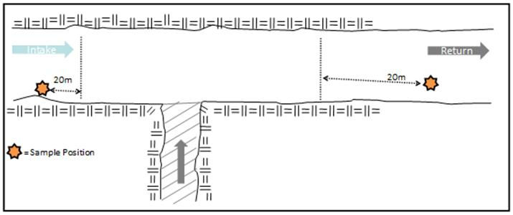

**Figure 2.1: Schematic (section) representation of study area for study methodology explanation purposes.**

### 2.3 Tests

### 2.3.1 Test 1 - Control operating and chemicals added to water

Test 1 will be conducted with theGE Water & Process Technologies water spray system operating and the chemicals ADDED. This is done to determine the respirable particulate concentration if theGE Water & Process Technologies water spray system is operating and the chemicals added. The airborne respirable silica concentration generated by the dust generating operation will then be quantified.

A total of 4 respirable gravimetric dust sampling filters will be obtained for X-Ray Diffraction (XRD) silica content analysis, during this test. Two Chromair™ NH3 passive colorimetric badges will be available for ammonia concentration classification.

The dust generating operation must be allowed to operate with the theENVIDROTECH fogger vapour system operating and the chemicals added, for at least 16 hours before the test can commence.

### 2.3.2 Test 2 – Control not operating

Test 2 will be conducted with theGE Water & Process Technologies water spray system NOT operating. This is done to determine the respirable particulate concentration if theGE Water & Process Technologies water spray system is not operating. The airborne respirable silica concentration generated by the dust generating operation will then be quantified.

A total of 4 respirable gravimetric dust sampling filters will be obtained for X-Ray Diffraction (XRD) silica content analysis, during this test. Two Chromair™ NH3 passive colorimetric badges will be available for ammonia concentration classification. This test will be conducted immediately after completion of test 1.

### 3 SAMPLE ANALYSIS

### 3.1 Gravimetric dust sampling filter weighing

All gravimetric dust sampling will be done in accordance with the requirements of GME Method No. 16/2/3/2/3 (Gravimetric Method).

### 3.2 Silica content analysis

X-Ray Diffraction (XRD) analysis will be conducted, on each individual filter to obtain the silica content, in accordance with the requirements of the MDHS 101 standard.

### 4 CALCULATIONS

### 4.1 Average percentage improvement

The average percentage improvement in dust concentrations, when the GE Water & Process Technologies water spray system is operating, will be calculated by:

* subtracting the average intake airway dust concentration from the average dust concentrations measured at each sampling position, and
* calculating the average percentage reduction in dust concentrations at each sampling position when the GE Water & Process Technologies water spray system was operating, compared to when the system was not operating.

This method is mathematically explained as follow:



Where:

 = Average dust concentration at return air side sampling position, with system operating (mg/m3)

 = Average dust concentration at intake air side sampling position, with system operating (mg/m3)

 = Average dust concentration at return air side sampling position, with system not operating (mg/m3)

 = Average dust concentration at intake air side sampling position, with system not operating (mg/m3)

**APPENDIX A**

|  |  |  |  |
| --- | --- | --- | --- |
| **MOSH Adoption System – South Deep Mine** | | | |
| **Dust Demonstration Project Survey Sheet** | | | |
| **Date:** | _______________ | **Test Number:** | _____________ |
| **Compiled by:** | _______________ | **Start time:** | _____________ |
| **End time:** _____________ | | | |

|  |  |  |  |  |
| --- | --- | --- | --- | --- |
| **A. Gravimetric Dust** | | **Sampling Position** | | |
|  | | **1** | | 2 |
| **Resp. Dust 1 Pump No.** | |  | |  |
| Start Time | |  | |  |
| Stop Time | |  | |  |
| **Resp. Dust 2 Pump No.** | |  | |  |
| Start Time | |  | |  |
| Stop Time | |  | |  |
| **B. Ammonia** | | | | |
| **Chromair™ monitor No.** | |  | |  |
| Start Time | |  | |  |
| Stop Time | |  | |  |
| **C. Environmental Conditions** | | | | |
| **Env. Conditions Monitor** | N/A | |  | |
| Start Time | N/A | |  | |
| Stop Time | N/A | |  | |
| D. Dimensions of area | | | | |
| Height (m) | |  | |  |
| Width (m) | |  | |  |
| **E. Water Quantity** | | | | |
| **Flow** | | **Flow** | Pressure | |
| Start | |  | |  |
| End | |  | |  |

**Appendix 5: Risk Analysis and the Preparation of Summary Risk Tables** **(Risk Story)**

|  |  |  |  |  |  |  |  |  |
| --- | --- | --- | --- | --- | --- | --- | --- | --- |
| **Risk summary: Table of related factors – causal chain** | | | | | | | | |
| **Part A – Description of the causal chain** | | | | | | | | |
| **No** | **Nature of the hazard** | | **No** | | **Exposure to the hazard** | | **No** | **Outcomes of exposure** |
| **1.**  **2.**  **3.** | Respirable crystalline silica dust OEL = 0.1 mg/m3  Cumulative dose effect  Hazardous chemical substance  Microscopic, ubiquitous  IARC – classified carcinogen (1997)  **High risk occupations**   * Stoping and development * Team leaders * Drill operators * Scraper with operators * Tip operators * Loco drivers and crew   **High risk activities**   * Drilling * Blowing out of holes * Blasting * Scraping, Cleaning & Sweeping * Loading * Transporting * Tipping * Hoisting * Crushing * Backfill * Shotcrete/ Drycrete * Raise / Blind Hole Drilling * Coal cutting * Roofbolting * Water jetting * Cleaning of filtration units | | **1.**  **2.** | | Inhalation is the major pathway of concern, microscopic particles (<10 micron) deeper lung deposition, irreversible damage. Inhalation of larger particles >10 micron are deposited in upper airways. Silica dust can be inhaled from contaminated garments and absorbed via the skin.  Employees are at risk of silicosis if there are inadequate dust control measures in conjunction with a lack of:   * Employer/employee commitment * Awareness of silica dust and its hazards * Adequate maintenance of engineering controls * Baseline risk assessments * Training employees in the hazards * Effective sampling protocols for silica dust * Written respiratory protection programme * Adequate respiratory protection * Medical surveillance programme * Auditing of such programmes * Planning especially with new initiatives * Individual susceptibility, eg smoking | |  | Long latency (10 – 15 years)  Silicosis in all its forms, acute, chronic and accelerated, is irreversible and incurable.  Other Silica dust diseases – pulmonary TB, chronic obstructive airways disease, lung cancer, and other autoimmune diseases  Accumulation on teeth and skin  Effects on tissues – lungs, kidneys  Effects on functions - lung functions, COPD  Effects on neurological performance - ataxia.  Effects on reproductive capabilities or functions – nil known  Effects on cognitive performance – nil known  Effects on ability to perform essential work or key tasks – nil known  Safe work performance can be compromised in the short and long-term, due to reversible and irreversible damage to tissues, especially the respiratory system where impairment is permanent.  Acute and chronic effects on occupational health impact negatively on fitness to work due to decreased functional, psychological and physical abilities. |
|  |  | |  | |  | |  |  |
|  | **Data Gaps**  1. Is OEL 0.1 mg/m3 correct? Should it be low**er** | |  | | **Data Gaps**  1. Effective sampling protocols.  2. Respiratory protection programme | |  | **Data Gaps**  1. Early indicators for silicosis, eg biomarkers  2. Poor exposure history |
|  | **Summary of major risks - Create a summary list of the major risks identified** | |  | | **Summary of major risks - Create a summary list of the major risks identified** | |  | **Summary of major risks - Create a summary list of the major risks identified** |
|  | 1. Cumulative dose exposure 2. Training 3. High risk occupations 4. High risk activities | |  | | 1. RPE program 2. Sampling methodology 3. Communication 4. Understanding of risk 5. Leadership commitment 6. Poor exposure history 7. Training | |  | * 1. Silica dust control as occupational health issue not high on agenda   2. Training |
|  | | | | | | | | |
| **Part B - Current risk mitigation controls and strategies – Identify and describe.** | | | | | | | | |
| **1.**  **2.**  **3.** | Baseline risk assessments to identify high risk exposures  Issue based risk assessments to compare to baseline or identify need for adoption of new / additional controls / leading practices  Communication modalities – comics, posters, induction programmes, electronic learning, H&S reps  (Communication of hazard is mitigation of hazard) | | |  | | Leading practices (technology) currently available, namely:   1. Multistage filters 2. Cleaning practice of intake airways (foot/side/hanging wall treatment and washing down and shaft cleaning) 3. Fogger units 4. Tip doors/covers 5. Wetting methods 6. Effective water reticulation systems 7. Wet head drum on continuous miners (CMs) 8. Integrated scrubber on CM’s 9. Equipment and control maintenance 10. Ventilation (main and face) 11. Respirable Protective Equipment 12. Removal from exposure (centralised blasting with multi blasting) 13. Training (classroom, interactive, onsite, E-learning) |  | 1. Medical surveillance |
|  | **Weaknesses – Identify and list the major weaknesses** | | |  | | **Weaknesses – Identify and list the major weaknesses** |  | **Weaknesses – Identify and list the major weaknesses** |
|  | 1. Quantifying silica content, no national accredited laboratory, pros and cons of infrared and XRD, cannot manage accurately if one cannot measure accurately 2. Communication of the hazard is mitigation of the hazard, currently not effective, still huge misperceptions amongst all level of employees about silica dust control, effects and outcomes 3. Awareness raising tools have been recently developed by MHSC and not yet rolled out 4. H&S underutilised, not trained in occupational health matters 5. Employees still have widespread distrust of management and Health Services 6. Medical terminology not in vocabulary, e.g. prefer to use phthisis or TB instead of silicosis 7. 7. Lack of employee empowerment wrt silica dust association with TB and other exacerbating risk factors such as HIV and tobacco smoking | | |  | | * 1. Leading practice silica dust controls lack effectiveness data   2. Lack of National Respiratory Protection Programme for high risk occupations and activities   3. No standardised sampling methodology to accurately allocate individual dosages |  | 1. Communication of linkages to exposures and outcomes (occupational health/hygiene) not always on leaders’ agendas. 2. Medical surveillance detects lag indicators (too late) |
|  | | | | | | | | |
| **Part C – Possible improvements in risk mitigation controls and strategies – Identify and describe** | | | | | | | | |
|  | | 1. National accredited laboratory service 2. Effective communication of the hazard 3. Occupational Health on the agenda 4. Behavioural communication strategy and plan 5. Leadership behaviour strategy and plans | |  | | * 1. MOSH Sampling methodology developed to quantify efficiency of controls (fogger)   2. Roll out multiple and appropriate leading practices simultaneously in keeping with baseline risk assessments targeting high risk occupations and activities. NB: CDC guideline, no one control will be effective, need multiple controls |  | Health Risk Assessments must be incorporated with medical surveillance examinations to identify early risk factors for silica dust diseases |

|  |  |  |
| --- | --- | --- |
| **Summary tabulation of major risks** | | |
| **No** | **Description** | **Priority Rating High / Moderate / Low** |
| **1** | If leading practices not fast tracked, milestones may not be achieved | High |
| **2** | Sampling methodology and silica content analysis not effective | Moderate |
| **3** | Awareness raising through communication of hazard/ risk | High |
| **4.** | Leadership behaviour in identifying occupational health matters such as silica dust control; high on list of priorities | High |
| **5.** | Poor exposure history |  |
| **6.** | Lack of respiratory protection programme | High |
|  | | |
| **Summary tabulation of identified improvement possibilities** | | |
| **No** | **Description** | **Priority Rating High / Moderate / Low** |
| **1** | Multiple leading practices to be adopted as far as reasonably practicable | High |
| **2** | MOSH protocol for effectiveness of controls | Moderate |
| **3** | Implement Behavioural Communication Strategy and plan  Rollout awareness raising tools with stakeholders, eg MHSC | High |
| **4.** | Implement leadership behaviour strategy and plans  Occupational health on agenda | High |
| **5.** | Respiratory protection programme to be introduced as leading practice | High |
| **6.** | Enhanced medical surveillance for current and ex mine workers | Low |

**Appendix 6: Mental Models Questionnaire**

LEADING PRACTICE ADOPTION SYSTEM

**Mental Models Interview Protocol**

**Adopters and Stakeholders**

Management; Unions; Labour; Section 12 Appointees / Engineers; OEMs; Maintenance crew

**Interview Purpose**: *To identify the need / value / priority and risks associated with adopting the proposed leading practice -* **the application of a fogger dust suppression system as part of the broader dust control strategy as leading practice for mines** *– and what is required to make adoption successful.*

**Solicitation**

Hello, my name is <*name*>, I am doing research for *<name of mine/department>.* Are you aware of this initiative to install the fogger dust suppression system leading practice? <*wait for response and if necessary, give brief explanation and promise to send further information later.* > As this is an important initiative for the mine, supported by the industry’s leaders, we are speaking to stakeholders like you to learn more about how we can assist in the adoption of leading practice at the mine.

We would be grateful for your participation and I am calling to ask if you would participate in a telephone or personal interview. Our conversation should take about 30 minutes and I will be asking you some in-depth questions. If now is not convenient, I can call back at a time that is better for you. Would you be interested in participating?

* <*If “no”*>. Thank you for your time
* <*If “not now*”>: What time would be more convenient for you? <*schedule a call-back time at the interviewee’s earliest convenience. Confirm call-back number*>.
* <If “yes”>: Proceed with Introduction

**If calling back at a scheduled time**

Hi this is <*Name* calling to keep our telephone appointment. As I mentioned when I set up the interview, we are doing research for the mine’s initiative to install the fogger dust suppression system leading practice. Our conversation should take about 30 minutes and I will be asking you some in-depth questions. Is this still a convenient time to talk?

* <If “yes”>: Proceed with **Introduction**
* <*If “not now*”>: Your contribution would really be useful to us. We can re-schedule a time more convenient for you in you prefer? <*schedule a call-back time at the interviewee’s earliest convenience. Confirm call-back number*>.
* <*If “no”*>. Thank you for your time

**Introduction**

I’d like to give you a brief overview on the fogger dust suppression system leading practice and then ask you for your thoughts on the specific challenges you face with silica dust in your mine and how our team’s proposed leading practice might work.

I have some questions to help guide our discussion, but please feel free to raise any topic related to this subject that comes to mind as we go along. There are no right or wrong answers, and all of the comments you provide will add value to our research.

Before we start, I’d like your permission to have <<name>> take notes throughout the interview. That would mean that our discussion will be on a speaker phone. Please be assured that we will not attribute any specific answers to you. What you say will be kept confidential to our research team and

We will only report the results in a summarized form for all interviews. Therefore, no personally identifying information will be passed along to any one associated with your company or other companies

May we proceed on that basis? Thank you.

|  |  |  |
| --- | --- | --- |
| **Opening**  **Share your agenda**  Our conversation will cover two topics. First, I’m going to ask you about the risk of crystalline silica dust at your mine, and then I’m going to ask you about how the proposed leading practice for crystalline silica dust might be adapted for your mine.  **Provide background**  The fogger dust suppression system was identified by the MOSH Dust Adoption Team as a means of significantly reducing crystalline silica dust in mining operations. Our goal as an industry is to ensure that by December 2008, 95 % of all exposure measurement results will be below the occupational exposure limit for respirable crystalline silica of 0.1mg/m3, and after December 2013, using present diagnostic techniques, no new cases of silicosis will occur amongst previously unexposed individuals.  *(Researcher: If Interviewee thinks that he or she does not know enough to answer the question, please use follow-ups, however, don’t press if the Interviewee still does not want to answer a question).*   * I’m just interested in hearing what you think. Again, there are no right or wrong answers. * Based on what you know, what are your thoughts on this topic? | | |
| **Question** | **Answer** | |
| ***(1) and (2) Perceived risk of Technology or Leading practice :*** Perceived Risks – Questions for revealing thinking and the need and priority for addressing crystalline silica dust in this mine and also context. | | |
| To start, perhaps you could tell me a bit about your role in the mine. What is your position?   * 1. Do you have people reporting to you?   2. What is your interest in crystalline silica dust at your mine?   Now, let’s talk a bit about the potential for crystalline silica dust at your mine   * 1. What are the likely sources of dust being released into the ventilating air in your operations?   2. Of the causes you mentioned, what is the most likely cause?   3. Is this also the most harmful to people?   4. If no, which one that you mentioned would be?   5. Thinking about the most harmful cause to people, to what extent is this repetitive?   6. Thinking about the most harmful cause << name it>> is there anything that is not understood about why it happens   7. From your perspective, what is the single most important thing that can reduce << this cause>> of crystalline silica dust on your mine?   8. Please explain your answer?   9. Thinking about current operations at the mine, what is being done well to prevent << this cause>> of crystalline silica dust?   10. And what still needs to be improved?   Thank you. This has been very helpful. Now I’d like to move on and talk about leading practices. | |  |

|  |  |
| --- | --- |
| **3) Adoption of Technology or Leading practice : (**Provide scenario):  The mine is considering the application of a fogger dust suppression system supported by a comprehensive dust management system manual as part of the broader dust control strategy. This would entail installing the latest available technology to ensure that all people are exposed to the minimum levels of crystalline silica dust before they enter a working area. It would also ensure that everyone implements all procedures for minimizing the creation of crystalline silica dust before they enter a working area and while working in it.  **Value and Priority** | |
| * 1. So, having heard a bit about the leading practice the team is considering, do you think this would achieve the intended objective of ensuring that all people entering a working area are exposed to the minimum levels of crystalline silica dust?   2. If not, what would achieve this objective?   3. What do you think would be the greatest benefits of adopting the leading practice at your mine?   4. In your opinion, would there be any downsides of adoption?   5. What do you think it would take for the adoption of this leading practice to be seen as a top priority in your mine?   6. Please explain your answer? |  |

|  |  |
| --- | --- |
| **4) Aids and Barriers to Adoption :** Broad Mental Models questions to prompt thinking about aids and barriers. | |
| * 1. When you think about adopting this fogger dust suppression system leading practice at your mine, what will be the most important things to enable successful adoption?   2. Tell me why that would be important?   <<If they do not mention it, prompt>>:   * 1. What functional requirements would be most important? By that I mean the equipment or the people to do the leading practice?   2. What leadership behaviours would be most important? By that I mean the actions that employees can observe leaders doing or not doing?   3. And what behavioural communications requirements would be most important? By that I mean, communications that enable people to act in a new way?   4. When you think about people who will be primarily responsible for implementing this fogger dust suppression system leading practice, what things would be particularly important for them to have in order to implement it successfully?   5. And why would that be important?   <<If they don’t mention it, prompt>>   * 1. How important would training be?   2. How about proper tools?   3. How about leadership by their supervisors?   4. How about behavioural communications?   5. Does anything else come to mind that would be important?   6. What barriers might prevent successful adoption?   7. How might <<take the ones mentioned one at a time>> be addressed? |  |

|  |  |
| --- | --- |
| **5) Leadership behaviours :** Specific questions about two major areas of focus that will be aids or barriers to adoption | |
| Thinking about leadership now…   * 1. What will be important for you to see your supervisor do to demonstrate support for adoption of this leading practice?   2. Why would this be particularly important?   3. Is there anything your supervisor should not do?   4. When you think about the adoption of leading practice, what should the supervisors in your mine do that they are not doing right now?   5. Why would that be particularly important? |  |

|  |  |
| --- | --- |
| **6) Behavioural Communications :** | |
| Now I’d like to discuss communications about the fogger dust suppression system leading practice.   * 1. Which leaders in your mine would be most trusted by teams working to ensure a safe working environment?   2. Please explain why that leader << if more than one, take them one at a time>> is most trusted?   3. For the most trusted leader, what messages will be important for << this leader>> to stress in their communications when they introduce this leading practice to the mine workforce?   4. Why might those things be really important?   5. What messages will be important for direct supervisors to stress in their communications when they introduce this leading practice to the teams working to ensure that the mine intake airways are kept free from crystalline silica dust?   6. Why might those things be really important?   7. What sorts of messages must be avoided by the direct supervisors?   8. Why?   9. What forms of communications would be most effective for introducing this leading practice to the teams?   10. Why those?   11. Any forms of communications that should be avoided?   12. Why? |  |

|  |  |
| --- | --- |
| **7) Close: Wrap up** | |
| You have been very helpful and I really appreciate the time you have taken to speak with me. In closing:   * 1. Is there anything else that came to mind while we were talking that you would like to be sure the team considers?   2. If you could offer one piece of advice to the fogger system project team, what would it be?   That now concludes this interview. Your comments have been very interesting and valuable. On behalf of the project team, and the mine, I’d like to thank you for your time. |  |

# Appendix 7: Project Charter

# Vision, mission, objectives, values and critical success factors/indicators

**VISION**

To assist the mine/industry with achieving the Mining Industry’s milestones for respirable crystalline silica dust, that is:

* by December 2008, 95 % of all individual measurements for respirable silica dust must be below the occupational exposure limit of 0.1mg/m3.
* after December 2013 there must be no new cases of silicosis in previously unexposed individuals, using current diagnostic methods.

**MISSION**

To facilitate adoption of technology and practice that will enhance occupational health and ultimately wellbeing.

**OBJECTIVES**

To successfully implement the fogger dust suppression system to reduce worker exposure to respirable crystalline silica dust as part of the mine’s broad dust control strategy, as well as to bring health issues into focus by incorporating behavioural and leadership strategies.

**VALUES**

We value:

* ***People:*** while we strive to achieve the milestones, this is the minimum standard; we must strive to reduce respirable silica dust levels as low as reasonably practical and possible
* ***Empathy:*** we must strive tounderstand people’s behaviours before imposing our own ideas
* ***Excellence:*** the project must produce a scientific and validated report that can be published and peer reviewed and shared by individuals across commodities
* ***Involvement:*** employees at all levels must be involved in understanding the technology and best practice in a way that they can identify with thereby creating ownership

**CRITICAL SUCCESS FACTORS**

The Leading Practice Project Team acknowledges that to facilitate the adoption and success thereof, the following elements are critical:

* Addressing the health gap in a way that is non-litigious to employers and non-accusatory nor fear-instilling to employees
* Simple and clear messaging in communications
* Sense of ownership by all stakeholders
* Focus by the project team on the objectives

**CRITICAL SUCCESS INDICATORS**

* 50 % reduction in respirable crystalline silica dust levels

**Appendix 8: Mental Models established at the Demonstration Mine (South Deep Mine) for the Fogger-based Leading Practice**

*Extracted from MOSH Dust Leading Practice Adoption System: Behavioural Communications and Leadership Behaviour Strategy, by MOSH Dust Adoption Team (Prepared by: Dr Vanessa Govender; Reviewed by: Mr Tom Rogans & Decision Partners), 14 July 2009.*

In July 2008, with guidance from Decision Partners, the MOSH Dust Team devised a Mental Models questionnaire (Appendix 2) to determine the mental models of employees at all levels of work in various mining companies and various commodity groups, namely gold, coal and platinum. Twenty five questionnaires were administered by Health and Safety personnel. Many of the responses received correlated very well with SIM 030603, see below, indicating that there is not much variance in the responses to and perceptions about silica dust between the different mining houses and commodity groups.

Findings from Mental Models Questionnaires, July 2008

• Lack of dust suppression measures

• Poor maintenance

• “Eliminate the ‘not invented here syndrome’”

• ‘Workers need to understand the long term health effect. They don’t see the immediate results and tend to neglect it’

• ‘Dust control is not a priority’

• ‘Leadership must demonstrate success through their behaviour’

• Improved communications to increase awareness and understanding of dust risk management

• PPE – ‘feeling of helplessness’

Stakeholder perceptions with regard to RCS dust controls have been extensively evaluated. In a comprehensive study of mine workers, mine managers and health and safety (H&S) representatives, SIM 030603, it was reported that:

• employees at all levels have various misunderstandings about RCS dust sources, prevention, control and effects.

• personal protective equipment (PPE) applicability, availability, accessibility and effectiveness can be and generally are poorly understood.

• H&S representatives are not effective and are under-utilised. The role of the health and safety representatives is unclear with only 8 % in the study reporting that dust control is a part of their job and only 3 % having been trained in dust control.

• there is confusion regarding silicosis, TB, phthisis and HIV/ AIDS.

• there is a well established myth that ‘milk’ can flush out dust from the lungs.

• there is little understanding regarding the relationship between germs and disease.

• workers feel powerless in the face of dust reporting that “there is no way to prevent it at all – dust will always be there”.

• there is a need for all employees to play a role in silica dust control.

Figure 1 highlights the key points raised by interviewees regarding silica dust control on the mines.

This report further highlighted a general lack of trust in mine management and health services. Workers clearly had a feeling of helplessness and powerlessness when it came to their ability to influence silica dust control activities, with some responding that “nothing can be done to control dust or to change their situation” and weak self efficacy prevailed amongst them. They felt that there were barriers such as bonuses and targets that prevented them from exercising effective RCS dust control.

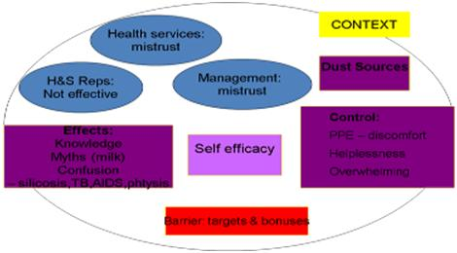

**Figure 1: Perceptions of workers about silica dust. (Adapted from SIM 030603, Track C)**

*(At South Deep)* Workers who were exposed to the technology were briefed by their supervisor, a member from the project team on silica dust sources, prevention and control methods and were advised on the milestones for silica dust. A post intervention questionnaire was designed for one-on-one communication and in such a way to evaluate the impact of the communication intervention. A total of 37 questionnaires were completed by the project team.

**Summary of post communication evaluation – 100 level South Deep Demonstration Mine:**

37 employees were interviewed and 65 % of these study subjects were previously briefed by the OE department.

The majority (73 %, n = 27) are aware of the milestones; of concern is that the remaining 27% who have not heard of the milestones or do not know how the milestones apply to him/her.

The majority (97 %) are aware of the poster on display.

Regarding the health question on “why is silica dust dangerous?”, the medical term “silicosis” is still largely unused with 22 % (n = 8) voluntarily using the term. Employees seem to prefer talking about ‘TB’ or ‘phthisis’.

The main sources of dust such as tipping, loading rocks, blasting, sweeping and crushing are well known to the employees.

Silica dust controls such as ventilation, and watering down are also well known to the employees. 27 % (n = 10) stated that the fogger unit was a means of dust control.

Of importance is that the majority (81 %) are of the opinion that management is doing something to reduce silica dust. Of concern though is that employees do not view supervisors as being helpful.

The mechanism for reporting malfunctions needs to be communicated: between 8 % and 24 % knew what to do in the case of the fogger not working, and cited various means to do so.

It is encouraging that 59 % of employees are aware that the fogger unit is making a difference to their lives.

The analysis of the questionnaires illustrated the following:

|  |  |  |  |
| --- | --- | --- | --- |
| Question no: | Question | Response | N (%) |
|  | **Are you aware of the milestones for dust?** | **Yes** | **27 (73)** |
|  | **Were you involved with the first communication at 100 level with Lebo (OE Observer)?** | **Yes** | **24 (65)** |
|  | **Are there any posters/pamphlets that have helped increase your understanding?** | **Yes** | **36 (97)** |
|  | **Why is dust dangerous?** | Causes Phthisis.  Causes Silicosis.  Causes TB.  Enters the lungs, damages the lungs.  Causes lung cancer.  Causes the flu. | 14 (38)  8 (22)  23 (62)  13 (35)  4 (11)  2 (5) |
|  | **What are the likely sources of dust being released into the ventilating air?** | Drilling  Tipping  Loading rocks  Blasting  Tramming scoops  In the air  Sweeping  Crushing  Walking  Cement | 10 (3)  19 (51)  10 (27)  18 (49)  5 (14)  5 (14)  3 (8)  3 (8)  2 (5)  2 (5) |
|  | **What are the controls for Silica Dust?** | Fans  Ventilation  Watering down  PPE (Dust mask Sprays (Fogging unit) ) | 3 (8)  13 (35)  30 (81)  13 (35)  10 (27) |
|  | **Are you aware of management doing anything new to control silica dust?** | **Yes** | **30 (81)** |
|  | **How were you made aware of this process? If yes to 6.**  . | Briefing session held with Lebo  Shaft Foreman  He was there when the system was installed. | 23 (62)  2 (5)  3 (8) |
|  | **How has your supervisor been helpful? If yes to 7.** | No, my supervisor does not discuss the fogger unit.  No, not helpful.  Guided during the process  Safety meeting. | 6 (16)  18 (49)  2 (5)  2 (5) |
|  | **What should you do if you notice the fogger system is not working as it should?** | Report to Supervisor  Report to the Banksman, Control Room  Report to Ventilation Department  Safety rep./safety department  Report to shaft personnel  Report to Lebo | 4 (11)  5 (14)  9(24)  3 (8)  3(8)  3(8) |
|  | **Has the fogger made a difference to your life?** | Yes, dust and gases are better than before the unit was installed.  Yes, dust is reduced.  Yes, ammonia is also reduced.  Yes, ammonia is eliminated.  Can’t say because he works in the development ends.  Yes, the smell is better than before.  Has never noticed or taken notice of the ammonia smell. | 3(8)  22 (59)  13(35)  2(5)  3(8)  2 (5)  2 (5) |
|  | **Do you know where you can go for help if you are not feeling well?** | Special doctor  Medical station  Inform Supervisor  Foreman  Personal doctor  Go to the traditional doctor | 13 (35)  17 (46)  15/37  1 (3)  3 (8)  1 (3) |

Additional responses to question number 1 included:

* Only knows a little bit about the milestones
* Yes, he has read about the milestone, but does not know how they apply to him

Additional responses to question number 4 included:

* Causes chest pains
* It causes difficulty in breathing.
* It enters the lungs and irritates the throat and nose.
* There are chemicals formed when blasting and those chemicals are airborne with the dust. The chemicals enter the lungs and cause TB.
* The fine dust enters our lungs and accumulates in the lung over a long period of time. The fine dust damages our lungs and causes silicosis.
* There are chemicals coming from explosives that make dust – Dangerous to our bodies.
* He does not know the dangers and hazards of exposure to dust.
* Causes high blood pressure

Additional responses to question number 5 included:

* Not watering down
* Suspending and cables
* UV
* Methane explosions
* Ventilation
* Dust from the hangingwall
* Sweeping
* Underground haulages
* Machinery

Additional responses to question number 6 included:

* Nothing
* Fogger units, ventilation but it is not effective.

Additional responses to question number 8 included:

* Saw it.
* Saw the OEM installing the system

Additional responses to question number 9 included:

* My supervisor does communicate with us about the fogger unit.
* None

Additional responses to question number 10 included:

* Report to foreman.
* Does not know.
* Report to Safety Rep and continue working.
* Report to the management.
* Don’t know what to do if the system is not working.

Additional responses to question number 11 included:

* “No he does not work at the tips”
* Yes, dust is eliminated.
* I can’t say about ammonia.

**Appendix 9: Modalities of Communication**

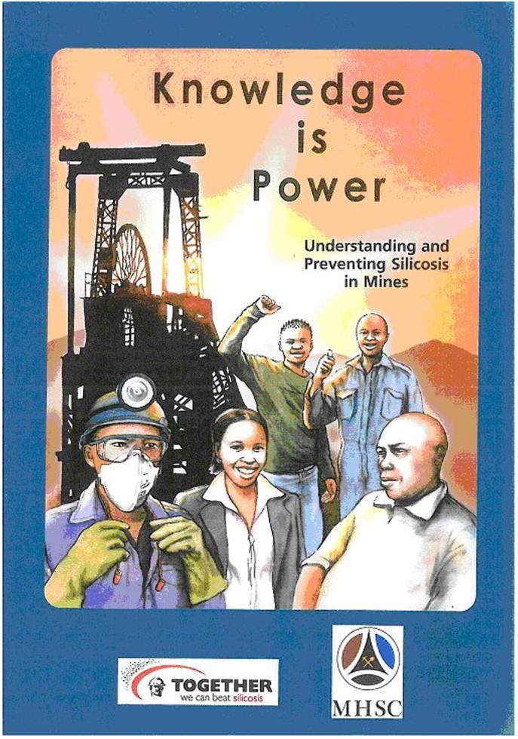

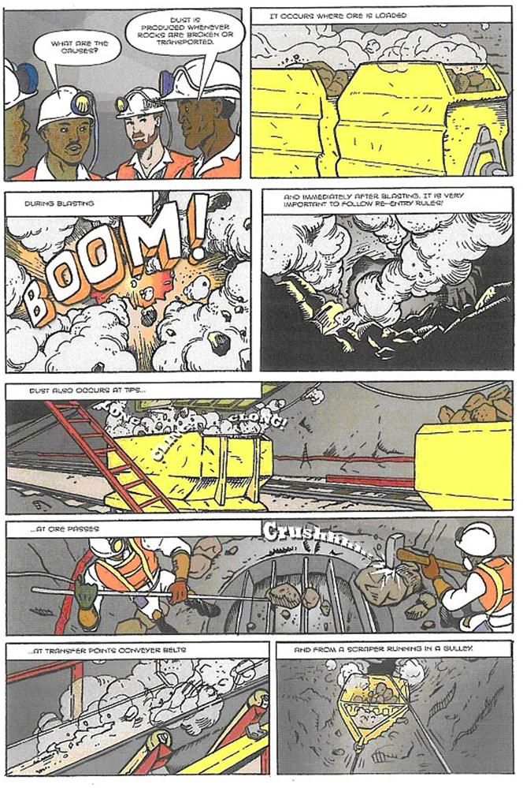

**Gold Fields Comic Page**

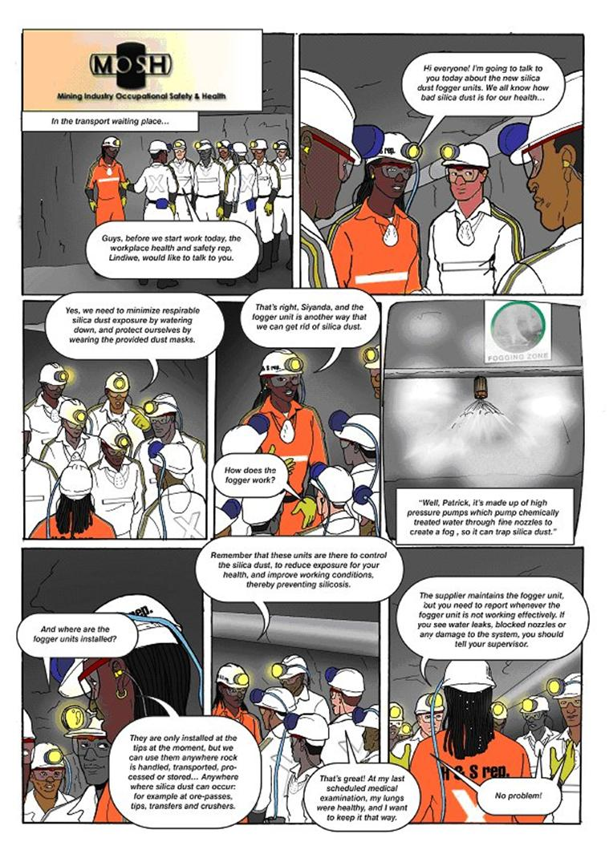

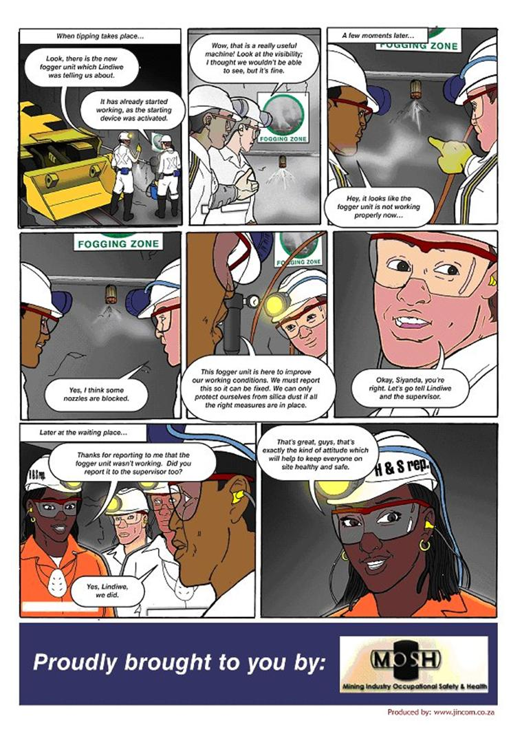

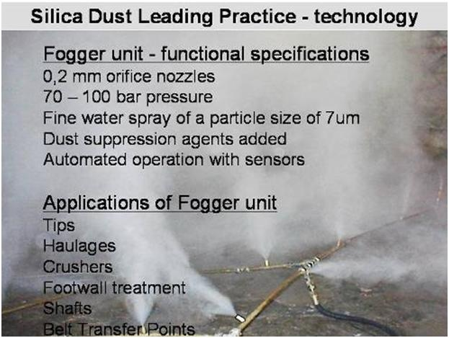

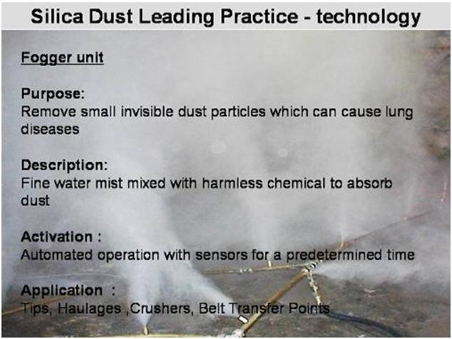

**Electronic Learning Slides**

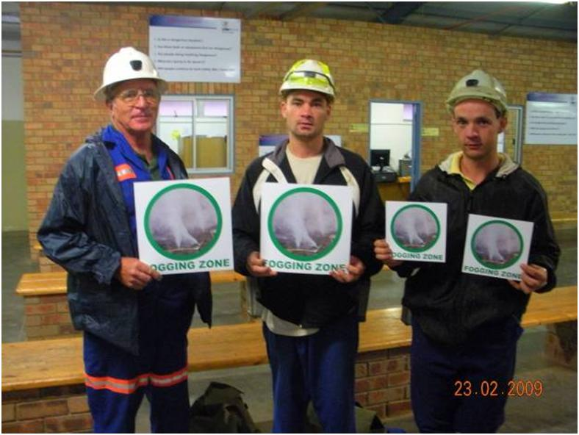

**Fogger Zone Demarcation Signage**

**Appendix 10: Communication Brief**

MOSH DUST ADOPTION SYSTEM

**COMMUNICATION BRIEF TO ADOPTERS**

**(BASED ON SIM 030603 AND MOSH MENTAL MODELS SURVEY)**

|  |
| --- |
| **Communication Agenda** |
| 1. **Milestones for Silica dust**   The Mining Industry is working to significantly reduce crystalline silica dust in mining operations. Our goal as an industry is to ensure that by December 2008, 95 % of all exposure measurement results will be below the occupational exposure limit for respirable crystalline silica of 0.1mg/m3, and after December 2013, using present diagnostic techniques, no new cases of silicosis will occur amongst previously unexposed individuals. |
| 1. **Why is Silica dust dangerous?**   Silica dust particles are so small that you can’t see them. The dust particles are so small that they go deep into our lungs where they get trapped. No amount of coughing gets it out.  People don’t feel sick at first, but there is no cure.  Doctors use X-rays to see if a worker has silicosis or not so it is very important for mine workers to be x-rayed regularly.  Silicosis damages lungs and makes it much easier for the TB germs to make the person sick. |
| 1. **Sources of silica dust**   There is silica dust wherever rock gets broken or moved. Almost all underground activities make silica dust fly into the air around them, i.e.:   * 1. Crushing   2. Grinding and loading rock   3. Drilling   4. Blasting   5. Sweeping   6. In the underground haulage |
| 1. **Controls for Silica Dust?**   Ventilation engineers work to take away the dust with ventilation (fans and extractors) and filters.  Mine workers water down to keep the dust out of the air.  They also have their own protection equipment (PPE), which may be uncomfortable, but helps them to keep safe. |
| 1. **Management initiatives – fogger dust suppression system**   Management is considering the application of a fogger dust suppression system with or without dust suppression agents added to water as part of the broader dust control strategy as leading practice. It would entail installing the latest available technology to ensure that all people are exposed to the minimum levels of crystalline silica dust before they enter a working area. It would also ensure that everyone implements all procedures for minimizing the creation of crystalline silica dust before they enter a working area and while working in it. |
| 1. **Maintenance of the fogger dust suppression system**   If you notice that the unit is not working properly, water leaking, pipe burst, nozzle blocked, you must not attempt to fix it, instead, report to the supervisor, or Health and Safety Rep immediately.  Ensure no one tampers with the system. |

**Appendix 11: Post On-site Communication Evaluation Questionnaire**

**POST ONSITE COMMUNICATION EVALUATION QUESTIONS**

|  |  |
| --- | --- |
| **Question** | **Answer** |
| 1. **Are you aware of the milestones for dust?** |  |
| 1. **Were you involved with the first communication at XX level with XXX (OE Superintendant?** | Yes / No |
| 1. **Are there any posters / pamphlets that have helped increase your understanding?** | Yes / No |
| 1. **Why is dust dangerous?** |  |
| 1. **What are the likely sources of dust being released into the ventilating air** |  |
| 1. **What are the controls for Silica Dust?** |  |
| 1. **Are you aware of management doing anything new to control silica dust?** |  |
| 1. **How were you made aware of this process? If yes to 6** |  |
| 1. **How has your supervisor been helpful? If yes to 7** |  |
| 1. **What should you do if you notice the fogger dust suppression system is not working as it should?** |  |
| 1. **Has the fogger dust suppression system made a difference to your life?** |  |
| 1. **Do you know where you can go for help if you are not feeling well?** |  |

**Appendix 12: Integration of Behavioural Plans into the Overall Plan**

**An indicative list of envisaged key activities in implementing a leading practice at an adoption mine is given below. Implementation of the customised leadership behaviour and behavioural communication plans needs to be included either as new activities or appropriately built into activities already identified as being necessary to implement the leading practice at the adoption mine - see comments column.**

| **Activity** | **Comment** |
| --- | --- |
| 1. Prepare and present the case for adopting the leading practice. |  |
| 1. Obtain a clear decision from top management to implement the leading practice at the mine |  |
| 1. Secure appointment of a suitable project leader / champion at the mine |  |
| 1. Identify an acceptable piloting section / area at the mine |  |
| 1. Secure the appointment of an appropriate project team at the mine |  |
| 1. Provide the project team with copies of the leading practice adoption guide |  |
| 1. Establish effective working / liaison relationship with the COPA |  |
| 1. Identify and appoint person to oversee customisation and integration of behavioural plans |  |
| 1. Identify persons needed to conduct direct enquiry interviews and analysis of enquiry results |  |
| 1. Arrange any special training necessary for the project leader and behaviour plan oversight person |  |
| 1. Mine project team to clarify the operational details necessary for implementing the plan |  |
| 1. Consider / arrange supportive input / secondment / training through COPA interaction |  |
| 1. Identify and arrange any specialist technical support needed for implementation of the project |  |
| 1. Facilitate a meeting of the mine project team to refine and agree the detailed implementation plan |  |
| 1. Critically assess whether sufficient time and resources have been provided for the project |  |
| 1. Conduct a “what if” exercise and adjust plans as necessary |  |
| 1. Prepare an agreed planning chart for managing the project |  |
| 1. Arrange for the purchase of the required equipment |  |
| 1. Identify adopters and key stakeholders |  |
| 1. Secure support of regional and mine level union representatives |  |
| 1. Prepare for and conduct direct enquiry interviews (guidance note 12- adoption guide) |  |
| 1. Analyse results of direct enquiry interviews |  |
| 1. Customise leadership behaviour and behavioural communication plans |  |
| 1. Ensure that customisation checks have been fully satisfied |  |
| 1. Obtain top management agreement to implementation of customised behavioural plans |  |
| 1. Integrate behavioural plans into the detailed leading practice implementation plan |  |
| 1. Brief the supervisory levels involved in implementing the practice | Input from Behavioural plans |
| 1. Arrange for access to any required intellectual property |  |
| 1. Brief the workers involved in implementing the practice | Input from Behavioural plans |
| 1. Set up the required training programme at the mine | Input from Behavioural plans |
| 1. Prepare key training documentation | Input from Behavioural plans |
| 1. Train the workers involved in implementing the practice | Input from Behavioural plans |
| 1. Set up the required equipment maintenance arrangements |  |
| 1. Prepare documentation and signage to assist in implementing the practice | Input from Behavioural plans |
| 1. Agree critical success factors for the demonstration project | Input from Behavioural plans |
| 1. Identify key measurements needed to demonstrate performance of the practice | Input from Behavioural plans |
| 1. Set up monitoring and data collection arrangements | Input from Behavioural plans |
| 1. Clarify and agree criteria and time scale for completion of the project |  |
| 1. Provide COPA with feedback on implementation challenges and successes |  |
| 1. Conduct preliminary implementation of the practice |  |
| 1. Decide and document any needed customisation of the practice prior to mine wide roll out |  |
| 1. Introduce agreed custom refinements and commence roll out of the practice |  |
| 1. Implement the monitoring and reporting programme | Input from Behavioural plans |
| 1. Store key data in an electronic data base for later analysis |  |
| 1. Prepare and issue progress updates to key stakeholders | Input from Behavioural plans |
| 1. Analyse data to demonstrate the performance achieved | Input from Behavioural plans |
| 1. Prepare a report describing the practice implemented and the performance achieved – send to COPA | Input from Behavioural plans |

**Appendix 13: Implementation Project Checklist**

|  |  |
| --- | --- |
|  |  |
| Implementation Project Factors and Factors Checklist | |
| 1 | Is there still a need for the new technology or practice? |
| 2 | Is the technology, practice or knowledge ready for transfer and adoption? |
| 3 | Is further development required to arrive at a commercially and practically viable technology or practice? |
| 4 | Has the equipment to be tested (technology to be adapted) been adequately designed to withstand the harsh underground environment? |
| 5 | Has the operation of the technology or practice been adequately simplified for mine application? |
| 6 | Is a trial installation warranted or will a desktop study provide adequate performance information? |
| 7 | Which parts of the mine would benefit most from adoption of the technology or practice? |
| 8 | Which persons on the mine have the incentive and attributes necessary for championing the technology or practice? |
| 9 | Will (has) the mine appoint(ed) an appropriate champion? |
| 10 | Which persons at the mine need to be brought into the planning of the project at the earliest stage possible, and has this been done? |
| 11 | Which persons should be invited to join an oversight group to assist in spreading the adoption experience? |
| 12 | Has the mine staff responsible for the project been provided with adequate time and resources to successfully undertake the project? |
| 13 | Who will take responsibility for documenting and writing up the outcome of the project for communication to others? |
| 14 | What technical support is needed to assist mine staff with the adoption process? |
| 15 | Are new skills or organisational structures needed to achieve successful adoption? |
| 16 | Will the equipment supplier be able to meet the mine’s needs in the event of a successful implementation? |
| 17 | Can or should the technology and/or leading practice be implemented as part of a larger, more beneficial system? |
| 18 | What are the possible unintended consequences of the technology and/or best practice and how will they be addressed if they arise? |
| 19 | Do the risks warrant consideration being given to setting up arrangements to underwrite the implementation project? |
| 20 | Has adequate time been allowed for the implementation project to be undertaken to its proper conclusion? |
| 21 | What are the criteria for the implementation project to be considered complete and successful? |
| 22 | What are the criteria for the technology and/or best practice to be considered a success once adopted? |
| 23 | Which persons or mines are going to be most affected by adoption of the technology and/or leading practice? |
| 24 | What steps need to be taken to ensure proper communication about the new technology or practice in regard to its application and its positive and negative impacts? |
| 25 | What special training is necessary for mine staff to facilitate successful adoption? |
| 26 | Which persons on the mine could make or break the project and how have they been accommodated? |
| 27 | What will be the benefits to the various people on the mine who are or will be affected by adoption of the technology and/or best practice, in particular the workers and first line supervisors? |
| 28 | What measures, in addition to training, need to be adopted to gain support of the workforce for the technology and/or leading practice? |
| 29 | Which persons will be negatively affected and how have their concerns been taken into account to secure their support? |
| 30 | Good and constructive union participation? |
| 31 | Strong and constructive Health and Safety Committee? |

**Appendix 14: Modus Operandi – Standard Operating Procedure**

**(courtesy of DEPRO CLEANING trading as ENVIDROCLEAR)**

**THE PRINCIPLE MODUS OPERANDI OF THIS SYSTEM**

The finer the droplet size of the water mist / vapour employed, the greater the absorption and attraction forces of the medium (water) molecules to airborne dust, smoke and gas particles.

The smarter way of dust suppression and or fire prevention is to create mist / vapour curtains applied at the source of the emissions and friction areas where potential fire hazards are identified.

**How droplet size can affect agglomeration.**

If a droplet diameter is much greater than the dust particle, the dust particle simply follows the air stream lines around the droplet and little or no contact occurs.

**Dust particle impacts**

**And agglomerates**

**FOG DROPLET**

**SPRAY DROPLET**

If the water droplet is the same size or smaller compared to that of the dust particle, contact occurs as the dust particle tries to follow the air stream lines.

The probability of impaction increases as the size of the water droplets decreases

The coagulation and absorption rate of the mist / vapour is further enhanced by the addition of specific blends of wetting / surfactant agents. Up to 98 % removal rate of specific airborne pollutants were possible this way.

**Characteristics of the mist / vapour.**

The following are unique characteristics of the vapour mainly arising from the fact that the volume of one drop of water is increased by 1640 times!!

* Faster coagulation of suspended particles in the air.
* Faster cleanup of airborne dust particles.
* Removal of soluble gas particles in the air.
* Increased dilution of explosive gases
* Oxygen reduction at the possible source of fire / heat.
* Immediate drop in temperature of surrounding air.
* Huge absorption of energy from fires and friction areas.
* Odour control.
* Reduce friction.

**The following are advantages of the Envidroclear Vaporizing Fogger systems compared to other similar systems available on the market.**

* Use water only, no compressed air needed for vaporization.
* No oscillating nozzles.
* Low water consumption:- 80 ml/minute/nozzle at 70 bar pressure.
* Working pressures from 70 to 120 bar.
* 100% ultra fine vapour.
* Vapour particle sizes:- 7 micron and smaller.
* Different Fogger models available:- 70 to 470 nozzles.
* One system can cover several transfer / pollution areas over 400 meters.
* Suitable for various underground / surface applications.
* Operation can be fully automated.

# STANDARD OPERATING PROCEDURE FOR THE FOGGER DUST

# SUPPRESSION SYSTEM

* + Complete a pre-assessment (risk assessment) of the area.
  + Get the necessary tools and equipment that are needed for the task.
  + Make sure all the tools are inspected and are in good condition.
  + Make sure that you have enough manpower to do the job and that all employees are fit and possess the necessary skills/permits to complete the job safely in time.
  + Ensure proper authorisation from the mine or business to work in a particular area
  + Plan your job in such a way that it can be completed in normal time if possible. Avoid working unnecessary overtime if it can be avoided. Avoid a situation of possible laps in concentration because of fatigue.
  + Check feed water pressure at the pressure regulating valve (PRV). Adjust the pressure to maximum of 1.7 bar if necessary.
  + Check chemical dosing nipple for leaks.
  + Check feed water line for leaks.
  + Check sand filter for leaks or cracks.
  + Check sand filter controls for leaks.
  + Check cartridge filters for leaks and fouling.
  + Check power supply to the Fogger unit.
  + Check the control circuit of the Fogger unit.
  + Check the working pressure of the Fogger, adjust to 70 bar if necessary.
  + Make sure that the filters are clean before replacing them.
  + Switch the Fogger unit Off.
  + Check the oil level of the pump, top up if necessary, if oil is milky colour repair the oil seals, replace the oil. Replace the pump if necessary.
  + Close the feed water control valve.
  + Release the line pressure of the feed water by opening the valve on the Centrapour filter
  + Repair all water leaks if necessary and replace seals if found perished.
  + Replace dirty filter cartridges.
  + Check chemical level in step down tank, refill if necessary.
  + Check the chemical dosing pump for good working order and calibrate if necessary.
  + Set the two-way valve at the back of the Fogger to dump the water for rinsing of the cartridge filters after filter replacement.
  + Open the main feed water supply valve to the system.
  + Check again for the correct pressure of 1.7 bar at the PRV.
  + Select Backwash on the sand filter control, backwash until the water is clear.
  + Select Rinse on the sand filter control and rinse until the water is clear.
  + Select Filter on the sand filter control.
  + Rinse the total filtration system until the water at the last filter is clear.
  + Close the two-way valve at the back of the Fogger to restore the water flow to the system.
  + Start the Fogger Unit.
  + Check for the correct working pressure of the Fogger (70 bar), adjust the pressure with the PRV on the high pressure (Hp) side of the pump.
  + Check for any leaks at filter system. Rectify if applicable.
  + Check the Hp feed line to the dosing areas for damage. If leaks are found, switch the Fogger off and carry out the necessary repairs.
  + Switch the Fogger on and check for nozzle blockages at all different dosing areas.
  + Close the control valve on each frame and clean or replace the blocked nozzles. Open the control valve, check for vapour distribution and replace the dosing frame in its position.
  + Repeat above with all the dosing frames.
  + If an Hp feed line close to a conveyor is damaged, the following procedure must be followed.

Communicate with Process Personnel and find a suitable time as soon as possible to stop conveyor so that it is convenient for every body.

* Isolate the power supply to the conveyer.
* Replace damaged piping.
* Repair/ Replace damaged dosing frames if necessary.
* Cancel lockout.
* Start unit.
* Check the system for correct operating pressure.
* Report to management after completion of the repairs.

**Appendix 15: Risk Assessment**



|  |  |
| --- | --- |
| Date of risk assessment | 28 July 2008 |
| Revision Date | 04 November 2008 |

INTRODUCTION

SOUTH DEEP 95 LEVEL FOGGING SYSTEM

**1. Aim:**

* 1. The aim of the study is to determine risks associated with the operation and maintenance of the 95 Level Tip section fogging system.

**2. Objective:**

2.1 The objective of the study is to conduct a SWIFT study to determine the risk of the exercise.

* 1. Analyze potential hazards, reviewing existing controls and current safe guards and make recommendations to eliminate, control, minimize the risk

**3. Scope:**

* 1. The risk assessment covers the risks during the operation and maintenance of the system.

**4. Methodology**

* 1. Members from the South Deep OE(H) Department, MOSH team and GE Water & Process Technologies were involved.
  2. A risk matrix, included in this report, was used to prioritise all risks identified.
  3. Recommendations were made, where existing controls were found according to the team to be insufficient for control and eliminating existing hazards. See the risk assessment sheets attached to this document.

### 5. Hazards identified

5.1 See Executive Summary attached.

###### TEAM MEMBERS: RISK ASSESSMENT: 95 LEVEL TIP FOGGING SYSTEM

|  |  |  |  |
| --- | --- | --- | --- |
| Name | **Mine** | **Designation** | **Years Experience** |
| B.C. Vreugdenburg  (Facilitator) | South Deep | OE (H) Manager | 29 |
| D.C. Theron | GEWPT | Account Manager | 4 |
| C..Massyn | GEWPT | Area Manager | 9 |
| T Rogans | MOSH team | Full time MOSH team member | +30 |
| V. Govender | MOSH team | OMP | 13 |
| C. Malebanye* | South Deep | OE (H) Superintendent | 14 |
| M. Dikana* | South Deep | OE (H) Superintendent | 16 |

*Part of Review Team on 04 November 2008

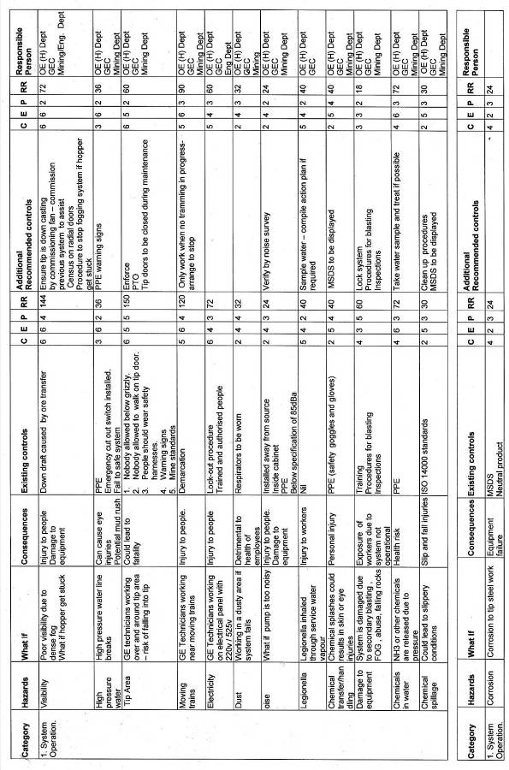

|  |  |  |  |
| --- | --- | --- | --- |
| **Value** | **0-100** | **101- 215** | **216-343** |
| **Risk ranking** | **Low risk** | **Significant risk** | **High risk** |

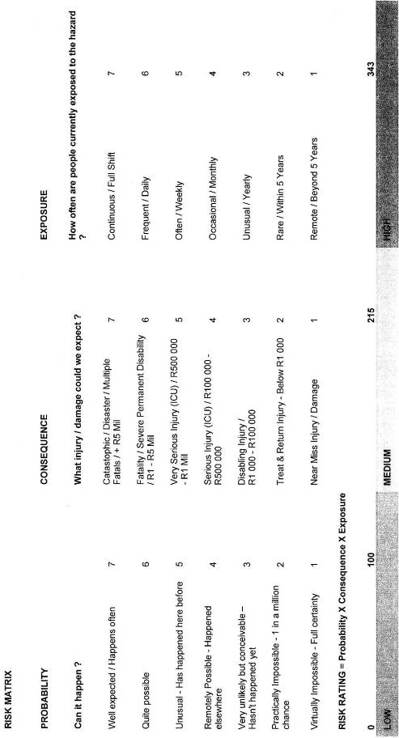

Collieries Environmental Control Service

STANDARD METHOD

### CECS method 3:1988

**Alpha Quartz (SiO2 ) Analysis – Wafer Preparation for IR Spectrophotometry**

### Based on NIOSH method 7602

#### Scope and field of application

This standard specifies a method for preparing KBr wafers for determining the concentration of alpha quartz (SiO2) present in respirable airborne pollutants employees may be exposed to during their work activities as required by the Department of Minerals and Energy (DME) Guideline for the compilation of a mandatory code of practice for an occupational health programme on personal exposure to Airborne Pollutants Ref. No. DME 16/3/2/4-A1.

#### Apparatus

**Electronic microbalance**,capable of recording mass to 1/100th of a milligram.

**Sampled filter**, sampled according to CECS Standard Method 1:1988.

**Muffle furnace**, able to achieve at least 700°C, porcelain crucibles.

**Mortar and pestle**, 50mm agate or mullite, metal microspatula, non-serrate non-magnetic forceps, desiccator, camel’s hair brush.

**Laboratory press**, 0-10 ton,with evacuable die.

**Specacards**, 10mm diameter circular aperture ± 1mm.

**Drying oven**, 0-200°C.

##### Chemicals

**Potassium Bromide (KBr)**, chemically pure >95%.

**Glycerol**, chemically pure > 95%.

##### Procedure

Dry potassium bromide (KBr) for between 12 and 24 hours at 130-140°C.

Condition ash crucible for 1-2 hours at 120-130°C.

**CECS method 3:1988**

Allow ash crucible to cool down to room temperature in desiccator.

Accurately determine the mass of the ash crucible to 5 decimals and record the mass (M1).

Place filter(s) to be assessed upside down into ash crucible.

Place two drops of glycerol onto filter(s).

Place ash crucible with filters into an oven at 50-60°C to allow even distribution of the glycerol.

Ash the ash crucible with filters in muffle furnace at 590-610°C for 2-2½ hours. Do not open muffle furnace while ashing is in process.

Switch off muffle furnace and allow to cool down properly.

Meanwhile weigh off ±70 mg KBr into a mortar.

After cooling down, accurately determine the mass of the ash crucible again to 5 decimal accuracy and record the mass (M2).

Work the ashed sample down the sides of the crucible with a micro-spatula and lightly grind the ash with a pestle to a fine powder. Mix sample carefully until homogeneous.

If the ashed mass of the sample weighs more than 1mg, carefully weigh off approximately 1mg of ash into a weighing pan and store the rest of the sample in a clearly marked container,

Carefully weigh off ±70 mg of KBr into a watch glass, pour into a mortar and grind to a fine powder. Return the finely ground KBr to a watch glass.

Mix approximately half of the finely ground KBr (± 35mg) with the ash of the sample in the crucible, mix and pour into a mortar. Use the balance of the KBr to properly scrape clean the ash crucible and mix with the mixture of KBr/ash in the mortar.

Carefully grind the total mixture in the mortar with a pestle until fine and homogeneous.

It is important that the total mass of the mixture not exceed 80mg to ensure wafers of even thickness.

Use a micro-spatula to “wash” the mortar’s contents into a 13 mm Evacuable Die.

### CECS method 3:1988

Connect vacuum pump to evacuable die’s side branch, open the shut-off valve and switch pump on.

Close the shutoff valve connected to the side-branch of the die, put the evacuable die into the press and tighten the press while pump motor is still running.

Wait for approximately 2 – 3 minutes, pressurise the press to between 4.5 and 5.5 tons for 2½ to 3½ minutes, open the vacuum to the side branch of the die at the shut-off valve and switch off the pump.

Remove the evacuable die from the press, remove the wafer from the die and insert the wafer in a Specacard with a 10mm ±1mm diameter circular window. Clearly number the Specacard containing the wafer with the relevant mine information for identification.

Keep wafer overnight at 110-120°C or in a desiccator if it cannot be taken to the scanning laboratories immediately. Take to scanning laboratory at earliest convenience.

# 6 Expression and reporting of results

When results are received from scanning laboratory, calculate concentration of Alpha Quartz (SiO2) using the under mentioned formulae:

If full mass of ash from sample is utilised:

## D x 100

A

= % SiO2

If only a portion of the mass of the ash from the sample is utilised:

## D x B x 100

C x A

= % SiO2

**Where:**

A = Total mass of original sample (mg),

B = Mass of ash (mg) (M1 – M2),

C = Mass of portion of ash utilised for wafer (mg), and

D = mg SiO2 concentration in wafer as determined from graph at scanning laboratory.

CECS method 3:1988

**The SiO2 concentration (%) is reported to 1 decimal accuracy.**

##### 6 Transportation details

* 1. **Specacards** with wafers ready for scanning are neatly and carefully placed into a Specacard container and the lid properly closed.
  2. **Specacard** container together with the duly completed control sheet identifying each Specacard is carefully placed on the seat of a CECS vehicle and transported to the scanning laboratory.
  3. **Specacard** container and control sheets are delivered to the scanning laboratory by hand, taking care to prevent accidental knocks or dropping of the container.

1.
2.
3.
4.
5.
6.
7.
8.
9.
10.
11.
12.
13.