The MOSH Leading Practice Adoption System – a leading practice in its own right

S Malatjiand J M Stewart

*(Chamber of Mines of South Africa and JM Stewart Consulting)*

There has been a remarkable improvement in the safety performance of the South African mining industry since 2003. Many factors and initiatives have been responsible for this, but ultimately, they all find expression in actiontaken *by operational* management on mines. Ideally, this action should be voluntary and originate from on-mine considerations of how best to *provide and maintain a working environment that is safe and without risk to the health of employees*. Although legislative or other top down dictates may sometimes result in short-term improvements, if the action taken constitutes reluctant compliance, it is unlikely to stand the test of time. It is in this context that the MOSH Leading Practice Adoption System has an important role to play, in that it is focussed on achieving conditions that lead to voluntary and eager adoption of identified leading practice. Cutting edge techniques derived from behaviour science have been embedded in the detailed systematic approach of the adoption system to achieve this intrinsically sustainable outcome. In this sense, the MOSH Adoption System is a leading practice in its own right. Its potential contribution in addressing the lesser improvements achieved to date in the area of occupational health, as well as the substantial safety challenge that still remains, should be clear to those committed to achieving zero harm work places in the South African mining industry. The primary purpose of this paper is to present the MOSH Leading Practice Adoption System in a readily understood format. A graphical style presentation with brief supporting notes is used for this purpose.

**Motivating context for development of the System**

**2013 Tripartite Industry Milestones**

**Notes**

1. The MOSH Leading Practice adoption system was developed to assist industry in its efforts to meet the Tripartite agreed Occupational Health and Safety Milestones.
2. The milestones were agreed to in 2003 and in 2005 the CEOs of the major mining companies committed their companies to achieve the 2013 milestones.
3. The MOSH Adoption system was developed in 2007 and piloted in 2008.

**MINING INDUSTRY TRIPARTITE OCCUPATIONAL HEALTH AND SAFETY TARGETS AND MILESTONES SET IN 2003**

**OCCUPATIONAL SAFETY**

***Industry Target: Zero rate of fatalities and injuries***

***Milestones:***

* **In the Gold Sector**: By 2013 achieve safety performance levels equivalent to current international bench marks for underground metalliferous mines, at the least;
* **In the Platinum, Coal and Other Sectors**: By 2013 achieve constant and continuous improvement equivalent to current international benchmarks, at the least.

**OCCUPATIONAL HEALTH**

***Industry Target: Elimination of Silicosis***

***Milestones:***

* By December 2008, 95% of all exposure measurement results will be below the occupational exposure limit for respirable crystalline silica of 0.1mg/m3 (these results are individual readings and not average results)
* After December 2013, using present diagnostic techniques, no new cases of silicosis will occur amongst previously unexposed individuals (Previously unexposed individual = individuals unexposed prior to 2008, i.e. equivalent to a new person entering the industry at 2008).

***Industry Target: Elimination of Noise Induced Hearing Loss (NIHL)*** *(The present noise exposure limit specified in regulation is 85dB/A)*

***Milestones:***

* After December 2008, the hearing conservation programme implemented by industry must ensure that there is no deterioration in hearing greater than 10% amongst occupationally exposed individuals
* By December 2013, the total noise emitted by all equipment installed in any workplace must not exceed a sound pressure level of 110dB (A) at any location in that workplace (includes individual pieces of equipment).

1. Industry has made considerable progress since 2003, but attainment of the milestones will require further sustained effort for the foreseeable future.

**Key features of the adoption system – industry ownership and behaviour modification**

1. The Task Force is comprised of senior executives from mining companies. It decides on the major areas of risk to be addressed by the adoption system.
2. The MOSH Adoption Teams are led by experienced persons seconded to the Learning Hub by mining companies. The teams, which include representatives from the mining companies, are supported by a specialist secretariat.
3. Leading Practices having the greatest OHS improvement potential are selected at a workshop involving technical experts drawn from the mining companies and other organisations as appropriate.

Industry ownership – schematic of the MOSH structures



1. The adoption system recognises that a change in people’s behaviour is fundamental to the adoption of any new practice or technology. Without this, adoption will not occur.
2. It also recognises that sustainable adoption requires prevailing mental models, which can act as barriers to adoption, to be identified and addressed through appropriate behavioural communication and leadership behaviour programmes.
3. Importantly, the required behavioural programmes are derived from a comparison of the prevailing mental model with scientifically established best available knowledge.
4. Industry ownership and behaviour modification are two key features of the MOSH Leading Practice Adoption System. Together they distinguish it from all previous approaches at facilitating the transfer and adoption of new technology or practice.

Schematic of the Behaviour Change Process



New Mental Model

**It makes sense to me**

**It will improve my safety**

**Safe production is important**

**We must make it work**

**🡫**

***-Well-founded Acceptance-***

Direct Enquiry Process

**Analysis of direct enquiry responses to establish prevailing Mental Model**

**Behavioural communication plan to address:**

* **Misperceptions**
* **Knowledge gaps**
* **Harmful beliefs**

**Leadership behaviour plan to address:**

* **Training needs, etc.**
* **Key behaviours**
* **Supervisor support**



**Compare with expert model and behaviour science to identify communication and leadership gaps and needs**

***Best Available Knowledge***

**Expert model of risk situation**

**Established behaviour science**



Existing Mental Model

**Misperceptions**

**Poor understanding**

**Knowledge gaps**

**Disbelief**

**Misperceptions**

**🡫**

***-Misplaced Resistance-***

**Simple logic of the MOSH Adoption process**

1. The essence of the MOSH Adoption Process is extremely simple. It is not new. What makes it special is the detail –full implementation of the detail is thus most important.

**Step 1**

**Identify the leading practice with the greatest OHS benefit**

**Step 2**

**Document the leading practice, including behavioral plans**

**Step 3**

**Facilitate widespread adoption of the leading practice**

**The basic MOSH process**

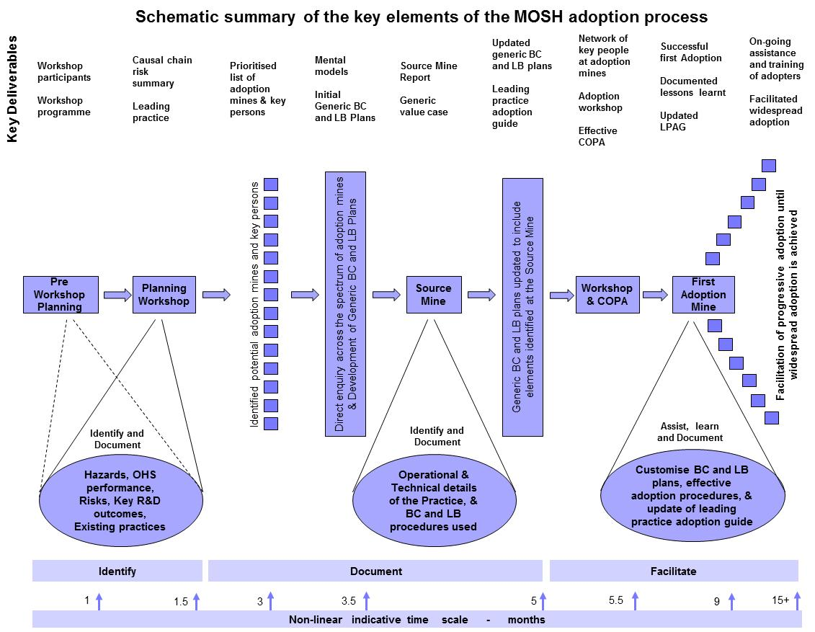

1. The two schematic representations of the process shown here illustrate the systematic step by step approach, as well as the time scale and detailed nature and scope of the process, which is presented here in broad terms.

**Legend for both figures**

BC Behavioural Communication

LB Leadership Behaviour

COPA Community of Practice for Adoption

LPAG Leading Practice Adoption Guide

LP Leading Practice



**Ongoing provision of specialist support**

1. In order to ensure that the industry led MOSH Adoption Teams are fully effective in executing the MOSH adoption process they are supported by a dedicated full-time secretariat with the necessary specialist and administrative skills. *This is a very important enabling aspect of the adoption system*.

**Permanent full-time specialist secretariat to support Adoption Teams and Process**

* **Adoption Specialist for each Adoption Team**
* **Behaviour Specialist**
* **Monitoring Specialist**
* **Administrative support**

**Establishment of MOSH Adoption Teams in key risk areas**

1. There has been a remarkable improvement in FOG fatality rates since 2002. It is no longer the stand-out leading cause of fatalities in SA mines.
2. Transport and Machinery accidents as a cause of fatalities in SA mines is now comparable with those caused by falls of ground. With increasing mechanisation the importance of this risk area is likely to grow, and efforts in this area will need to be intensified.
3. Control of respirable dust to eliminate silicosis one of the major challenges facing the mining industry. Silicosis is responsible for disability and death on a scale that is clearly unacceptable.
4. Elimination of Noise Induced Hearing Loss (NIHL) due to conditions at work is another major risk area. It is responsible for significant harm being experience by the workforce. Ideally, the problem should be addressed at source by buying quiet equipment and maintaining it so.

**Developing an expert understanding of the risk situation**

|  |  |  |  |  |  |
| --- | --- | --- | --- | --- | --- |
| **Basic Framework of a Generic Causal Chain Risk Summary Table** | | | | | |
| **Part A – Description of the causal chain** | | | | | |
| **No** | **Nature of the hazard** | **No** | **Exposure to the hazard** | **No** | **Outcomes of exposure** |
|  | Description of the identified hazard/s (substances / equipment / events / etc.) |  | Description of the different categories of exposed persons, the nature and duration of exposure, and any other details that characterise the exposure |  | Description of all the ways in which workers might be affected and harmed by exposure to the risk, including biological or physiological effects. |
|  | **Data Gaps** | | | | |
|  | Identify any gaps that need to be investigated |  | Identify any gaps that need to be investigated |  | Identify any gaps that need to be investigated |
|  | | | | | |
| **Part B - Current risk mitigation controls and strategies** | | | | | |
|  | Identify and describe |  | Identify and describe |  | Identify and describe |
|  | **Weaknesses** | | | | |
|  | Identify and describe |  | Identify and describe |  | Identify and describe |
|  | | | | | |
| **Part C – Possible improvements in risk mitigation controls and strategies** | | | | | |
|  | Identify and describe |  | Identify and describe |  | Identify and describe |
|  | **Possible new practices** | | | | |
|  | Identify and describe |  | Identify and describe |  | Identify and describe |

1. The need for an expert understanding of the risk area being addressed is obvious. Without such an understanding the risk of addressing symptoms and not causes is real.
2. In the adoption system there is another equally important reason. Unless one has such an understanding, it is not possible to identify the knowledge gaps, misperceptions and mistaken beliefs of adopters and key stakeholders. It is these mental models that can act as barriers to adoption of a selected. leading practice

**Example expert model influence diagram - for the dust risk**



1. In the adoption system this expert understanding is captured in an expert model. The model may take the form of a causal chain risk summary table and / or an influence diagram.

**Selection of the leading practice with greatest potential**

1. A special workshop involving the most experienced and knowledgeable people in industry is held to select the leading practice that has the greatest potential to improve OHS in the risk area in question.
2. The practice is selected using a rigorous procedure and relevant selection criteria agreed upon by workshop. participants.

**Adoption Team (Group) inputs**

**Risk assessment analysis**

**Review of R&D outcomes**

**Visits and discussions at mines**

**Input from selected experts**

**Leading practice selection criteria agreed at workshop**

**Selected Leading Practice with greatest OHS benefit**

**Identify / invite key persons to participate in workshop**

**Preparatory Work**

**Identification of potential adoption mines and their key persons**

1. With input from the Task Force and mining company representatives of the MOSH Adoption Team, all potential adoption mines, and the key people at these mines are identified.
2. This enables:
   * The identification of key adopters, decision makers and other key stakeholders.
   * The selection of an appropriate group of persons to be interviewed in the direct enquiry process to establish the prevailing mental models, and,
3. The initiation of a communication process to inform key persons of relevant findings and developments.

**Identification of potential adoption mines**

**Is the leading practice applicable at the mine?**

**Will the mine benefit from adoption?**

**Contact details of Manager and relevant Specialist?**

**Input and guidance:**

* **Task Force Rep.**
* **Adoption Team**
* **Group Specialist**

**Prioritised list of potential adoption mines**

(To focus on mines with greatest benefit – most likely adopters – interviewees for direct enquiry process – recipients of early behavioural communications material)

**Identification of prevailing mental models**

1. The direct enquiry process recognises that all interviewees are experts about what they experience. It is thus a respectful process. It is used to identify the mental models of the key adopters, deciders and other stakeholders.
2. The carefully developed open ended questions of the direct enquiry process provide the interviewees with an opportunity to confidentially say exactly what they think.
3. The empirically determined mental models provide the basis for developing behavioural communication and leadership behaviour plans that are generically applicable to the complete spectrum of identified potential adoption mines.

**Identify key adopters and other stakeholders**

**Develop direct enquiry protocol (procedures / questions)**

**Select persons to be interviewed**

**Train interviewers and conduct enquiries**

**Analyse responses and establish mental model**

**Develop Behavioural Communication**

**and**

**Leadership Behaviour plans**

**Documenting the leading practice at the Source mine**

1. A detailed plan is developed for conducting the investigations at the source mine.
2. Investigation of the behavioural aspects is based on the insights gained in developing the generic behavioural plans.
3. The behavioural aspects observed at the source mine are used to update the generic behavioural plans.
4. The investigations seek to capture all the information needed to enable the practice to be replicated at another mine.

**Technical details:** Investigate and document

**Leadership detail:** Investigate and document

**Communications:** Investigate and document

**Example materials**

* Training
* Communications
* Signage

**Detailed Source investigations report**

**Identifying and documenting the full value case**

1. The value case is determined for each leading practice through a process of careful investigation.
2. The value case includes business case considerations but it also identifies the often more important strategic benefits associated with adoption of the leading practice.
3. Setting the goal of achieving zero harm at work is aspirational and admirable: adopting and appropriately acting on it requires high-level strategic decision making.

**Financial Impacts**

* Initial cost
* Operational cost
* Financial benefits
* Production
* Etc.

**Strategic Impacts**

* Health & Safety
* Relationships
* Image
* Investor support
* Etc.

**The Generic Value Case**

**Provision of a Leading Practice Adoption Guide to facilitate widespread adoption**

1. This is a user-friendly document that contains all the information that a potential adoption mine needs to voluntarily decide whether or not to adopt the practice, and to then successfully adopt the practice should it decide to do so.
2. The Leading Practice Adoption Guide (LPAG) makes it clear that the leading practice comprises of three equally important legs. All three need to be implemented for adoption to be complete and sustainable.



**Part 1: Strategic Context**

* **The problem**
* **The practice**
* **The value case**

**Part 2: Detailed Adoption Guidance**

**Part 3:**

**The Leading Practice**

* Technical details
* Behavioural communication
* Leadership behaviour

**Detailed appendices:**

Pro-forma plans - Worksheets -Example materials

**Customisation of the leading practice at adoption mines**

1. The adoption procedures outlined in the Leading Practice Adoption Guide include guidance on customising the leading practice to fit in with mine-specific circumstances.

**Review practice against mine operational standards**

**Mine-specific circumstances**

**Customise non-core elements of Leading Practice**

**Conduct direct enquiries to establish mine-specific mental model issues**

**Customise Generic Behavioural Communication Plan**

**Customise Generic Leadership Behavioural Plan**

**The Leading Practice Adoption Workshop - initiates facilitation of widespread adoption**

1. Key persons from all identified potential adoption mines are invited to attend the Leading Practice Adoption Workshop.
2. The workshop, which leads to the establishment of a Community of Practice for Adoption (a COPA)actively starts the process of facilitating industry wide adoption of the selected leading practice.

**Who to attend?**

* Mine Managers
* Relevant specialists
* Other key stakeholders

**What is covered?**

* Leading Practice details
* Value case
* Behavioural processes
* Leading Practice Adoption Guide
* Role and function of COPA
* Establishment of COPA

**Establishment of a Community of Practice for Adoption – for on-going facilitation**

1. The COPA serves as a mechanism for mines to acquire guidance, assistance and specialist training to achieve successful adoption of the Leading Practice.
2. The COPA terminates its existence when its members feel that it is no longer needed.

**Who?**

* Mine Managers (initially)
* Relevant specialists
* Mine Adoption Team Manager
* Mine Behavioural Overseer

**What?**

* Explain / use Leading Practice Adoption Guide
* Provide / arrange training
* Problem solving
* Provide / arrange assistance
* Share adoption experience
* Continuous improvement
* Mine visits as appropriate

**Modus operandi?**

* Regular meetings
* Jointly implement Leading Practice Adoption Guide
* Work directly with lead adopter mine
* Assist other adoption mine to extent possible

**Conclusion – the process is continuous**

1. The process of continuous improvement never stops.

**Establish COPA and facilitate widespread adoption**

**Investigate / document new practice for adoption**

**Identify new leading practice with best potential**

**Disband COPA when no longer needed**

**Cycle of continuous OHS improvement**

Acknowledgement

The role and contribution of the MOSH Adoption Teams, the Learning Hub Secretariat and Chamber member mining companies to the development of the MOSH Leading Practice Adoption System is gratefully acknowledged. So too is the contribution of Decision Partners LLC, Pittsburgh, USA, particularly in regard to development of the behaviour-based techniques that form a key element of the system. Much of the material presented in this paper is drawn from the Guidance Handbook on the MOSH Leading Practice Adoption System prepared by J M Stewart on behalf of the Chamber of Mines of South Africa.